HILL CLIMB ACKLEY

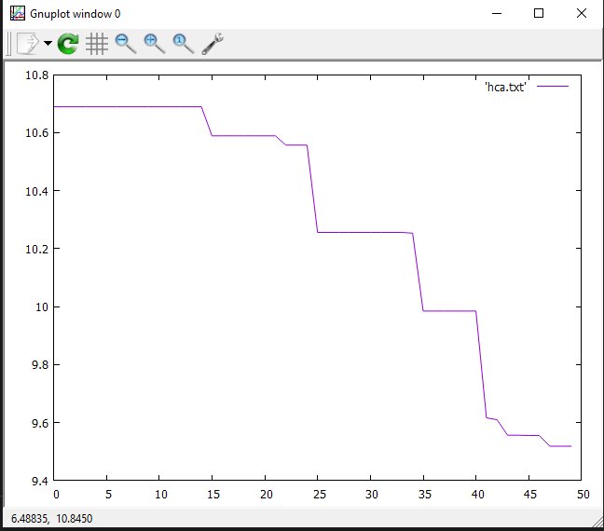

HILL CLIMB BOOTH

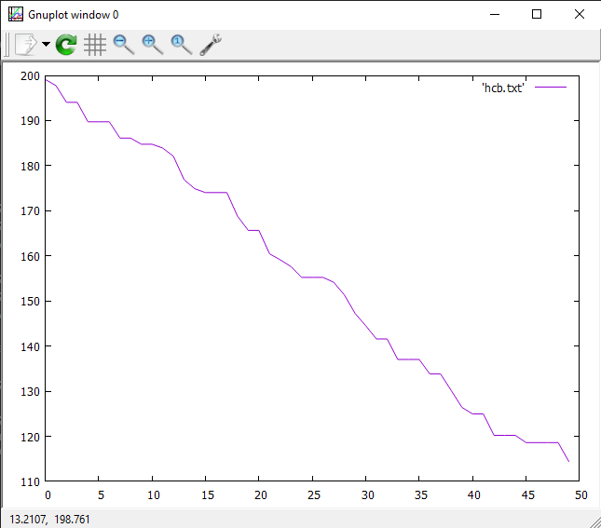

SIMULATED ANNEALING ACKLEY

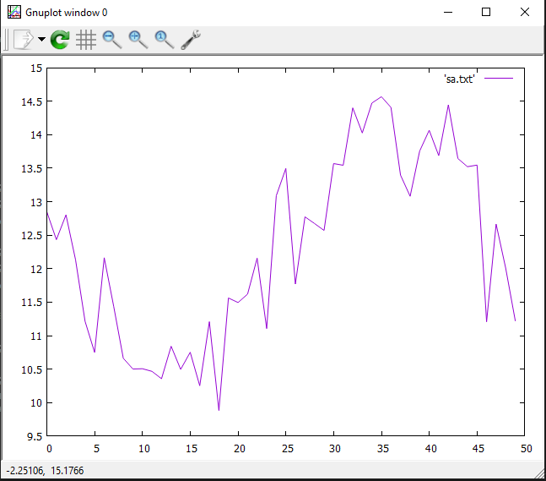

SIMULATED ANNEALING BOOTH

