Social Network Analysis in Eurovision Context

Table of Contents

## Executive Summary

Still in progress

## Introduction

### Concept of Eurovision

Eurovision, the big singing contest with countries from all over, is not just about who sings the best. It’s like a colorful puzzle of different nations trying to win. But, if you pay attention, you’ll see that winning isn’t just about singing really well. There is this interesting thing where countries tend to vote for their friends. It’s not about the song alone; it’s like a secret voting club based on things like being neighbors or having a history together. So, in Eurovision, it’s not only about hitting the high notes but also about who your buddies are behind the scenes. The competition becomes a mix of music and a kind of international friendship dance.

Studying social networks within the Eurovision context is of paramount importance for various reasons. First, it provides invaluable cultural insights, as Eurovision serves as a reflection of the diverse cultures and values of participating countries. Additionally, examining voting patterns illuminates the influence of political and regional alliances on the integrity of the competition, offering potential avenues for reform.

Furthermore, the substantial public engagement generated by Eurovision on social media offers insights into which aspects of the contest resonate most with the audience. Social network analysis also enables predictive analytics, aiding contestants, broadcasters, and sponsors in making informed decisions about the popularity of acts or songs.

Understanding fan communities on social media helps tailor strategies to engage and mobilize passionate supporters, while assessing marketing and promotion effectiveness through social networks aids in reaching a broader audience. Finally, it’s crucial for optimizing the digital experience and gathering audience feedback to enhance the overall Eurovision experience.

### Research on Social Networks in the Eurovision Context

Research has already been conducted in the field of social networks regarding voting patterns which as a consequence leads to creating communities within the Eurovision participants. Dekker A. (2007) (A. Dekker 2007) has already conducted the research using Eurovision cast from 2005 where he analysed the friendship network using techniques previously developed for valued networks (Dekker, 2005) (A. H. Dekker 2005), which combine network-analysis methods with statistical methods. His analysis revealed a set of friendship blocs.

In 2019, Angelo S.D. et al. (D’Angelo, Murphy, and Alfò 2019) introduced the concept of modeling latent spaces in multidimensional networks, specifically focusing on its application to the exchange of votes within the Eurovision Song Contest. The model was put into practice to analyze voting patterns in the Eurovision Song Contest, spanning from 1998 to 2015. This analysis incorporated cultural and geographical factors. It was discovered that the only significant factor in explaining observed voting patterns was the presence of a shared border between two countries. Interestingly, the similarities among participants during the 1998-2015 period only partially correlated with their respective geographical locations.

In 2022 Ginsbrugh V et al. suggested (Ginsburgh and Moreno-Ternero 2022) that in the context of the 2021 edition, the findings suggest a greater propensity for reciprocity among geographically proximate nations. For instance, we previously highlighted the case of Greece and Cyprus, and this pattern is also discernible in other pairs, such as Bulgaria and Moldova, Moldova and Russia, Russia and Azerbaijan, and Bulgaria and Greece. Furthermore, our analysis delves into the concept of group reciprocity, wherein we investigate the presence of voting clusters among countries A notable example comprises the Scandinavian nations, encompassing Denmark, Finland, Iceland, Norway, and Sweden. It is worth noting that Denmark did not progress to the final round of the competition. Within this cluster, Finland received 13 points, constituting approximately 20% of its total score, Iceland amassed 27 points, Norway obtained 5 points, which represented a third of its overall score, and Sweden achieved a particularly noteworthy outcome, garnering 25 points, equivalent to over half of its total score.

Hence, it is evident that extensive research has already been undertaken concerning Eurovision voting patterns in the domain of social networks. Studies take into consideration various aspects but there is a lack of research when it comes to the newest Eurovision editions. Moreover, there is a lack of research when it comes to analyzing the influence of the political system of the country as well as the influence of language family.

### Research questions and hypothesis

Analyzing the current state of the art and identifying the research gaps led to the following research questions:

* ***RQ1: To what extent do countries formulate small communities between each other in the Eurovision competition?***
* ***RQ2: To what extent governmental system and language family influence how the countries distribute their votes during the Eurovision competition?***

The aforementioned research questions lead to the following hypothesis regarding first research question:

* H0: There is not a significant number of communities within Eurovision competition.
* H1: There is a significant number of communities within Eurovision competition.

The aforementioned research questions lead to the following hypothesis regarding second research question:

* H0: Governmental system and language family do not have an influence on how countries distribute their votes Eurovision competition
* H1: Governmental system and language family have an effect on how countries distribute their votes during Eurovision competition

Answering the aforementioned research questions and testing hypotheses is going to help us to understand to a certain extent whether there are voting patterns inside Eurovision as well as to understand what may cause those phenomena.

To answer the first research question and to validate the first hypothesis we are going to run a Conditional Uniform Graph (CUG) test. The CUG allows detecting communities within a network firstly by generating a null model and randomizing the network while preserving certain structural properties, such as node degrees. Then it applies a detection algorithm to identify potential groups of nodes in the original network. How exactly the CUG model is going to be used and which community detection algorithms is chosen in this project is described in the Conditional Uniform Graph using walktrap community detection section.

To answer the second research question and to validate the second hypothesis we are going to run Exponential Random Graph Model (ERGM) test. It offers a robust and flexible approach to examine the effects of exogenous attributes on network structure while considering the complex dependencies and configurations within the network itself.

In the rest of the report, we will carefully describe the datasets that are going to be used to conduct the research. Data cleaning and if necessary data preprocessing are going to be run before any analysis. Descriptive analysis is going to be performed to understand the data better. The research rationale is going to be discussed to provide the reasoning why CUG and ERGM have been chosen as suitable models for answering research questions and testing hypotheses.

## Methodology

### Dataset

For this project, the data has been collected from several sources. Using multiple origins of data allowed us to enrich the dataset and run a more comprehensive analysis.

On the Eurovision website (n.d.a) the data is presented in a table which by switching the tab on the top of the page can be easily filtered by Jury or Public votes. Data is presented in a matrix where columns are created by countries who were giving the points and rows are represented by countries who were receiving scores. Each entry of the matrix is represented by the number of points that were given/received. Due to the time constraint of this project, for each country only the top 3 votes were taken into consideration thus possible edge attributes are represented in the set {8,10,12} which corresponds to the top 3 votes given by the country. This data was produced 13th of May 2023 when the final of the tournament took place.

To enrich the data we also collected information about each country’s language family [the source to language family], country population (n.d.b), and country political system [the source to governmental system]. This data was manually inserted into CSV files which eventually allowed to transform it to the network object.

As a result, the whole dataset contains 3 CSV files. The first CSV file contains information about the countries which in this paper are also going to be referred to as nodes, population, country language family, and country political system. This file is used to create a list of nodes which is used to create a network object.

The second CSV file contains information about the votes of jurys from the countries. There are 3 columns in this file sender, receiver, and score which represent the amount of points given from the sender to receiver. This file is used to create an edge list which is used to create a first network object.

The third CSV file contains information about the votes from the public from the countries. There are 3 columns in this file sender, receiver, and score which represent the amount of points given from the sender to receiver. This file is used to create an edge list which is used to create a second network object.

In this paper, 2 network objects are created and analyzed. The first network object is created using Node List which comes from the first csv file and an edge list which represents jurys votes and is created from the second csv file. The second network object is created using the same Node List and an edge list which represents public votes and is created from the third csv file.

The selection of node attributes has been done after doing the research and discovering research gaps. That led nodes to have the following attributes:

* country_name
* country_population
* country_language_family
* country_government_system

Furthermore, 3 CSV files allowed the creation of 2 network objects which as a consequence allowed to perform deeper analysis and reveal potential differences in voting patterns between jury and public.

### Potential bias in the datasets

All data is publicly available online in English thus anyone with access to the internet can view it. Language barrier can be a limitation, however, nowadays a lot of online dictionaries are available to translate the websites immediately. Thus no major biases in the data have been identified.

## Exploration of the dataset

Data exploration in social network analysis is essential as it reveals network structures, identifies influential nodes, and uncovers patterns of interaction. This initial step is pivotal for understanding, interpreting, and drawing meaningful insights from the complex web of relationships within social networks.

### Descriptive analysis <yet in progress>

Firstly descriptive analysis needs to be conducted to establish a foundational understanding crucial for informed decision-making and insightful conclusions. Since both networks show similar descriptive statistics they are going to be both described under one paragraph. In the paragraph below first network is considered as a network created from votes from the jury and the second one as the network created from votes from the public.

From the descriptive analysis for both networks, it can be observed that there are 37 vertices and 112 edges. Density is 0.084 and 0.083 for the first and second network respectively which is really low and the networks can be considered sparse with few connections between nodes in total. Reciprocity is equal to 0.125 and 0.053 which indicates that 12.5% of the edges in the network involve mutual connections in the first network and 5.3% in the second network. Transitivity is equal to 0.209 and 0.208 which shows that there is very low likelihood of “a friend of my friend is my friend” phenomenon. The mean distance in both network is just slightly between 2.5 and 2.65 which means that on average the shortest path is around 2.5 steps long which means that nodes are relatively close to each other and the networks are compact. There are no isolates present in either network. There are all types of triad census present in the first network except *300* and the absence of *120U* and *300* in the second one. It indicates a diverse and comprehensive set of structural configurations among triplets of nodes in both networks.

* Appendix A shows the plot of the network of Jury votes Eurovision can be found.
* Appendix B shows the plot centralities of Jury votes Eurovision. An explanation of the centralities terms can be found in Appendix G.
* Appendix C shows descriptive statistics of the network of Jury votes Eurovision
* Appendix D shows the plot of the network of Jury votes Eurovision
* Appendix E shows the plot centralities of Jury votes Eurovision
* Appendix F shows the descriptive statistics of the network of Jury votes Eurovision

### Data analysis (Research Rationale)

It is important to understand why CUG and ERGM tests are suitable for this data and how they are going to help to answer the research question and what are the potential alternatives for them. As it has been already described Research questions and hypothesis to answer the first research question, the CUG test is going to be conducted, and to answer the second research question ERGM model is going to be developed.

#### Conditional Uniform Graph using walktrap community detection

To answer first research question and to test the first hypothesis it will be checked to what extent small communities are formed within the Eurovision contest. Firstly, it needs to be decided which algorithm is suitable for detecting the communities within this network characteristics. Since both networks are relatively small and they are characterized by short-range interactions which can be observed by looking at the mean distance, walktrap community detection has been chosen as the suitable algorithm to detect communities within the networks.

The walktrap community detection algorithm was introduced in the paper by Pascal Pons and Matthieu Latapy in 2005 (Newman 2006). The paper was presented at the International Workshop on Computer Science and its Applications (CSA) in 2005. The primary focus of the algorithm is on detecting community structures in networks by leveraging the concept of random walks. It aims to identify groups of nodes that are likely to be part of the same community based on the tendency of nodes to be frequently visited together in random walks.

There are also other possible algorithms to detect communities such as fast-greedy, Girvan-Newman and Louvain. However, after analyzing the network structure, it has been decided that the walktrap community suits the best data characteristics.

##### Understanding CUG test

The Conditional Uniform Graph (CUG) facilitates community detection in a network by initially creating a null model and randomizing the network while maintaining specific structural characteristics, such as node degrees. Subsequently, it employs a detection algorithm to pinpoint potential clusters of nodes in the original network. Within this test, it is possible to specify which algorithm is going to be used to detect communities and as it has been described above walktrap community detection algorithm is going to be applied.

#### Exponential Random Graph Models <yet in progress>

The second research question analyzes to what extent language family or governmental political system influences voting patterns during the Eurovision contest. These are both exogeneous terms and their effect can be measured by ERGM models. This model allows dyadic dependent as well as dyadic interdependent terms which allow capturing the structure of the network. ERGMs provide a basis for statistical inference, allowing assessing the significance of the effects of governmental systems and language families on the network.

## Results <still in progress>

(about 2000 words)

### Model 1 <still in progress>

## CUG test for detecting communities  
walktrap_num_f <- function(x, directed = TRUE) {   
 x <- snafun::fix_cug_input(x, directed = directed)  
 snafun::extract_comm_walktrap(x) |> length()  
}  
eurovision_coms <- sna::cug.test(net_eurovision, FUN = walktrap_num_f, mode = "graph", diag = FALSE, cmode = "dyad.census", reps = 1000)  
  
print(eurovision_coms)

still in progress

### ERGM <still in progress>

edges are dyadic independent model (In ERGMs, the “edges” term models the presence or absence of edges between pairs of nodes (dyads) in the network. Dyadic independence implies that the presence or absence of an edge between any pair of nodes is considered independent of the presence or absence of edges in other dyads.)

1. Baseline model (Claudia said it should be just with edges)

* ## Baseline ERGM model (prerequisities: must be a network object)  
  baseline_model_0.1 <- ergm::ergm(net_eurovision ~ edges)   
  (s1 <- summary(baseline_model_0.1))

1. Exploratory models
2. Final model
3. MCMC diagnostics for the best selected model
4. Goodness of fit (GOF)
5. Interpret results

still in progress

## Conclusion

still in progress

# Appendix A

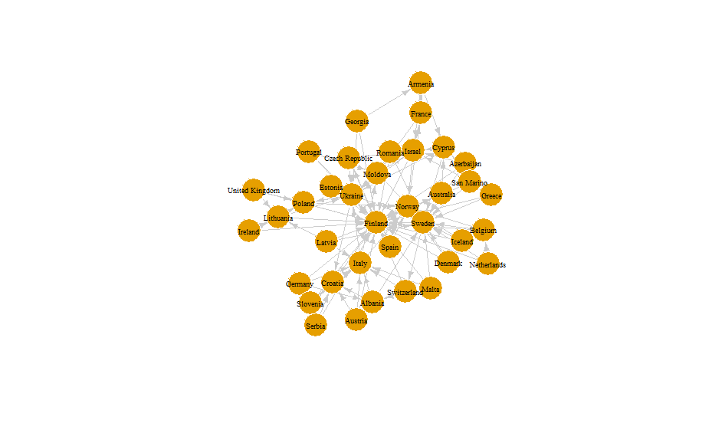

Eurovision Public

# Appendix B

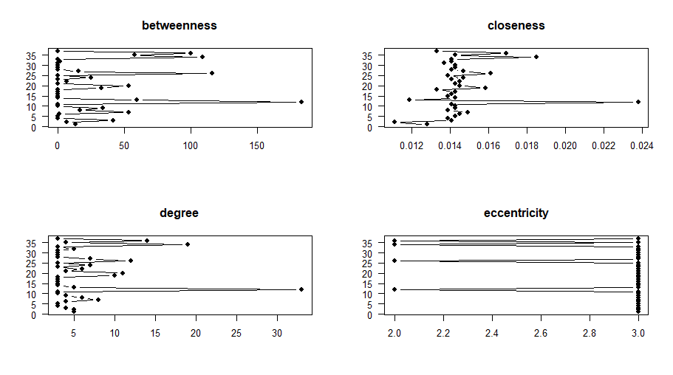

Eurovision Public Plot Centralities

# Appendix C

## Eurovision public   
## $number of vertices  
## [1] 37  
## $number_of_edges  
## [1] 112  
## density   
## [1] 0.08408408  
## reciprocity  
## [1] 0.125  
## transitivity  
## [1] 0.2097902  
## mean_distance  
## [1] 2.50487  
## number_of_isolates  
## character(0)  
## dyad_census  
## Mutual Asymmetric Null  
## 7 98 561  
## triad_census  
## 003 012 102 021D 021U 021C 111D 111U 030T 030C 201 120D 120U 120C 210 300  
## 5026 1776 107 31 541 104 104 8 48 3 3 11 4 3 1 0

# Appendix D

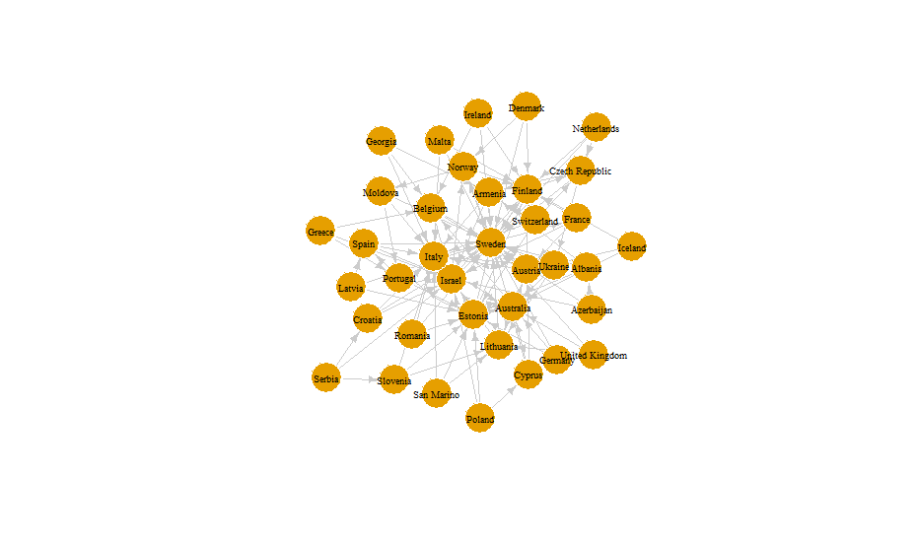

Eurovision Jury Plot

# Appendix E

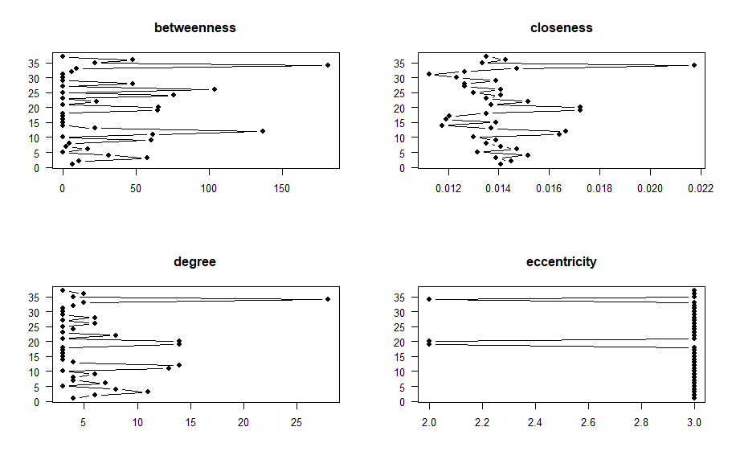

Eurovision Jury Plot Centralities

# Appendix F

## Eurovision jury   
## $number of vertices  
## [1] 37  
## $number_of_edges  
## [1] 112  
## density   
## [1] 0.08333333  
## reciprocity  
## [1] 0.05357143  
## transitivity  
## [1] 0.2084691  
## mean_distance  
## [1] 2.619632  
## number_of_isolates  
## character(0)  
## dyad_census  
## Mutual Asymmetric Null  
## 7 105 558  
## triad_census  
## 003 012 102 021D 021U 021C 111D 111U 030T 030C 201 120D 120U 120C 210 300  
## 4847 2070 60 43 449 184 47 6 46 3 0 11 0 3 1 0

# Appendix G

***Betweenness centrality*** of *i* is the proportion of all shortest paths in the network that pass through *i*. It shows which nodes have information access advantage and which are important to the network’s efficiency. It also shows the relative stress on nodes. Mathematically, it is defined as follows:



***Closeness*** measures how much effort it takes to reach all other nodes in the network. Sum the distances from *i* to all other vertices, this is it’s fairness. Then, the sum is inverted. Mathematically is defined as follows:

 where *d(v, i)* equal to the path length between *i* and *v*.

***Degree*** measures a node’s extraversion/outgoingness (“out-degree”), popularity (“in-degree”), or involvement (“total degree”).

$\text{In-Degree}(v) = \text{Number of incoming edges to node } v \\\text{Out-Degree}(v) = \text{Number of outgoing edges from node } v \\\text{Total Degree}(v) = \text{In-Degree}(v) + \text{Out-Degree}(v)$

***Eccentricity*** measures the maximum distance or shortest path length from a specific node to any other node in the network. In other words, it quantifies how far a node is, on average, from all other nodes in the network. Mathematically, it is defined as follows:

* $E\left(x\right)=\max_{y}d\left(x,y\right)$ where *E(X)* represents the eccentricity of node *x*, and *d(x,y)* is the shortest path distance between nodes *x* and *y*.

# References

n.d.a. *Eurovisionworld*. <https://eurovisionworld.com/eurovision/2023>.

———. n.d.b. *Worldometer*. <https://www.worldometers.info/world-population/population-by-country/>.

D’Angelo, Silvia, Thomas Brendan Murphy, and Marco Alfò. 2019. “Latent Space Modelling of Multidimensional Networks with Application to the Exchange of Votes in Eurovision Song Contest.” *The Annals of Applied Statistics* 13 (2). <https://doi.org/10.1214/18-aoas1221>.

Dekker, A. H. 2005. “Conceptual Distance in Social Network Analysis.” *Journal of Social Structure* 6 (3). <http://www.cmu.edu/joss/content/articles/volume6/dekker/>.

Dekker, Anthony. 2007. “The Eurovision Song Contest as a ‘Friendship’network.” *Connections* 27 (3): 53–58.

Ginsburgh, Victor, and Juan D. Moreno-Ternero. 2022. “The Eurovision Song Contest: Voting Rules, Biases and Rationality.” *Journal of Cultural Economics* 47 (2): 247–77. <https://doi.org/10.1007/s10824-022-09456-5>.

Newman, Mark EJ. 2006. “Finding Community Structure in Networks Using the Eigenvectors of Matrices.” *Physical Review E* 74 (3): 036104.