Krzysztof Anioł, gr. 1, IS IMiIP, st.2

Multiscale Modelling – Report

# User Interface

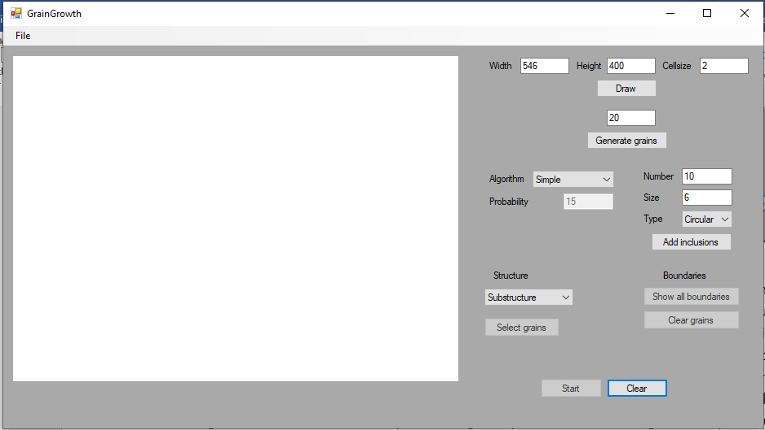

Figure 1 Main window

The program’s graphical interface allows user to customize simulation. The main picture box is the rectangular domain of simulation. To the right there are a bunch of options. On the top there are an option to redraw the picture box to the selected values. Below user can generate passed value of nucleons on random positions. Below to the right, there is an inclusion menu, which allows to pick kind of inclusion to be placed in domain, squared or radial, size of is its’ side length or radius of circular inclusion. Inclusions can be places at the beginning of simulation as well as at the end. Further to right, we can set an algorithm of CA grain growth algorithm and set probability of shape control algorithm. On the left corner of the settings after simulation user can pick some grains preserve them in original form(substructure) or change them into uniform grain(dual-phase), either way, preventing them from growing. On the other side “Show all boundaries” button gives user a possibility to draw grains boundaries and “Clear grains” button to draw only boundaries. On the bottom there is “Start” button to start simulation and “Clear” to reset the whole domain. User also have control over importing and exporting domain in .txt and .bmp format, options for that are placed in upper left corner.

# Examples of simulation

## 

* 10 square inclusions of size 3
* Simple grain growth algorithm
* Substructure selection

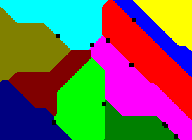

Figure 2 Domain after primary growth

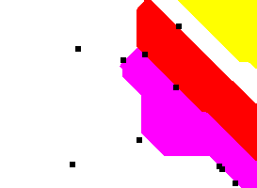

Figure 3 Domain after grain selection

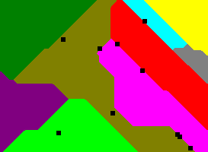

Figure 4 Domain after secondary growth

After simulation the grains; red, yellow and pink were selected, as well as new grains was generated to fill empty part of domain. After selection and randomization simulation has been started again. Figure 4 shows growth of nuclei that appeared due to re-randomization. As shown in fig. 4, secondary grains did not grow.

## 

* 6 square inclusions of size 6
* Shape control grain growth algorithm with 35% probability
* Dual-phase selection

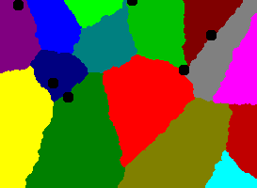

Figure 5 Domain after primary grain growth

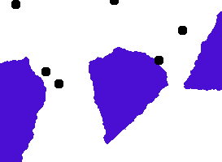

Figure 6 Domain after dual-phase selection

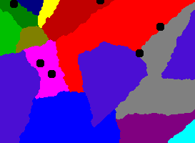

Figure 7 Domain after secondary grain growth

After simulation, grains; red, yellow and pink were selected and merged into grain 1 with option „Dual Phase”. Initial inclusion remained the same as it should be. The effect of selection is combining set of 3 grain types into 1 as if they were the same. As shown in fig. 7, dual phase grain did not grow.

* No inclusions
* Shape control grain growth algorithm with 90% probability

## 

Figure 8 Domain after primary growth

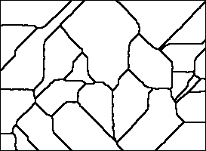

Figure 9 Domain after global grain selection

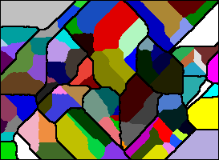

Figure 10 Domain after secondary growth

After simulation boundaries detection has been selected. Effect is shown in fig. 9. After that new grains has been generated. The distribution of grains is not uniform in regards to detected grains which leads to situations where some areas have multiple grains and some have none. Result of secondary grain growth is shown in fig. 10, as shown, some grains are empty due to above-mentioned reasons.

# Comparison with real-life simulation

Figure Ferritic cast iron with spheroidal graphite.

Figure Grain structure after customized grain growth

Figure Grain structure after customized grain growth

Figure Alumunium grain structure

# Summary

With pretty simple model of grain growth using CA we can get satisfying results, by adjusting options of simulation. Model is simple enough that the simulation for whole domain is reasonably quick, although time complexity grows quadratically when increasing dimensions of domain. As for simulations with bigger grains, it’s significantly more close to the real-world example in comparison to the second example. The aforementioned example suffers from poor approximation of roundness of original grains. It’s caused by relatively small size of grains, the smaller grains the harder it is to represent them as round shape but rather as jagged edges. The issue is simply mitigated or even completely avoided by scaling up the simulation domain, bigger grains mean easier to reproduce round shapes, although we have to keep in mind that domain cannot be too large. It would because severe damage to performance and resources requirements. By far the most important factor in performance is probability of modified Moore rule – shape control algorithm.