**Interactions between the server and client**

1. Execute the server using port 1155(anyport can be used between 1024, 65535)

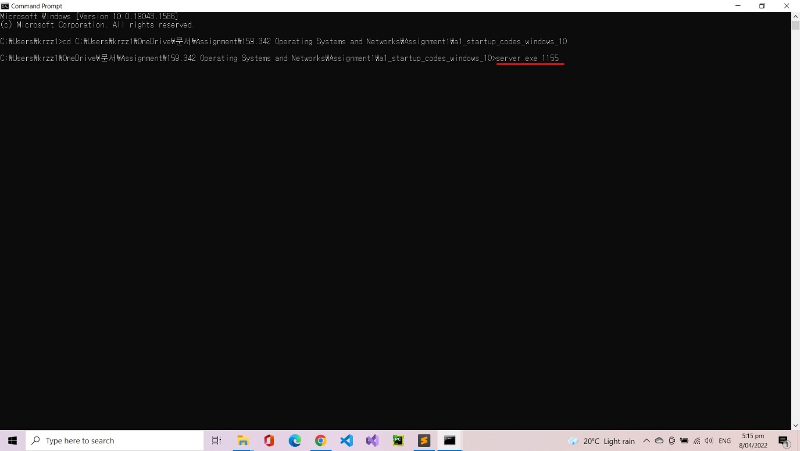

Server is waiting for any incoming client

1. Client connects to the server using the same port number 1155

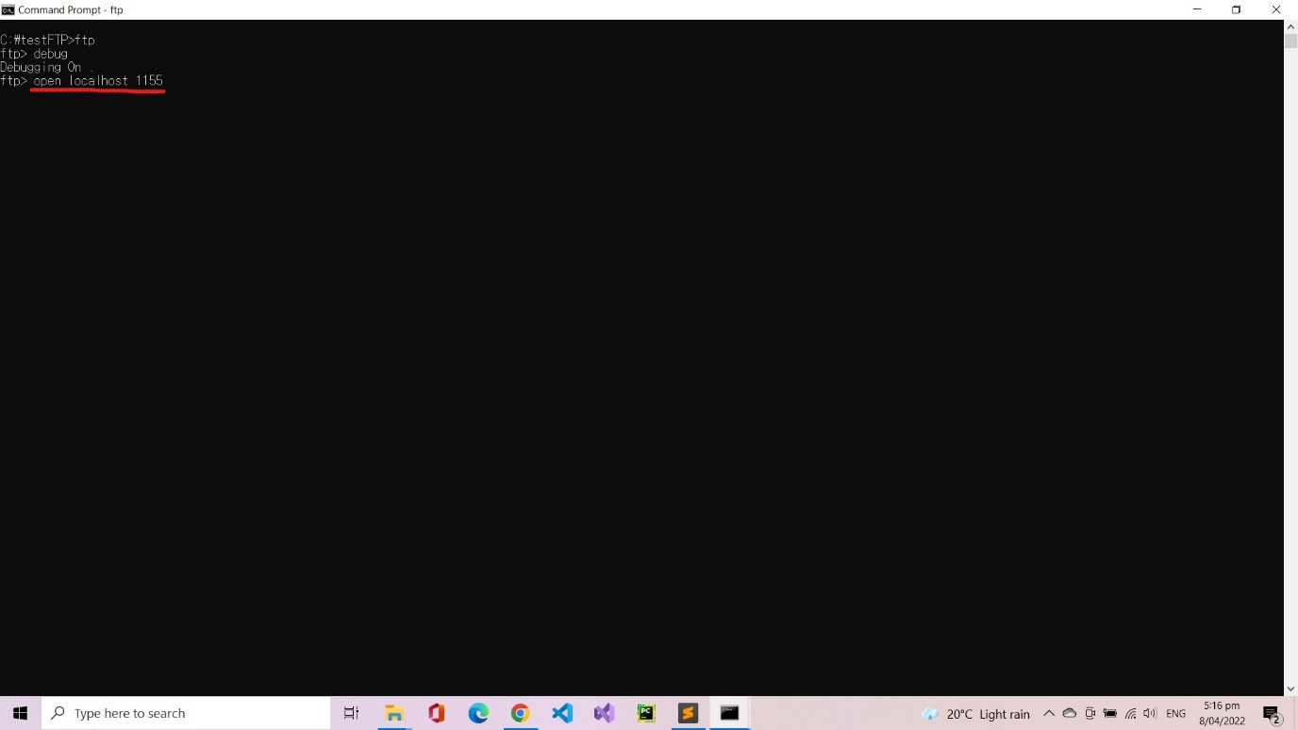

1. Server sends “220 FTP server ready” and client enter username ‘napoleon’.

(Server only accepts **username:** napoleon, **password:** 342 as log-in

identification.)

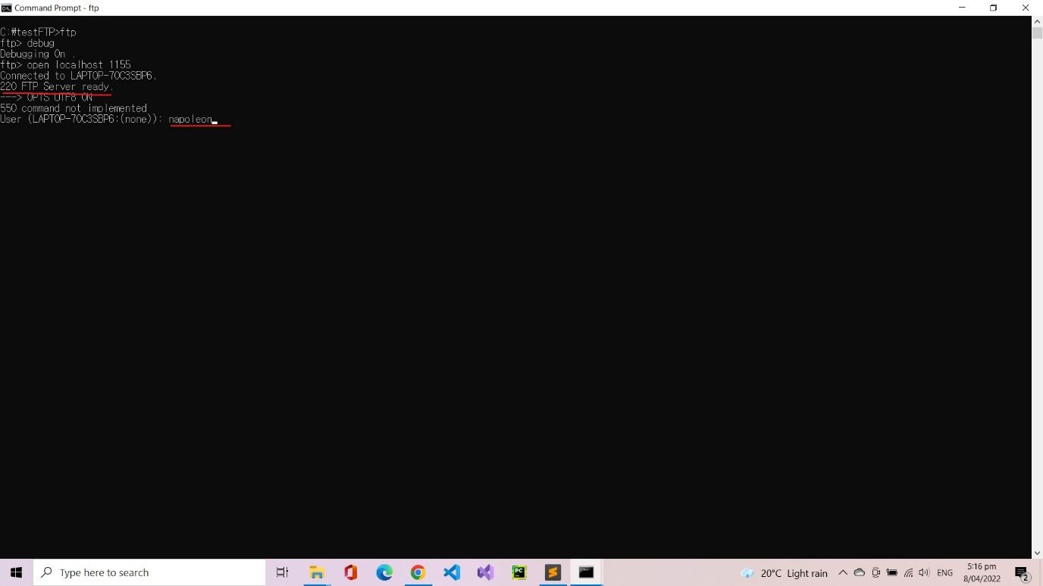

1. Server receives ‘USER napoleon’ and sends back “331 password required”, client send ‘PASS 342’ and receives ‘230 Public login successful’.

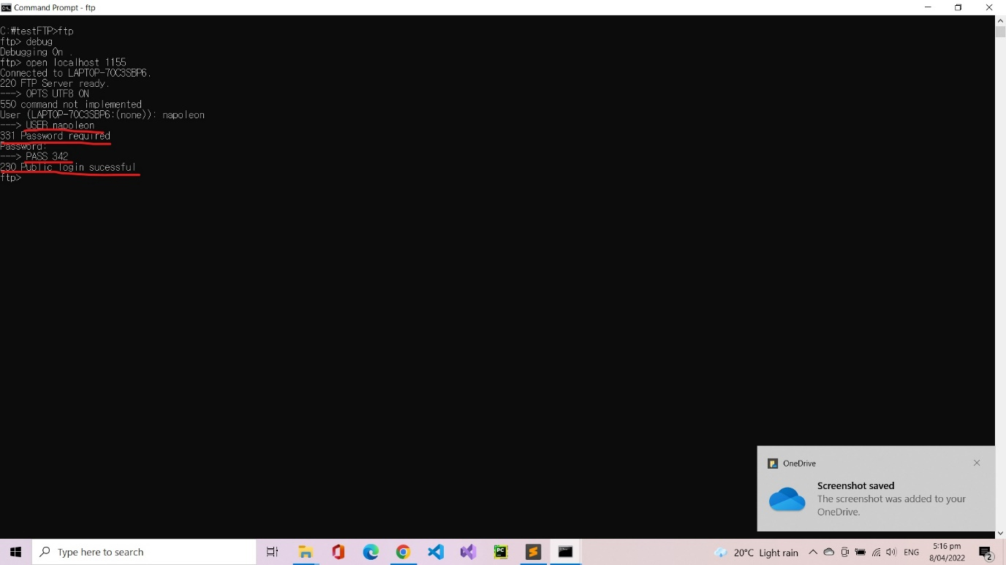

1. User types ‘dir’ and sends ‘EPRT |2|::1|6980|, server receives it and send back “200 EPRT Command successful”, client send ‘LIST’, server replies with “150 Opening ASCII mode data connection” and sends the lists of server-side files with “226 File transfer completed”

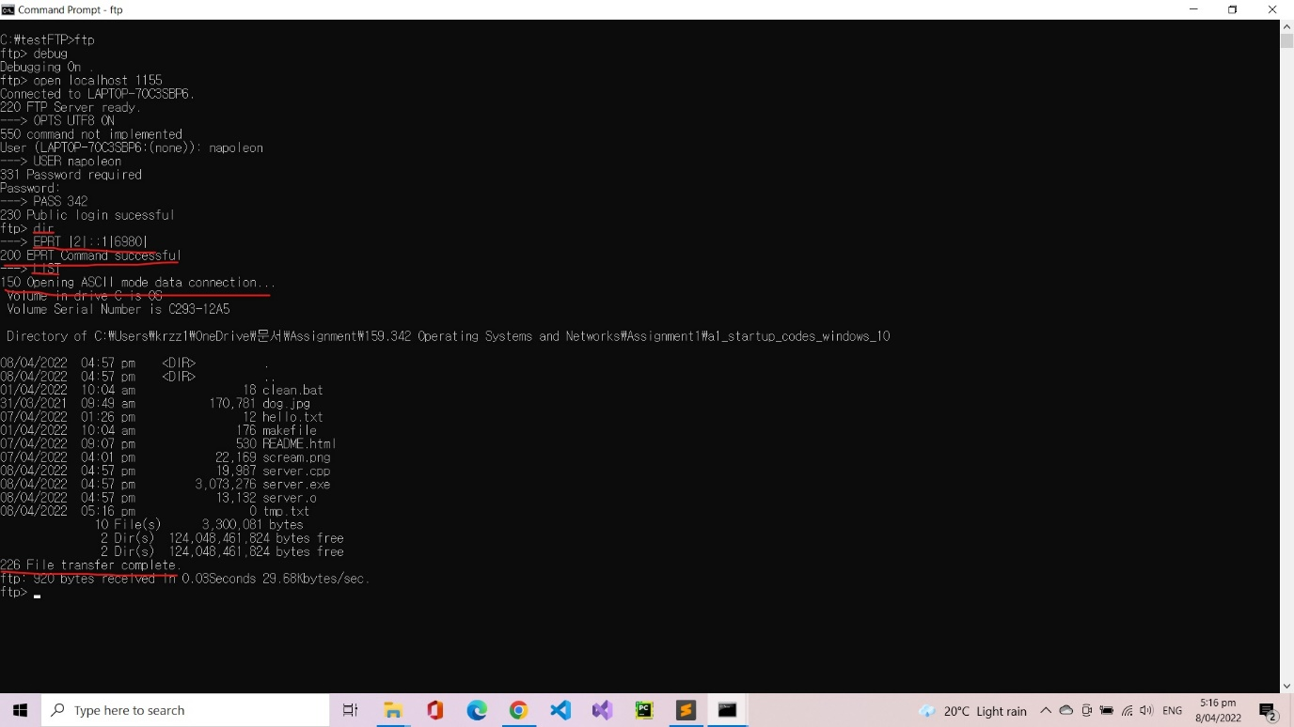

1. Client requests a file using “get tmp.txt”, connects with the server using EPRT and sends the data with RETR command.

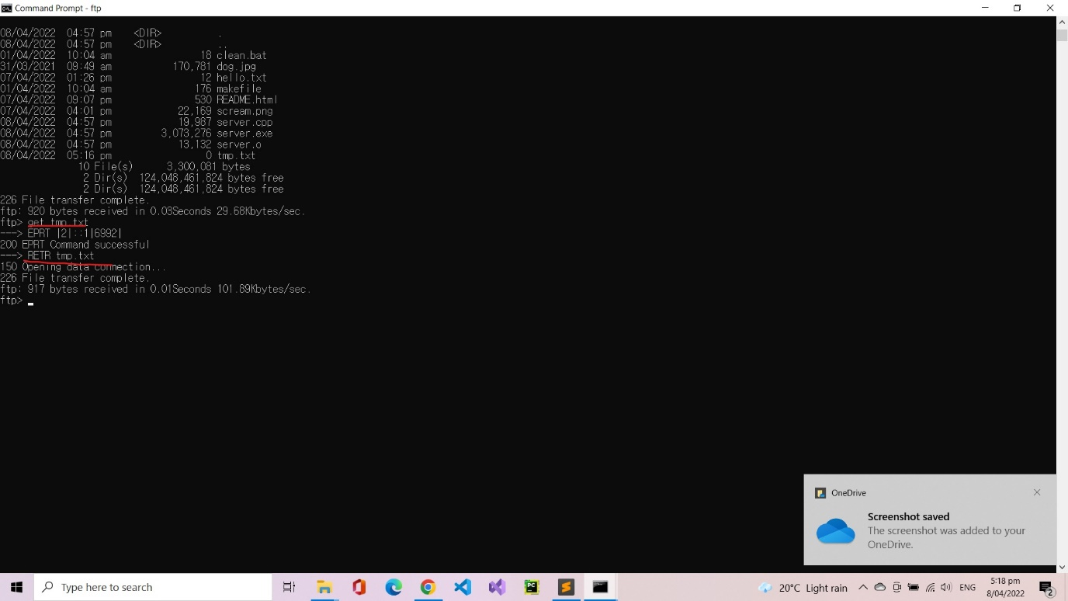

Client receives ‘tmp.txt’ file.

(Initially folder was empty.)

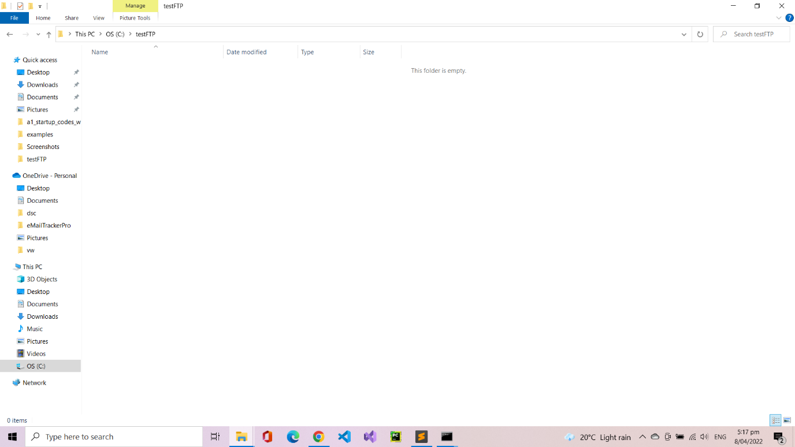

(Received “tmp.txt”)

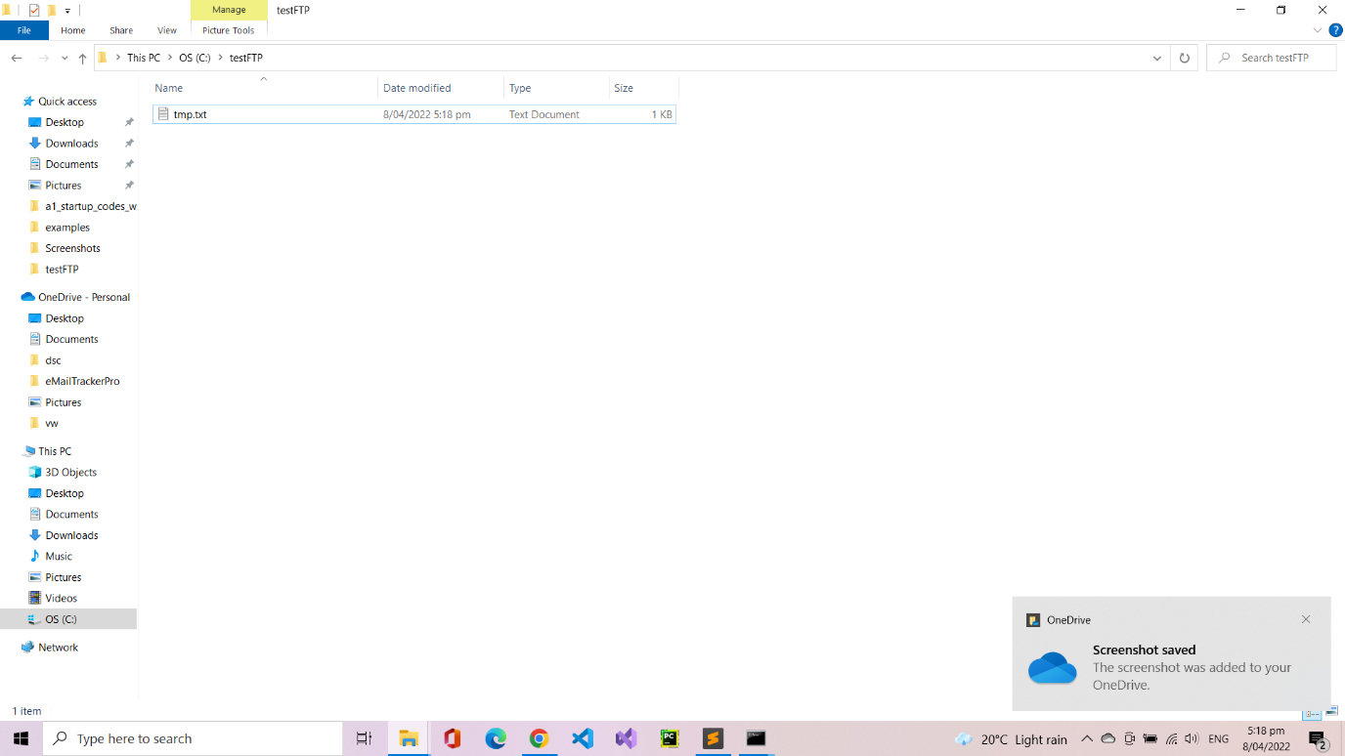

(File received without any corruption)

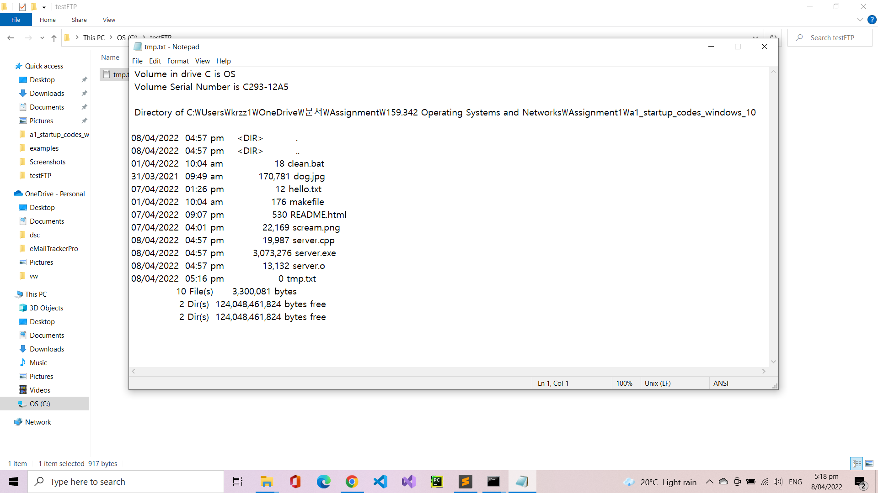

1. Client can choose which data type they want to get from the server using ‘ascii’ or ‘binary’ command. Text type data can be downloaded using ascii mode and image type can be download using binary mode.

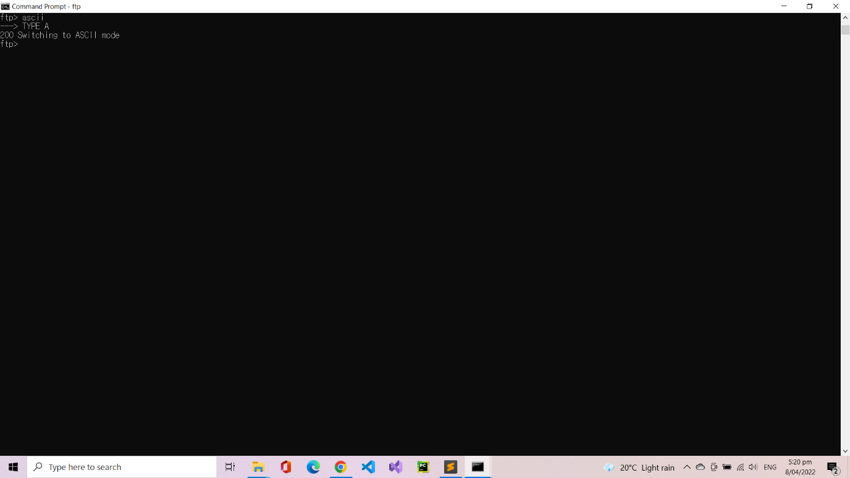

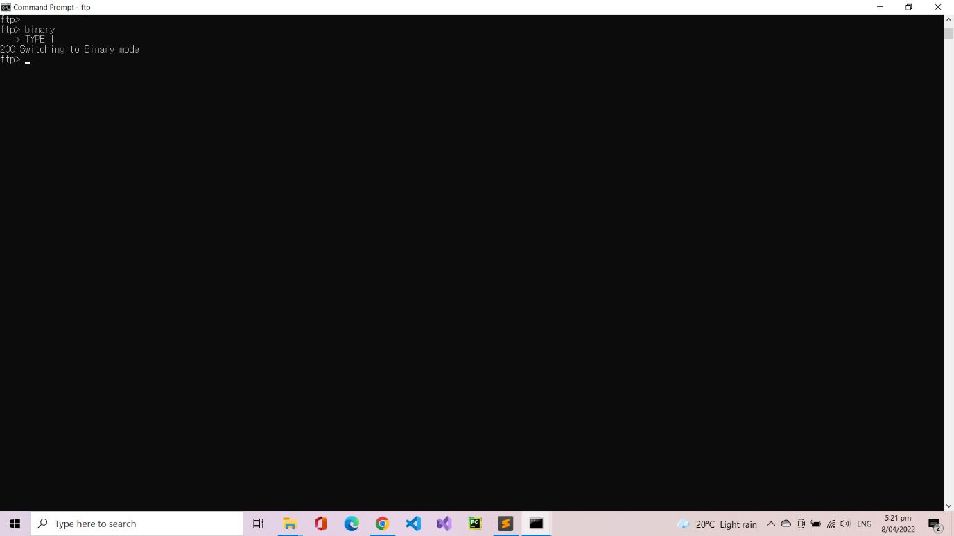

1. Image files also can be downloaded using ‘get’ command. Let’s try downloading jpg file from the server by typing ‘get dog.jpg’.

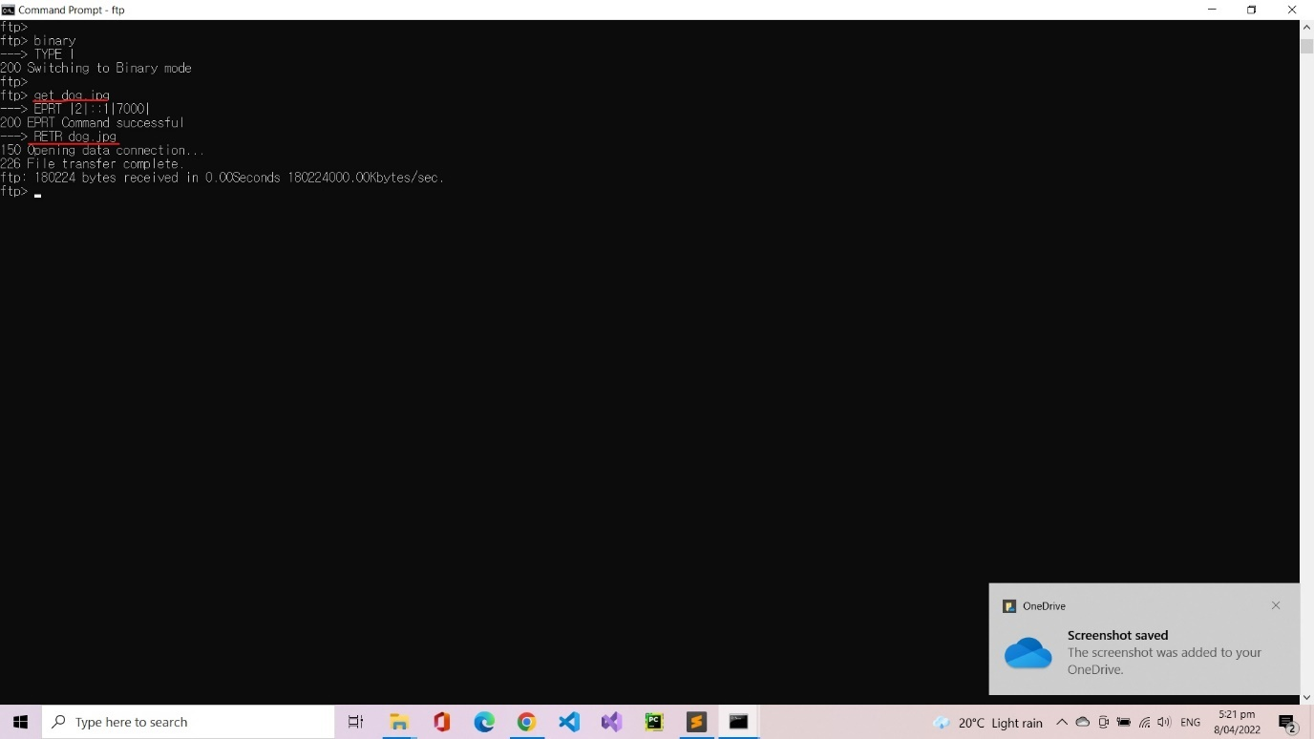

(dog.jpg file has been downloaded from the server)

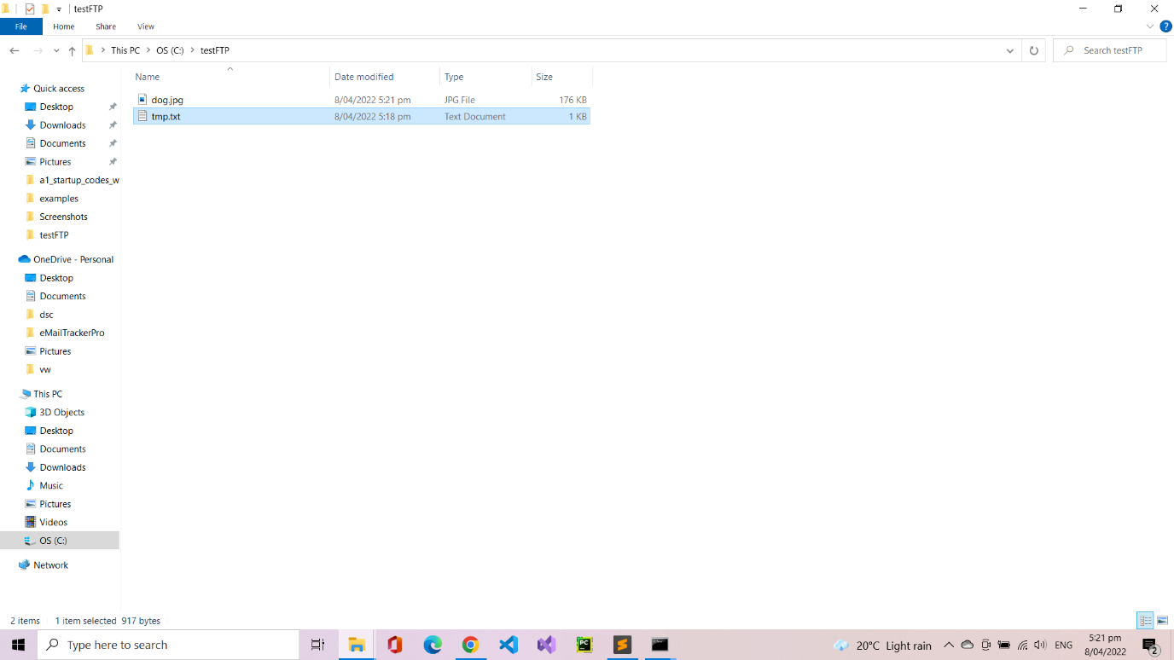

(File is not corrupted)

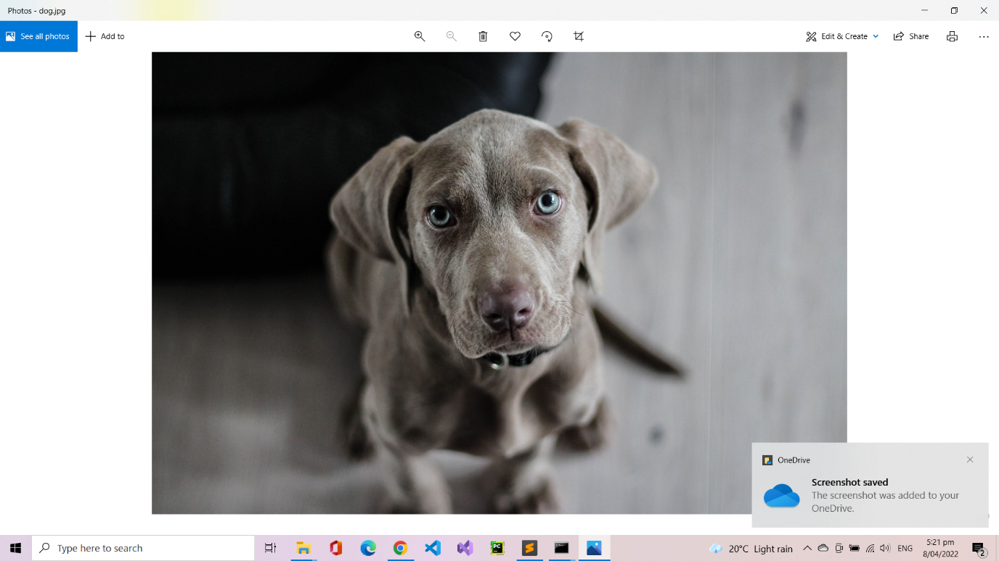

How about other types of image file? Let’s try downloading .png file using ‘get scream.png’.

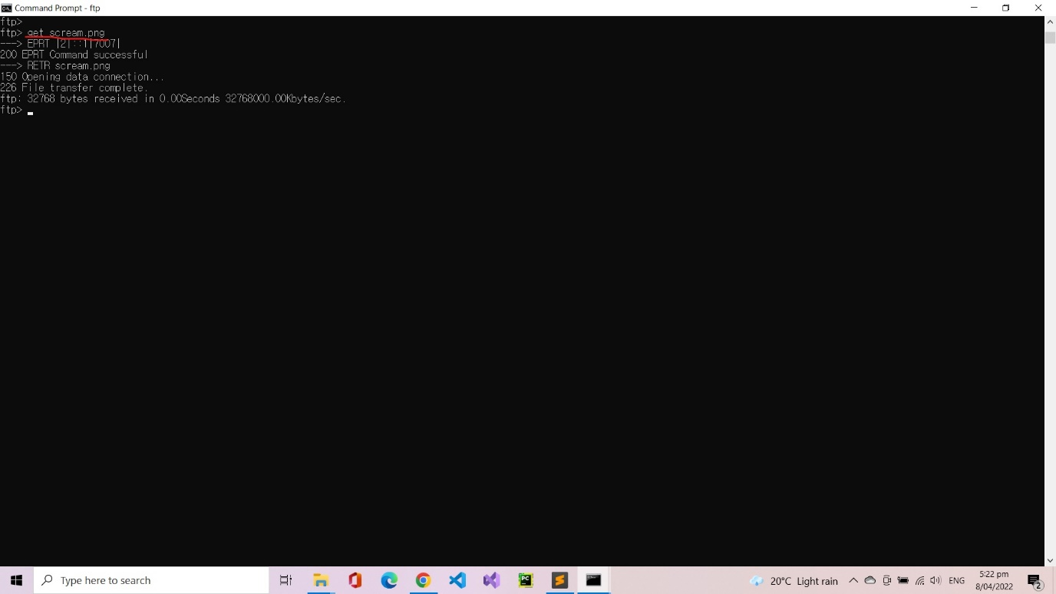

(Successfully downloaded without any corruption)

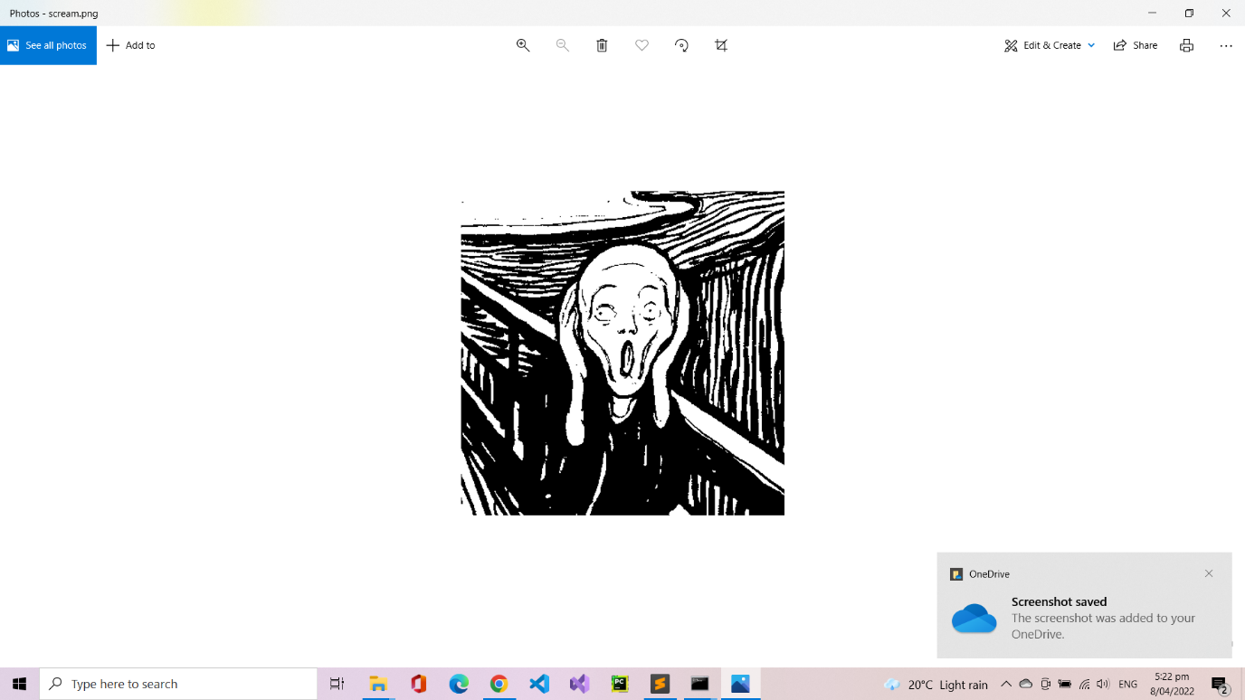

1. Simple ‘quit’ command will disconnects from the server.

“221 Connection close by client” was sent by the server.

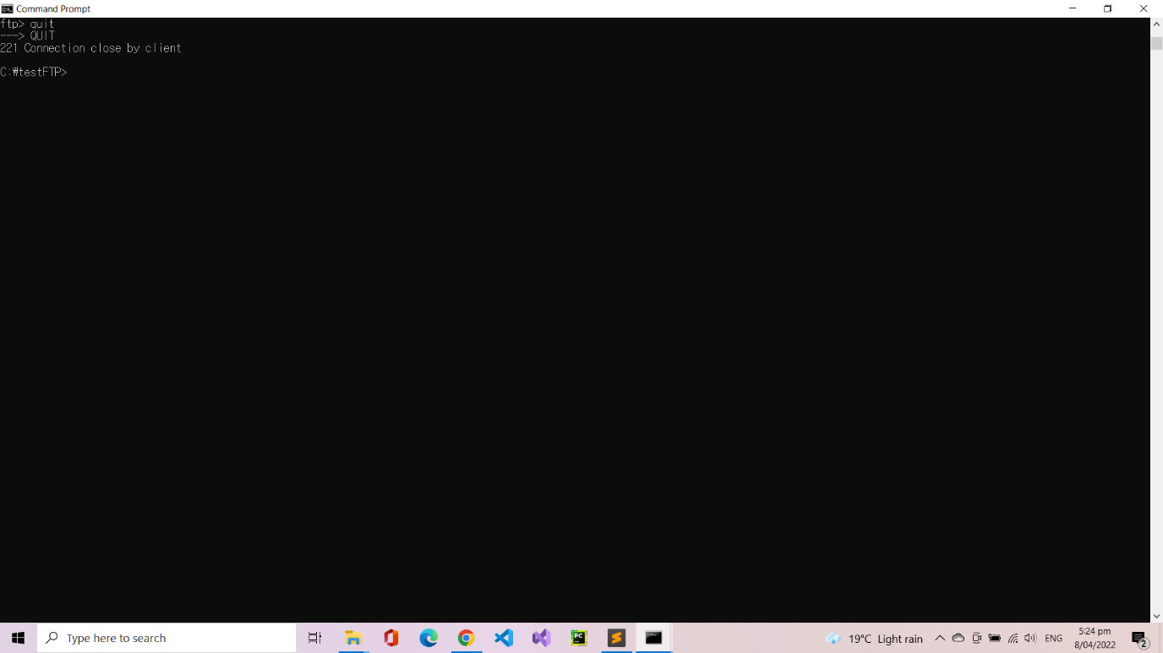

1. After the disconnection, server waits for any incoming connection requests.

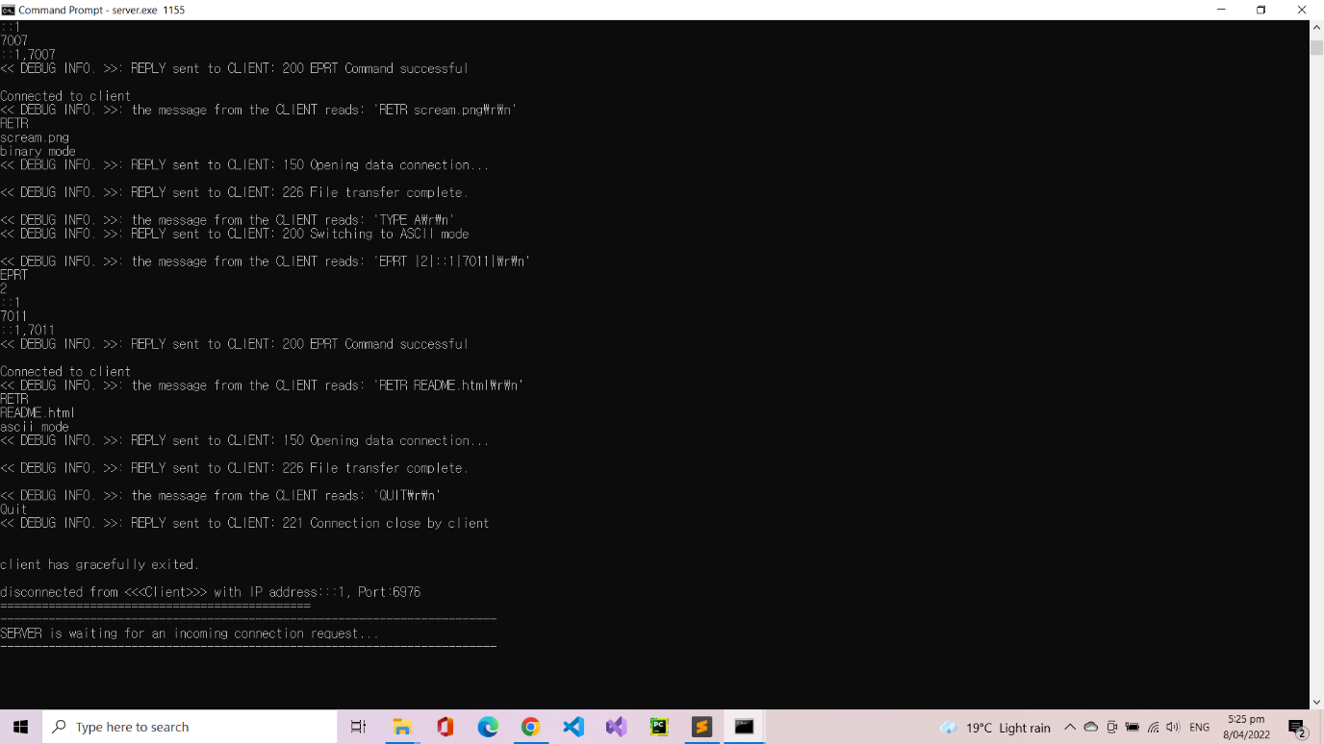

1. Client can reconnect to the server any time using the same port number.

