Lab Experiments
Data Structures and Algorithms
(24IC203P)
SCHOOL OF TECHNOLOGY
PANDIT DEENDAYAL ENERGY UNIVERSITY GANDHINAGAR, GUJARAT, INDIA

Information and Communication Technology LAB File (2025-26)
Data Structures and Algorithms LAB (24IC203P)


Student Name:

Enrollment No.: Course with Semester:

Division:

Group:

Instructors: Dr. Rutvij H. Jhaveri Lab
Dr. Rajendra Choudhary
Dr. Davinder Singh
Table of Contents

Course Outcomes (COs):
On completion of the course, student will be able to
CO1 - Differentiate linear and non-linear data structures.
CO2 - Enhance logical reasoning and programming skills.
CO3 - Implement linear and non-linear data structures.
CO4 - Identify suitable data structures to solve complex computing problems.
CO5 - Apply the algorithms on the small and large data sets.
CO6 - Design and implement an appropriate hashing function for an application.

List of Experiments:
Sr. No. | Experiments Performed | Mapped CO | Mapped PO
1 | Revision of Arrays and Structures | CO-1 | PO - 1
2 | Revision of Pointers and Structures | CO-1 | PO - 1
3 | Stack | CO-2, CO-3 | PO – 1, 2, 4, 5
4 | Stack Applications | CO-2, CO-3 | PO – 1, 2, 3, 5
5 | Queue | CO-2, CO-3 | PO – 1, 2, 4, 5
6 | Linked List | CO-2, CO-3 | PO – 1, 2, 4, 5
7 | Trees | CO-2, CO-4 | PO – 1, 2, 4, 5
8 | Graphs | CO-2, CO-5 | PO – 1, 2, 4, 5
9 | Sorting | CO-2, CO-6 | PO – 1, 2, 4, 5
10 | Searching | CO-2, CO-6 | PO – 1, 2, 4, 5
11 | Mini Project | CO - 1, 2, 3, 4, 5, 6 | PO - 1, 2, 3, 5, 8, 9, 10, 11
12 | Mini Project | CO - 1, 2, 3, 4, 5, 6 | PO - 1, 2, 3, 5, 8, 9, 10, 11
13 | Mini Project | CO - 1, 2, 3, 4, 5, 6 | PO - 1, 2, 3, 5, 8, 9, 10, 11

Pre-requisites:
- Basic knowledge of Computer Programming Fundamentals: Understanding of Arrays, Strings, Structure, Pointers and other fundamentals.

Instructions
- Make all the programs using C language only.
- You are allowed to use gcc compiler and command prompt for running the programming. Also, you are allowed to use any IDE (like, CODEBLOCKS) for implementation.
- Each program must print your name and enrollment number in the starting of your each C program.
- In each lab after making the programs, paste the code (in text format) with the output (snapshot of the output) in this file.
- Evaluation will be carried out based on Correctness of Code, Code Efficiency (Optimization), Use of Appropriate Data Structures, Code Readability and Structure, Documentation and Comments, Modularity and Reusability, Test Cases and Output, Handling of Errors, Memory Management, Innovative Approach and Viva Performance,.
- You must submit only a soft copy of the lab manual.

List of Practicals

Exp. No. | Experiment Title | Date | Signature
1 | [Revision of Arrays and Structures]  Programs covering basics of Arrays and Structure.  - Write a program in C to perform addition of two 3x3 matrices.  - Create a structure Student in C with student name, student roll number and student address as its data members. Create the array of type student and print their values.  Practice Problem:  - Write a program in C that obtains the minimum and maximum element from the array. Modify this program to give the second largest and second smallest element of the array.  Q.1  Program:  #include<stdio.h>  int main(){  printf("Name:Krish Patel\nRoll No:25BIT123\n\n");  //declare 3*3 arrays  long int arr1[3][3],arr2[3][3],arr_sum[3][3];  //accept two 3*3 arrays;  printf("enter matrix-1:\n");  for(int i=0;i<3;i++){  for(int j=0;j<3;j++){  scanf("%ld",&arr1[i][j]);  }  }  printf("enter matrix-2:\n");  for(int i=0;i<3;i++){  for(int j=0;j<3;j++){  scanf("%ld",&arr2[i][j]);  }  }  for(int i=0;i<3;i++){  for(int j=0;j<3;j++){  arr_sum[i][j]=arr1[i][j]+arr2[i][j];  }  }  printf("Sum of two matrices is:\n");  for(int i=0;i<3;i++){  for(int j=0;j<3;j++){  printf("%ld\t",arr_sum[i][j]);  }  printf("\n");  }  }  OUTPUT:  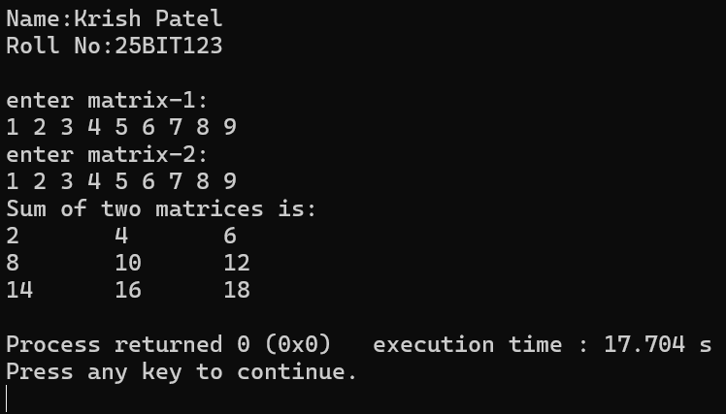  Q.2  Program:  #include<stdio.h>  #include<string.h>  struct student{  char name[50];  int roll_numbers;  char address[50];  };  void main(){  printf("Name:Krish Patel\nRoll No:25BIT123\n\n");  struct student student1= {"Krish",123,"Himatnagar"};  struct student student2= {"Soham",109,"Kadi"};  struct student student3= {"Vatsalya",70,"Rajkot"};  printf("Student_1\n");  printf("Name:%s\n",student1.name);  printf("Roll Number:%d\n",student1.roll_numbers);  printf("Address:%s\n\n",student1.address);  printf("Student_2\n");  printf("Name:%s\n",student2.name);  printf("Roll Number:%d\n",student2.roll_numbers);  printf("Address:%s\n\n",student2.address);  printf("Student_3\n");  printf("Name:%s\n",student3.name);  printf("Roll Number:%d\n",student3.roll_numbers);  printf("Address:%s\n",student3.address);  }  OUTPUT:  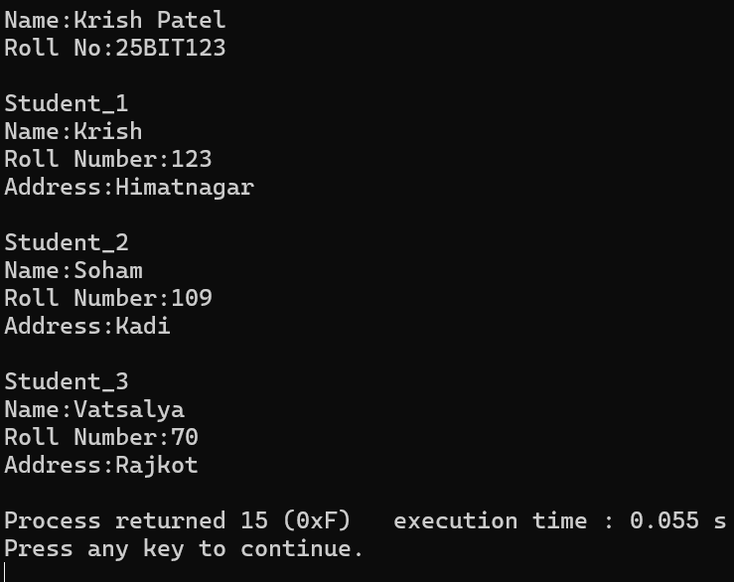  Q.3  Program:  #include <stdio.h>  int main(){  int arr1[]={6,2,3,5,7,1};  int max=arr1[0];  int min=arr1[0];  int secondlargest=arr1[0];  int secondsmallest=arr1[0];  //for largest element  printf("Name:Krish Patel\nRoll No:25BIT123\n\n");  for(int i=0;i<(sizeof(arr1)/sizeof(1));i++){  if(max<arr1[i]){  max=arr1[i];  }  }  //for smallest element  for(int i=0;i<(sizeof(arr1)/sizeof(1));i++){  if(min>arr1[i]){  min=arr1[i];  }  }  //for second largest  for(int i=0;i<(sizeof(arr1)/sizeof(1));i++){  if(secondlargest<arr1[i] && arr1[i]!=max){  secondlargest=arr1[i];  }  }  //for second smallest  for(int i=0;i<(sizeof(arr1)/sizeof(1));i++){  if(secondsmallest>arr1[i] && arr1[i]!=min){  secondsmallest=arr1[i];  }  }  printf("smallest element is:%d\n",min);  printf("largest element is:%d\n",max);  printf("second largest element is:%d\n",secondlargest);  printf("second smallest element is:%d",secondsmallest);  return 0;  }  OUTPUT:  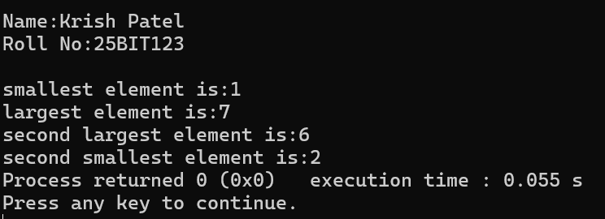
2 | [Revision of Pointers and Structures]  Programs covering structure definition, array of structure, nested structures etc.  - Write a program in C to implement arrays of pointers and pointers to arrays.  - Write a program in C to implement pointers to structures.  Practice Problem:  3.Write a program in C to perform swapping of two numbers by passing addresses of the variables to the functions.  Q.1  Program:  #include <stdio.h>  const int SIZE = 4;  int main()  {  printf("\nKrish Patel\nRoll No:25BIT123\n\n");  //array of pointers  // creating an array  int arr[] = { 1, 2, 3 ,4};  // storing the address of array elements  int i, *ptr[SIZE];  for (i = 0; i < SIZE; i++) {  // assigning the address of integer.  ptr[i] = &arr[i];  }  printf("\nArray to pointer:\n");  for (i = 0; i < SIZE; i++) {  printf("Value of arr[%d] = %d\n", i, *ptr[i]);  }  // Pointer to an array of five numbers  int(*x)[5];  int b[5] = { 1, 2, 3, 4, 5 };  int j = 0;  // Points to the whole array b  x= &b;  printf("\nPointer to an array:\n");  for (j = 0; j < 5; j++){  printf("Value of arr[%d]=%d\n",j, *(*x + j));  }  }  Output:  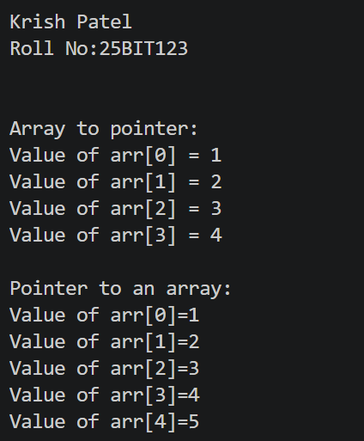  Q.2  Program:  #include <stdio.h>  #include <string.h>  //creating structure of books title,price and pages  struct book{  char title[100];  long int price;  int pages;  };  int main(){  printf("\nKrish Patel\nRoll No:25BIT123\n\n");  //inserting values of books title,price and pages  struct book b1 = {"Fundamentals of IT", 675, 325};  struct book b2 ={"Introduction To AI",1500, 1300};  struct book b3 ={"Discrete Mathematics by Rossen",1100, 700};  //storing books data using pointer  struct book *strptr1;  //To store the address  strptr1 = &b1;  struct book *strptr2;  strptr2 = &b2;  struct book *strptr3;  strptr3 = &b3;  printf("\n===Books Details===\n\n");  /*using Indirection Operator to access the elements  of a struct variable to which the pointer references to*/  printf("Title: %s\n", strptr1 -> title);  printf("Price: %ld\n", strptr1 -> price);  printf("No of Pages: %d\n\n", strptr1 -> pages);  printf("Title: %s\n", strptr2 -> title);  printf("Price: %ld\n", strptr2 -> price);  printf("No of Pages: %d\n\n", strptr2-> pages);  printf("Title: %s\n", strptr3-> title);  printf("Price: %ld\n", strptr3-> price);  printf("No of Pages: %d\n\n", strptr3 -> pages);  return 0;  }  Output:  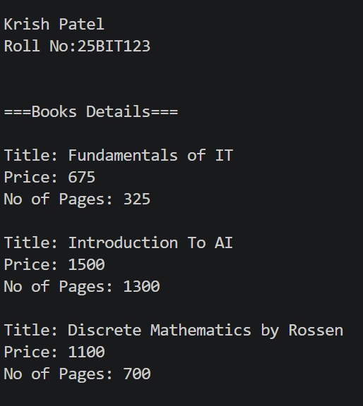  Q.3:  Program:  #include <stdio.h>  //function to pass addresses of variables and swap them using third variable t;  void swap(int *p1 , int *p2 )  {  int t;  t = *p1;  *p1 = *p2;  *p2 = t;  }  int main()  {  printf("\nKrish Patel\nRoll No:25BIT123\n\n");  int x,y;  printf("Enter two numbers:");  scanf("%d%d",&x,&y);  printf("Before swapping x = %d y = %d\n" , x, y);  //calling the function swap and passing addresses of variables  // Swapping Value of Two Variables using Call by Address  swap(&x , &y);  printf("After swapping x = %d y = %d\n" , x, y);  return 0;  }  Output:  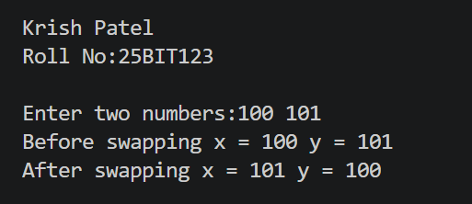
3 | [Stack]  Programs covering stack and applications.  - Implement a stack using an array. Implement the following functions:  - isEmpty(): Tests whether stack is empty or not.  - push(): Adds new element to the stack.  - pop(): Removes top element from the stack.  - top(): Returns value of the top element.  Practice Problems:  - Write a program to reverse a given string using a stack.  - Given an expression, write a program to examine whether the pairs and the orders of “{“, “}”, “(“, “)”, “[“, “]” are correct in the expression or not.  Example:  Input: exp = $“\left[\left(\right)\right]\{\}\{\left[\left(\right)\left(\right)\right]\left(\right)\}”$ Output: Balanced  Input: exp = $“”$ Output: Not Balanced  Q.1:  Program:  #include <stdio.h>  #include <stdlib.h>  #define MAX 100 // maximum size of stack  // Defining stack structure  struct Stack {  int arr[MAX];  int top;  int capacity;  };  // Initialize stack  void initStack(struct Stack* stack, int capacity) {  stack->top = -1;  stack->capacity = capacity;  }  // Check if stack is empty  int isEmpty(struct Stack* stack) {  return stack->top == -1;  }  // Push element onto stack  void push(struct Stack* stack, int value) {  if (stack->top == stack->capacity - 1) {  printf("Stack Overflow\n");  return;  }  stack->arr[++stack->top] = value;  printf("%d pushed to stack\n", value);  }  // Pop element from stack  void pop(struct Stack* stack) {  if (isEmpty(stack)) {  printf("Stack Underflow\n");  return;  }  printf("%d popped from stack\n", stack->arr[stack->top--]);  }  // Return top element  int top(struct Stack* stack) {  if (isEmpty(stack)) {  printf("Stack is empty\n");  return -1;  }  return stack->arr[stack->top];  }  // driver code to use structure and functions defined above  int main() {  printf("\nKrish Patel\nRoll No:25BIT123\n\n");  struct Stack stack;  initStack(&stack, MAX);  push(&stack, 11);  push(&stack, 21);  push(&stack, 35);  printf("Top element is %d\n", top(&stack));  pop(&stack);  pop(&stack);  printf("Top element is %d\n", top(&stack));  return 0;  }  Output:  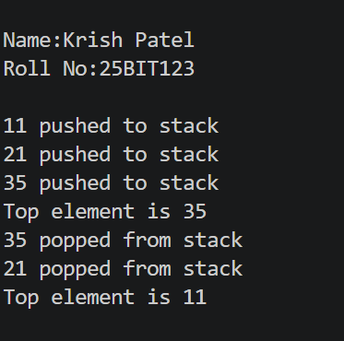  Q.2  Program:  #include <stdio.h>  #include <string.h>  #define MAX 100  // Define stack structure  struct Stack {  char arr[MAX];  int top;  };  // Initialize stack  void initStack(struct Stack* stack) {  stack->top = -1;  }  // Check if stack is empty  int isEmpty(struct Stack* stack) {  return stack->top == -1;  }  // Push character onto stack  void push(struct Stack* stack, char ch) {  if (stack->top == MAX - 1) {  printf("Stack Overflow\n");  return;  }  stack->arr[++stack->top] = ch;  }  // Pop character from stack  char pop(struct Stack* stack) {  if (isEmpty(stack)) {  printf("Stack Underflow\n");  return '\0'; }  return stack->arr[stack->top--];  }  // Function to reverse a string using stack  void reverseString(char str[]) {  struct Stack stack;  initStack(&stack);  // Push all characters  for (int i = 0; i < strlen(str); i++) {  push(&stack, str[i]);  }  // Pop all characters to reverse  for (int i = 0; i < strlen(str); i++) {  str[i] = pop(&stack);  }  }  int main() {  printf("\nName:Krish Patel\nRoll No:25BIT123\n\n");  char str[MAX];  printf("Enter a string: ");  gets(str); //as we have only one parameter to pass, if we need to pass 3 parameters we will use fgets()  reverseString(str);  printf("Reversed string: %s\n", str);  return 0; }  Output:  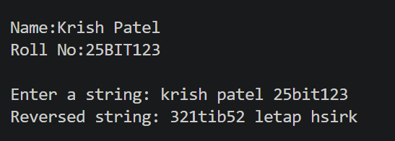  Q.3:  Program:  #include <stdio.h>  #include <stdbool.h>  #include <string.h>  bool isBalanced(const char *s) {  // A variable-length array sized to the input can hold at most one stack entry per character.  char stack[strlen(s)];  int top = -1;  for (int i = 0; s[i] != '\0'; i++) {  char c = s[i];  if (c == '(' || c == '{' || c == '[') {  stack[++top] = c;  }  else if (c == ')' || c == '}' || c == ']') {  // No opening bracket  if (top == -1) return false;  char opening = stack[top--];  if ((c == ')' && opening != '(') ||  (c == '}' && opening != '{') ||  (c == ']' && opening != '[')) {  return false;  }  }  }  // Balanced if stack is empty  return top == -1;  }  int main() {  printf("\nName:Krish Patel\nRoll No:25BIT123\n\n");  const char *s = "[({})]";  printf("Given expression %s: \nIt is",s);  printf("%s",isBalanced(s) ? "\tBalanced" : "Not Balanced");  return 0;  }  Output:  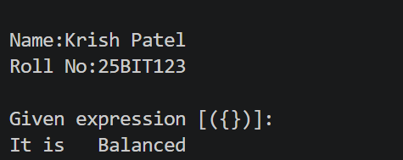
4 | [Stack]  - Convert the given infix expression into postfix expression using stack.  Practice Problems:  - Write a program to evaluate the following given postfix expressions:  e.g. Input: $231*+9-$ Output: -4  3. Convert the given infix expression into prefix expression using stack.  Q.1  Program:  #include <stdio.h>  #include <stdlib.h>  #include <ctype.h>  #include <string.h>  int prec(char c) {  if (c == '^')  return 3;  else if (c == '/' || c == '*')  return 2;  else if (c == '+' || c == '-')  return 1;  else  return -1;  }  // Check if operator is right-associative  int isRightAssociative(char c) {  return c == '^';  }  void infixToPostfix(char* exp) {  int len = strlen(exp);  char result[len + 1];  char stack[len];  int j = 0;  int top = -1;  for (int i = 0; i < len; i++) {  char c = exp[i];  // If operand, add to result  if (isalnum(c)) {  result[j++] = c;  }  // If '(', push to stack  else if (c == '(') {  stack[++top] = '(';  }  // If ')', pop until '('  else if (c == ')') {  while (top != -1 && stack[top] != '(') {  result[j++] = stack[top--];  }  // pop '('  top--;  }  // If operator  else {  while (top != -1 && stack[top] != '(' &&  (prec(stack[top]) > prec(c) ||  (prec(stack[top]) == prec(c) && !isRightAssociative(c)))) {  result[j++] = stack[top--];  }  stack[++top] = c;  }  }  // Pop remaining operators  while (top != -1) {  result[j++] = stack[top--];  }  result[j] = '\0';  printf("Postfix expression:%s\n", result);  }  int main() {  printf("\nName:Krish Patel\nRoll No:25BIT123\n\n");  char exp1[50];  printf("Enter the infix expression:");  scanf("%s",exp1);  infixToPostfix(exp1);  return 0;  }  Output:  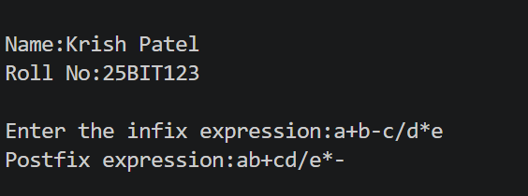  Q.2  Program:  #include <stdio.h>  #include <stdlib.h>  #include <ctype.h>  #include <math.h>  #include <string.h>  #include <stdbool.h>  #include <limits.h>  #define MAX 100  typedef struct {  int top;  int arr[MAX];  } Stack;  void push(Stack *s, int val) {  if (s->top == MAX - 1) {  printf("Stack Overflow\n");  return;  }  s->arr[++s->top] = val;  }  int pop(Stack *s) {  if (s->top == -1) {  printf("Stack Underflow\n");  return INT_MIN;  }  return s->arr[s->top--];  }  // Check if token is an operator  bool isOperator(char *token) {  return strcmp(token, "+") == 0 || strcmp(token, "-") == 0  || strcmp(token, "*") == 0 || strcmp(token, "/") == 0  || strcmp(token, "^") == 0;  }  // Floor division for negative numbers  int floorDiv(int a, int b) {  if (a * b < 0 && a % b != 0)  return (a / b) - 1;  return a / b;  }  // Evaluate postfix expression  int evaluatePostfix(char **arr, int n) {  Stack s = { -1 };  for (int i = 0; i < n; i++) {  // If it's an operand (number), push it onto the stack  if (isdigit(arr[i][0]) || (strlen(arr[i]) > 1 && arr[i][0] == '-')) {  push(&s, atoi(arr[i]));  }  // Otherwise, it must be an operator  else if (isOperator(arr[i])) {  int val1 = pop(&s);  int val2 = pop(&s);  if (strcmp(arr[i], "+") == 0) push(&s, val2 + val1);  else if (strcmp(arr[i], "-") == 0) push(&s, val2 - val1);  else if (strcmp(arr[i], "*") == 0) push(&s, val2 * val1);  else if (strcmp(arr[i], "/") == 0) push(&s, floorDiv(val2, val1));  else if (strcmp(arr[i], "^") == 0) push(&s, (int)pow(val2, val1));  }  }  return pop(&s);  }  int main() {  printf("\nName:Krish Patel\nRoll No:25BIT123\n\n");  char *arr[] = {"2", "3", "1", "*", "+", "9", "-"};  int n = sizeof(arr) / sizeof(arr[0]);  printf("Input postfix expression is: ");  for (int i = 0; i < n; i++) {  printf("%s%s", arr[i], i == n - 1 ? "\n" : " ");  }  printf("Solution: %d\n", evaluatePostfix(arr, n));  return 0;  }  Output:  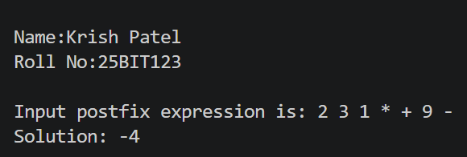  Q.3  Program:  #include <stdio.h>  #include <string.h>  #include <ctype.h>  #include <stdlib.h>  // function to return precedence of operators  int precedence(char c) {  if (c == '^') return 3;  else if (c == '*' || c == '/') return 2;  else if (c == '+' || c == '-') return 1;  else return -1;  }  // function to check if operator is right-associative  int isRightAssociative(char c) {  return c == '^';  }  // function to check if a character is an operator  int isOperator(char c) {  return (c == '+' || c == '-' || c == '*' || c == '/' || c == '^');  }  // function to convert infix expression to prefix  char* infixToPrefix(char* s) {  int n = strlen(s);  char* result = (char*)malloc(n * 2);  int resIndex = 0;  char st[100];  int top = -1;  // scan from right to left  for (int i = n - 1; i >= 0; i--) {  char c = s[i];  if (isalnum(c)) {  result[resIndex++] = c;  }  else if (c == ')') {  st[++top] = c;  }  else if (c == '(') {  while (top != -1 && st[top] != ')') {  result[resIndex++] = st[top--];  }  if (top != -1) top--; // pop ')'  }  else if (isOperator(c)) {  while (top != -1 && isOperator(st[top]) &&  (precedence(st[top]) > precedence(c) ||  (precedence(st[top]) == precedence(c) && !isRightAssociative(c)))) {  result[resIndex++] = st[top--];  }  st[++top] = c;  }  }  // pop remaining operators  while (top != -1) {  result[resIndex++] = st[top--];  }  result[resIndex] = '\0';  // reverse at the end to get correct prefix  for (int i = 0; i < resIndex / 2; i++) {  char temp = result[i];  result[i] = result[resIndex - i - 1];  result[resIndex - i - 1] = temp;  }  return result;  }  int main() {  printf("\nName:Krish Patel\nRoll No:25BIT123\n\n");  char exp1[50];  printf("Enter the infix expression: ");  scanf("%49s", exp1);  char* prefix = infixToPrefix(exp1);  printf("Prefix Expression is %s\n", prefix);  return 0;  }  Output:  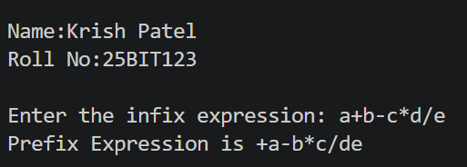
5 | [Queue]  - Implement various functionalities of Queue using Arrays. For example: insertion, deletion, front element, rear element etc.  Practice Problems:  - Implement Priority Queue, where every element has a priority associated with it. Perform operations like Insertion and Deletion in a priority queue.  - Implement Double Ended Queue that supports following operation:  - insertFront(): Adds an item at the front of Deque.  - insertLast(): Adds an item at the rear of Deque.  - deleteFront(): Deletes an item from the front of Deque.  - deleteLast(): Deletes an item from the rear of Deque.  Q.1:  Input:  #include <stdbool.h>  #include <stdio.h>  #define MAX_SIZE 100  // Defining the Queue structure  typedef struct  {  int items[MAX_SIZE];  int front;  int rear;  } Queue;  // Function to initialize the queue  void initializeQueue(Queue *q)  {  q->front = -1;  q->rear = 0;  }  // Function to check if the queue is empty  bool isEmpty(Queue *q)  {  return (q->front == q->rear - 1);  }  // Function to check if the queue is full  bool isFull(Queue *q)  {  return (q->rear == MAX_SIZE);  }  // Function to add an element to the queue (Enqueue  // operation)  void enqueue(Queue *q, int value)  {  if (isFull(q))  {  printf("Queue is full\n");  return;  }  q->items[q->rear] = value;  q->rear++;  }  // Function to remove an element from the queue (Dequeue  // operation)  void dequeue(Queue *q)  {  if (isEmpty(q))  {  printf("Queue is empty\n");  return;  }  q->front++;  }  // Function to get the element at the front of the queue  // (Peek operation)  int peek(Queue *q)  {  if (isEmpty(q))  {  printf("Queue is empty\n");  return -1; // return some default value or handle  // error differently  }  return q->items[q->front + 1];  }  // Function to print the current queue  void printQueue(Queue *q)  {  if (isEmpty(q))  {  printf("Queue is empty\n");  return;  }  printf("Current Queue: ");  for (int i = q->front + 1; i < q->rear; i++)  {  printf("%d ", q->items[i]);  }  printf("\n");  }  int main()  {  printf("\nName:Krish Patel\nRoll No:25BIT123\n\n");  Queue q;  initializeQueue(&q);  // Enqueue elements  enqueue(&q, 20);  printQueue(&q);  enqueue(&q, 35);  printQueue(&q);  enqueue(&q, -10);  printQueue(&q);  // Peek front element  printf("Front element: %d\n", peek(&q));  // Dequeue an element  dequeue(&q);  //will follow FIFO and dequeue 20  printQueue(&q);  // Peek front element after dequeue  printf("Final Front element : %d\n", peek(&q));  return 0;  }  Output:  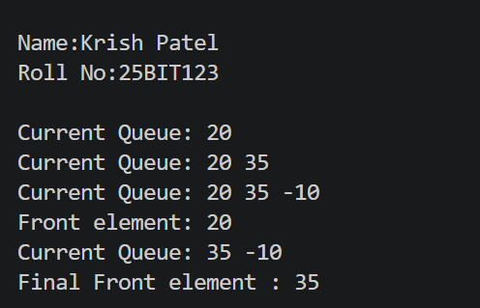  Q.2  Program:  #include <stdio.h>  #define MAX 100  struct PriorityQueue {  int elements[MAX];  int priorities[MAX];  int size;  };  // Initialize queue  void initQueue(struct PriorityQueue *q) {  q->size = 0;  }  // Insert element with priority  void insert(struct PriorityQueue *q, int element, int priority) {  if (q->size == MAX) {  printf("Queue Overflow\n");  return;  }  q->elements[q->size] = element;  q->priorities[q->size] = priority;  q->size++;  printf("Inserted %d with priority %d\n", element, priority);  }  // Delete element with highest priority  void delete(struct PriorityQueue *q) {  if (q->size == 0) {  printf("Queue Underflow\n");  return;  }  int highest = 0;  for (int i = 1; i < q->size; i++) {  if (q->priorities[i] > q->priorities[highest]) {  highest = i;  }  }  printf("Deleted %d with priority %d\n", q->elements[highest], q->priorities[highest]);  for (int i = highest; i < q->size - 1; i++) {  q->elements[i] = q->elements[i + 1];  q->priorities[i] = q->priorities[i + 1];  }  q->size--;  }  // Display queue  void display(struct PriorityQueue *q) {  if (q->size == 0) {  printf("Queue is empty\n");  return;  }  printf("Queue (element:priority): ");  for (int i = 0; i < q->size; i++) {  printf("%d:%d ", q->elements[i], q->priorities[i]);  }  printf("\n");  }  int main() {  printf("\nName:Krish Patel\nRoll No:25BIT123\n\n");  struct PriorityQueue q;  initQueue(&q);  insert(&q, 20, 2);  insert(&q, 30, 5);  insert(&q, 40, 1);  insert(&q, 50, 5);  display(&q);  delete(&q);  delete(&q);  display(&q);  delete(&q);  delete(&q);  delete(&q);  return 0;  }  Output:  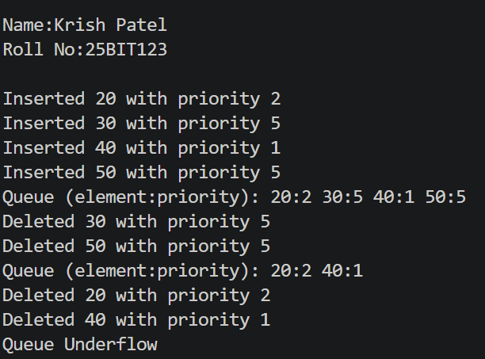  Q.3  Program:  #include <stdio.h>  #include <stdlib.h>  #define MAX 5 // Define maximum size of the deque  int deque[MAX];  int front = -1;  int rear = -1;  // Function to check if the deque is full  int isFull() {  return ((front == 0 && rear == MAX - 1) || (front == rear + 1));  }  // Function to check if the deque is empty  int isEmpty() {  return (front == -1);  }  // Function to insert an element at the front of the deque  void insertFront(int key) {  if (isFull()) {  printf("Overflow: Unable to insert element at the front. Deque is full.\n");  return;  }  if (front == -1) { // If deque is initially empty  front = 0;  rear = 0;  } else if (front == 0) {  front = MAX - 1; // wrap around  } else {  front = front - 1;  }  deque[front] = key;  printf("Inserted %d at the front.\n", key);  }  // Function to insert an element at the rear of the deque  void insertLast(int key) {  if (isFull()) {  printf("Overflow: Unable to insert element at the rear. Deque is full.\n");  return;  }  if (rear == -1) { // If deque is initially empty  front = 0;  rear = 0;  } else if (rear == MAX - 1) {  rear = 0; // wrap around  } else {  rear = rear + 1;  }  deque[rear] = key;  printf("Inserted %d at the rear.\n", key);  }  // Function to delete an element from the front of the deque  void deleteFront() {  if (isEmpty()) {  printf("Underflow: Unable to delete element from the front. Deque is empty.\n");  return;  }  int removed = deque[front];  if (front == rear) { // Deque has only one element  front = -1;  rear = -1;  } else if (front == MAX - 1) {  front = 0; // wrap around  } else {  front = front + 1;  }  printf("Deleted %d from the front.\n", removed);  }  // Function to delete an element from the rear of the deque  void deleteLast() {  if (isEmpty()) {  printf("Underflow: Unable to delete element from the rear. Deque is empty.\n");  return;  }  int removed = deque[rear];  if (front == rear) { // Deque has only one element  front = -1;  rear = -1;  } else if (rear == 0) {  rear = MAX - 1; // wrap around  } else {  rear = rear - 1;  }  printf("Deleted %d from the rear.\n", removed);  }  // Function to display the deque  void displayDeque() {  if (isEmpty()) {  printf("Deque is empty.\n");  return;  }  printf("Deque elements are: ");  int i = front;  while (1) {  printf("%d ", deque[i]);  if (i == rear)  break;  i = (i + 1) % MAX;  }  printf("\n");  }  // Main function to test the operations  int main() {  printf("\nName:Krish Patel\nRoll No:25BIT123\n\n");  insertLast(25);  displayDeque();  insertFront(17);  displayDeque();  insertLast(5);  displayDeque();  deleteFront();  displayDeque();  deleteLast();  displayDeque();  return 0;  }  Output:  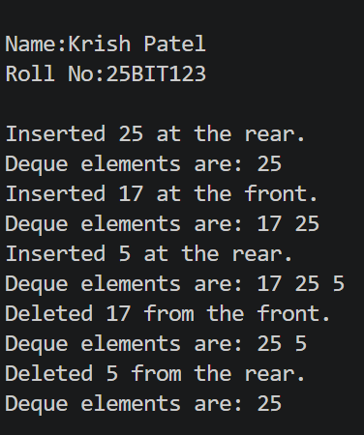
6 | [Linked List]  - Implement doubly linked list with following functions:  - insertAtBeginning(): Inserts a node at the end of the list  - insertAtEnd(): Inserts a node at the end of the list.  - insertAtPosition() – Inserts a node at a specific index.  - deleteFromBeginning(): Deletes the first node.  - deleteFromEnd(): Deletes the last node.  - deleteFromPosition(position) : Deletes a node from a specific position.  - forwardTraverse(): Traverses and displays the list from head to tail.  - backwardTraverse(): Traverses and displays the list from tail to head  - search: search(): Searches for a node with given data and returns its position (or index).  Practice Problems:  - Implement Stack and Queue using linked list with suitable functions (e.g. insert, delete, checking stack/queue is empty or full).  - Implement Circular and Double ended queues using linked list with suitable functions.  - Write a program that takes two sorted lists as inputs and merge them into one sorted list.  For example, if the first linked list A is 5 =>10 =>15, and the other linked list B is 2 => 3 => 20, then output should be 2 => 3 => 5 => 10 => 15 => 20.
7 | [Trees]  - Implement binary search tree with recursive functions: insert(),inorderTraverse(), preorderTraverse(), postorderTraverse(), search() and findHeight().  Practice Problems:  - Implement binary search tree with non-recursive functions: insert(), inorderTraverse(), preorderTraverse(), postorderTraverse(), countNodes(), and countLeafNodes().
8 | [Graphs]  - Implement Minimum Spanning Tree (MST) using the greedy Kruskal’s algorithm  Practice Problems:  - For a given graph $G=\left(V,E\right)$, study and implement the Breadth First Search and Depth First Search.  - Given a directed graph, check whether the graph contains a cycle or not. Your function should return true if the given graph contains at least one cycle, else return false. Perform same task for undirected graph as well.  - Implement Minimum Spanning Tree (MST) using the Prim’s algorithm.
9 | [Sorting]  - Implement Insertion sort to arrange the numbers in ascending order.  - Implement Quick sort to arrange the numbers in ascending order.  Practice Problems:  - Implement Bubble sort to arrange the numbers in ascending order.  - Implement Selection sort to arrange the numbers in descending order.  - Implement Merge sort to arrange the numbers in ascending order
10 | [Searching]  - Implement Linear search to search a number from a sorted array.  - Implement Binary search to search a number from a sorted array.  Practice Problem:  3. Given a sorted array of integers (in descending order), write a C program to find the first and last occurrence of a given number x. If the element is not found, print suitable message.
11 | Experiment No. 11, 12, 13 [Mini Project and Problem Solving]  These laboratory sessions are dedicated for doing a mini project and doubt solving sessions. Students are expected to do a mini project by forming a group of 5 on the concepts they have learned in data structures. They are free to select any mini project as per their choice. If they are not able to decide, they can select any one from the following:  - Hospital Patient Record System: This system manages patient information in a hospital. It stores patient records, including ID, name, age, disease, date of admission, and status (admitted/discharged). You can implement: Add patient details, Search patient by ID, Discharge patient, View all current admitted patients  Data Structures Used: Linked Lists (for dynamic record handling), Queues (for patient appointments)  - Bank Management System: This project simulates basic banking operations: Account creation, Deposit/withdrawal, Balance check, Displaying account details. Each account can be stored in a hash table or binary search tree to allow fast searching and updates.  - College Admission Management System: Simulate the admission process of students into different courses based on merit and availability. Features: Student registration, Merit list sorting, Course seat allocation, Waiting list generation Data Structures Used: Arrays and Structures (for sorting using marks), Queues (for waitlist), Priority Queue (optional for merit)  - Online Food Ordering System: Simulate an online food delivery system. Functions include: Display menu, Place order, Cancel order, Show bill, Maintain order history Data Structures Used: Stacks (for order undo), Queues or Linked Lists (for order processing), Arrays (for menu)

