## CK project discussion

* Group or individual
* Cooperate robots
* Design two robotic arms
* Goals
  + Pair of hands to play a note/piano OR
  + To pick stuff up
* Design
  + 3D printing

Want to two arms

Can we get some stuff machined?

SLA

Could get metal stuff made ourselves

How much design work is done

Will send cad

* Can design the specification

Mahonri is co supervisor more mechanical part

### Resources

Obtaining parts

Can buy online from from jaycar

D.G.12

F.1.01 is Chi Kit’s office

## First Lecture/Intro

### Todo

Setup weekly meeting

Chi Kit office hours etc

### Evidence

Posters - designed for very non-technical audience **OR**

Stand

Need to distinguish who did what

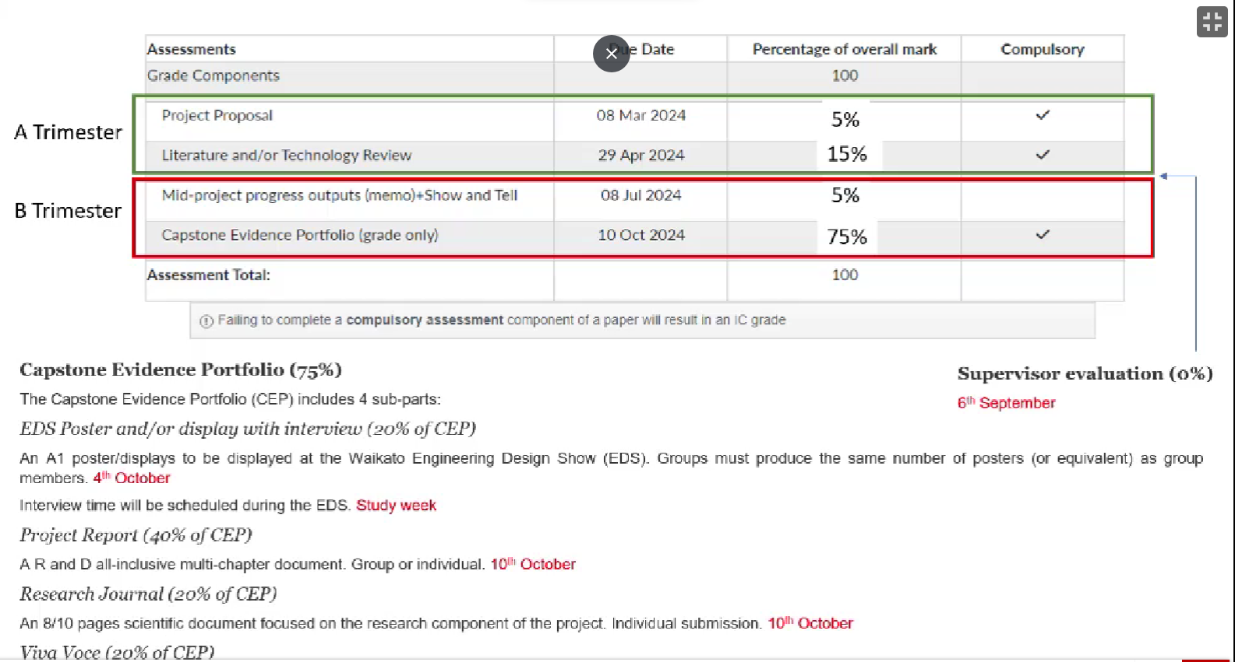

### Proposal

* Background, aim, R&D specs, show we understand the project
* Assessed by supervisor
* “Plus” title page, Plus gantt chart, 3-4 pages
* Upload a duplicate copy each
* Don’t have to put in assessment dates to Gantt chart
  + Monday.com, excel, microsoft project
* **Resources**
  + Space, equipment, software, tools
* **Wider impact**

## Literature and technology review

13 to 30 pages excluding title, references, appendices

More than 30 references

Single line spacing, times new roman, 12pt text and 14pt font

Look at what scholarly stuff has been done before

**It is not**

* Meta-analysis - analysis of number of papers published etc in field
* Annotated bibliography
* A textbook/essay going through the theory of the topic
* A history of the area

**Focus and Scope**

* The right level of broadness/narrowness
* What are your research questions

**Steps**

* Search for sources
* Evaluate
* Identify themes debates and gaps
* Outline the structure
* Write the literature review

**Sources**

* Papers
* Theses
* Conference papers
  + Not all peer reviewed
* Reports
  + White (green) papers (for public, non-peer reviewed research, often with positions)
  + Government papers
* Textbooks
  + Yes but this is generally established knowledge anyway
* Journals
  + Scholarly>trade>popular (eg nat geo)
  + Impact factor >
  + Is it peer reviewed
* Tech review
  + Catalogues, spec sheets

Endnote, Zotero, Mendeley

### Relevant stuff

Critically analyse published work in the field

* Books and journals

Technology vs literature review

* Tech review looks at what has been built before

Talk to chi Kit about what he wants

Probably do a hybrid

Kieran to do

* Digital twining
* Control systems
* Motor drivers

Jack to do

* Mechanical side of arm systems

Someone

* Electric motors
* Degrees of freedom that are useful
* Methods of evaluating the quality of a humanoid arm

### Review structure

* Organise around
  + Themes
  + Focuses
  + **Components**
* Get some nice
  + Flow, keeping the same sort of path, nothing out of the blue
  + Ordering
* Put lots of descriptive subheadings
* Can put into the intro some context about the project
* Don't forget the bigger picture and link stuff together

### Writing style

Clear and concise

Prior knowledge - Can assume examiner is an engineer in a relevant field

Third person only

Avoid direct quotes

### Questions to ask when reviewing

If you were reading it would you think it was good?

Is it enough for a workplace?

## Referencing and Endnote

Endnote is free…?

Nothing much important

## Update mid-progress

## Research Journal

* Don't need to put all the results, just the most important ones
* Just the research component but doesn't have to just be academic type research
* Types of research that can be included
  + Literature review
  + Some parts of the development, e.g. why certain design decisions were made
  + But the main part should be the testing and evaluation of the prototype

## EDS and Poster

* One A1 per student or A0 posters for 2 students
* Needs
  + Title
  + Name
  + Supervisors name
  + Acknowledgments
  + Needs to show both R&D aspects
* No penalty for late submission

## Report

* No page numbers for these bits
  + Acknowledgements
  + Declaration of authorship
  + Table of contents
  + List of figures
  + List of tables
* Chapter 1
  + Introduction and summary
  + Significance of project (just like the project proposal but in past tense)
  + Up to 5 pages (not strict) that also include a summary of literature review
    - Can include any updates content beyond the original literature review
    - The original literature review will be referred to as appendix
* Chapter 2
  + Clearly portray the the research and development parts of the project (minimum ⅓ of each)
  + Include
    - Methodology
    - R&d plan
    - Results and analysis
* Chapter x+1
  + Conclusions, recommendations

## Viva Voce

* 5 min presentation
* 25/30 minutes of Q&A
* 5 min for assessors to determine the mark

Markers can only mark based on what you present (report, viva voce, etc)