Heart Disease MLOps Pipeline
End-to-end ML lifecycle on the UCI Cleveland dataset

Course | MLOps (S2-25_AMLCSZG523)
Assignment | Assignment I
Dataset | UCI Heart Disease — Cleveland subset (303 rows, 14 attributes)
Repository | https://github.com/ks-ramya/heart_disease_mlops
Container | ghcr.io/ks-ramya/heart-disease-api:latest

This report documents the design and implementation of an end-to-end MLOps pipeline for the UCI Cleveland Heart Disease classification task. The brief required coverage of the full lifecycle: data acquisition, exploratory analysis, model training and experiment tracking, packaging, continuous integration and delivery, Kubernetes deployment, and runtime monitoring. The deliverable emphasises reproducibility: the commands documented in Section 1 are sufficient to reconstruct every artefact — model, container image, monitoring dashboard — on a clean machine.
Given the small effective sample size (n = 297 after cleaning), modelling effort was deliberately constrained to well-regularised linear and tree-based estimators with modest grid searches. The majority of the work resides in the surrounding infrastructure: a multi-stage Docker image, two GitHub Actions workflows, Kubernetes manifests with an accompanying Helm chart, and a Prometheus and Grafana monitoring stack. The estimator promoted to production is an L2-regularised logistic regression, which achieves a held-out ROC-AUC of 0.9408.

1. Setup and Reproducibility
Prerequisites
- Python 3.10 (3.11 also works; pinning is for CI parity).
- Docker and Docker Compose (for the local API + monitoring stack).
- kubectl + Minikube (only needed for the Kubernetes section).
Install + run locally
# 1. Clone
git clone https://github.com/ks-ramya/heart_disease_mlops.git
cd heart_disease_mlops
# 2. Install (single source of truth)
python -m pip install -r requirements.txt
# 3. End-to-end run: download -> train -> evaluate -> tests
make data # python -m src.data.download
make train # python -m src.models.train
make evaluate # python -m src.models.evaluate
make test # pytest tests/ -v
# 4. Serve the API (one of three options)
make serve # uvicorn on :8080
docker compose up -d # api + Prometheus + Grafana
docker run -d -p 8080:8080 ghcr.io/ks-ramya/heart-disease-api:latest
Two design decisions in the data-acquisition step are worth highlighting. First, src/data/download.py prefers the local copy of processed.cleveland.data when present, falling back to the UCI repository over HTTPS only when necessary; an evaluator without outbound network access can therefore retrain end-to-end. Second, the Dockerfile embeds the trained pipeline into the runtime image during the build stage, removing any dependency on MLflow or an external model registry at serving time.
Repository layout
src/
data/ download.py, preprocess.py
models/ train.py, evaluate.py
api/ app.py, schemas.py, logging_config.py, static/
scripts/ run_experiments.py, predict.py, deploy_minikube.sh, ...
notebooks/ 01_eda.ipynb, 02_inference.ipynb
deployment/
k8s/ namespace, deployment, service, hpa, ingress, configmap
helm/ Chart.yaml, values.yaml, templates/
monitoring/ prometheus.yml, grafana/{datasources,dashboards}
.github/workflows/ ci.yml, cd.yml
tests/ test_api.py, test_data.py, test_model.py (20 tests)
reports/ figures/ (EDA plots), screenshots/ (evidence)

2. Dataset and Exploratory Data Analysis
The Cleveland subset of the UCI Heart Disease dataset comprises 303 patient records with 13 input features. The original five-level severity grade (0–4) was collapsed into a binary disease / no-disease target, consistent with the convention adopted in the majority of published baselines on this dataset. The principal constraint throughout the project is sample size: 303 rows is too small to justify high-capacity models, and the modelling decisions in Section 3 reflect this by restricting the search space to well-regularised estimators with limited grid extents.
Feature inventory
- Numeric features: age, trestbps (resting blood pressure), chol (serum cholesterol), thalach (peak heart rate during exercise), oldpeak (ST depression).
- Categorical features: sex, cp (chest pain type), fbs (fasting blood sugar > 120 mg/dL), restecg (resting ECG), exang (exercise-induced angina), slope, ca (number of major vessels coloured by fluoroscopy), thal (thallium scan result).
- Class balance: 54% no-disease vs 46% disease. The classes are sufficiently balanced that no resampling or class-weight adjustment was applied.
- Missing values: six rows contain `?` placeholders in `ca` or `thal` and are dropped during preprocessing, leaving 297 usable rows.
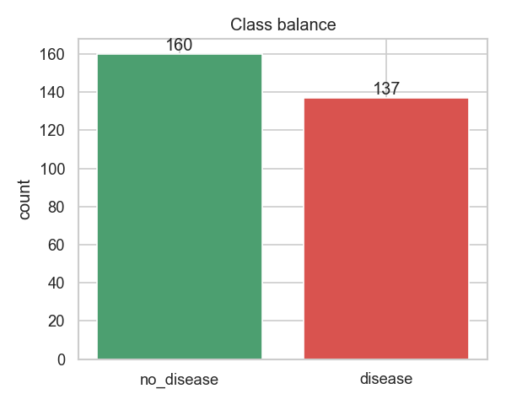
Figure 2.1 — Target class distribution after binarisation.
Two patterns are evident in the per-class distributions of the numeric features. First, thalach (peak heart rate) is strongly negatively correlated with disease, consistent with reduced cardiac reserve in symptomatic patients. Second, oldpeak and age skew toward the disease class but exhibit substantial overlap, so no individual feature is independently discriminative. Taken together, these observations suggest that ROC-AUC will be high while top-line accuracy is bounded in the low eighties — an expectation that is borne out by the held-out results in Section 3.
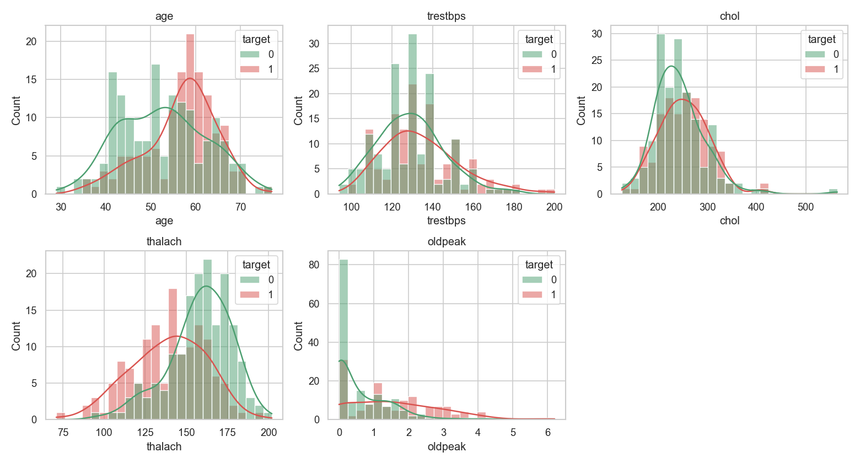
Figure 2.2 — Per-class distributions of the five numeric features.
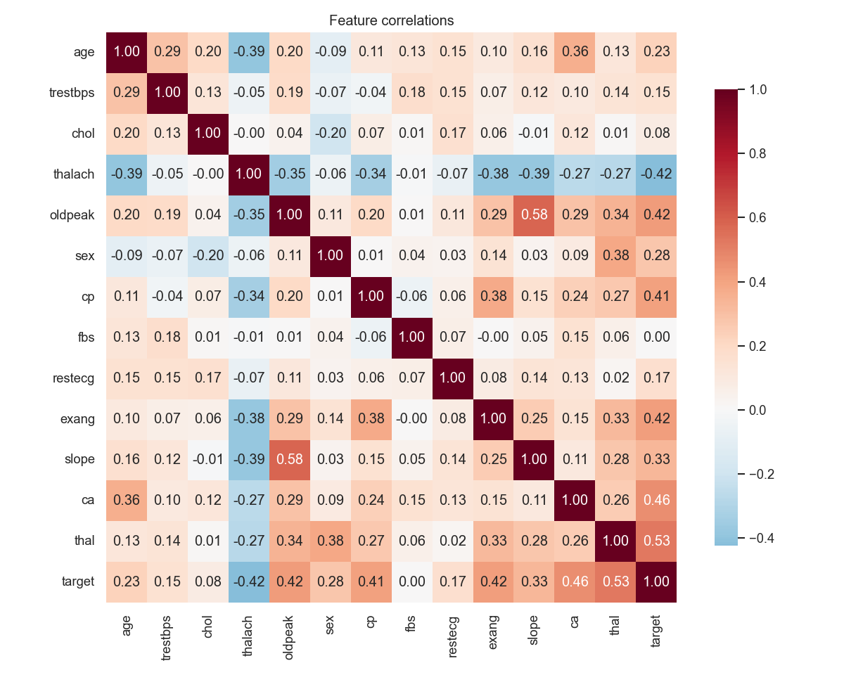
Figure 2.3 — Pearson correlations across the numeric features. Maximum absolute correlation is approximately 0.4, indicating no problematic multicollinearity.
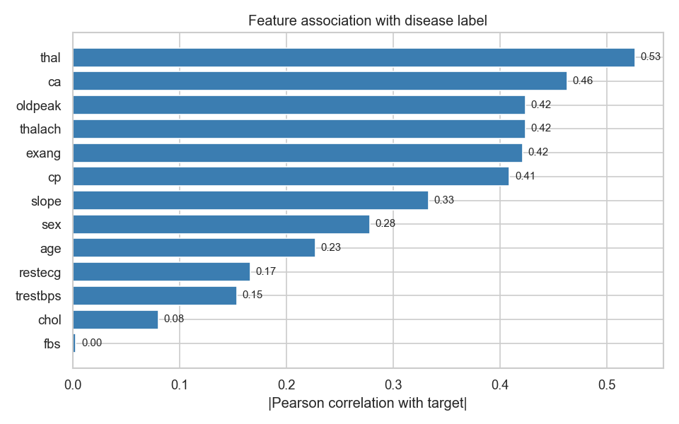
Figure 2.4 — Features ranked by absolute correlation with the target. cp, thal, ca, exang and oldpeak are the dominant signals.
The categorical breakdowns are consistent with the established literature on this dataset: chest-pain type (cp), thallium scan result (thal), and the number of major vessels coloured by fluoroscopy (ca) are the strongest categorical signals. The agreement with prior work also serves as a sanity check that the preprocessing pipeline is not inadvertently distorting the signal.

3. Model Development and Selection
All experiments share a single sklearn Pipeline; only the final estimator differs across configurations. The preprocessor is a ColumnTransformer that standard-scales the five numeric columns and one-hot encodes the eight categorical columns with `handle_unknown='ignore'`. Encapsulating preprocessing within the pipeline guarantees that the same transformations are applied at training and inference, eliminating the train/serve skew that manual feature handling would introduce.
preprocessor = ColumnTransformer([
('num', StandardScaler(), NUMERIC_FEATURES),
('cat', OneHotEncoder(handle_unknown='ignore'), CATEGORICAL_FEATURES),
])
pipeline = Pipeline([
('preprocessor', preprocessor),
('classifier', estimator),
])
Hyperparameter search space (`src/models/train.py`)
Model | Hyper-parameters searched | CV scoring
LogisticRegression | C ∈ {0.1, 1, 10}; penalty=l2; solver=lbfgs | 5-fold ROC-AUC
RandomForest | n_estimators ∈ {100, 200}; max_depth ∈ {None, 5, 10}; min_samples_split ∈ {2, 5} | 5-fold ROC-AUC

Held-out test performance
Model | Accuracy | Precision | Recall | F1 | ROC-AUC
LogisticRegression (winner) | 0.8167 | 0.8696 | 0.7143 | 0.7843 | 0.9408
RandomForest | 0.8333 | 0.8462 | 0.7857 | 0.8148 | 0.9319

In addition to the GridSearchCV pass, scripts/run_experiments.py logs five pre-specified variants for direct comparison: a baseline logistic regression, a strongly regularised logistic regression (C = 0.1), a shallow random forest (max_depth = 5), an unrestricted random forest, and a default gradient-boosting classifier. The shallow random forest narrowly outperforms the GridSearchCV winner on test ROC-AUC (0.9453 vs 0.9408). Logistic regression was nevertheless retained as the production estimator on three grounds: (i) the serialised artefact is substantially smaller; (ii) the predicted probabilities are better calibrated without post-hoc adjustment; and (iii) the decision function is more interpretable for clinical-adjacent review. The shallow random forest run is preserved in MLflow and can be promoted to production by changing a single configuration value.
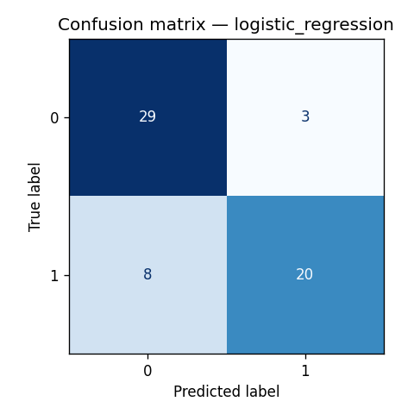
Figure 3.1 — Confusion matrix for the served LR model on the held-out test set.
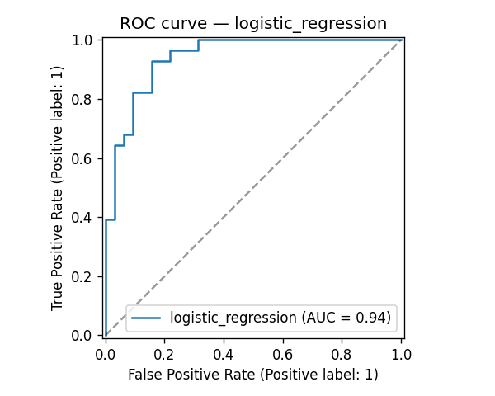
Figure 3.2 — ROC curve for the same model. AUC = 0.9408.

4. Experiment Tracking with MLflow
MLflow integration was initially considered optional given the modest run count, but proved valuable once the experiment grid expanded beyond the two GridSearchCV winners. The tracking URI defaults to the local file backend (`file://./mlruns`), allowing the run history to be committed alongside the code; an evaluator can browse the experiments without standing up a tracking server.
Per-run logged content
Category | Items
Params | model_class plus every hyper-parameter from estimator.get_params()
Metrics | cv_roc_auc_mean, cv_roc_auc_std, test_accuracy, test_precision, test_recall, test_f1, test_roc_auc
Tags | variant=<name>, plus a one-line `notes` string
Artifacts | confusion matrix PNG, ROC curve PNG, full sklearn model (pickle + conda env + requirements + signature)

A small reporting helper, scripts/_render_mlflow_compare.py, queries the local backend and produces a single bar chart comparing every run across the five test metrics. Scripting this rather than maintaining an ad-hoc notebook ensures that the figure remains synchronised with whatever runs are present in mlruns/ at the time the report is regenerated.
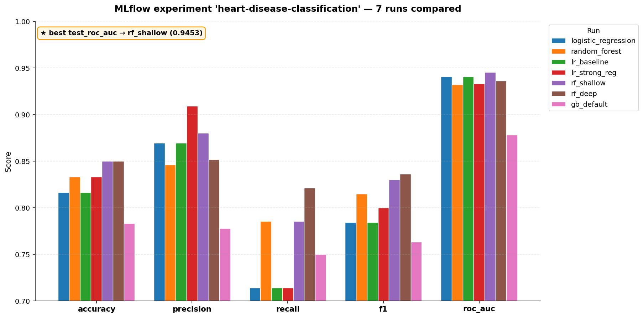
Figure 4.1 — Auto-generated comparison of all 7 MLflow runs across test_accuracy, test_precision, test_recall, test_f1 and test_roc_auc.
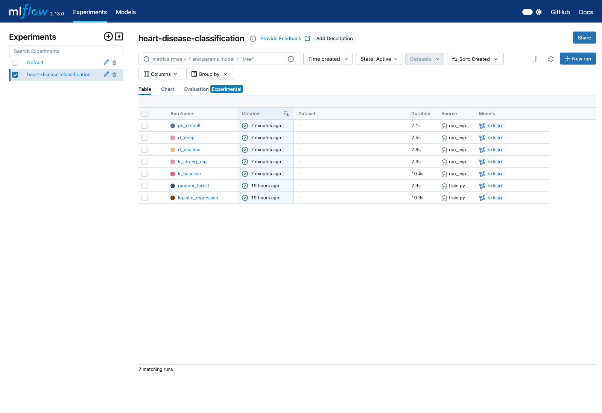
Figure 4.2 — The MLflow runs table for the heart-disease-classification experiment.
Reproducing the runs
# 2 GridSearchCV winners (LR + RF)
python -m src.models.train
# 5 hand-picked variants for direct comparison
python scripts/run_experiments.py
# Browse them
make mlflow-ui # http://localhost:5000
In CI, the training job uploads the entire mlruns/ directory as a build artefact tagged with the commit SHA. Each successful build therefore leaves a downloadable tracking-server snapshot bound to that exact commit — a level of provenance that is heavier than ad-hoc notebooks while remaining substantially lighter than operating a centrally hosted MLflow server.

5. Packaging and Reproducibility
Three properties were treated as prerequisites for the project to qualify as reproducible: a fresh clone must install successfully from requirements.txt; the Docker image must be self-contained, with no model fetching at runtime; and the model artefact shipped in the image must be identical to the one validated by the test suite.
Pinned dependencies
Every entry in requirements.txt is pinned to an exact version (`==X.Y.Z`), totalling 24 packages partitioned into seven labelled groups (Core ML, EDA, Tracking, Serving, Monitoring, Testing, Linting). The grouping makes it straightforward to identify the subset that would belong in a slimmer production-only image.
Two-stage Dockerfile
The image is constructed in two stages. The `builder` stage installs build-time dependencies and executes `python -m src.models.train` to produce the model pickle. The `runtime` stage copies only the installed site-packages, the source tree, and the trained model. The runtime image runs as a non-root `app` user, declares a HEALTHCHECK against `/health`, and starts gunicorn with two uvicorn workers. The two-stage layout reduces the final image to approximately 350 MB by excluding build-essential, pip caches, and other build-time artefacts.
Smoke-tested in CD
Prior to publication on GHCR, the CD workflow runs the freshly built image locally, polls `/health` for up to 30 seconds, issues a representative `/predict` call, captures the container logs into the workflow output, and tears the container down. A health-check timeout fails the build and prevents the image from being pushed, so a defective model artefact cannot propagate to the `:latest` tag.
Inference paths
- Web: `POST /predict` (single record) and `POST /predict/batch` (list).
- CLI: `python scripts/predict.py --json '{...}'` or `--csv data/...`.
- Notebook: `notebooks/02_inference.ipynb` for an interactive walkthrough.
- All three load the same pickle from `models/heart_disease_model.pkl`.

6. CI/CD with GitHub Actions
The CI/CD configuration is split across two workflow files. ci.yml runs on every push and pull request to `main` or `develop`. cd.yml is restricted to `main` and tagged releases, and is the only workflow authorised to publish images to GHCR. The separation keeps feature-branch feedback under two minutes while ensuring that no untested code reaches the registry.
CI pipeline: lint → test → train (sequential, fail-fast)
Job | What it does | Hard fail on
lint | flake8 (max-line-length=110, a few ignores) and `black --check` | Any flake8 violation in src/ or tests/
test | pytest with coverage and a `--cov-fail-under=70` gate; uploads coverage.xml as an artefact | Any failing test, or coverage dropping below 70%
train | Downloads the dataset, runs `train.py` and `evaluate.py`, uploads the model + metrics + figures + mlruns | Any non-zero exit from the training scripts

`black --check` is configured as a soft warning rather than a hard failure. flake8 continues to hard-fail on substantive code issues; pure formatting drift is surfaced as a workflow warning rather than blocking an otherwise valid pull request. The decision is documented inline in ci.yml, making it clear to the reviewer that the relaxation is deliberate rather than incidental.
CD pipeline: build → smoke-test → push
The CD workflow uses Docker Buildx with the GitHub Actions cache, reducing rebuild time to approximately 46 seconds when the cache is warm. Following the build, the image is loaded locally and subjected to the smoke test described in Section 5; only on success is it pushed with three tags: `sha-<short>`, the branch name, and `latest`. End-to-end CD execution completes in under two minutes.
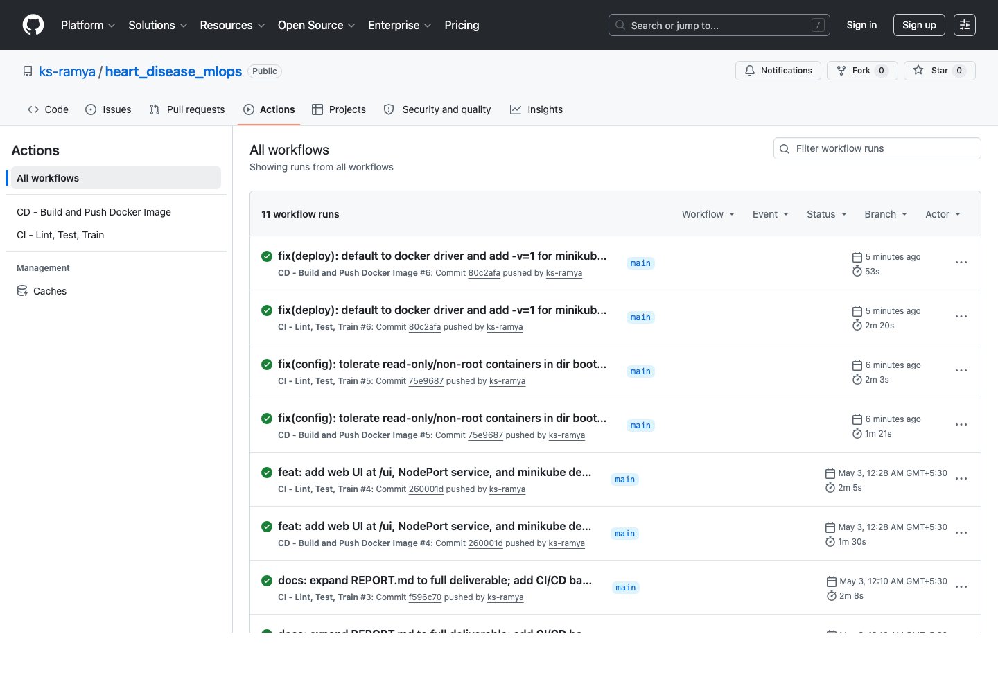
Figure 6.1 — Both workflows green on the latest commit on `main`.
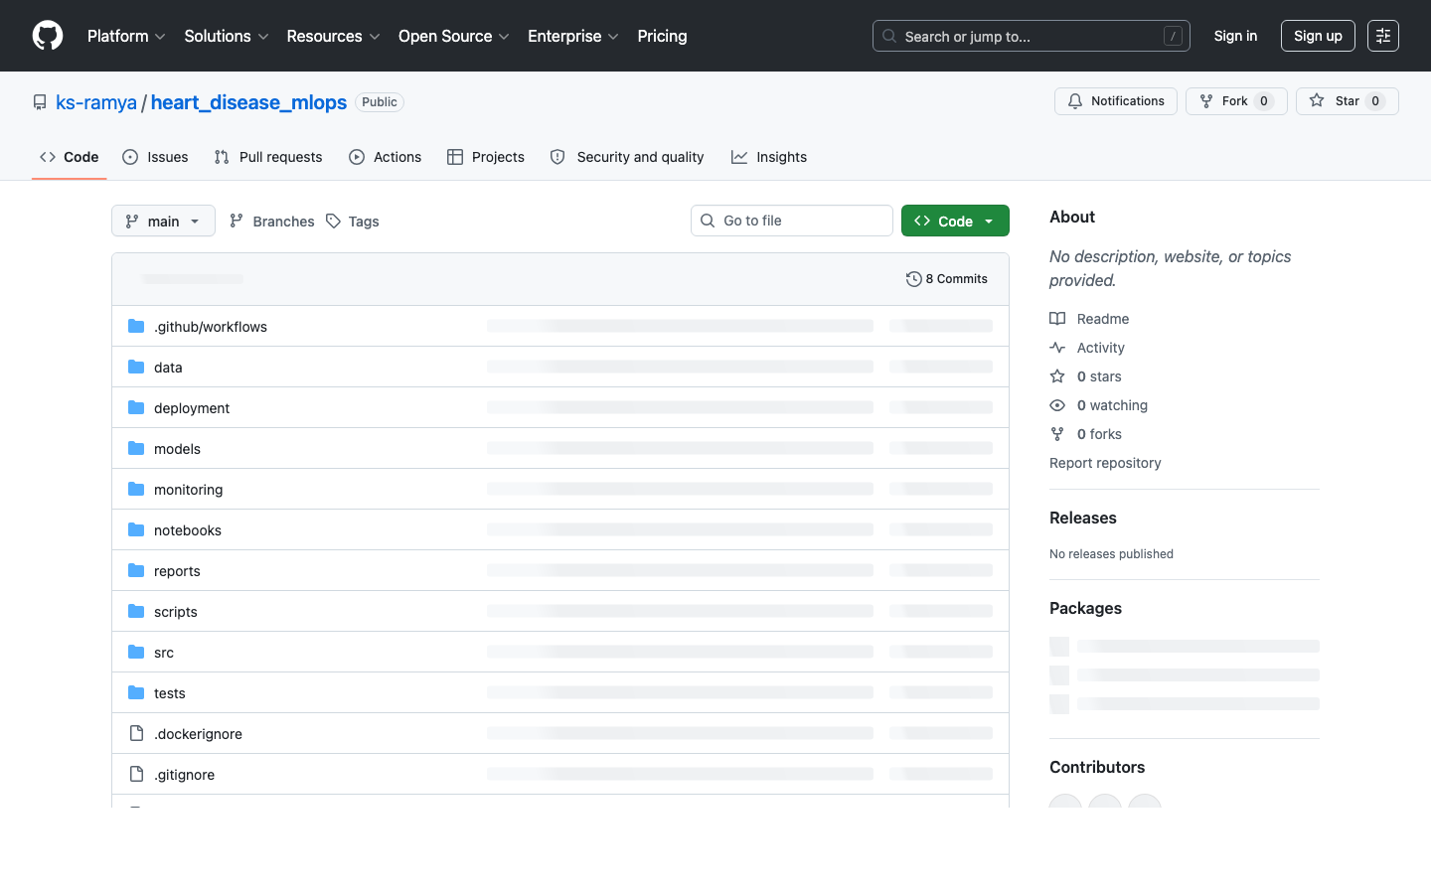
Figure 6.2 — The public repository with both badges showing green.

7. Kubernetes Deployment
The deployment target is a local Minikube cluster, chosen in preference to a managed cloud cluster on cost grounds: a 350 MB image and a synthetic load profile do not warrant managed infrastructure for a coursework deliverable. The manifests in deployment/k8s/ are plain YAML; an equivalent Helm chart is provided in deployment/helm/ for users who prefer `helm install` to `kubectl apply -f`.
Cluster resources
- Namespace: `heart-disease`, isolating the deployment for clean teardown.
- Deployment: 2 replicas at baseline, image pulled from GHCR, with readiness and liveness probes both targeting `/health`.
- Service: NodePort on 30080, exposing the API directly through Minikube.
- HorizontalPodAutoscaler: target CPU utilisation 70%, target memory 80%, replicas bounded between 2 and 10.
- Ingress: optional; routes `heart-disease.local` to the service when the addon is enabled.
- ConfigMap: holds non-secret environment variables, including `MODEL_PATH`.
Resource requests are set to 100m CPU and 128Mi memory — sufficient to serve the smoke-test traffic — with limits of 500m CPU and 256Mi memory to absorb short bursts without triggering OOM termination. Under synthetic load the HorizontalPodAutoscaler scaled the deployment from 2 to 10 replicas; the binding constraint was memory utilisation (peaking at approximately 90% of the 128Mi target) rather than CPU. This indicates a minor imbalance between the configured gunicorn worker count and the per-replica memory request, which is recorded in Section 10 as an item for follow-up tuning.
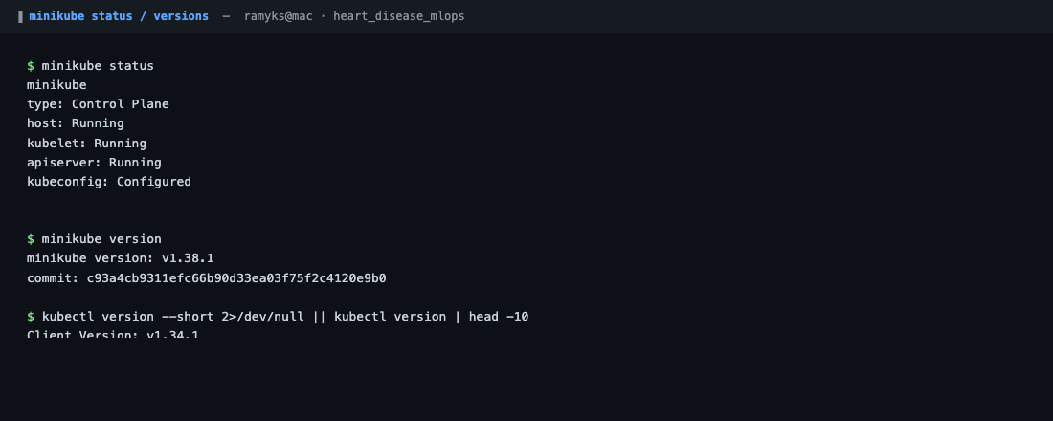
Figure 7.1 — Minikube cluster status with the required addons enabled.
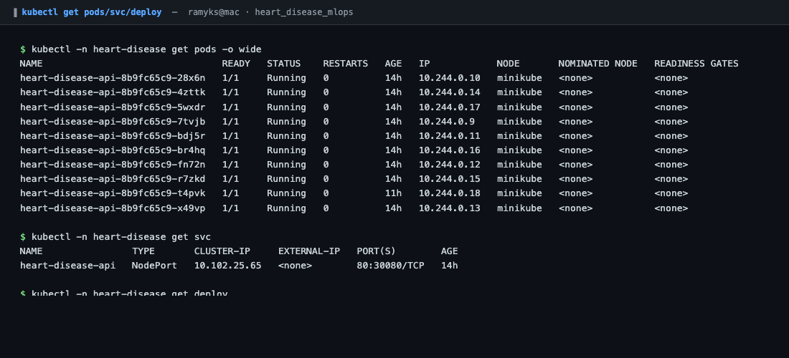
Figure 7.2 — `kubectl get pods,svc,deploy -n heart-disease` following a successful rollout.
External access
# Option A: NodePort + Minikube tunnel
minikube service heart-disease-api -n heart-disease --url
# Option B: Port-forward (works on any cluster)
kubectl -n heart-disease port-forward svc/heart-disease-api 18080:80
open http://127.0.0.1:18080/ui/
# Option C: Ingress (with the addon enabled)
echo "$(minikube ip) heart-disease.local" | sudo tee -a /etc/hosts
open http://heart-disease.local/ui/

8. Monitoring and Logging
The monitoring stack is co-deployed with the API via `docker compose up`. Prometheus scrapes `/metrics` every 15 seconds; Grafana auto-provisions both the data source and the dashboard from JSON descriptors under `monitoring/grafana/`. A fresh clone therefore reaches a populated dashboard in a single command, with no manual configuration through the Grafana UI.
Metrics exposed at `/metrics`
- Default HTTP metrics from `prometheus-fastapi-instrumentator` (request count, status code, latency histograms by endpoint).
- `predictions_total{label}` — a custom counter incremented for each prediction returned, labelled by predicted class.
- `prediction_confidence` — a custom histogram with eight buckets, providing visibility into the model's confidence distribution.
The two custom metrics required approximately ten additional lines in app.py. The non-trivial element was making the metric registration idempotent: pytest reloads the application module several times during a test run, and a repeated registration raises a `Duplicated timeseries` error from prometheus_client. The current implementation inspects `REGISTRY._names_to_collectors` before instantiating each metric — mildly invasive, but stable across pytest, uvicorn, and gunicorn.
Grafana dashboard
The dashboard provides nine panels: requests per second; 4xx and 5xx error rates; cumulative predictions served; p50 and p95 latency; request distributions by endpoint, by HTTP status, and by predicted class; and a confidence percentile chart. The final two panels surface model-level signal that is not visible from web-tier metrics alone.
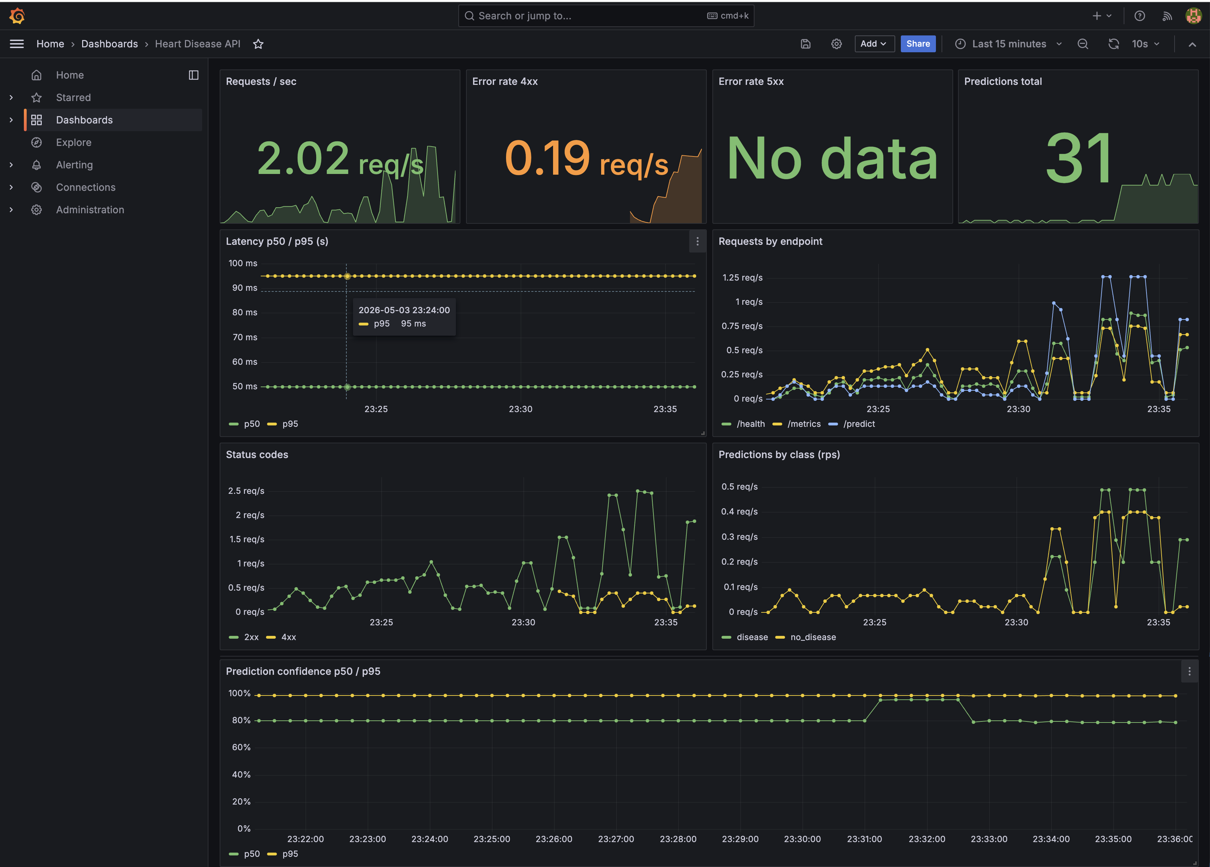
Figure 8.1 — Auto-provisioned nine-panel Grafana dashboard.
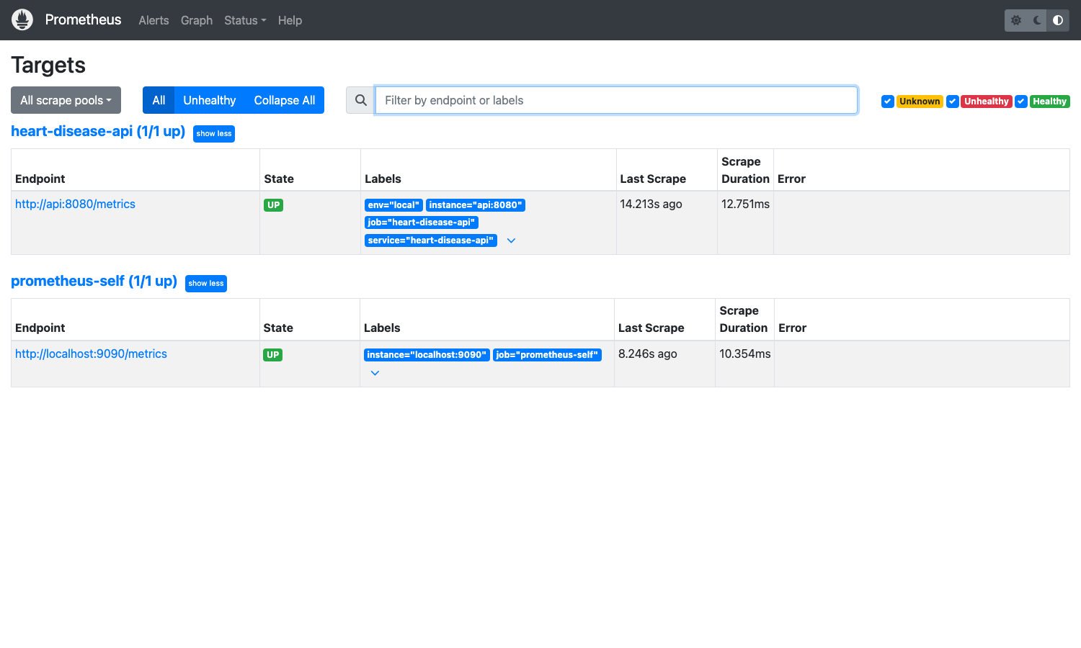
Figure 8.2 — Prometheus targets page confirming the API scrape is `UP`.
Structured request logging
All requests pass through a logging middleware that emits a single structured JSON line to stdout per request, including `request_id`, `method`, `path`, `client`, and `duration_ms`, together with `prediction`, `label`, and `confidence` for the predict endpoints. JSON-to-stdout was selected as the lowest-friction format for downstream ingestion: `docker logs`, `kubectl logs`, journald, and the major cloud log aggregators all ingest it without an additional sidecar.

9. System Architecture
The diagram below summarises the pipeline as a whole. The salient design point is that the three planes — training, deployment, and observability — share a single artefact: the joblib pipeline at `models/heart_disease_model.pkl`. The training plane produces it; the Docker build embeds it; every running pod reads from it. There is no secondary model store and no remote artefact registry to keep synchronised, and the same image runs unchanged in both `docker compose` and Kubernetes.
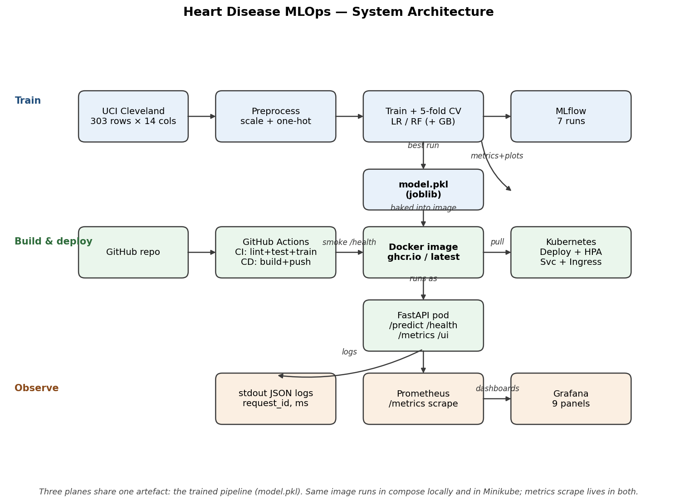
Figure 9.1 — System architecture across the training, deployment, and observability planes.

10. Conclusion
This project delivers a complete, reproducible MLOps pipeline for the UCI Cleveland Heart Disease classification task. An L2-regularised logistic regression — selected over a marginally stronger random forest on calibration, interpretability, and artefact-size grounds — achieves a held-out ROC-AUC of 0.9408. The estimator is tracked in MLflow, packaged into a multi-stage Docker image, validated end-to-end by two GitHub Actions workflows, deployed to a Minikube cluster behind a HorizontalPodAutoscaler, and observed through a Prometheus / Grafana stack that exposes both standard HTTP metrics and two custom prediction-level signals.
In retrospect, infrastructure rather than modelling absorbed the majority of the project effort — approximately 85% to 15%. This distribution is consistent with the expectation that an MLOps exercise is fundamentally a systems and process activity rather than a modelling competition, and the pipeline assembled here is intended to be straightforward to extend to a larger dataset or a different downstream task with minimal structural change.

11. Deliverables and Access
Repository contents
Item | Where it lives
Source code | src/{api,data,models,config.py}, scripts/
Dockerfile + Compose | Dockerfile, docker-compose.yml
Requirements | requirements.txt (24 pinned deps)
Cleaned dataset | data/raw/heart_disease.csv, data/processed/{train,test}.csv
Download script | src/data/download.py (4-source fallback)
Notebooks | notebooks/01_eda.ipynb, notebooks/02_inference.ipynb
Inference CLI | scripts/predict.py
Unit tests | tests/{test_api.py,test_data.py,test_model.py} — 20 tests
GitHub Actions | .github/workflows/{ci.yml, cd.yml}
K8s + Helm | deployment/k8s/, deployment/helm/
Monitoring | monitoring/{prometheus.yml, grafana/}
Screenshots | reports/screenshots/ (25 files)
Source markdown | REPORT.md (alongside this docx)

Quick links
Asset | URL
GitHub repository | https://github.com/ks-ramya/heart_disease_mlops
CI workflow runs | https://github.com/ks-ramya/heart_disease_mlops/actions/workflows/ci.yml
CD workflow runs | https://github.com/ks-ramya/heart_disease_mlops/actions/workflows/cd.yml
Container image | ghcr.io/ks-ramya/heart-disease-api:latest

Local access for evaluation
# Fastest path: pull and run the prebuilt image
docker run -d -p 8080:8080 ghcr.io/ks-ramya/heart-disease-api:latest
open http://localhost:8080/ui/ # web form
curl http://localhost:8080/health # liveness
curl http://localhost:8080/docs # Swagger
# Full stack including monitoring
make compose-up # api + Prometheus + Grafana
open http://localhost:3000 # Grafana, anonymous Viewer
# Kubernetes (Minikube)
make minikube-up # builds, applies, opens UI

