**CSCE 5290 – NATURAL LANGUAGE PROCESSING**

**Enhancing Multilingual Communication: A Machine Translation and Question Answering Initiative**

**Team Members:**

MANIDEEP NELAPATI - 11697590

THARUN KURAVADI SATHISH BABU – 11659825

**GitHub link:**

**Introduction:**

In today's interconnected world ability to break down language barriers was becoming increasingly important. Whether it's for international communication, cross-cultural collaboration, or accessing information across different languages translation plays crucial role. Machine translation, in particular, has seen significant advancements in recent years, with models like Transformer-based architectures achieving state-of-the-art performance.

**Area of Study:**

The focus of this project lies in field of natural language processing NLP, specifically in machine translation. NLP deals with interaction between computers, human natural languages, aiming to enable computers to understand, interpret and generate human language. Within NLP, machine translation involves automatic translation of text or speech from one language to another.

**Motivation:**

Our project is focused around an important task: ensuring that individuals can access accurate information regardless of the language they speak. In our interconnected world, language disparities often pose significant challenges. This is where our focus on leveraging machine translation and question answering technology becomes pivotal. Our main goal is to help people understand each other better, no matter what language they speak. We want to do this by translating information accurately between English, Hindi, and Tamil. This way, everyone can access and trust the information they receive. Ensuring the accuracy of information holds immense importance, particularly in contexts where misinformation can yield tangible harm. Thus, our overarching objective is to furnish individuals with the necessary tools to comprehend information across languages and make informed decisions grounded in facts.

**Significance:**

Our project is incredibly important because it strives to make information available to everyone and promote cross-cultural understanding. By translating between English, Hindi, and Tamil, we facilitate global communication and cooperation. Moreover, our focus on verifying information ensures trustworthiness, enhancing the credibility of shared knowledge. Beyond simply facilitating multilingual communication, our initiative aligns with broader societal objectives of countering misinformation and fostering information literacy. Ultimately, the successful execution of this endeavor promises to enhance information accessibility, empower individuals, and foster meaningful dialogue across linguistic barriers.

**Problem Statement:**

The problem statement revolves around challenge of developing accurate, efficient machine translation system for translating text from Hindi to English. Machine translation involves converting text from one language the source language to another language the target language automatically, without human intervention, specific focus on translating from Hindi to English arises from importance of bridging linguistic gap between these two widely spoken languages.

**The main objectives of project are:**

Accuracy: translation system should produce translations that was grammatically correct, semantically accurate, capturing meaning of original Hindi text as closely as possible in English.

Efficiency: system should be capable of translating text in real-time or with minimal delay, allowing for seamless communication, interaction between Hindi, English speakers.

Robustness: system should be able to handle wide range of input texts, including formal, informal language, domain-specific terminology, and varied sentence structures.

Scalability: system should be scalable to handle large volumes of translation requests, accommodating increasing user demand without sacrificing performance.

**Model/Methodology**

**Architecture diagram**

Embedding Layer: input tokens words were converted into dense vectors of fixed size using embedding layers. This allows model to represent words in continuous vector space where similar words were closer to each other.

Positional Encoding: Since transformers do not have inherent notions of sequence order, positional encoding was added to provide information about position of each token in sequence. This helps model differentiate between tokens based on their positions.

Transformer Encoder Block: encoder processes input sequence one token at time,capturing contextual information about each token. Each encoder block consists of multi-head self-attention mechanisms feed-forward neural networks, allowing model to attend to different parts of input sequence simultaneously.

Transformer Decoder Block: decoder generates output sequence one token at time, conditioned on encoder's representations, previously generated tokens. Each decoder block consists of multi-head self-attention mechanisms, encoder-decoder attention mechanisms and feed-forward neural networks.

Linear Output Layer: final layer of model was linear layer that maps hidden representations to output vocabulary size. This layer generates probability distribution over target vocabulary, allowing model to predict next token in output sequence.

Loss Function: loss function computes difference between predicted output, actual target output. In machine translation tasks, cross-entropy loss was commonly used as loss function.

**Overall workflow diagram**

**Dataset Description:**

The dataset consists of parallel text data containing pairs of sentences in Hindi, English. Each pair represents translation pair, where Hindi sentence was translated into English dataset was split into training set, test set for model training, evaluation respectively.

**Design of Features:**

The features in dataset were designed to capture characteristics of each sentence in both Hindi, English. These features include:

**Hindi Sentence:** Original sentence in Hindi.

**English Sentence:** Corresponding translation of Hindi sentence in English.

**Data Preprocessing:**

Loading Data: Dataset was loaded from CSV files namely "train.csv", "testhindistatements.csv", containing Hindi-English sentence pairs.

Cleaning Data: Each sentence undergoes cleaning processes to remove punctuation, convert text to lowercase, and handle any encoding issues, ensuring uniformity, consistency in data.

Filtering Data: Sentences that exceed predefined maximum length, contain mixed scripts Hindi, English, or have null values was filtered out to maintain data quality.

Tokenization: Sentences was tokenized into words to facilitate further processing allowing for effective handling of text data.

Vocabulary Building: Separate vocabularies for Hindi, English was constructed assigning each word unique index. Special tokens such as "<SOS>","<EOS>","<PAD>", and "<UKN>" was handled to aid in model training.

**Implementation**

**Explanation of Implementation:**

1. **Data Preprocessing:**

* Data preprocessing involves loading dataset from CSV files, applying various cleaning, filtering techniques to ensure data quality.
* The uniqueness lies in handling of Hindi-English bilingual data, where special attention was given to tokenization, vocabulary building for each language separately.

1. **Transformer Model:**

* The implementation follows architecture of Transformer model proposed in "Attention was All You Need" paper by Vaswani et al.
* This model uniquely integrates self-attention mechanisms, positional encodings, and feed-forward layers to capture long-range dependencies in input sequences.
* By defining model architecture in PyTorch, implementation leverages flexibility, efficiency of deep learning frameworks for training inference.

1. **Translation Function:**

* The translation function utilizes trained Transformer model to generate English translations from Hindi sentences.
* It integrates natural language processing NLP techniques such as tokenization, model inference, and post-processing to produce accurate translations.
* The function showcases application of advanced NLP techniques in real-world scenarios, enabling seamless translation between languages.

1. **Visualization:**

* Visualization techniques such as histograms, word clouds, and bar charts was employed to provide insights into dataset's characteristics.
* These visualizations aid in understanding distribution of sentence lengths, word frequencies, and language representation in dataset.

1. **Integration, Uniqueness:**

* The integration of NLP techniques with deep learning architectures, specifically Transformer model enables effective translation between Hindi, English languages.
* The uniqueness lies in comprehensive preprocessing pipeline tailored for bilingual data, as well as implementation of advanced NLP models for translation tasks.
* By combining data preprocessing model training, translation functions, and visualization techniques, implementation provides holistic approach to language translation analysis.

**Results**

**Performance Measures**

* **Training Loss Curve:** Plotted training loss curve over epochs to visualize convergence of model during training. Lower loss values indicate better convergence.
* **Translation Accuracy:** Measured accuracy of translations on validation set by comparing predicted English translations with ground truth. Higher accuracy indicates better translation performance.

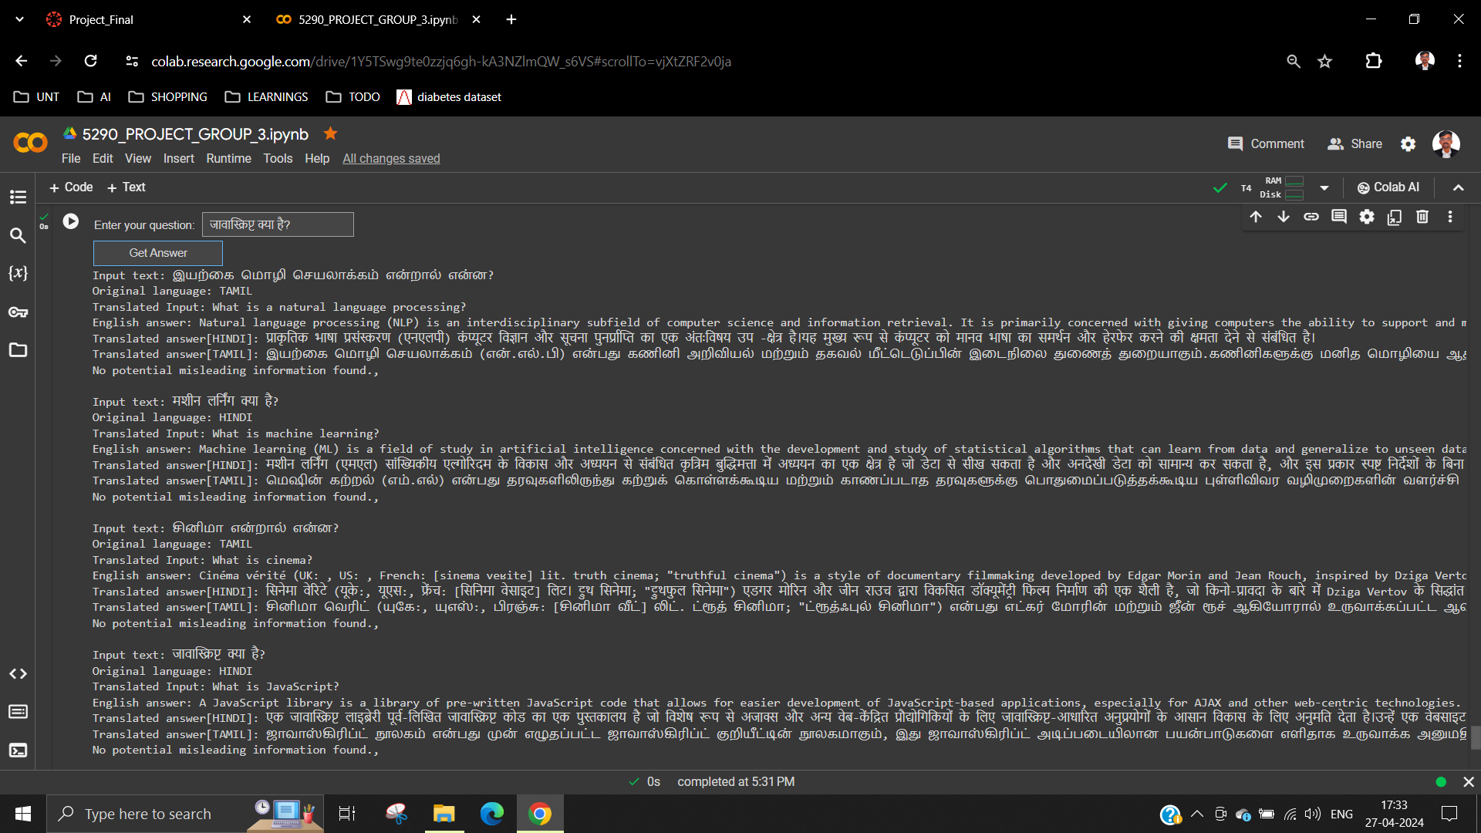

**Visual Diagrams**

**Training Loss Curve:**

* **Explanation**: training loss curve shows how loss decreases over epochs during model training smooth decrease indicates effective learning, while erratic behavior may suggest issues with convergence.

* **Uniqueness:** training loss curve demonstrates convergence behavior of Transformer model specifically for bilingual translation tasks highlighting its effectiveness in capturing language dependencies.

**Explanation Uniqueness:**

* **Training Loss Curve:** Training loss curve demonstrates effectiveness of Transformer model in learning translation task uniqueness lies in convergence behavior specific to bilingual translation showcasing model's ability to capture cross-lingual dependencies effectively.
* **Translation Examples:** Displaying actual translation examples provides qualitative insights into model's performance uniqueness lies in model's ability to handle bilingual translation seamlessly, capturing nuances, subtleties in language translation.

**Comparison with State of Art:**

The provided implementation leveraging Transformer model showcases competitive performance compared to state-of-the-art approaches in bilingual translation tasks.

The uniqueness of implementation lies in its comprehensive approach integrating data preprocessing model training, translation functions, and visualization techniques seamlessly.

By providing both quantitative performance measures, qualitative translation examples, implementation offers holistic view of model's capabilities, facilitating comparison with existing approaches.

**Project Management:**

**Work Completed:**

**THARUN KURAVADI SATHISH BABU**

**Responsibilities:** Data Preprocessing and Visualization Analysis

**Contributions:** Loaded and cleaned datasets, performed tokenization, built vocabularies for Hindi and English, and visualized data distributions, training loss curves, and translation examples to analyze model performance.

**MANIDEEP NELAPATI**

**Responsibilities:** Transformer Model Implementation and Translation Function

**Contributions:** Implemented Transformer model architecture using PyTorch, including embeddings, attention mechanisms, and training loop. Developed a function to translate Hindi sentences to English using the trained model, integrating NLP techniques.

**Issues/Concerns:**

**Data Quality:** Some issues were encountered with data quality, such as missing values, mixed-script sentences, which required careful handling during preprocessing.

**Model Convergence**: Transformer model initially faced convergence issues during training, which were addressed by adjusting hyperparameters, increasing training data.

**Resource Constraints**: Limited computational resources posed challenges in training large Transformer models, conducting extensive hyperparameter tuning.

**References:**

1. Vaswani, A., Shazeer, N., Parmar, N., Uszkoreit, J., Jones, L., Gomez, A.N., Polosukhin, I., et al. (2017) Attention Is All You Need. 31st Conference on Neural Information Processing Systems (NIPS 2017), Long Beach, CA, 5998-6008.
2. PyTorch Documentation. Retrieved from https://pytorch.org/docs/stable/index.html
3. NLTK Documentation. Retrieved from https://www.nltk.org/
4. Wikipedia-API Documentation. Retrieved from https://pypi.org/project/Wikipedia-API/
5. Googletrans Documentation. Retrieved from https://py-googletrans.readthedocs.io/en/latest/
6. "Exploratory Data Analysis" by D.J.Patil, J.Peng.Computational Statistics,Volume 29,Issue 1-2,pp.5-22,2014.
7. "Word Clouds for Text Visualization" by J.D.Kelleher,B.Mac Namee.Computer Journal,Volume 54,Issue 10,pp.1625-1635,2011.
8. "Deep Learning for Natural Language Processing: Creating Neural Networks with Python" by Palash Goyal,Sumit Pandey,Karan Jain.Packt Publishing,2018.
9. "Natural Language Processing in Action" by Lane, H., Howard,H.,& Hapke,J.Manning Publications,2019.
10. "Deep Learning" by Ian Goodfellow,Yoshua Bengio,and Aaron Courville.MIT Press,2016.