Lab 8 Output
Q1.
Q1(a)
t Error Error h halved ratio
0.000000 0.000000 0.000000 NaN
1.000000 0.000605 0.000284 0.469243
2.000000 0.000222 0.000104 0.470073
3.000000 0.000081 0.000038 0.470606
4.000000 0.000030 0.000014 0.471528
5.000000 0.000011 0.000005 0.473412

Q1(b)
t Error Error h halved ratio
0.000000 0.000000 0.000000 NaN
1.000000 0.003385 0.001627 0.480818
2.000000 0.001229 0.000595 0.483909
3.000000 0.000447 0.000218 0.486458
4.000000 0.000161 0.000079 0.491026
5.000000 0.000057 0.000029 0.500859

Q1(c)
t Error Error h halved ratio
0.000000 0.000000 0.000000 NaN
1.000000 0.001627 0.000770 0.473454
2.000000 0.000595 0.000283 0.475192
3.000000 0.000218 0.000104 0.476462
4.000000 0.000079 0.000038 0.478690
5.000000 0.000029 0.000014 0.483329

Q1(d)
t Error Error h halved ratio
0.000000 0.000000 0.000000 NaN
1.000000 0.000770 0.000362 0.469935
2.000000 0.000283 0.000133 0.470928
3.000000 0.000104 0.000049 0.471584
4.000000 0.000038 0.000018 0.472722
5.000000 0.000014 0.000007 0.475055

Q2.
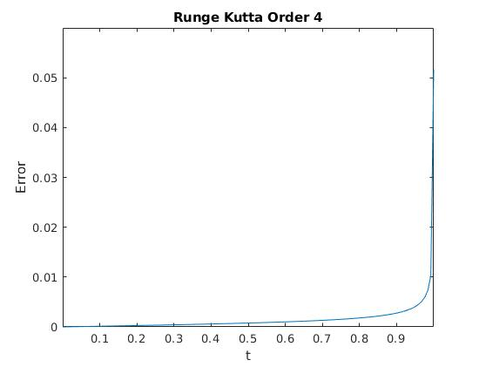
Q3.
Amount of potassium hydroxide after 0.2s = 2.079408e+03

Q4.
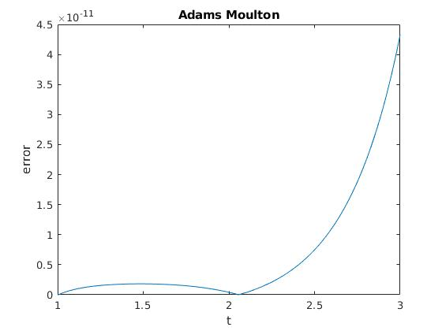
(a) Using exact solution to get first inital values
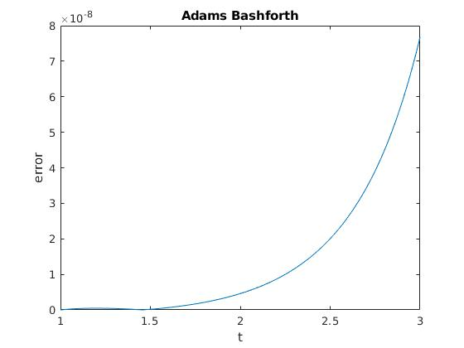

Using Runge Kutta Methods to get initial values
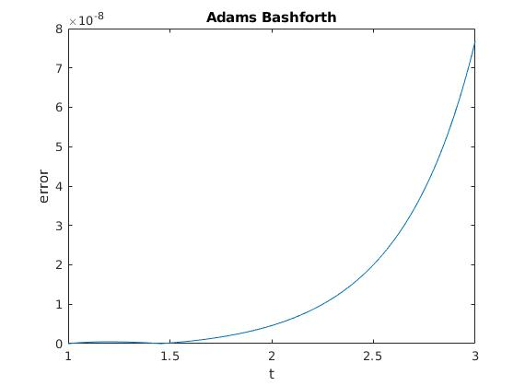
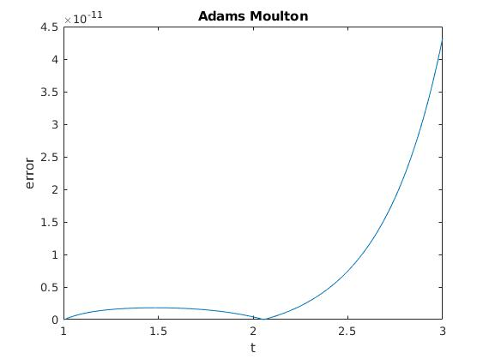
(b)
Using actual solution to get the first few values

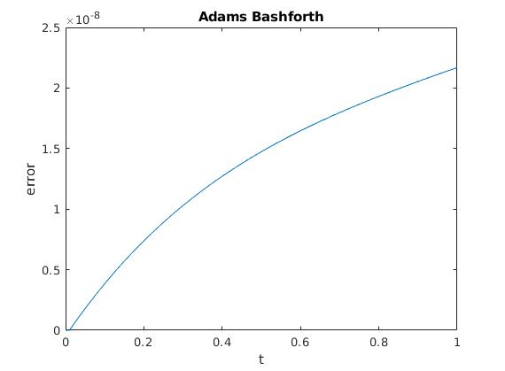

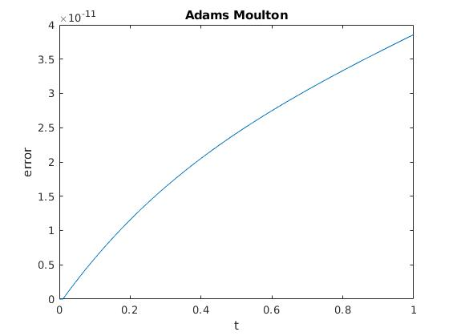
Using Runge Kutta Method to get initial values
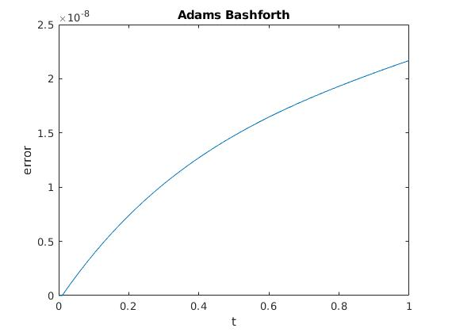

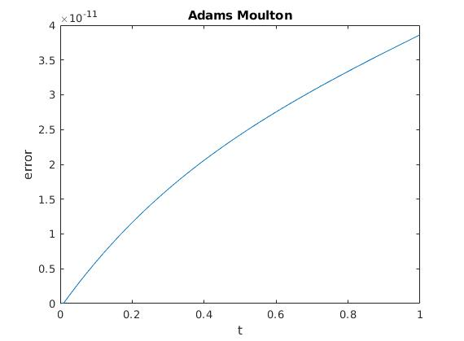
Q5.
h = 0.01

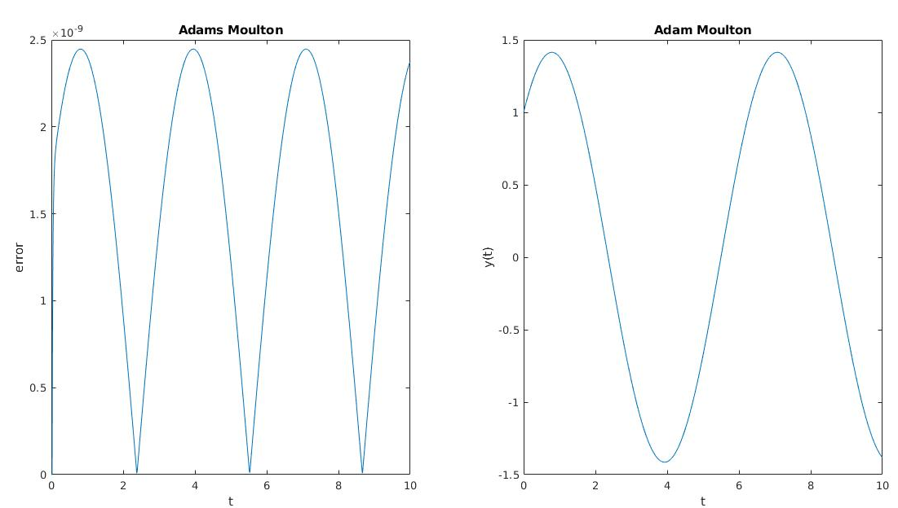
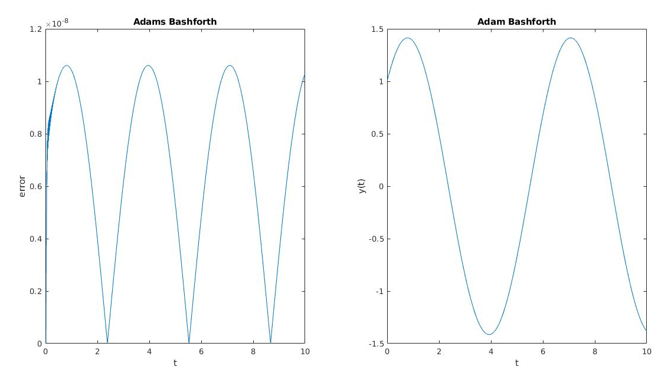

h = 0.001
