Lab 9 Output
Roll no. - 170123057

Q1(a)
The plot for solution using Central difference for the first order derivative is
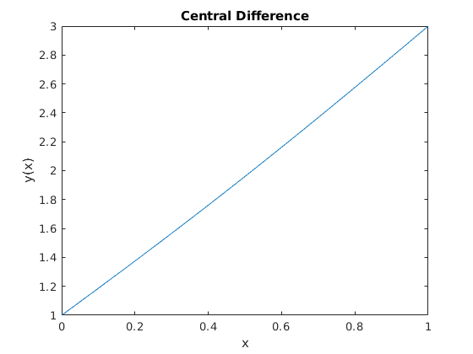
The plot for solution using Backward difference for the first order derivative is
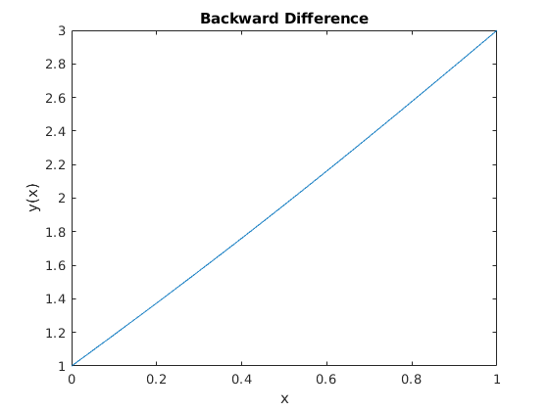
The plot for solution using Forward difference for the first order derivative is
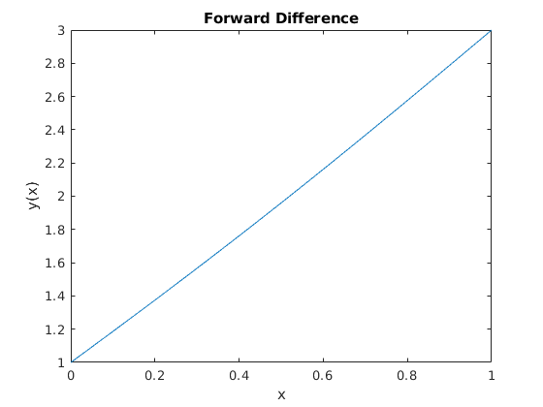
Q1(b)
The plot for solution using Central difference for the first order derivative is
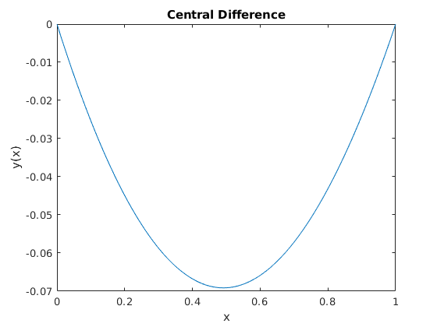
The plot for solution using Backward difference for the first order derivative is
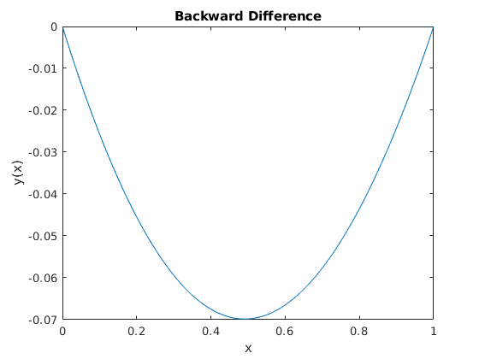
The plot for solution using Forward difference for the first order derivative is
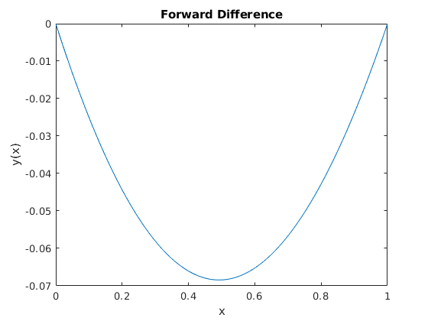

Q2.
Q2(a)
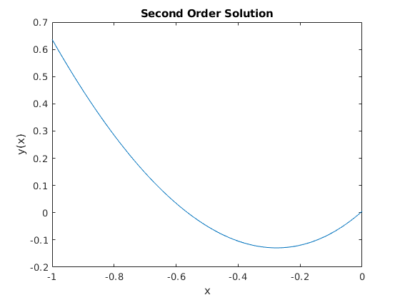
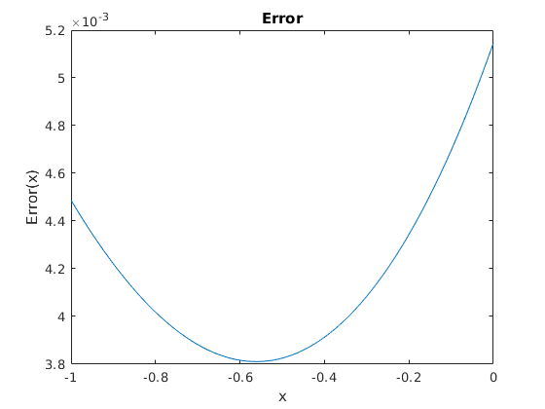

Q2(b)
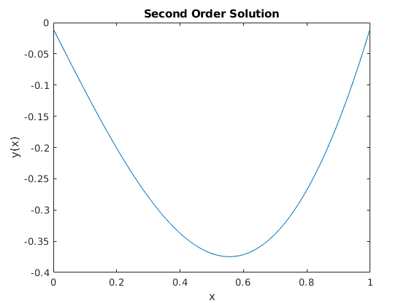

No error plot because the given exact solution was not satisfying the given second order PDE

Q3.

Plot for Q3(a)
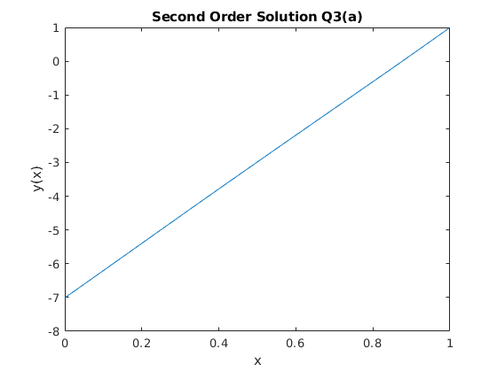

Plot for Q3(b)