Output 1
Q1.
Call Option Price at t=0 for M=1 = 38.16764
Call Option Price at t=0 for M=5 = 34.90653
Call Option Price at t=0 for M=10 = 33.62502
Call Option Price at t=0 for M=20 = 33.85945
Call Option Price at t=0 for M=50 = 33.98118
Call Option Price at t=0 for M=100 = 34.01116
Call Option Price at t=0 for M=200 = 34.01958
Call Option Price at t=0 for M=400 = 34.01913

Put Option Price at t=0 for M=1 = 19.94172
Put Option Price at t=0 for M=5 = 16.68061
Put Option Price at t=0 for M=10 = 15.39910
Put Option Price at t=0 for M=20 = 15.63353
Put Option Price at t=0 for M=50 = 15.75527
Put Option Price at t=0 for M=100 = 15.78524
Put Option Price at t=0 for M=200 = 15.79366
Put Option Price at t=0 for M=400 = 15.79321

Q2.
step = 1
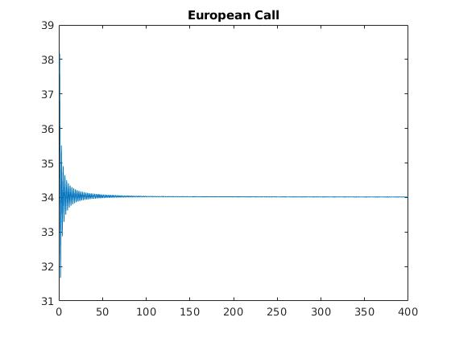

Step = 5
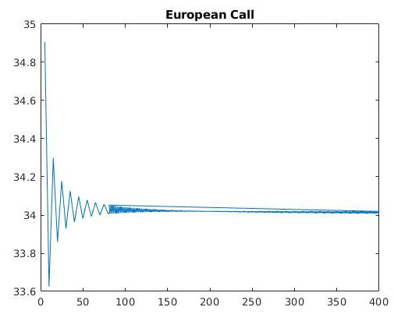

Step = 1
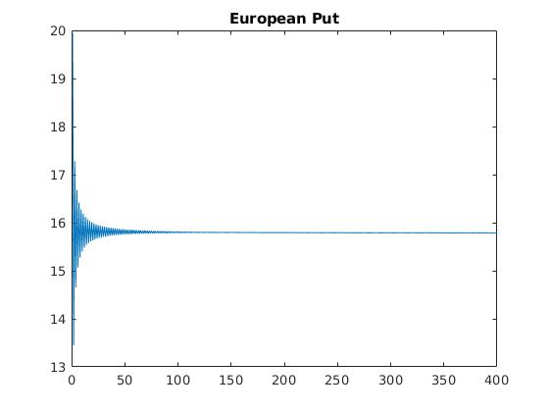
Step = 5
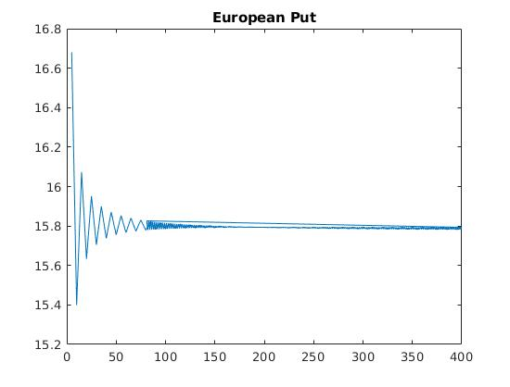
Q3.
M = 20
CALL OPTION PRICES
Option Price at t=0 :
33.8594

Option Price at t=0.5 :
59.9588
31.8933
15.0959

Option Price at t=1 :
100.6627
57.7000
29.8040
13.4697
5.1548

Option Price at t=1.5 :
160.6114
98.4389
55.2954
27.5732
11.7675
4.1214
1.1250

Option Price at t=3 :
519.0997
359.9342
242.0302
154.8417
91.1934
46.9762
19.7252
6.1485
1.2360
0.1183
0
0
0

Option Price at t=4.5 :
1.0e+03 *

1.4194
1.0250
0.7328
0.5163
0.3560
0.2372
0.1491
0.0840
0.0363
0.0081
0
0
0
0
0
0
0
0
0

PUT OPTION PRICES
Option Price at t=0 :
15.6335

Option Price at t=0.5 :
8.4792
15.4871
24.6728

Option Price at t=1 :
3.5042
8.0042
15.2694
24.9833
35.9653

Option Price at t=1.5 :
0.9424
2.9982
7.4363
14.9634
25.2710
36.9701
48.3050

Option Price at t=3 :
0
0
0.0087
0.1721
1.2357
4.9582
13.2218
25.9550
40.5333
53.8548
64.4333
72.3577
78.2282

Option Price at t=4.5 :
0
0
0
0
0
0
0
0
0.6015
8.2812
26.6400
46.2776
60.8254
71.6028
79.5868
85.5015
89.8832
93.1293
95.5341

