Lab 4 Output
Q1.
Risk Return Weights
0.248 0.005 2.479 -0.421 -1.058
0.248 0.005 2.477 -0.420 -1.057
0.248 0.005 2.475 -0.419 -1.055
0.247 0.005 2.473 -0.419 -1.054
0.247 0.006 2.470 -0.418 -1.053
0.247 0.006 2.468 -0.417 -1.051
0.246 0.006 2.466 -0.416 -1.050
0.246 0.006 2.464 -0.415 -1.049
0.246 0.006 2.462 -0.414 -1.048
0.246 0.006 2.460 -0.414 -1.046
At 0.15 risk
min return=0.053
Corresponding Portfolio: w1=1.799, w2=-0.151, w3=-0.648

At 0.15
max return=0.190
Corresponding Portfolio: w1=-0.163, w2=0.629, w3=0.534

At 0.18 risk
min return=0.038
Corresponding Portfolio: w1=2.008, w2=-0.234, w3=-0.774
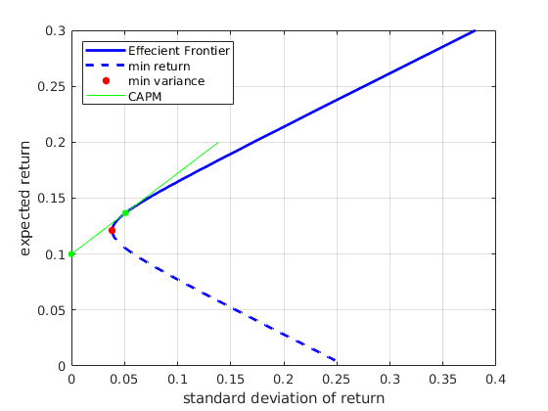

return for 0.1 risk=0.172
return for 0.25 risk=0.281

Q2.
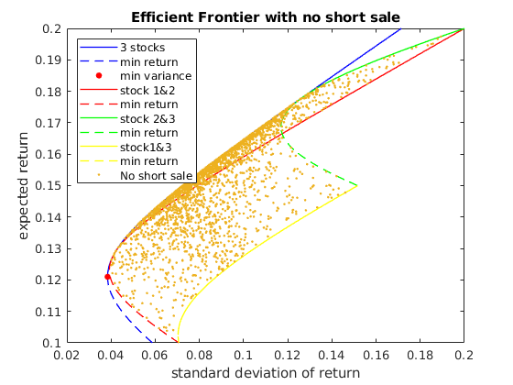
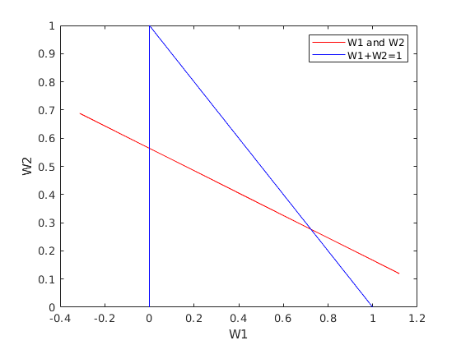

Q3.
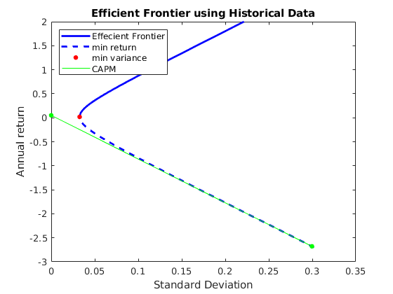
Market Portfolio has return=-2.678 and risk=0.300
