Lab 3 Output
Q1.

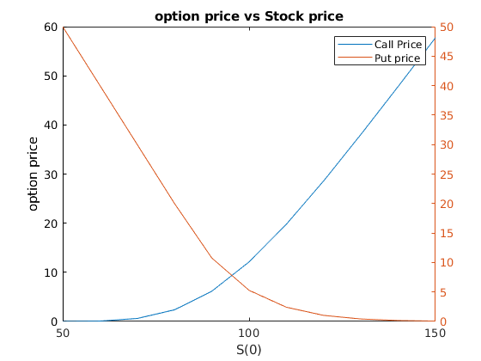
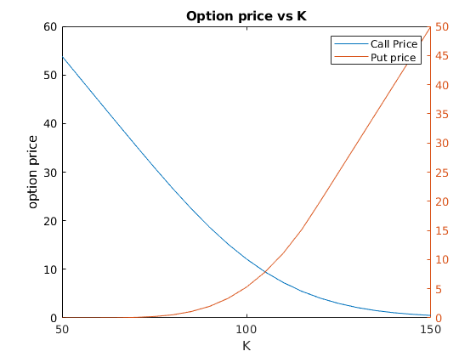
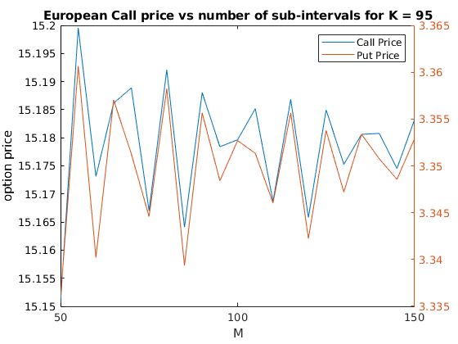
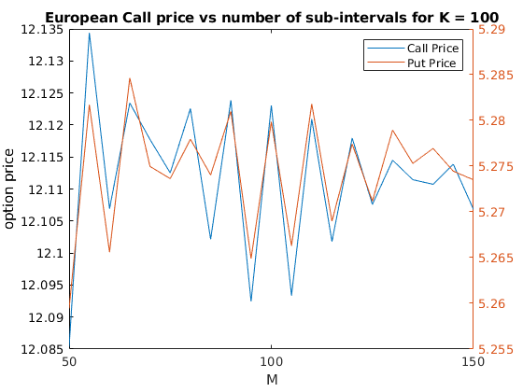
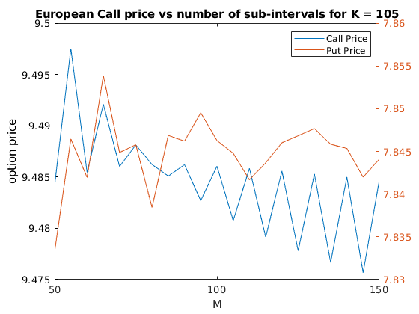
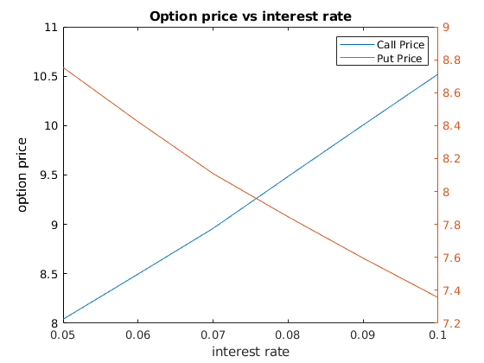
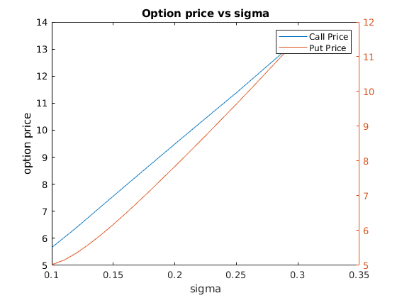

Q2.
M Lookback option price
5 9.119
10 10.081
15 10.519
20 10.805

Table of Option price at each time step
table = 32×6 table
 | T0 | T1 | T2 | T3 | T4 | T5
1 | 9.1193 | 9.5048 | 12.1687 | 17.5821 | 25.0512 | 32.1054
2 | 0 | 9.0280 | 7.1479 | 7.1484 | 10.6809 | 18.8059
3 | 0 | 0 | 9.7991 | 8.3246 | 10.6809 | 18.8059
4 | 0 | 0 | 8.5481 | 6.2019 | 3.8469 | 2.9014
5 | 0 | 0 | 0 | 13.7129 | 13.0714 | 18.8059
6 | 0 | 0 | 0 | 6.2019 | 3.8469 | 2.9014
7 | 0 | 0 | 0 | 9.9553 | 8.0036 | 7.8184
8 | 0 | 0 | 0 | 7.4168 | 4.6005 | 0
9 | 0 | 0 | 0 | 0 | 21.1881 | 21.2350
10 | 0 | 0 | 0 | 0 | 6.6808 | 5.3304
11 | 0 | 0 | 0 | 0 | 8.0036 | 7.8184
12 | 0 | 0 | 0 | 0 | 4.6005 | 0
13 | 0 | 0 | 0 | 0 | 15.6319 | 16.2664
14 | 0 | 0 | 0 | 0 | 4.6005 | 0
15 | 0 | 0 | 0 | 0 | 9.5714 | 9.3499
16 | 0 | 0 | 0 | 0 | 5.5016 | 0
17 | 0 | 0 | 0 | 0 | 0 | 29.4826
18 | 0 | 0 | 0 | 0 | 0 | 13.5780
19 | 0 | 0 | 0 | 0 | 0 | 13.5780
20 | 0 | 0 | 0 | 0 | 0 | 0
21 | 0 | 0 | 0 | 0 | 0 | 16.2664
22 | 0 | 0 | 0 | 0 | 0 | 0
23 | 0 | 0 | 0 | 0 | 0 | 9.3499
24 | 0 | 0 | 0 | 0 | 0 | 0
25 | 0 | 0 | 0 | 0 | 0 | 25.3946
26 | 0 | 0 | 0 | 0 | 0 | 6.3745
27 | 0 | 0 | 0 | 0 | 0 | 9.3499
28 | 0 | 0 | 0 | 0 | 0 | 0
29 | 0 | 0 | 0 | 0 | 0 | 19.4527
30 | 0 | 0 | 0 | 0 | 0 | 0
31 | 0 | 0 | 0 | 0 | 0 | 11.1814
32 | 0 | 0 | 0 | 0 | 0 | 0

Q3.
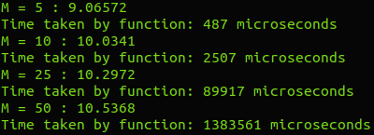

Q4.
Value of M Intial European call price
1 13.714
5 12.163
10 12.277
20 12.175
50 12.085
100 12.123
200 12.104
400 12.101
Elapsed time is 0.094152 seconds.

