Lab 9 Output
Kartik Sethi
Roll no – 170123057

Solving for niftyoptiondata
(a)
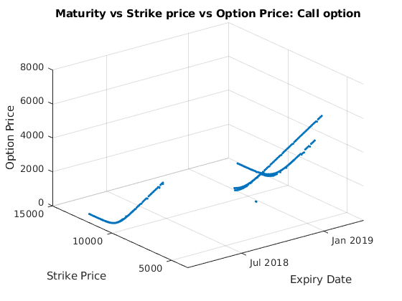
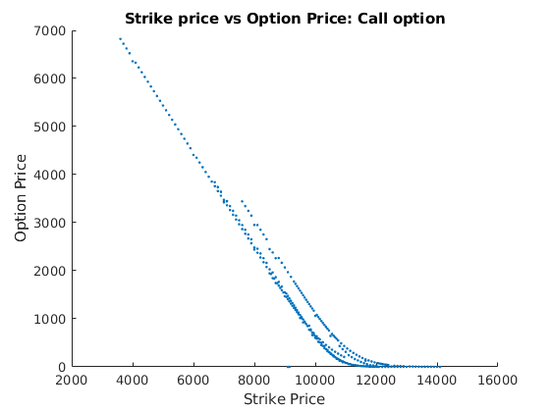
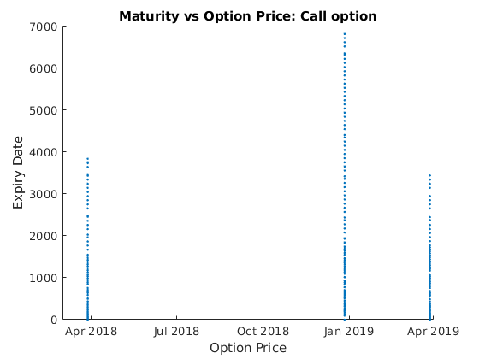
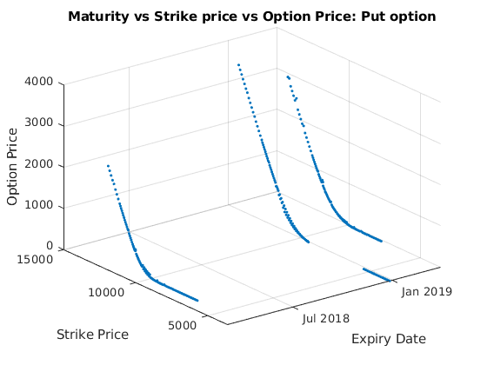
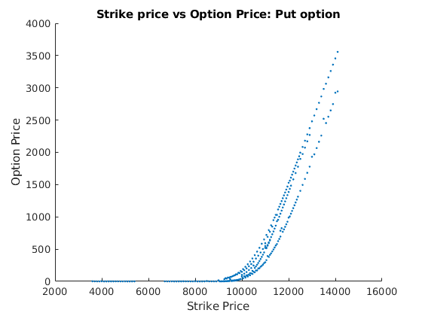
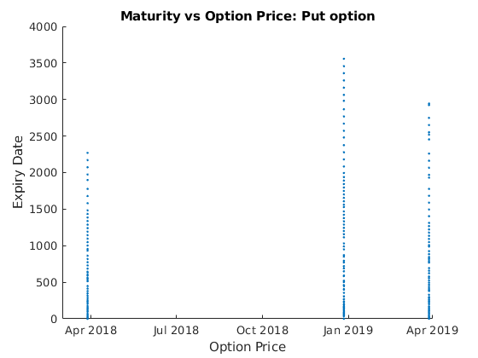
(b)
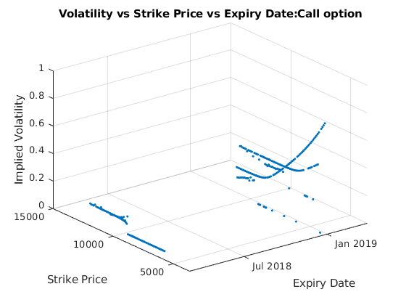
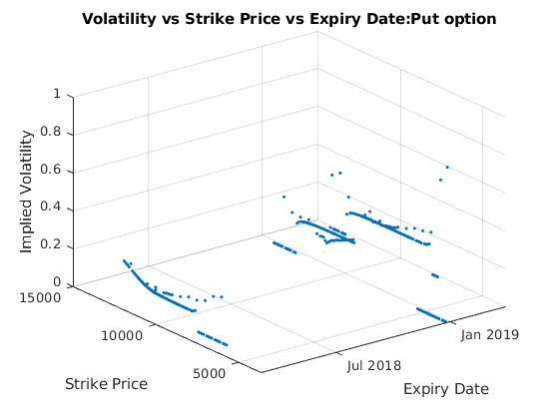
(c)
Start Date End Date Historical ImpliedVolatility
01-Jan-2018 28-Mar-2018 NaN 0.092
01-Jan-2019 28-Mar-2019 0.107 0.141
01-Nov-2018 27-Dec-2018 0.135 0.810
02-Nov-2018 27-Dec-2018 0.137 0.500
01-Jan-2018 28-Mar-2018 NaN 0.047
01-Jan-2019 28-Mar-2019 0.107 0.047
01-Nov-2018 27-Dec-2018 0.135 0.178
01-Nov-2018 27-Dec-2018 0.135 0.182

Solving for stockoptiondata
Stock taken is WIPRO
(a)
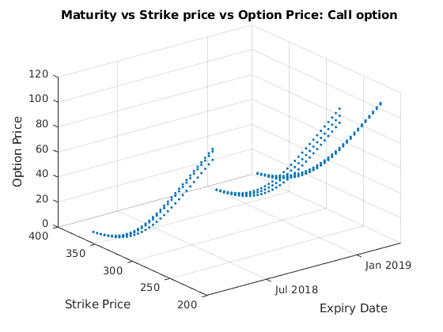
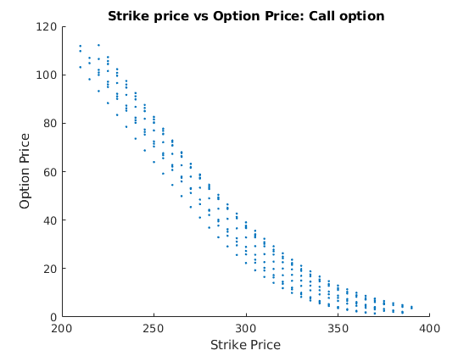
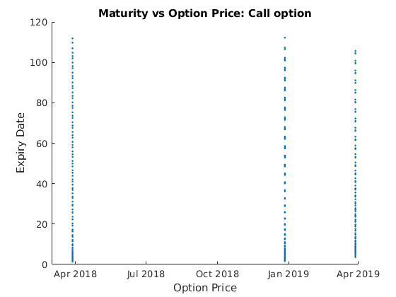
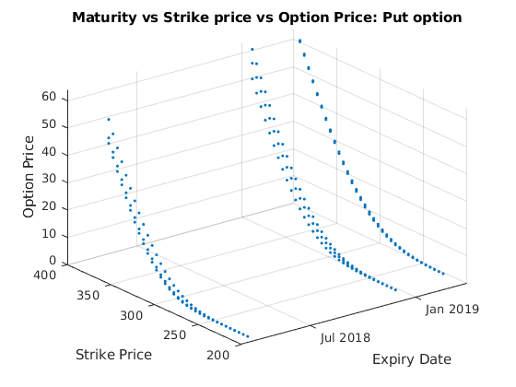
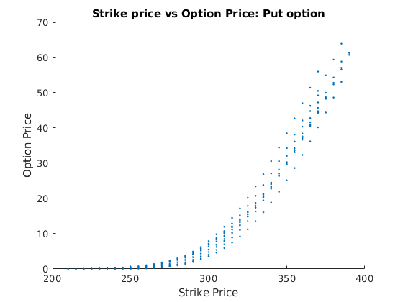
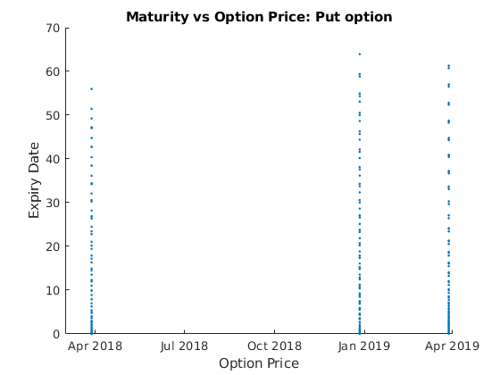
(b)
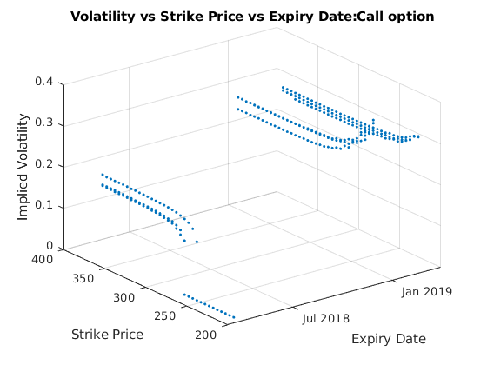
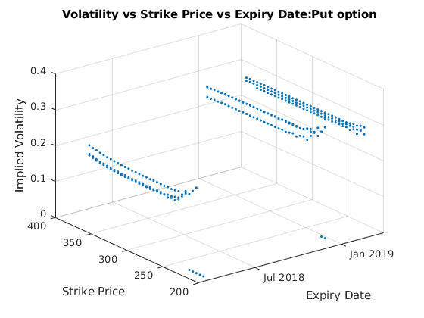

(c)

Start Date End Date Historical ImpliedVolatility
01-Jan-2018 28-Mar-2018 0.244 0.000
03-Jan-2018 28-Mar-2018 0.241 0.000
03-Jan-2019 28-Mar-2019 0.298 0.248
05-Nov-2018 27-Dec-2018 0.286 0.277
01-Jan-2018 28-Mar-2018 0.244 0.047
01-Jan-2019 28-Mar-2019 0.293 0.272
01-Nov-2018 27-Dec-2018 0.281 0.047
05-Nov-2018 27-Dec-2018 0.286 0.272

