Lab 10 Output
Kartik Sethi
Roll no – 170123057

Q1. Using monte Carlo methods without variance reduction techniques

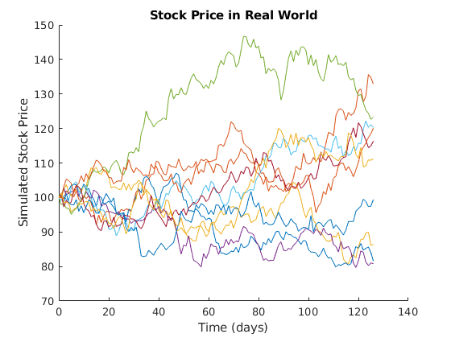
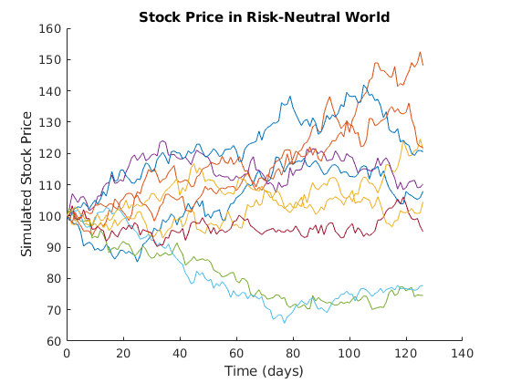
Asian call options with S0 = 100, r = 0.05, σ= 0.2,number of trials = 1000
K Call Option Put Option
90 12.6367 0.7690
105 3.3614 6.1233
110 1.8670 9.5054
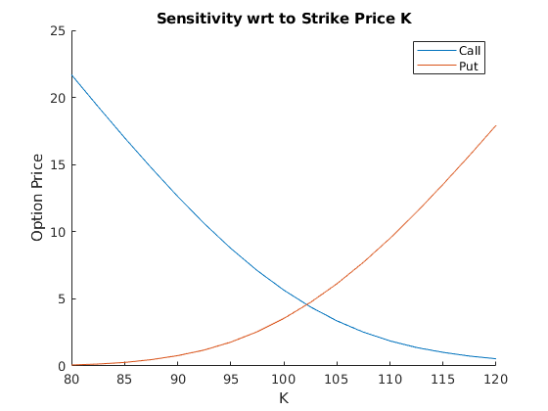
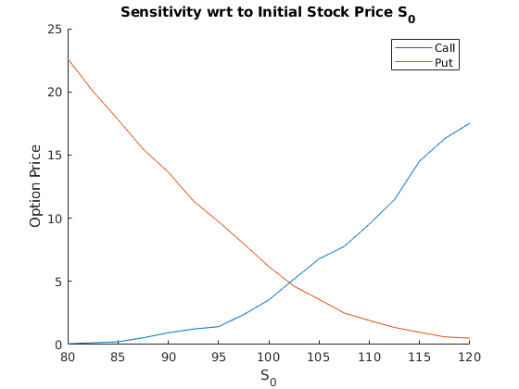
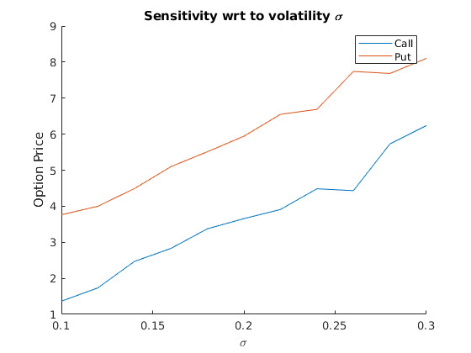

Q2 . Using antithetic variance reduction

where is the quantity we want to estimate ,
we can generate two sample and s.t. the new unbiased estimator of is

Hence we have

It is obvious that we could get a variance reduction if we have the two samples
negatively correlated.
If then we can apply the following algorithm
with i.i.d.

Asian call options with S0 = 100, r = 0.05, σ= 0.2,number of trials = 1000
K Call Option Put Option
90 12.2192 0.0000
105 0.0000 2.4104
110 0.0000 7.2870
