Lab 5 Output
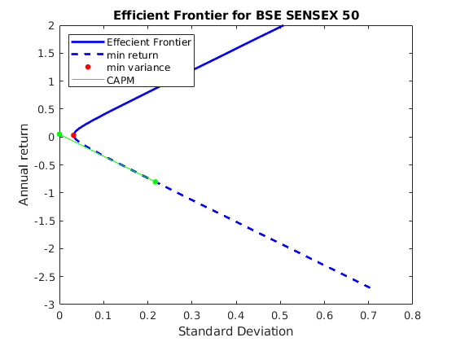
Market Portfolio has return=-0.804 and risk=0.217
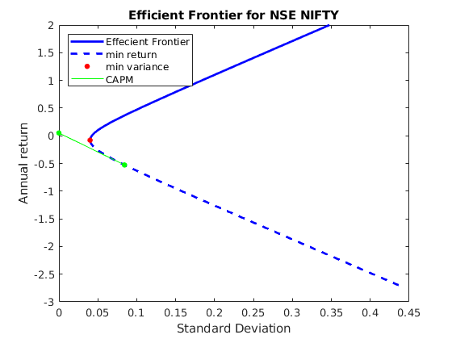
Market Portfolio has return=-0.527 and risk=0.084
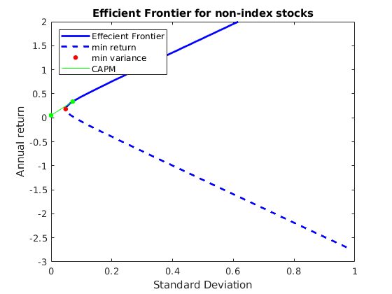
Market Portfolio has return=0.336 and risk=0.071
