LAB REPORT 3

Kartik Sethi
All workspaces saved in folder Workspace
Q1.
q1.m to execute the code and worspace saved as q1.mat
In our experiment we observe that there is a linear relationship between n and log(cond(H))
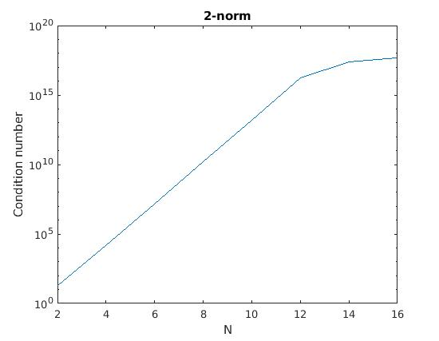
till cond(H) = 10¹⁸ after that floating point errors lead to the curve no longer being linear.

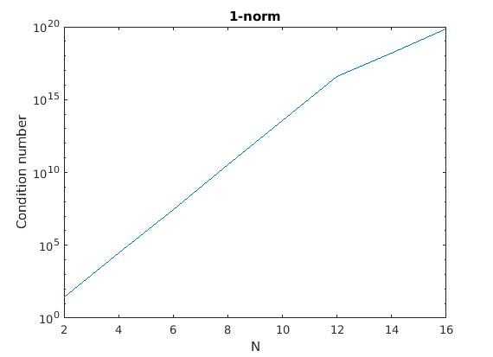
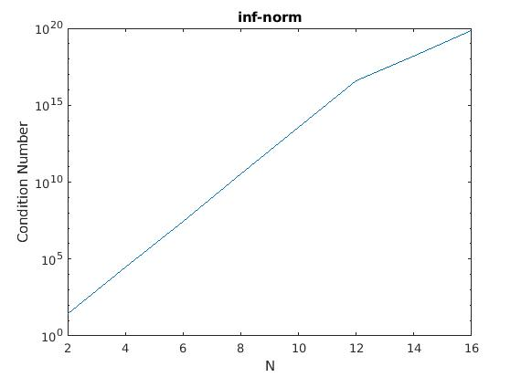

Q2.
q2.m to execute the code and worspace saved as q2.mat
Output
n = 8

0.706046088019609 0.706046088012541 0.706046088012162 0.706046088011975
0.031832846377421 0.031832846761154 0.031832846580759 0.031832846784067
0.276922984960890 0.276922979901710 0.276922986134943 0.276922979679189
0.046171390631154 0.046171418218357 0.046171415182965 0.046171419088235
0.097131781235848 0.097131706506352 0.097131807564899 0.097131704902439
0.823457828327293 0.823457934606389 0.823457962571329 0.823457936005740
0.694828622975817 0.694828547017259 0.694828591860903 0.694828546544806
0.317099480060861 0.317099501570728 0.317099491508923 0.317099501577638

cond(H) 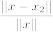 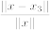
1.0e+10 *

1.525757556662796 0.000000000000000 0.000000000000000 0.000000000000000

n = 10

0.950222048838355 0.950222048705845 0.950222048803993 0.950222048867865
0.034446080502909 0.034446092750798 0.034446109641809 0.034446078785707
0.438744359656398 0.438744084419080 0.438743959066460 0.438744380799567
0.381558457093008 0.381561068536921 0.381557528998687 0.381558384913616
0.765516788149002 0.765503893996335 0.765497966579702 0.765516642632803
0.795199901137063 0.795236367978524 0.795240947483085 0.795201459289516
0.186872604554379 0.186811340267909 0.186759675744338 0.186868401983530
0.489764395788231 0.489824796926765 0.489890852555291 0.489769845575134
0.445586200710899 0.445553943502319 0.445567475546798 0.445582698729156
0.646313010111265 0.646320209610038 0.646333829829119 0.646313905014906

cond(H)
1.0e+13 *

1.602502816811318 0.000000000000000 0.000000000000000 0.000000000000000

n = 12

0.709364830858073 0.709364821910038 0.709364837698075 0.709364831791799
0.754686681982361 0.754687706567284 0.754684796646133 0.754686426929440
0.276025076998578 0.275995584964463 0.276076437797058 0.276036492987236
0.679702676853675 0.680074201348015 0.679348205802127 0.679509598028731
0.655098003973841 0.652559241943245 0.654400175234051 0.656741504541920
0.162611735194631 0.173079365738261 0.157349714951451 0.154545877826427
0.118997681558377 0.091474514292029 0.151832057637556 0.143482848503947
0.498364051982143 0.545604608727642 0.446252343114693 0.450893912748202
0.959743958516081 0.907011186962890 1.042340967551302 1.018621050731120
0.340385726666133 0.377290189799310 0.299654838850888 0.295184857477381
0.585267750979777 0.570559242138038 0.572894967682627 0.604828823808057
0.223811939491137 0.226359451456255 0.223784721784977 0.220163882671529

cond(H)
1.0e+16 *

1.621163904747499 0.000000000000000 0.000000000000000 0.000000000000000

in some cases are not even accurate upto 1 significant digit. So all s=16 digits are lost.
Results do match the rule-of-thumb mentioned in the assignment as we have cond(A) = , for and so the number of signifcant digits = s-t.

All give pretty much the same results so there is no difference between the methods used to generate them.

Q3.
Use q3.m to execute the code and q3,mat for workspace
= 9.518115e-17
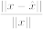 = 1.013915e-04
This shows that being small does not imply the perturbation in the solution( ) will be small

Q4.

Method |  | cond(A) |  | 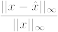
GEPP | 32 | 1.421555e+01 | 9.007462e-10 | 1.637298e-09
 | 64 | 2.860298e+01 | 1.543653e+00 | 2.809000e+00
QR | 32 | 1.421555e+01 | 3.909811e-16 | 8.364506e-16
 | 64 | 2.860298e+01 | 4.753311e-16 | 8.580680e-16

a) For both n, QR seems to give lower forward error.
b) The rule of thumb is predicting well for QR method as s = 16, t = 1 and we have s – t = 15.
and the our is correct upto 15 significant digits as seen in forward error.
c)for both n, QR has lower
d) Given that QR method has lower forward error and compared to GEPP. It is more stable algorithm.
Q5
The code file is q5.m and workspace is stored as q5.mat
N | GENP Error | LU error
20 | 1.584245e-01 | 2.581129e-15
40 | 1.466903e-01 | 3.989207e-15
60 | 1.440104e+00 | 9.474908e-15
80 | 9.169778e-02 | 1.035070e-14
100 | 1.801790e+00 | 2.272122e-14

for all n, GENP produces larger norm

