
Graduate School of Applied and Professional Psychology
Rutgers, The State University of New Jersey
152 Frelinghuysen Road
Piscataway, NJ 08854
p. (848) 445-2000
https://gsapp.rutgers.edu/continuing-education

CERTIFICATE OF COMPLETION

This is to certify that
NAME

has attended, in its entirety, the following Live Continuing Education activity sponsored by the
Graduate School of Applied and Professional Psychology:

“TITLE”
PROGRAM DATE:
CE CREDIT HOURS:
LOCATION:
FORMAT:


Rutgers Graduate School of Applied and Professional Psychology has been approved by NBCC as an Approved Continuing Education Provider, ACEP No. 8145. Programs that do not qualify for NBCC credit are clearly identified. Rutgers Graduate School of Applied and Professional Psychology is solely responsible for all aspects of the Programs.
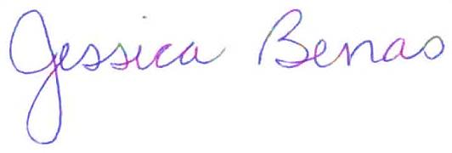

Jessica Benas, Ph.D.
Director of Continuing Education
ce@rutgers.edu
(848) 445-3987

41 Gordon Road, Suite A
Piscataway, NJ 08854-8067
Tel: 732.445.7504
www.nj-charactered.net

