
Graduate School of Applied and Professional Psychology
Rutgers, The State University of New Jersey
152 Frelinghuysen Road
Piscataway, NJ 08854
p. (848) 445-2000
https://gsapp.rutgers.edu/continuing-education

This is to certify that
NAME

has attended, in its entirety, the following Continuing Education activity sponsored by the
Graduate School of Applied and Professional Psychology:

“TITLE”
COMPLETION DATE:
CE CREDITS:
LOCATION: Virtual Event
FORMAT: Live Webinar

Rutgers Graduate School of Applied and Professional Psychology (GSAPP), is approved by the American Psychological Association to sponsor continuing education for psychologists. Rutgers Graduate School of Applied and Professional Psychology (GSAPP) maintains responsibility for this program and its content.

41 Gordon Road, Suite A
Piscataway, NJ 08854-8067
Tel: 732.445.7504
www.nj-charactered.net
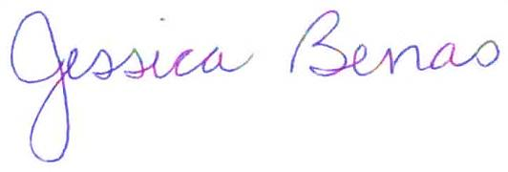

Jessica Benas, Ph.D.
Director of Continuing Education
jbenas@rutgers.edu
(848) 445-3987

