Graduate School of Applied and Professional Psychology  Rutgers, The State University of New Jersey 152 Frelinghuysen Rd  Piscataway, NJ 08854-8020 | http://gsapp.rutgers.edu  Phone: (732) 445-2000  Fax: (732) 445-4888


DOCUMENTATION OF ATTENDANCE

DATE
To whom it may concern:
This is to certify that NAME has attended, in its entirety, the following Continuing Education activity sponsored by Rutgers Graduate School of Applied and Professional Psychology.

“Program title”
presented by Name, Degree
on DATE from TIME – TIME ET via Live Zoom Webinar/at Rutgers University in Piscataway, NJ/City, State

This activity provided X continuing education contact hours. This letter verifies only that the participant attended the complete activity. It does not attest to the participant’s skills or knowledge in the subject matter of the workshop.

Sincerely,
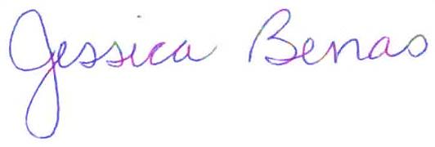

__________________________
Jessica Benas, Ph.D.
Director of Continuing Education
Graduate School of Applied and Professional Psychology
Rutgers University
jbenas@rutgers.edu

Rutgers Graduate School of Applied and Professional Psychology is approved by the National Association of School Psychologists to offer continuing education for school psychologists. Rutgers Graduate School of Applied and Professional Psychology maintains responsibility for the program.

