
Graduate School of Applied and Professional Psychology
Rutgers, The State University of New Jersey
152 Frelinghuysen Road
Piscataway, NJ 08854
p. (848) 445-2000
https://gsapp.rutgers.edu/continuing-education

This is to certify that
NAME

NY Psychology License #

has attended, in its entirety, the following Continuing Education Activity sponsored by the
Graduate School of Applied and Professional Psychology:

“TITLE”
INSTRUCTOR:
COMPLETION DATE:
CE CREDITS:
LOCATION: Virtual Event
FORMAT: Live Webinar

Rutgers Graduate School of Applied and Professional Psychology (GSAPP) is recognized by the New York State Education Department’s State Board for Psychology as an approved provider of continuing education for licensed psychologists #PSY-0123

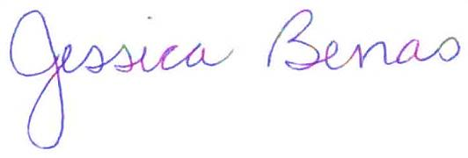

Jessica Benas, Ph.D.
Director of Continuing Education
jbenas@rutgers.edu; 848-445-3987

41 Gordon Road, Suite A
Piscataway, NJ 08854-8067
Tel: 732.445.7504
www.nj-charactered.net

