*Kristopher Schall*

*CIS 5 44187*

*4/17/2017*

*Minesweeper Roulette*

Project #1

Introduction:

Title: Minesweeper Roulette

Minesweeper is traditionally played on a computer or smartphone. It consists of trying to clear a grid without clicking one of the bombs and blowing up. In the traditional game, it will provide you with numbers showing how many bombs are located adjacent to the square. Minesweeper Roulette does not offer this feature; therefore, it is more of a game of chance giving no clues. The Player begins by entering in a number for the X axis and Y axis. If they spot has no bomb it will be marked with an X and the player can proceed to enter in the next box to check until they complete the grid without blowing up, or hitting a bomb and ending the game. The game will notify you that you hit a bomb with an “!” as well as notifying you that you have been blown up.

Summary:

Project Size: 100+ lines

Number of Variables: 11

Number of Method: 2

I created this game because minesweeper is one of my favorite games to play to pass the time. Though it is not the traditional form of minesweeper it is entertaining to play nonetheless. This project took some time to code and perfect being that it is the first complex project that I have had to build.

I incorporated all the knowledge and codes that I have learned in the first portion of this course.

Flowchart

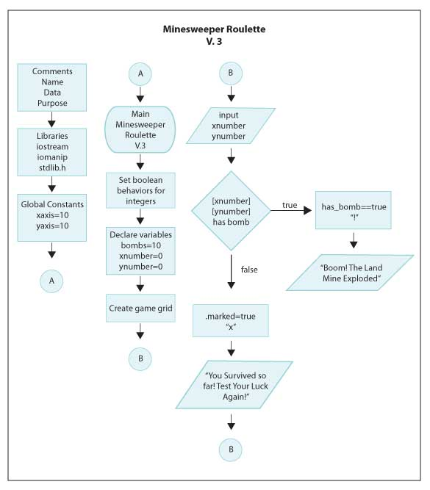



Program:

File: main.cpp

Author: Kristopher Schall

Created on April 14, 2017, 3:15 PM

Purpose: Minesweeper Roulette, Will you test your luck and can you survive the mine field?

*/

//System Libraries

#include <iostream>

#include <iomanip>

#include <stdlib.h>

using namespace std;

//Declare Variables

int bombs, xnumber, ynumber;

//Global Constants

const int xaxis=10, yaxis=10;

//set behavior of integers

bool lose;

//Create Game Grid

class Grid {

public:

bool has_bomb, marked;

Grid(void){

has_bomb=false;

marked=false;

}

};

void drawBoard(Grid board[xaxis][yaxis])

{

cout<<" _";

for (int i=0; i<xaxis; i++)

{

cout<<i<<"_";

}

cout<<endl;

for(int y=0; y<yaxis; y++)

{

cout<<y<<"|";

for (int x=0; x<xaxis; x++)

{

if(board[x][y].has_bomb && board [x][y].marked)

{

cout<<"!|";

}

else if(board[x][y].has_bomb)

{

cout<<"_|";

}

else if(board[x][y].marked)

{

cout<<"x|";

}

else

{

cout<<"_|";

}

}

cout<<endl;

}

}

int main()

{

//Declare Variables and Intro to Game

lose=false;

bombs=10;

xnumber=0;

ynumber=0;

Grid gameboard [xaxis][yaxis];

cout<<"WELCOME TO MINESWEEPER ROULETTE\n";

cout<<"There are 10 bombs on the minefield!\n";

cout<<"Can you survive by choosing the correct squares?\n";

for(int i=0; i<bombs; i++)

{

//Randomize Position of Bombs on Grid

int xpos=rand()%10;

int ypos=rand()%10;

if(gameboard[xpos][ypos].has_bomb==false)

{gameboard[xpos][ypos].has_bomb=true;}

else

{

i--;

}

}

drawBoard(gameboard);

cout<<endl;

while(lose != true)

{

//Input X and Y position and Output

cout<<"Input a number (0-9) to check the X (horizontal) grid: ";

cin>>xnumber;

cout<<endl<<"Input a number (0-9) to check the Y (vertical) grid: ";

cin>>ynumber;

if(gameboard[xnumber][ynumber].has_bomb== true)

{cout<<"Boom! The Land mine Exploded!\n";

cout<<"Better Luck Next Time!";

lose=true;

}

else

{

cout<<"You Survived so far! Test your luck again!"<<endl;

}

gameboard[xnumber][ynumber].marked=true;

cout<<endl;

drawBoard(gameboard);

cout<<endl;

}

return 0;

}