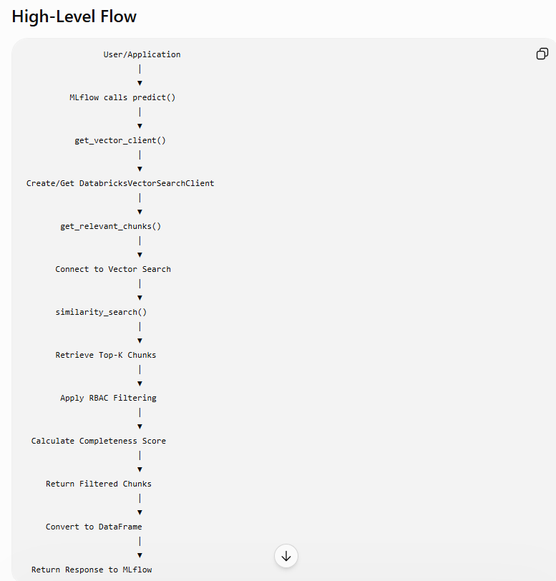
Step-by-Step Execution (According to Your Code)
Step 1: MLflow Creates the Model
When this file is loaded, these lines execute:
retriever_model = SimpleRetriever()

mlflow.models.set_model(retriever_model)
What happens?
SimpleRetriever Object Created

↓

MLflow now knows

"This is the model to serve."
Nothing is searched yet.

Step 2: User Sends a Query
Suppose the user asks:
How many casual leaves are allowed?
The request reaches the MLflow endpoint.
Example input:
model_input =
---------------------------------
query : Leave Policy
top_k : 5
username : Rahul
country : India

Step 3: MLflow Automatically Calls predict()
MLflow internally executes
predict(context, model_input)
Execution enters here.
class SimpleRetriever(mlflow.pyfunc.PythonModel):

def predict(...):
Think of this as
API Request

↓

predict()

Step 4: Get the Vector Client
Inside predict()
vector_client = get_vector_client()
Execution jumps here
def get_vector_client():

What does it do?
Checks
Has a client already been created?

│
Yes / No
If No
Creates
DatabricksVectorSearchClient(...)
This runs
__init__()
Inside constructor
Store

endpoint

vector index

workspace url

identity
Object created
client

│

├── endpoint

├── vector index

├── workspace

└── identity

If already created
Reuse the existing client.
This avoids reconnecting every request.

Step 5: Back to predict()
Now
vector_client
is ready.
Loop starts
for idx,row in model_input.iterrows():
Suppose
Only one row
Extract
query

top_k

username

country

Step 6: Call Retriever
Now
result = vector_client.get_relevant_chunks(...)
Execution jumps here
get_relevant_chunks()
This is where the real retriever starts.

Step 7: Create Databricks Connection
Inside
vsc = VectorSearchClient(...)
Connection created.
Think
Python

↓

Databricks Vector Search

Step 8: Open Vector Index
index_client = vsc.get_index(...)
Now
Python knows
Which Vector Database
to search.

Step 9: Search the Index
Most important line
results = index_client.similarity_search(...)
Execution
User Query

↓

Embedding

↓

Compare with all vectors

↓

Top K Similar Chunks
Suppose
Chunk A

Chunk B

Chunk C

Chunk D

Chunk E
returned.

Step 10: Convert Results
Databricks returns
Rows

Columns
The code converts them into
[
{
"title":...,

"content":...,

"source":...
},

...
]
This becomes
chunks

Step 11: Apply RBAC
Now
rbac_chunks = self.rbac_function(...)
Execution jumps here
rbac_function()
Current implementation
return chunks
So
Input

↓

Chunks

↓

Output

↓

Same Chunks
No filtering.
In future
Chunks

↓

Permission Check

↓

Remove Unauthorized Chunks

↓

Allowed Chunks

Step 12: Calculate Completeness
Now
score = self.completeness(...)
Execution jumps here
completeness()
Suppose
Retrieved

10

Allowed

8
Returns
8/10

=

0.8

Step 13: Return from Retriever
Now
return {

data,

completeness_score,

status_code

}
Execution returns
back to
predict()

Step 14: Build Response
Inside
responses.append(result)
If multiple rows
Repeat.

Step 15: Convert to DataFrame
Finally
return pd.DataFrame(responses)
MLflow always wants
DataFrame
instead of Python dictionary.

Step 16: MLflow Returns Response
MLflow sends
{
"data":[...],

"status_code":200,

"completeness_score":0.8
}
back to
Application

↓

Prompt Builder

↓

Azure OpenAI

↓

Answer

Complete Code Flow
File Starts
│
▼
Create SimpleRetriever
│
▼
Register with MLflow
│
────────────────────────────────────
User Sends Query
────────────────────────────────────
│
▼
predict()
│
▼
get_vector_client()
│
▼
Create DatabricksVectorSearchClient
(if not already created)
│
▼
__init__()
│
▼
Store endpoint/index/workspace
│
▼
Return client
│
▼
predict()
│
▼
Extract query/top_k/user
│
▼
get_relevant_chunks()
│
▼
Connect Vector Search
│
▼
Open Index
│
▼
similarity_search()
│
▼
Retrieve Top-K Chunks
│
▼
Convert Results
│
▼
rbac_function()
│
▼
Filter Unauthorized Chunks
(Currently returns all)
│
▼
completeness()
│
▼
Calculate Score
│
▼
Return Result
│
▼
predict()
│
▼
Build DataFrame
│
▼
Return to MLflow
│
▼
Application Receives Chunks
│
▼
LLM Uses Those Chunks
│
▼
Final Answer
One important observation
Notice the flow carefully:
- predict() is the entry point because MLflow calls it.
- get_vector_client() creates or reuses the retriever object.
- get_relevant_chunks() contains the core retrieval logic.
- rbac_function() filters the retrieved chunks based on access permissions (currently it's a placeholder and returns all chunks).
- completeness() calculates how much of the retrieved information remains after filtering.
- The retriever returns the chunks to the caller. It does not call the LLM.
So the complete RAG flow is:
Documents
│
▼
Chunking
│
▼
Embeddings
│
▼
Databricks Vector Search
│
────────────────────────────
User Question
│
▼
Your Retriever Code
│
▼
Relevant Chunks
│
▼
Prompt Builder (another component)
│
▼
Azure OpenAI / GPT
│
▼
Final Answer
This distinction is important: your code implements only the Retriever layer, while the Prompt Builder and LLM Generator are separate components that use the retriever's output.
MLfow is the model am i right what will be the work
This is a very common confusion. The answer is:
No. MLflow is not the model itself.
MLflow is a platform/framework that manages and serves models.
Think of it like this.

Real-Life Example
Imagine you have a restaurant.
Chef
│
▼
Cooks Food
Who is the chef?
Your Retriever Code
Who is the restaurant?
MLflow
The restaurant does not cook food.
The restaurant:
- Accepts customer orders
- Sends the order to the chef
- Receives the cooked food
- Gives it back to the customer
MLflow works in exactly the same way.

In your code
Your actual model (retriever) is
class SimpleRetriever(mlflow.pyfunc.PythonModel):
Inside this class, the important method is
def predict(...)
This SimpleRetriever is your model.
MLflow is only the framework that hosts it.

Architecture
MLflow
┌────────────────────────┐
│ │
│ Calls predict() │
│ │
└──────────┬─────────────┘
│
▼
SimpleRetriever
│
▼
DatabricksVectorSearchClient
│
▼
Databricks Vector Search

What is the work of MLflow?
MLflow has several responsibilities.
1. Model Packaging
Suppose you write
class SimpleRetriever(mlflow.pyfunc.PythonModel):
MLflow packages it as a deployable model.
Without MLflow, it's just a normal Python class.
With MLflow, it becomes something that can be served.

2. Model Serving
Suppose someone sends
POST /invocations
MLflow receives it.
Instead of you writing API code,
MLflow automatically calls
predict()

Flow
User

↓

REST API

↓

MLflow

↓

predict()

↓

Return Response

3. Model Registry
MLflow stores versions.
Example
Retriever v1

Retriever v2

Retriever v3
You can always go back.

4. Deployment
MLflow makes deployment easier.
Instead of writing
Flask

FastAPI

Gunicorn

Docker
MLflow can deploy your model.

5. Standard Interface
MLflow expects every model to have
predict()
That's why your class inherits from
mlflow.pyfunc.PythonModel

What happens when a request comes?
Suppose your application sends
{
"query":"Leave Policy",
"top_k":5
}
Flow
Application
│
▼
MLflow Server
│
▼
predict()
│
▼
get_relevant_chunks()
│
▼
Databricks Vector Search
│
▼
Return Chunks
│
▼
MLflow
│
▼
Application
Notice something?
MLflow never searches the vector database.
Your retriever does.

In your code
These two lines
retriever_model = SimpleRetriever()

mlflow.models.set_model(retriever_model)
mean
Create Retriever Object

↓

Tell MLflow

"This is the model you should serve."

Is MLflow doing the retrieval?
No.
The retrieval is done here:
result = vector_client.get_relevant_chunks(...)
MLflow doesn't know how to retrieve documents.
It simply calls your code.

Complete Picture
USER
│
▼
MLflow Server
(Receives HTTP/API Request)
│
▼
SimpleRetriever.predict()
│
▼
DatabricksVectorSearchClient
│
▼
similarity_search()
│
▼
Relevant Chunks Found
│
▼
Return to MLflow
│
▼
Return to User

Simple analogy
Real World | Your Project
Restaurant | MLflow
Chef | SimpleRetriever
Cooking | get_relevant_chunks()
Kitchen | Databricks Vector Search
Customer | User/Application
The restaurant (MLflow) doesn't cook. It manages the process.
The chef (your retriever) does the actual work.

One small correction to your understanding
You asked:
"MLflow is the model, am I right?"
A more accurate statement is:
- ❌ MLflow is the model.
- ✅ MLflow is the framework that packages, manages, and serves your model.
- ✅ SimpleRetriever is your model.
- ✅ DatabricksVectorSearchClient contains the core retrieval logic that the model uses.
This distinction is important because in Databricks you'll often see many different MLflow models (retrievers, classifiers, forecasting models, etc.) all being managed by the same MLflow platform.

Yes. This is one of the biggest advantages of MLflow Model Versioning.
Suppose your model versions are:
knowbot_retriever

Version 1
Version 2
Version 3 ✅ Old Stable Version
Version 4
Version 5
Version 6
Version 7
Version 8 ✅ New Version
Currently, your endpoint is serving Version 8.
Now you discover a bug in Version 8 and want to go back to Version 3.
Option 1 (Recommended) - Update the Serving Endpoint
Simply change:
entity_version = "8"
to
entity_version = "3"
Then run:
w.serving_endpoints.update_config(
name=endpoint_name,
served_entities=[
ServedEntityInput(
name="knowbot-retriever",
entity_name=entity_name,
entity_version="3",
workload_size="Small",
scale_to_zero_enabled=True
)
]
)
Databricks will perform:
Serving Endpoint

Version 8
│
▼
Loading Version 3
│
▼
Endpoint Restart
│
▼
Now Serving Version 3
The endpoint name does not change.
It is still
knowbot-retriever
The URL is still
/serving-endpoints/knowbot-retriever/invocations
Only the model version changes.

What happens internally?
Before rollback
User

↓

knowbot-retriever Endpoint

↓

Version 8

↓

predict()
After rollback
User

↓

knowbot-retriever Endpoint

↓

Version 3

↓

predict()
The application calling the endpoint doesn't even know you rolled back.

Do we need to run Cell 2 again?
No.
Cell 2 is only used when you are creating a new model version.
For rollback:
- ❌ No need to modify relevant_chunks.py
- ❌ No need to register the model again
- ❌ No need to create Version 9
Just change the deployed version.

Production Example
Imagine:
Monday

Deploy Version 8
Users report problems.
Tuesday

Rollback to Version 3
You simply change:
entity_version = "3"
Run:
w.serving_endpoints.update_config(...)
Within a few minutes,
the endpoint starts serving Version 3 again.

Complete Rollback Flow
Version 8 Running

│
▼

Issue Found

│
▼

Change

entity_version = "3"

│
▼

Run update_config()

│
▼

Databricks loads Version 3

│
▼

Serving Endpoint Updated

│
▼

Users now use Version 3

Why is MLflow Versioning powerful?
Without MLflow:
Developer

↓

Copy old code

↓

Redeploy everything

↓

Risk of mistakes
With MLflow:
Version 8

↓

Change to Version 3

↓

update_config()

↓

Done
Rollback takes only a configuration change because MLflow has already stored every model version.

In your project
Your endpoint:
knowbot-retriever
can serve only one model version at a time (based on your current configuration).
If today it serves:
Version 8
and tomorrow you want:
Version 3
you simply update:
entity_version = "3"
and execute:
w.serving_endpoints.update_config(...)
The endpoint name and URL remain exactly the same; only the underlying model version changes. This is how rollback is typically done in production.

Overall Architecture
USER / APPLICATION
│
│
▼
POST /invocations (REST API)
│
▼
Databricks Serving Endpoint
│
▼
MLflow Model
│
▼
SimpleRetriever.predict()
│
▼
DatabricksVectorSearchClient
│
▼
Databricks Vector Search
│
▼
Top-K Relevant Chunks
│
▼
Return Response

Part 1 : relevant_chunks.py (Model Logic)
This file contains all the business logic.
relevant_chunks.py
────────────────────────────────────────────

Start

│

├── Import Libraries
│ │
│ ├── mlflow
│ ├── pandas
│ ├── VectorSearchClient
│ ├── Azure Identity
│ └── Databricks SDK
│
▼

DatabricksVectorSearchClient Class

│

├── __init__()
│ │
│ ├── Save Endpoint Name
│ ├── Save Index Name
│ ├── Save Workspace URL
│ └── Initialize Variables
│
├── completeness()
│ │
│ └── Calculate
│
│ RBAC Chunks
│ ───────────
│ Total Chunks
│
├── rbac_function()
│ │
│ └── Filter documents
│ based on user access
│
└── get_relevant_chunks()
│
▼
Create VectorSearchClient
│
▼
Connect Vector Index
│
▼
similarity_search()
│
▼
Get Top-K Chunks
│
▼
Apply RBAC
│
▼
Calculate Completeness
│
▼
Return JSON Response

────────────────────────────────────────────

Singleton

get_vector_client()

│

If client exists
│
▼
Reuse Client

Else
│
▼
Create Client

────────────────────────────────────────────

SimpleRetriever (MLflow Model)

predict()

│

Load Vector Client

│

Loop through every query

│

Extract

query

top_k

username

country

│

Call

get_relevant_chunks()

│

Receive Chunks

│

Create DataFrame

│

Return DataFrame

────────────────────────────────────────────

Register Model

retriever_model = SimpleRetriever()

↓

mlflow.models.set_model(retriever_model)

END

Part 2 : saving_model Notebook
This notebook packages and deploys the retriever.
saving_model Notebook
────────────────────────────────────────────

Cell 1

Install Libraries

↓

Restart Python

────────────────────────────────────────────

Cell 2

Import MLflow

↓

Create Sample Input

↓

Create Sample Output

↓

Infer Signature

↓

Declare Resources

(Vector Index)

↓

Declare Embedding Endpoint

↓

Start MLflow Run

↓

log_model()

↓

Read relevant_chunks.py

↓

Find

mlflow.models.set_model()

↓

Package Retriever

↓

Register Model

↓

Unity Catalog

knowbot_retriever

Version X

────────────────────────────────────────────

Cell 3

Load Registered Model

↓

Read Metadata

↓

Print Signature

────────────────────────────────────────────

Cell 4

Create Test Input

↓

Load Model

↓

predict()

↓

SimpleRetriever.predict()

↓

Vector Search

↓

Return Chunks

↓

Print Output

────────────────────────────────────────────

Cell 5

Display Result

↓

Convert to DataFrame

↓

Pretty Display

────────────────────────────────────────────

Cell 6

WorkspaceClient

↓

Serving Endpoint

↓

Deploy Version

↓

REST API Ready

END

How Both Files Connect
This is the most important diagram.
relevant_chunks.py
------------------

class SimpleRetriever
│
▼
predict()
│
▼
mlflow.models.set_model(retriever_model)

▲
│
│
MLflow loads this file
│
▼

saving_model Notebook
---------------------

mlflow.pyfunc.log_model(
python_model="relevant_chunks.py"
)

│
▼

Package Retriever

│
▼

Register in Unity Catalog

│
▼

knowbot_retriever

Version 3

│
▼

Create Serving Endpoint

│
▼

knowbot-retriever

REST API

Complete Runtime Flow
When a user sends a question:
User

↓

"What is Leave Policy?"

↓

Serving Endpoint

↓

MLflow

↓

Load SimpleRetriever

↓

predict()

↓

get_vector_client()

↓

DatabricksVectorSearchClient

↓

similarity_search()

↓

Top 5 Chunks

↓

RBAC Filtering

↓

Completeness Score

↓

JSON Response

↓

DataFrame

↓

MLflow

↓

Serving Endpoint

↓

User

Complete Project Flow (Everything Together)
DEVELOPMENT PHASE
══════════════════════════════════════════════════════════════

Developer

│

▼

Write relevant_chunks.py

│

├── DatabricksVectorSearchClient
├── RBAC
├── Completeness
├── predict()
└── set_model()

│

▼

Run saving_model Notebook

│

├── Install Packages
├── Create Signature
├── Package Model
├── Register Model
├── Test Model
└── Create Endpoint

│

▼

Unity Catalog

knowbot_retriever

Version 3

│

▼

Serving Endpoint

knowbot-retriever

══════════════════════════════════════════════════════════════

PRODUCTION PHASE

Application

│

▼

REST API

POST /serving-endpoints/knowbot-retriever/invocations

│

▼

MLflow

│

▼

SimpleRetriever.predict()

│

▼

DatabricksVectorSearchClient

│

▼

Databricks Vector Search

│

▼

Retrieve Top-K Chunks

│

▼

Apply RBAC

│

▼

Calculate Completeness

│

▼

Return JSON

│

▼

Application

One-Line Summary of Each File
relevant_chunks.py
Defines the retriever model and contains all the retrieval logic (Vector Search, RBAC, Completeness, and predict()).

saving_model
Packages the retriever into an MLflow model, registers it in Unity Catalog, tests it, and deploys it as a Databricks Serving Endpoint.

