JSS MAHAVIDYAPEETHA

JSS SCIENCE AND TECHNOLOGY UNIVERSITY
SRI JAYACHAMARAJENDRA COLLEGE OF ENGINEERING JSS TECHNICAL INSTITUTIONS CAMPUS, MYSURU -570006



“LASER APPLICATION IN ENVIRONMENTAL ENGINEERING”
Submitted in partial fulfilment of curriculum prescribed for the award of the degree of

BACHELOR OF ENGINEERING IN ENVIRONMENTAL ENGINEERING

By

Harshini S 02JST22UEV020
Sahana K 02JST23UEV044
Thanushree K 02JST23UEV405

Under the Guidance of
ASHWINI G
Assistant Professor

DEPARTMENT OF ELECTRICAL & INSTRUMENTATION
INTRODUCTION
Laser technology has become one of the most advanced and effective tools in environmental engineering because of its ability to perform accurate, fast, and remote monitoring of environmental conditions. In environmental engineering, monitoring pollution and understanding changes in air, water, soil, and ecosystems are essential for protecting human health and maintaining ecological balance. Traditional monitoring techniques often require direct sampling, laboratory analysis, and manual observation, which may be time-consuming, expensive, and less efficient. Laser-based technologies solve many of these problems by enabling real-time monitoring with high precision.
The word LASER stands for “Light Amplification by Stimulated Emission of Radiation.” A laser produces a highly focused, coherent, monochromatic, and intense beam of light. These unique properties make lasers suitable for environmental applications where precision and sensitivity are important. Unlike ordinary light, laser beams travel long distances without much scattering and can interact with particles, gases, liquids, and surfaces to provide accurate information about environmental conditions.
In environmental engineering, laser systems are widely used for:
- Air pollution monitoring
- Water contamination analysis
- Soil quality assessment
- Forest and terrain mapping
- Climate monitoring
- Radiation measurement
- Disaster management and flood assessment
One major reason laser technology is valuable is because of its non-contact monitoring capability. Environmental engineers often need to monitor dangerous pollutants, toxic gases, or inaccessible areas. Laser systems can collect information remotely without physically touching the sample or environment. This increases safety and reduces human exposure to hazardous substances.

AIR QUALITY MONITORING – DIAL TECHNOLOGY
(Differential Absorption LiDAR)
Air pollution has become one of the major environmental concerns due to rapid industrialization, urbanization, increasing vehicle emissions, and burning of fossil fuels. Pollutants such as nitrogen oxides (NOₓ), sulphur dioxide (SO₂), methane (CH₄), carbon monoxide (CO), and ozone can seriously affect human health and damage ecosystems. Therefore, continuous monitoring of air quality is necessary to control pollution and maintain a healthy environment. One of the most advanced methods used for monitoring atmospheric pollution is Differential Absorption LiDAR (DIAL) technology. DIAL is a laser-based remote sensing system that helps environmental engineers detect harmful gases in the atmosphere accurately and quickly without direct contact with the polluted air. It is widely used in industries, urban pollution control, climate research, and environmental monitoring programs.
Principle of DIAL Technology
The principle of DIAL technology is based on the absorption characteristics of gases. Different gases absorb laser light at different wavelengths. DIAL technology uses two laser wavelengths to measure pollutant concentration in the atmosphere. One wavelength is called the ON wavelength, which is strongly absorbed by the target gas, while the other is called the OFF wavelength, which is weakly absorbed or not absorbed at all.
When the laser beam passes through the atmosphere, the pollutant gas absorbs some amount of laser energy. By comparing the difference in absorption between the ON and OFF wavelengths, the concentration of gases present in the air can be calculated. If more laser light is absorbed, it indicates a higher concentration of pollutants, whereas less absorption indicates lower pollution levels. This principle allows environmental engineers to measure air pollutants accurately even from long distances.
Working of DIAL Technology
The working process of DIAL technology involves several important stages. Initially, the laser transmitter emits two laser beams of different wavelengths into the atmosphere. These beams travel through the polluted air where gases interact with the laser light. The target pollutant absorbs energy from the ON wavelength, while the OFF wavelength remains mostly unaffected.
After interaction with atmospheric particles and gases, the remaining laser light gets scattered or reflected back toward the detector. A receiver then captures these reflected signals and sends them to a computer system for analysis. The computer compares the difference in returned signals between the two wavelengths and calculates the concentration of pollutants present in the atmosphere. This process happens very quickly, enabling real-time air quality monitoring.
The working can be summarized as:
- Laser emission → Two wavelengths are sent into air
- Absorption by gases → Pollutants absorb specific wavelengths
- Reflection/scattering → Light returns to detector
- Signal analysis → Pollutant concentration is calculated
- Data output → Real-time pollution levels are displayed
Applications of DIAL Technology
DIAL technology has many practical applications in environmental engineering. It is commonly used for industrial emission monitoring, where factories and thermal power plants use it to check pollutant release into the atmosphere. It is also used for urban air quality assessment to monitor pollution levels in cities and help governments develop pollution control measures.
Another important application is greenhouse gas monitoring, where DIAL helps detect gases like methane and carbon dioxide that contribute to global warming. Oil and gas industries also use DIAL systems for gas leak detection, helping prevent accidents and environmental contamination. Additionally, DIAL technology plays an important role in climate and atmospheric research by studying atmospheric composition and pollution trends.
Advantages of DIAL Technology
DIAL technology offers several important advantages that make it highly useful in environmental monitoring.
- Remote monitoring capability: Air quality can be monitored without direct sampling.
- High accuracy: Even small concentrations of harmful gases can be detected.
- Real-time monitoring: Pollution levels can be measured instantly.
- Large area coverage: It can monitor pollution over wide geographical regions.
- Multiple gas detection: Different atmospheric gases can be identified and measured.
- Improved safety: Human exposure to harmful pollutants is reduced because monitoring is done remotely.
Because of these advantages, DIAL technology is considered one of the most effective tools for modern air pollution monitoring.
Limitations of DIAL Technology
Despite its many advantages, DIAL technology also has some limitations. One of the major disadvantages is its high installation and maintenance cost, making it difficult for small organizations to adopt. The system is also highly dependent on weather conditions. Environmental factors such as fog, heavy rain, clouds, and dust can interfere with laser transmission and reduce accuracy.
Another limitation is that DIAL systems require skilled professionals for operation and data interpretation. Regular calibration and maintenance are also necessary to maintain accuracy. In addition, laser equipment consumes considerable electrical energy, increasing operational costs. Therefore, while DIAL technology is highly effective, its implementation may be limited by cost and environmental conditions.
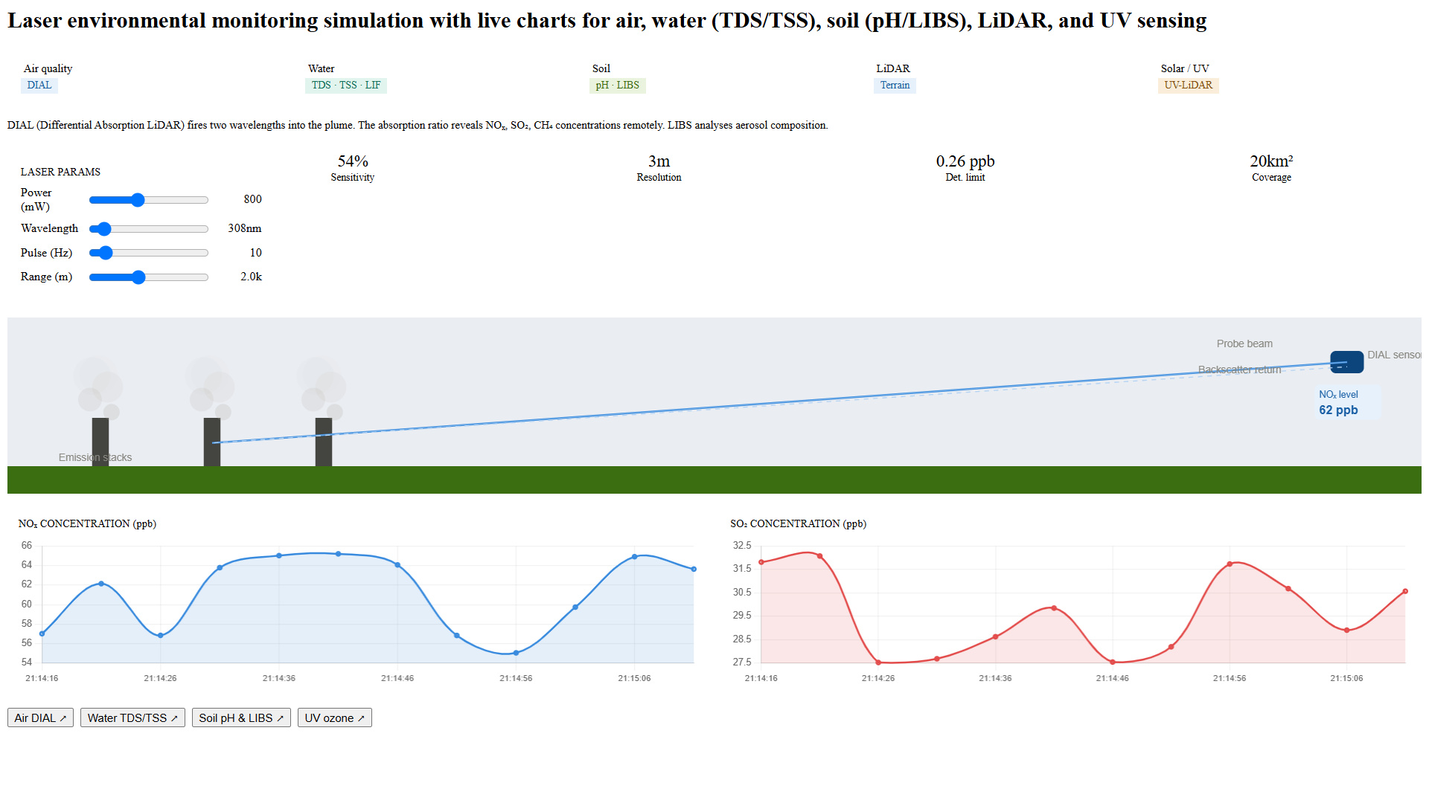

WATER QUALITY MONITORING
(Laser-Induced Fluorescence (LIF) and Raman Spectroscopy)
Introduction
Water is one of the most essential natural resources required for human survival, agriculture, industries, and ecosystem balance. However, due to industrial discharge, agricultural runoff, sewage disposal, and chemical contamination, water pollution has become a major environmental issue. Polluted water can contain harmful substances such as heavy metals, organic pollutants, microorganisms, algae, suspended solids, and dissolved impurities that affect both human health and aquatic ecosystems. Therefore, continuous monitoring of water quality is necessary to ensure safe drinking water and proper environmental management.
Traditional water testing methods usually involve collecting water samples and sending them to laboratories for analysis, which can be time-consuming and expensive. Laser-based monitoring systems provide a faster and more efficient alternative. In environmental engineering, Laser-Induced Fluorescence (LIF) and Raman Spectroscopy are advanced laser technologies used for detecting pollutants and studying water quality without directly touching the water body. These technologies provide accurate, real-time monitoring and are widely used in rivers, lakes, oceans, wastewater treatment plants, and drinking water systems.
LASER-INDUCED FLUORESCENCE (LIF)
Principle of LIF
The principle of Laser-Induced Fluorescence is based on the fluorescence property of substances. Certain contaminants present in water absorb laser energy and emit light of a different wavelength when excited by a laser beam.
In simple terms, when laser light strikes pollutants or biological materials present in water, those substances absorb energy and become excited. After a short time, they release this absorbed energy in the form of fluorescent light. By studying this emitted light, scientists can identify the type and concentration of contaminants present in water.
Different contaminants emit different fluorescence signals, making it easier to detect pollutants accurately. This principle is especially useful for identifying oil spills, algae growth, and organic pollutants in water bodies.
Working of LIF
The working of Laser-Induced Fluorescence involves several stages. Initially, a laser beam is directed toward the water sample or water body. When the laser interacts with contaminants such as algae, oil, or dissolved organic compounds, these substances absorb the laser energy.
After absorption, the contaminants become excited and emit fluorescent light. A detector or sensor collects this emitted light and sends the signal to a computer system. The computer analyzes the wavelength and intensity of fluorescence to determine the type and amount of pollutants present.
The working process can be summarized as:
- Laser beam directed into water
- Contaminants absorb laser energy
- Excitation of molecules occurs
- Fluorescent light is emitted
- Detector captures emitted light
- Computer analyzes contamination level
Applications of LIF
Laser-Induced Fluorescence has several environmental applications. It is widely used for:
- Detection of oil pollution in oceans and rivers
- Monitoring algae growth in lakes and reservoirs
- Identifying organic contaminants in drinking water
- Wastewater treatment monitoring
- Detection of biological pollutants in aquatic environments
LIF technology helps environmental agencies quickly identify pollution sources and take corrective action before severe contamination occurs.
Advantages of LIF
LIF technology offers many advantages in water quality monitoring.
- Non-contact monitoring: Water does not need to be physically sampled.
- Fast and real-time analysis: Results are obtained immediately.
- High sensitivity: Very small pollutant concentrations can be detected.
- Accurate identification: Different contaminants produce unique fluorescence patterns.
- Large area monitoring: Useful for lakes, rivers, and oceans.
These advantages make LIF highly useful in modern environmental monitoring systems.
Limitations of LIF
Despite its benefits, LIF also has some limitations. Certain contaminants may show similar fluorescence patterns, making identification difficult. Environmental conditions such as turbidity and suspended particles can interfere with laser performance. The system is expensive and requires specialized equipment and trained operators. Additionally, not all pollutants naturally fluoresce, limiting its effectiveness for some contaminants.

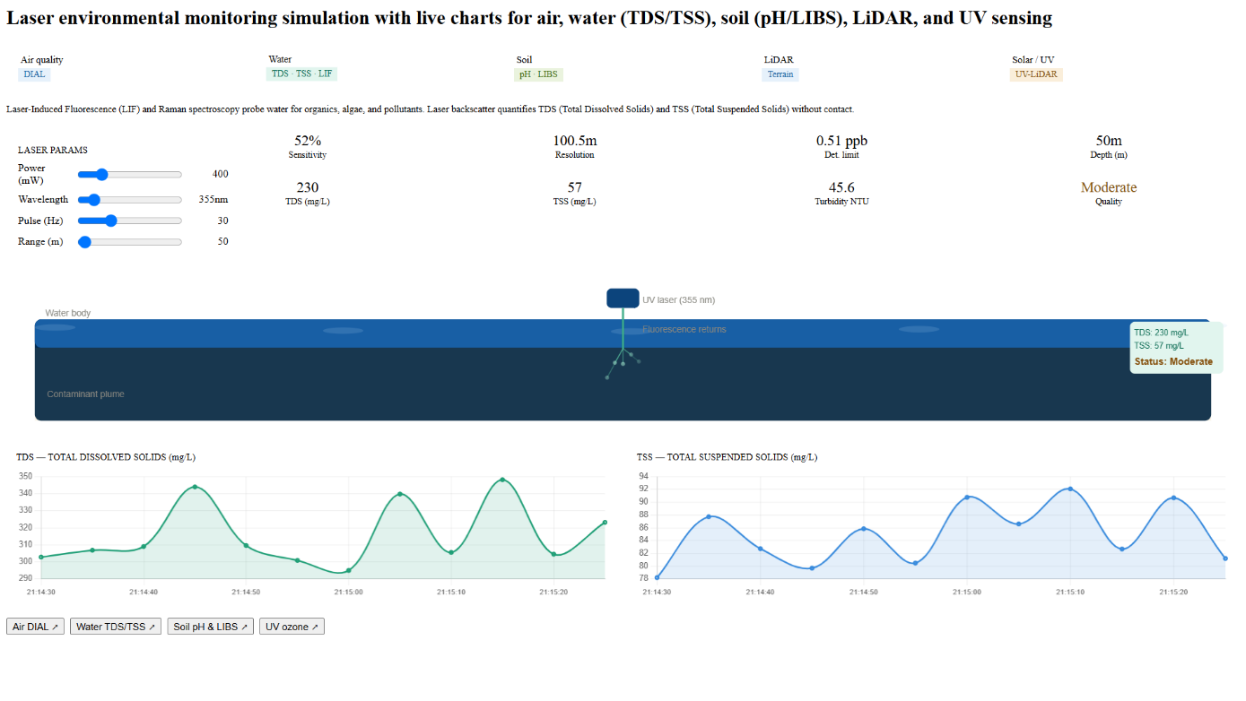
SOIL MONITORING – LIBS TECHNOLOGY
(Laser-Induced Breakdown Spectroscopy)
Introduction
Soil is one of the most important natural resources because it supports agriculture, vegetation growth, nutrient cycling, and ecosystem stability. The quality of soil directly affects agricultural productivity and environmental health. However, due to industrial waste disposal, excessive use of fertilizers, mining activities, pesticides, and urban pollution, soil contamination has become a major environmental concern. Harmful substances such as heavy metals, toxic chemicals, excess salts, and pollutants can reduce soil fertility and negatively affect crops, groundwater, and human health.
Traditionally, soil testing requires collecting samples and performing laboratory analysis, which can be time-consuming and expensive. In environmental engineering, advanced laser technologies are now used to make soil analysis faster and more efficient. One such important technique is Laser-Induced Breakdown Spectroscopy (LIBS). LIBS is a laser-based method that helps identify soil composition, nutrients, heavy metals, organic matter, and contamination levels quickly and accurately. It provides real-time analysis without requiring complicated sample preparation and is widely used in agriculture, mining, and environmental monitoring.
Principle of LIBS Technology
The principle of LIBS technology is based on the formation of plasma and emission spectroscopy. When a high-energy laser beam is focused on the soil surface, it heats a very small portion of the sample rapidly and creates an extremely hot plasma. Plasma is a state where atoms become excited and ionized due to high temperature.
As the excited atoms return to their normal energy state, they emit light at specific wavelengths. Each element present in the soil produces a unique light spectrum, known as an emission spectrum, which acts like a fingerprint. By analyzing this emitted light, scientists can identify which elements are present and determine their concentration in the soil.
This principle helps detect important components such as:
- Heavy metals (lead, cadmium, mercury)
- Nutrients (nitrogen, phosphorus, potassium)
- Organic carbon
- Soil minerals
- pH-related elements
Thus, LIBS technology helps environmental engineers understand soil quality and contamination accurately.
Working of LIBS Technology
The working of LIBS involves several stages. Initially, a high-energy laser pulse is directed onto the soil surface. The laser energy heats the sample rapidly and vaporizes a tiny amount of soil material.
Due to extremely high temperature, plasma is generated above the soil surface. This plasma contains excited atoms and ions from the soil sample. As these particles cool down, they release light of different wavelengths depending on the elements present.
A spectrometer collects the emitted light and sends the signal to a computer system for analysis. The computer compares the spectrum with standard reference data and identifies the soil composition and contamination level.
The working process can be summarized as:
- Laser pulse strikes soil surface
- Small amount of soil vaporizes
- Plasma formation occurs
- Excited atoms emit light
- Spectrometer detects emitted wavelengths
- Computer analyzes soil composition
Applications of LIBS Technology
LIBS technology has several important applications in environmental engineering and agriculture. It is widely used for soil contamination studies, especially to detect heavy metals and toxic substances. Farmers and agricultural experts use LIBS for soil nutrient analysis, helping improve crop productivity and fertilizer management.
The technology is also used in mineral exploration to identify valuable minerals present in land. Environmental agencies use LIBS to assess pollution caused by industrial waste and hazardous chemicals. Additionally, it helps study organic carbon content and soil fertility, which are important for sustainable agriculture.
Advantages of LIBS Technology
LIBS technology provides many advantages in soil monitoring.
- Rapid analysis: Results are obtained quickly.
- Minimal sample preparation: Soil can be analyzed directly.
- Real-time monitoring: Instant results are possible.
- Detection of multiple elements: Several contaminants can be identified simultaneously.
- Non-contact method: Physical handling is minimal.
- Portable systems available: Useful for field analysis.
These advantages make LIBS highly valuable in environmental engineering and precision agriculture.
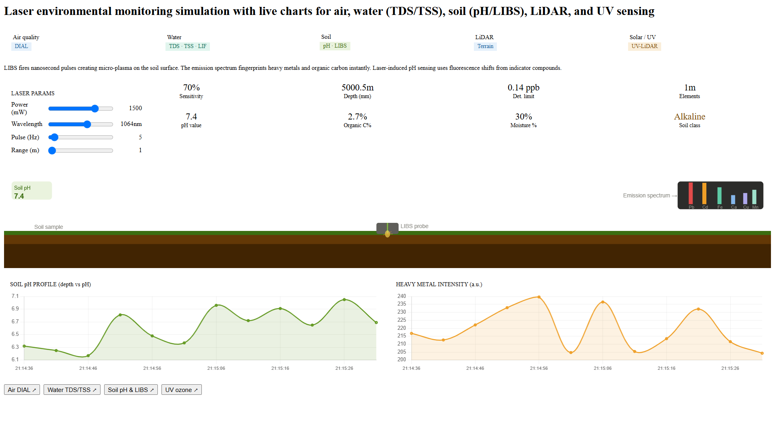
.

LiDAR FOR TERRAIN MAPPING
(Light Detection and Ranging)
Environmental engineers often need detailed information about land surface conditions for flood prediction, forest management, disaster planning, and land-use studies. Traditional surveying methods can be slow, expensive, and difficult in remote or inaccessible regions. To solve these problems, environmental engineers use Light Detection and Ranging (LiDAR) technology.
LiDAR is an advanced laser-based remote sensing technology used to create highly accurate three-dimensional (3D) maps of land surfaces. It helps measure elevation, terrain shape, vegetation structure, and land characteristics with high precision. LiDAR systems are commonly mounted on aircraft, drones, satellites, or vehicles to scan large areas quickly. This technology is highly useful in environmental engineering because it helps monitor forests, rivers, mountains, coastal regions, and disaster-prone areas efficiently.
Principle of LiDAR Technology
LiDAR works based on the principle of time-of-flight measurement. The system sends laser pulses toward the Earth’s surface and measures the time taken for the reflected laser signal to return.
The distance is calculated using the formula:
Distance = (Speed of Light × Time Taken) / 2
The division by 2 is necessary because the laser travels to the surface and then returns back.
By calculating millions of such distance measurements, LiDAR creates highly detailed 3D maps of terrain, vegetation, buildings, and environmental features. This principle allows accurate measurement of elevation and surface characteristics.
Working of LiDAR Technology
LiDAR systems continuously emit thousands of laser pulses toward the ground. These laser beams strike trees, buildings, water bodies, and land surfaces. After hitting the object, the light gets reflected back to the sensor.
A receiver records the time taken for each laser pulse to return. GPS and positioning systems are used to identify the exact location of each measurement point. The collected information is processed by computers to generate detailed 3D terrain maps.
The working process can be summarized as:
- Laser pulses are emitted
- Laser hits terrain/object
- Reflection occurs
- Sensor records return time
- GPS determines location
- Computer creates 3D map
Applications of LiDAR Technology
LiDAR technology is widely used in environmental engineering for:
- Forest monitoring and vegetation analysis
- Flood risk assessment
- Coastal erosion studies
- Disaster management planning
- River basin mapping
- Land elevation and topographic studies
- Urban planning and infrastructure development
It plays an important role in predicting floods and protecting ecosystems.
Advantages of LiDAR Technology
LiDAR offers many important advantages.
- Highly accurate terrain mapping
- Fast data collection over large areas
- Works in remote or inaccessible regions
- Provides detailed 3D visualization
- Useful for disaster management
- Reduces manual surveying effort
Because of these benefits, LiDAR is widely used in modern environmental engineering.
Limitations of LiDAR Technology
Despite its advantages, LiDAR has some limitations. The system is expensive to install and maintain. Dense vegetation, fog, rain, and atmospheric conditions can reduce accuracy. Data processing requires advanced computer software and skilled professionals.
Another limitation is that handling large amounts of LiDAR data can be difficult and time-consuming. Therefore, although highly accurate, LiDAR implementation may require significant investment and expertise.

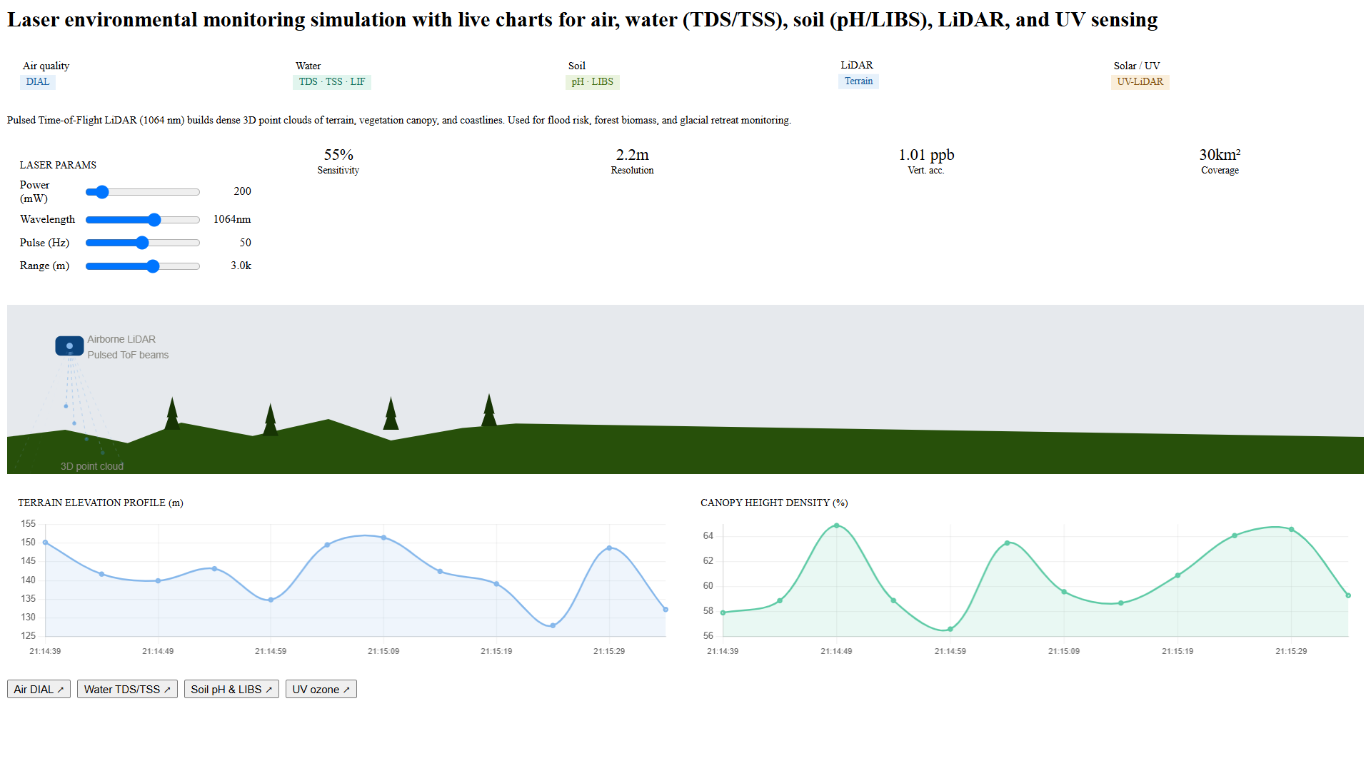

UV / SOLAR RADIATION MONITORING
(UV-LiDAR Systems)
Ultraviolet (UV) radiation from the sun plays an important role in maintaining life on Earth. However, excessive exposure to ultraviolet radiation can be harmful to humans, plants, animals, and ecosystems. Increased UV radiation due to ozone layer depletion may cause skin cancer, eye damage, reduced crop productivity, and environmental imbalance. In addition to UV radiation, atmospheric aerosols, dust particles, and ozone concentration also affect climate and air quality. Therefore, monitoring solar and ultraviolet radiation is very important in environmental engineering.
Traditional radiation monitoring methods often involve ground-based instruments that cover only limited areas. To overcome these limitations, advanced laser technologies such as UV-LiDAR systems are used. UV-LiDAR (Ultraviolet Light Detection and Ranging) is a laser-based remote sensing technology that helps monitor atmospheric aerosols, ozone concentration, pollution particles, and ultraviolet radiation levels from long distances. It provides accurate and real-time information for climate research, environmental studies, and public health monitoring.
Principle of UV-LiDAR Technology
The principle of UV-LiDAR is based on the scattering and absorption of ultraviolet laser light in the atmosphere. Different atmospheric particles and gases interact differently with UV laser beams. When ultraviolet laser light is transmitted into the atmosphere, gases such as ozone and tiny aerosol particles absorb or scatter part of the radiation.
By analyzing the scattered and absorbed signals, scientists can determine the concentration of atmospheric pollutants and the intensity of UV radiation. The amount of interaction between laser light and atmospheric particles helps estimate ozone levels, aerosol distribution, and environmental changes.
In simple terms:
- Higher absorption → Higher concentration of ozone or pollutants
- Lower absorption → Cleaner atmosphere or lower pollutant concentration
This principle helps environmental engineers continuously monitor atmospheric conditions and climate changes.
Working of UV-LiDAR Technology
The working of UV-LiDAR begins with the emission of ultraviolet laser pulses into the atmosphere. These laser beams travel through atmospheric layers and interact with ozone molecules, dust particles, aerosols, and pollutants.
Some part of the laser energy gets absorbed by atmospheric gases, while another portion is scattered back toward the sensor. A receiver collects the reflected signal and sends it to a computer for analysis. By studying the time taken for reflection and the amount of scattering or absorption, the system calculates radiation intensity and pollutant concentration.
The working process can be summarized as:
- UV laser beam is emitted
- Laser interacts with atmosphere
- Absorption and scattering occur
- Reflected signal returns to detector
- Data is analyzed by computer
- Radiation and pollution levels are calculated
Applications of UV-LiDAR Technology
UV-LiDAR has several important environmental applications. It is widely used for ozone layer monitoring, helping scientists study ozone depletion and atmospheric changes. It is also used for aerosol monitoring, where dust, smoke, and fine particles are detected in the atmosphere.
Another major application is climate change research, where scientists analyze atmospheric conditions affecting global warming. UV-LiDAR also helps in weather prediction, environmental pollution monitoring, and studying the harmful effects of ultraviolet radiation on ecosystems and human health. Additionally, it is used for monitoring forest fire smoke and industrial emissions.

Advantages of UV-LiDAR Technology
UV-LiDAR provides several important advantages in environmental monitoring.
- Remote monitoring capability: Large atmospheric areas can be monitored from a distance.
- Real-time monitoring: Instant environmental data can be collected.
- High accuracy: Helps measure ozone and aerosols precisely.
- Large area coverage: Suitable for regional and global studies.
- Useful for climate research: Helps understand environmental and atmospheric changes.
Because of these advantages, UV-LiDAR is an important tool for environmental engineers and climate scientists.
Limitations of UV-LiDAR Technology
Despite many advantages, UV-LiDAR also has limitations. The equipment is expensive to install and maintain. Atmospheric conditions such as fog, clouds, rain, and dust may interfere with laser signals and reduce measurement accuracy.
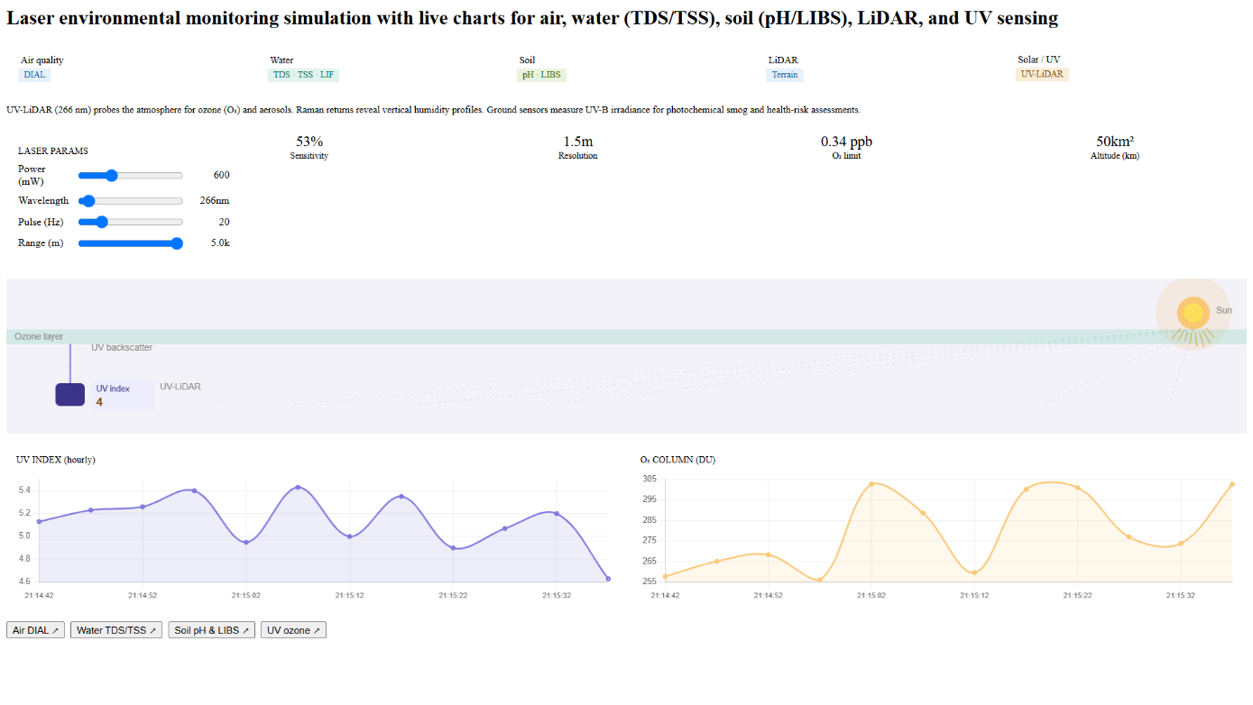
Another limitation is that UV-LiDAR systems require trained professionals for operation and data interpretation UV-LiDAR implementation may be limited by financial and technical challenges.

ADVANTAGES OF LASER ENVIRONMENTAL MONITORING
Laser-based environmental monitoring systems provide several important benefits compared to traditional monitoring methods. One of the major advantages is high accuracy. Laser systems can detect very small concentrations of pollutants and provide precise measurements, helping environmental engineers identify contamination early.
Another important advantage is non-contact monitoring. Environmental conditions can be analyzed remotely without directly touching harmful pollutants, toxic gases, or contaminated water and soil. This improves safety for workers and researchers.
Laser technologies also provide real-time monitoring, allowing immediate collection of environmental data. Unlike laboratory methods that may take several days, laser systems provide fast results, enabling quick environmental decision-making.
Some important advantages include:
- High precision and accuracy
- Remote and non-contact monitoring
- Fast and real-time results
- Large area coverage
- Early detection of pollution
- Reduced manual effort
- Supports disaster management
- Improves environmental protection strategies
Additionally, laser systems can monitor multiple environmental parameters simultaneously, making them highly efficient and suitable for sustainable environmental management.

LIMITATIONS OF LASER ENVIRONMENTAL MONITORING
Although laser technologies offer many advantages, they also have some common limitations. One of the major disadvantages is the high cost of equipment installation, operation, and maintenance. Many advanced laser systems require expensive instruments, software, and technical infrastructure.
Environmental conditions can also affect laser performance. Weather factors such as rain, fog, dust, smoke, and clouds may interfere with laser transmission, reducing measurement accuracy.
Other limitations include:
- Need for skilled professionals
- High energy consumption
- Regular maintenance and calibration required
- Complex data analysis
- High operational cost
Because of these limitations, laser-based monitoring systems may not always be suitable for smaller organizations or regions with limited resources. However, technological improvements are gradually reducing these challenges.
FUTURE SCOPE
The future scope of laser applications in environmental engineering is very promising. With rapid advancements in Artificial Intelligence (AI), remote sensing, drones, robotics, and smart sensors, laser technologies are becoming more efficient and intelligent.
Future developments may include:
- AI-integrated pollution monitoring systems
- Drone-based environmental laser surveys
- Advanced climate monitoring technologies
- Improved disaster prediction systems
- Smart urban environmental planning
- More affordable and portable laser devices
- As technology advances, laser systems will likely become more accurate, affordable, and widely available, helping achieve sustainable development and better environmental protection.
CONCLUSION
Laser applications in environmental engineering have revolutionized the way environmental monitoring is performed. These advanced technologies provide fast, accurate, and reliable methods for studying environmental conditions without direct physical contact. Unlike traditional methods, laser systems allow environmental engineers to collect real-time data and identify pollution at an early stage, helping reduce environmental damage and improve public safety.
Technologies such as DIAL, Laser-Induced Fluorescence (LIF), Raman Spectroscopy, LIBS, LiDAR, and UV-LiDAR have significantly improved the monitoring of air quality, water contamination, soil health, terrain mapping, and atmospheric radiation. These technologies provide high precision and help governments, industries, and researchers make informed environmental decisions. Their ability to monitor large geographical areas remotely has increased efficiency and reduced risks associated with hazardous environmental conditions.
Although laser systems have certain limitations such as high cost, weather dependency, and the need for skilled professionals, their advantages greatly outweigh these challenges. Continuous advancements in technology are gradually making these systems more efficient, portable, and cost-effective. Integration with AI, smart sensors, and remote sensing techniques will further improve their capabilities in the future.
In conclusion, laser technology plays a major role in environmental protection and sustainable development. It provides environmental engineers with powerful tools for pollution detection, climate monitoring, disaster management, and resource conservation. As environmental challenges continue to grow, laser applications will become increasingly important in ensuring a cleaner, healthier, and more sustainable future for society and the environment.

