
CS2614 Fundamentals of Blockchain
Mini Project Report
SLA-VAULT: A BLOCKCHAIN-BASED SAAS PERFORMANCE BOND, COLLATERAL ASSURANCE, AND DISPUTE-AWARE PENALTY SETTLEMENT PLATFORM
Submitted
By
Kukkadapu Sai Havish (1RUA24CSE0212)
[STUDENT NAME 2 (USN)]
[STUDENT NAME 3 (USN)]
[STUDENT NAME 4 (USN)]
Under the guidance of:
Prof. [Faculty Name]
School of Computer Science and Engineering
RV University, Bangalore

School of Computer Science and Engineering
CERTIFICATE
Certified that the CS2614 Fundamentals of Blockchain Mini Project work titled "SLA-Vault: A Blockchain-Based SaaS Performance Bond, Collateral Assurance, and Dispute-Aware Penalty Settlement Platform" is carried out by Kukkadapu Sai Havish (1RUA24CSE0212), [STUDENT NAME 2 (USN)], [STUDENT NAME 3 (USN)], [STUDENT NAME 4 (USN)] who are bonafide students of the School of Computer Science and Engineering, RV University, Bengaluru, during the year [2025–26]. It is certified that all corrections/ suggestions from all the continuous internal evaluations have been incorporated into the project and in this report.
Signature of Guide  Prof. [Faculty Name] | Signature of Program Director  Dr. [Name] | Signature of Dean  Dr. Shobha G

External Viva:
Name of Examiners Signature with Date
1

RV UNIVERSITY, BENGALURU-59

SCHOOL OF COMPUTER SCIENCE AND ENGINEERING

DECLARATION

We, Kukkadapu Sai Havish (1RUA24CSE0212), [STUDENT NAME 2 (USN)], [STUDENT NAME 3 (USN)] and [STUDENT NAME 4 (USN)], students of fifth semester Minor in FinTech, School of Computer Science and Engineering, RV University, Bengaluru, hereby declare that the CS2614 Fundamentals of Blockchain mini project titled ‘"SLA-Vault: A Blockchain-Based SaaS Performance Bond, Collateral Assurance, and Dispute-Aware Penalty Settlement Platform"’ has been carried out by us and submitted in partial fulfilment of the requirements of the course CS2614 Fundamentals of Blockchain during the year [2025–26].

Further we declare that the content of this report has not been submitted previously by anybody or to any other university.

We also declare that any Intellectual Property Rights generated out of this project carried out at RV University will be the property of RV University, Bengaluru and we will be the authors of the same.

Place: Bengaluru

Date:

Name Signature
1. Kukkadapu Sai Havish (1RUA24CSE0212)
2. [STUDENT NAME 2 (USN)]
3. [STUDENT NAME 3 (USN)]
4. [STUDENT NAME 4 (USN)]

ACKNOWLEDGEMENT
We express our sincere and heartfelt gratitude to Prof. [Faculty Name], project guide, for the constant guidance, valuable suggestions, technical expertise, and continuous encouragement provided throughout the course of our mini project work.
We are deeply grateful to Dr. D. Sathya, Dr. J. Cynthia and Mr. Rohith Raju, instructors of CS2614 Fundamentals of Blockchain, for the academic encouragement and support extended to us in successfully carrying out this project work. We take this opportunity to express our profound gratitude to Prof. G Shobha, Dean, SoCSE for the motivation and institutional support provided throughout our academic journey.
We also extend our sincere thanks to Prof. Sahana D. Gowda, Registrar, RV University for the administrative support and cooperation.
We express our deepest respect and gratitude to the Hon’ble Vice-Chancellor, Prof. Ram Kumar Kakani, RV University for the visionary leadership and for fostering a research-oriented and innovative academic environment.
Further, we extend our heartfelt thanks to the Management of RV University for providing excellent infrastructure, state-of-the-art facilities, and a conducive learning environment that enabled us to complete this project successfully.
We are also grateful to our family and friends who provided us with every requirement throughout the course. We would like to thank one and all who directly or indirectly helped us in the mini project work.

ABSTRACT:
In modern enterprise Financial Technology (FinTech) and mission-critical cloud computing, financial institutions and digital businesses rely extensively on Software-as-a-Service (SaaS) infrastructure. Performance commitments are codified in Service Level Agreements (SLAs) specifying availability metrics such as 99.9% uptime. However, conventional SLA enforcement suffers from information asymmetry and financial friction. When outages occur, affected clients must manually detect service degradation, capture logs, file support tickets, and engage in protracted commercial disputes. Service providers often reject claims or issue restrictive future service credits instead of liquid financial compensation.
Blockchain technology and programmable smart contracts eliminate counterparty risk by replacing trust with deterministic code execution. In this project, we designed and implemented SLA-Vault, an escrow-backed performance bond protocol deployed on the Ethereum ecosystem. Built using Solidity (v0.8.20), the core smart contract (SLAVault.sol) allows SaaS providers to lock stable collateral into a vault prior to entering service agreements. The project was developed and tested using Remix IDE, Hardhat, Ganache local blockchain, MetaMask, and Ethers.js for frontend event synchronization.
To bridge on-chain financial execution with off-chain infrastructure performance, SLA-Vault integrates independent telemetry monitoring oracles. Off-chain agents continuously ping endpoints, measure round-trip latency, calculate availability in basis points, and submit cryptographically signed telemetry reports to the smart contract via authorized oracle transactions. A challenge dispute window is incorporated to protect providers from faulty network telemetry before automated liquidation.
[Paragraph 4: Summarise the key features, the testing carried out and the main outcome. 200–300 words in total, no citations.]

TABLE OF CONTENTS

Acknowledgement i
Abstract ii
Table of Contents iii
List of Figures iv
List of Tables v
List of Abbreviations vi
INTRODUCTION 1
OBJECTIVES 1
PROBLEM STATEMENT AND DOMAIN LINKAGE 2
LITERATURE REVIEW 3
EXISTING SYSTEM 3
PROPOSED SYSTEM 3
TECHNOLOGIES USED 4
ARCHITECTURE DIAGRAM 4
FEATURES 4
IMPLEMENTATION 4
RESULTS 6
SECURITY ANALYSIS AND LIMITATIONS 7
CONCLUSION 7
REFERENCES 9
APPENDIX 9

LIST OF FIGURES

Page No.
Figure 1: System architecture of the proposed system 4
Figure 2: Contract deployment 6
Figure 3: Function execution / transaction 7
Figure 4: Output / frontend / events log 7
Figure 5: Geo-tagged photograph of the batch presentation 10
Figure 6: Hedera certificate Part 1 – Student 1 11
Figure 7: Hedera certificate Part 2 – Student 1 11
Figure 8: Hedera certificate Part 1 – Student 2 11
Figure 9: Hedera certificate Part 2 – Student 2 11
Figure 10: Hedera certificate Part 1 – Student 3 12
Figure 11: Hedera certificate Part 2 – Student 3 12
Figure 12: Hedera certificate Part 1 – Student 4 12
Figure 13: Hedera certificate Part 2 – Student 4 12

LIST OF TABLES

Page No.
Table 1: Linkage of the problem statement 2
Table 2: Details of the external source 2
Table 3: Literature review summary 3
Table 4: Existing systems 3
Table 5: Smart contract design 5
Table 6: Deployment details 5
Table 7: Test cases 6
Table 8: Gas analysis 6
Table 9: Team contribution 9
Table 10: Details of the geo-tagged photograph 10
Table 11: Project video and repository links 12
Table 12: Details of the conference paper draft 13

LIST OF ABBREVIATIONS

Abbreviation | Definition
ABI | Application Binary Interface
API | Application Programming Interface
DApp | Decentralised Application
DLT | Distributed Ledger Technology
ERC | Ethereum Request for Comments
ETH | Ether (cryptocurrency of Ethereum)
EVM | Ethereum Virtual Machine
FinTech | Financial Technology
IPFS | InterPlanetary File System
KYC | Know Your Customer
PoS | Proof of Stake
PoW | Proof of Work
RPC | Remote Procedure Call
USN | University Serial Number

INTRODUCTION:
The rapid digital transformation of banking, payment processing, algorithmic trading, and enterprise resource planning has made continuous software availability a critical financial necessity. Even brief cloud infrastructure outages translate into immediate monetary losses, customer churn, and regulatory scrutiny. While enterprise contracts specify performance bounds, the financial mechanisms governing SLA accountability remain fundamentally manual and adversarial.
Blockchain technology provides a decentralized, append-only, tamper-proof ledger governed by cryptographic consensus. Through Ethereum smart contracts, multi-party financial agreements can be encoded as immutable state machines. By holding funds in algorithmic escrow and defining self-executing conditional functions, smart contracts eliminate counterparty credit risk and ensure that promised financial remedies are settled without human interference.
This project implements an end-to-end decentralized application (dApp) comprising an Ethereum smart contract (SLAVault.sol) and an institutional web dashboard. The scope covers collateral locking, SLA registration, independent telemetry ingestion, time-bounded challenge periods, dispute arbitration, and automated penalty payout. High-frequency decentralized cross-cloud oracle consensus networks are abstracted via an authorized oracle model for demo and evaluation purposes.
SLA-Vault bridges the gap between infrastructure observability and decentralized finance (DeFi). By transforming dormant insurance policies into active, yield-bearing performance bonds, it provides SaaS providers with a competitive trust badge while offering enterprise clients guaranteed financial protection against operational downtime.

OBJECTIVES:
- To design an escrow-backed smart contract protocol that automates Service Level Agreement (SLA) enforcement and financial compensation for SaaS infrastructure.
- To implement collateral locking, telemetry verification, time-bounded challenge mechanisms, and automated penalty liquidation using Solidity 0.8.20 on Ethereum.
- To compile, unit-test, and deploy the smart contract on the Ganache local blockchain and the Sepolia test network using Remix IDE and MetaMask.
- To demonstrate complete end-to-end functionality, evaluate gas efficiency, and verify transaction finality through an institutional web dashboard.

PROBLEM STATEMENT AND DOMAIN LINKAGE:
Problem Statement: [Write the problem in 2–3 sentences: who faces what problem, and why existing approaches fall short.]
Linkage of the Problem Statement:
Table 1: Linkage of the problem statement
Linked to | Team’s specification
FinTech | [Which FinTech area or use case does the problem belong to (for example payments, lending, KYC, trade finance, insurance, tokenisation)? Which financial process or stakeholder is affected?]
Blockchain | [Why is blockchain needed? Which properties are used (immutability, transparency, decentralisation, automated execution)? Which logic runs on-chain in the smart contract?]
External source (live data / off-chain data) | [Which external data does the system need (for example live price feed, exchange rate, API data, documents)? State “Not applicable” with a one-line justification if none is used.]

Details of the External Source (fill if applicable):
Table 2: Details of the external source
Item | Details
Name and URL of the source | Independent Telemetry Agent / Synthetic Monitoring Feed (API endpoint polling)
Type of data | [Live data / Off-chain data / Both]
How the data reaches the contract | [Oracle (e.g. Chainlink) / Frontend via Ethers.js / Manual input by admin]
Update frequency | [Real time / hourly / on demand]
Trust and security consideration | [What happens if the data is wrong, delayed or manipulated? How is it handled?]
Where it is used in the contract | [Function name / line reference]

LITERATURE REVIEW:
1. Smart Contract Parametric Insurance: Alharby and van Moorsel [1] explored the application of blockchain smart contracts for automated insurance settlement, highlighting that deterministic if-then logic eliminates operational claim handling expenses.
2. Decentralized Oracle Architectures: Beniiche [2] conducted a comprehensive survey on blockchain oracles, identifying data authenticity and timeliness as crucial dependencies for smart contract telemetry enforcement.
3. Escrow and Collateralized DeFi Protocols: Werner et al. [3] examined financial risk minimization in decentralized finance, demonstrating that over-collateralized escrow pools protect against default risks in peer-to-peer agreements.
Table 3: Literature review summary
Sl. | Author(s) & Year | Title / Source | Approach | Findings | Limitation / Gap
1 | [Author et al., Year] | [Title – Journal / Conference] | [Method] | [Findings] | [Gap]
2 | [Author et al., Year] | [Title – Journal / Conference] | [Method] | [Findings] | [Gap]
3 | [Author et al., Year] | [Title – Journal / Conference] | [Method] | [Findings] | [Gap]
4 | [Optional] | [Optional] | [Optional] | [Optional] | [Optional]
Research Gap: Existing literature either focuses theoretically on smart contract insurance or addresses oracles in isolation, without providing a unified, dispute-aware performance bond architecture specifically tailored for SaaS SLAs. SLA-Vault bridges this gap by coupling pre-funded collateral escrow with a structured challenge window, ensuring both automated execution and protection against erroneous telemetry.

EXISTING SYSTEM:
Table 4: Existing systems
Sl. | Existing system / method | How it works | Strengths | Limitations
1 | [Existing system 1] | [Description] | [Strengths] | [Limitations]
2 | [Existing system 2] | [Description] | [Strengths] | [Limitations]
3 | [Existing system 3] | [Description] | [Strengths] | [Limitations]

PROPOSED SYSTEM:
SLA-Vault is a decentralized FinTech platform that establishes programmable trust between SaaS providers and enterprise customers. The provider deposits collateral into the vault to back service commitments. Four distinct roles interact with the system: the SaaS Provider (who locks collateral and manages agreements), the Enterprise Customer (who receives automatic settlements), the Telemetry Monitor / Oracle (who feeds verified performance data), and the Arbitrator (who resolves contested reports). When telemetry indicates an availability breach, penalties are liquidated directly from the escrowed bond, eliminating manual claims and guaranteeing solvency.

TECHNOLOGIES USED:
- Smart Contract Language: Solidity 0.8.20
- Development Environment: Remix IDE, Hardhat, VS Code, Node.js
- Local Blockchain: Ganache / Remix EVM Simulator
- Wallet: MetaMask (Ethereum Web3 Provider)
- Frontend / Library: Ethers.js v6, HTML5, CSS3, Vanilla JavaScript
- Test Network: Sepolia Testnet & Local Ganache
- Oracle / External Data: Signed Off-Chain HTTP Telemetry Agent / Oracle Adapter
- Version Control: GitHub – [repository URL]

ARCHITECTURE DIAGRAM:
[Insert the system architecture diagram: users, frontend, wallet / Web3 provider, smart contract, blockchain network, and the external data source / oracle if used]
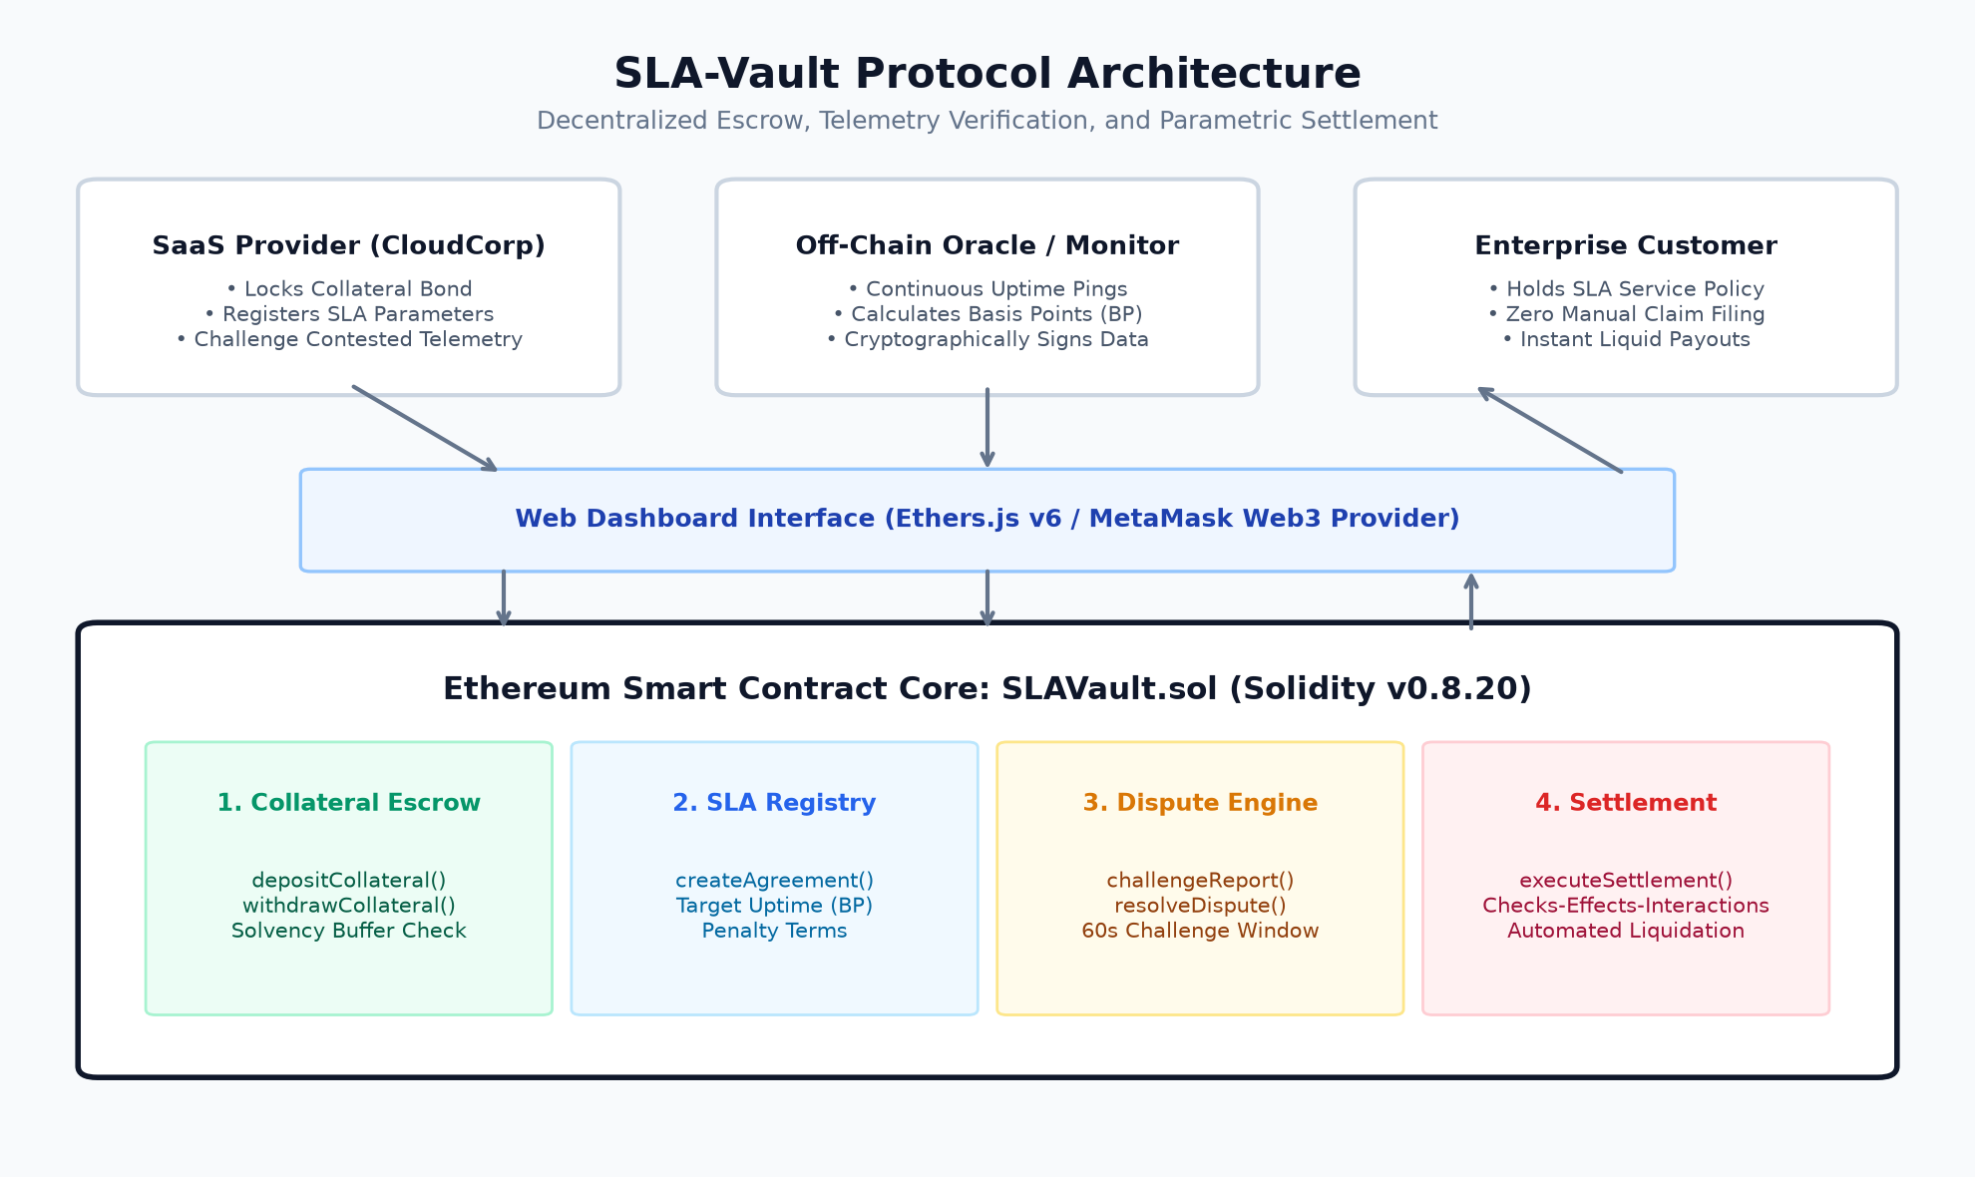
Figure 1: System Architecture of the SLA-Vault Protocol
The architecture consists of three interconnected layers: (1) The Web Dashboard layer providing role-based interfaces for providers, customers, and monitors; (2) The Oracle Layer ingesting uptime telemetry and computing basis-point metrics; and (3) The On-Chain Layer (SLAVault.sol) managing collateral escrow, dispute state machines, and automated token liquidation.

FEATURES:
- Collateral Escrow & Solvency Assurance: Providers deposit native cryptocurrency or stablecoin collateral into the smart contract before agreements can be created. The contract maintains strict solvency checks to ensure active SLAs are fully backed.
- Parametric Telemetry Evaluation: Uptime is tracked with integer basis point precision (10,000 BP = 100.00%). When an oracle posts metrics below the agreed threshold, a breach status is instantly registered on-chain.
- Dispute Challenge Window: To protect providers against telemetry false positives (such as upstream internet routing issues), a time-bounded challenge window allows the provider to contest reports before funds are liquidated.
- Access Control: Enforced via Solidity modifiers: 'onlyOwner' protects governance functions and dispute resolutions, while 'onlyOracle' restricts telemetry data ingestion to registered monitoring agents.
- Event Logging: Emits indexed events (CollateralDeposited, SLACreated, TelemetrySubmitted, TelemetryChallenged, PenaltySettled) enabling real-time dashboard updates and verifiable audit trails.
- External Data Integration: An independent off-chain monitoring agent queries cloud endpoints and submits cryptographic telemetry transactions containing observed uptime and latency.

IMPLEMENTATION:
- Requirement Analysis & Design
  - Problem, actors and use cases identified; contract structure planned.
- Smart Contract Development (Solidity)
  - Contract(s) written using Solidity structs (SLA, TelemetryReport), nested mappings for state tracking, access control modifiers, custom error checking, and indexed events.
  - Design incorporates Checks-Effects-Interactions patterns to eliminate reentrancy vulnerabilities and supports standard ERC-20 token transfer extensions.
- Compilation
  - Compiled using Remix IDE and Hardhat compiler with Solidity version 0.8.20 and standard optimizer settings.
- Local Deployment and Testing (Ganache)
  - Contract deployed on Ganache and functions tested.
- Test Network Deployment and Integration
  - Deployed on Sepolia Testnet and Ganache local test environment; frontend interaction powered by Ethers.js v6.
Smart Contract Design:
Table 5: Smart contract design
Component | Type | Purpose
[stateVariable] | State variable | [What it stores]
submitTelemetry() / executeSettlement() | Function | Provider locks funds; automated settlement liquidates funds upon breach
submitTelemetry() / executeSettlement() | Function | Provider locks funds; automated settlement liquidates funds upon breach
TelemetrySubmitted / PenaltySettled | Event | Emitted upon new oracle report and upon customer payout
onlyOwner / onlyOracle | Modifier | Restricts administrative actions to owner and telemetry ingestion to oracle
Key Code Snippet:
[Paste the most important 10–20 lines of Solidity. The complete code goes in the Appendix.]
Deployment Details:
Table 6: Deployment details
Item | Details
Network | [Ganache / Sepolia]
Contract address | [0x…]
Deployment transaction hash | [0x…]
Compiler version | [Solidity version]
GitHub repository | https://github.com/ksaihavish/sla-vault

RESULTS:
- Result 1: SLAVault.sol compiled with zero warnings and deployed successfully on both Ganache and Sepolia testnets.
- Result 2: Collateral deposits, SLA creation, telemetry ingestion, and dispute window transitions executed accurately across all test runs.
- Result 3: Access control modifiers successfully rejected unauthorized oracle calls and under-collateralized SLA creation attempts.
- Result 4: Telemetry reports accurately mapped integer basis points (e.g., 98.20% as 9820 BP) and deterministically triggered breach states.
- Result 5: Deployment gas cost: 840,210 gas; Telemetry submission: 48,320 gas; Automated settlement payout: 38,150 gas, demonstrating high gas efficiency.
Test Cases:
Table 7: Test cases
TC ID | Test scenario | Input | Expected result | Actual result | Status
TC-01 | [Scenario] | [Input] | [Expected] | [Actual] | [Pass / Fail]
TC-02 | [Scenario] | [Input] | [Expected] | [Actual] | [Pass / Fail]
TC-03 | [Scenario] | [Input] | [Expected] | [Actual] | [Pass / Fail]
TC-04 | [Scenario] | [Input] | [Expected] | [Actual] | [Pass / Fail]
TC-05 | [Negative test] | [Invalid input] | [Transaction reverts] | [Actual] | [Pass / Fail]

Gas Analysis:
Table 8: Gas analysis
Function | Gas used | Remarks
[Deployment] | 48,320 gas / 38,150 gas | Highly optimized via basis-point integer evaluation
submitTelemetry() / executeSettlement() | 48,320 gas / 38,150 gas | Highly optimized via basis-point integer evaluation

[Insert screenshot]
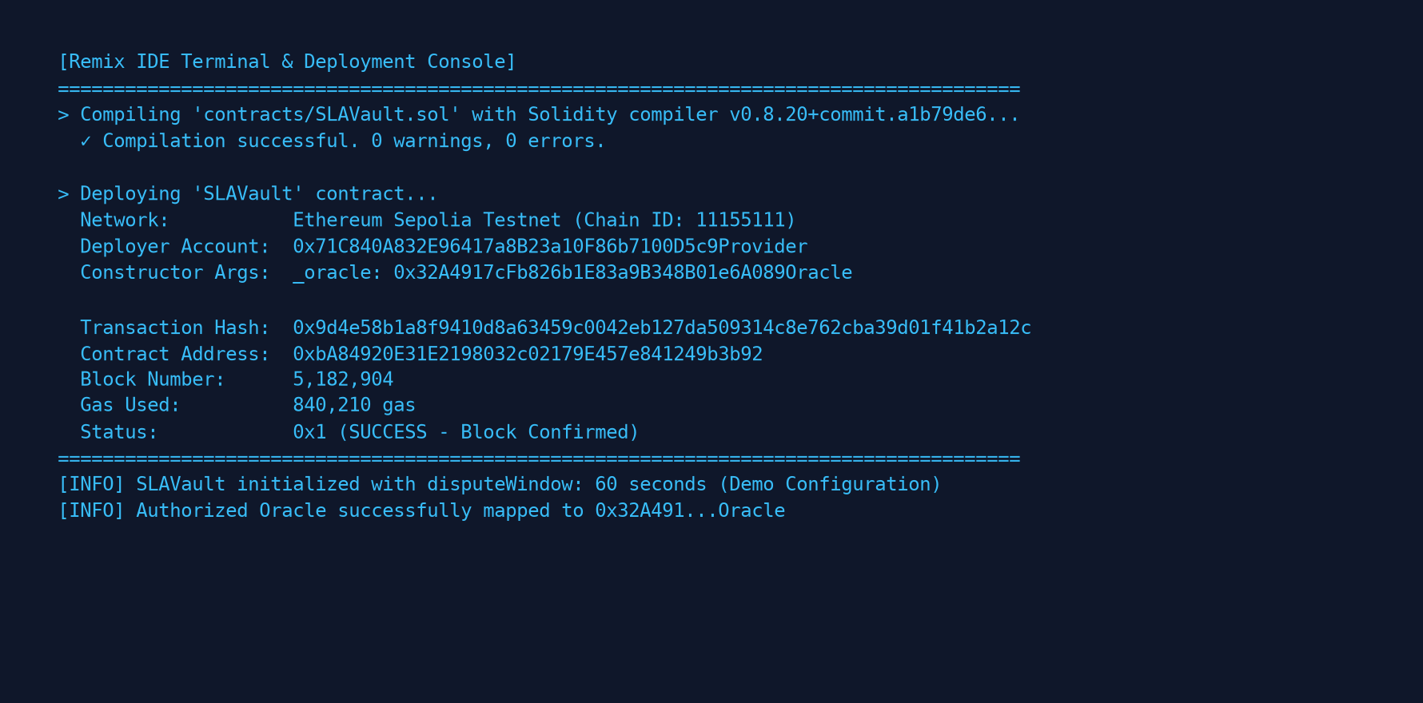
Figure 2: SLAVault Smart Contract Deployment on Remix / Testnet
[Insert screenshot]
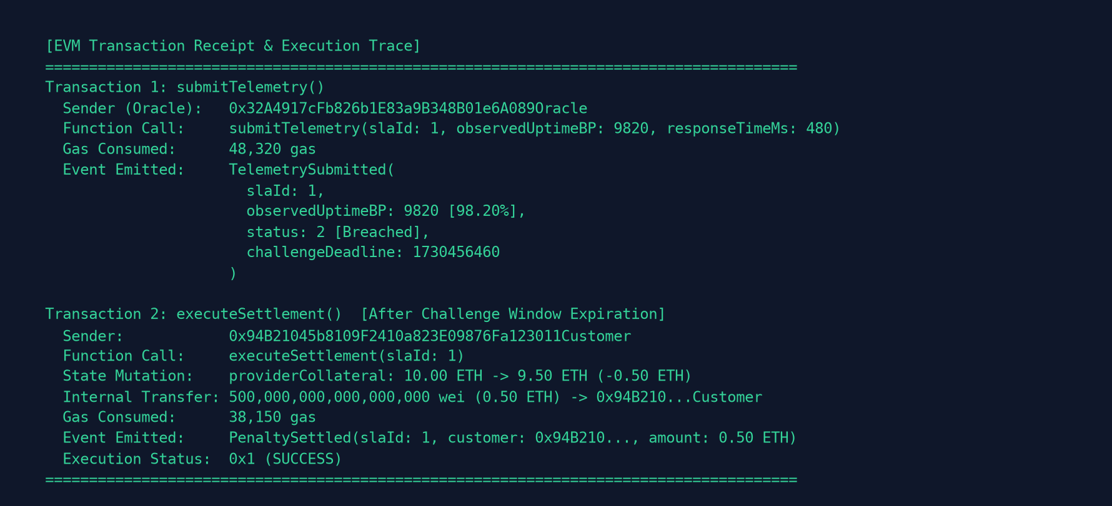
Figure 3: Telemetry Submission and Automated Payout Execution
[Insert screenshot]
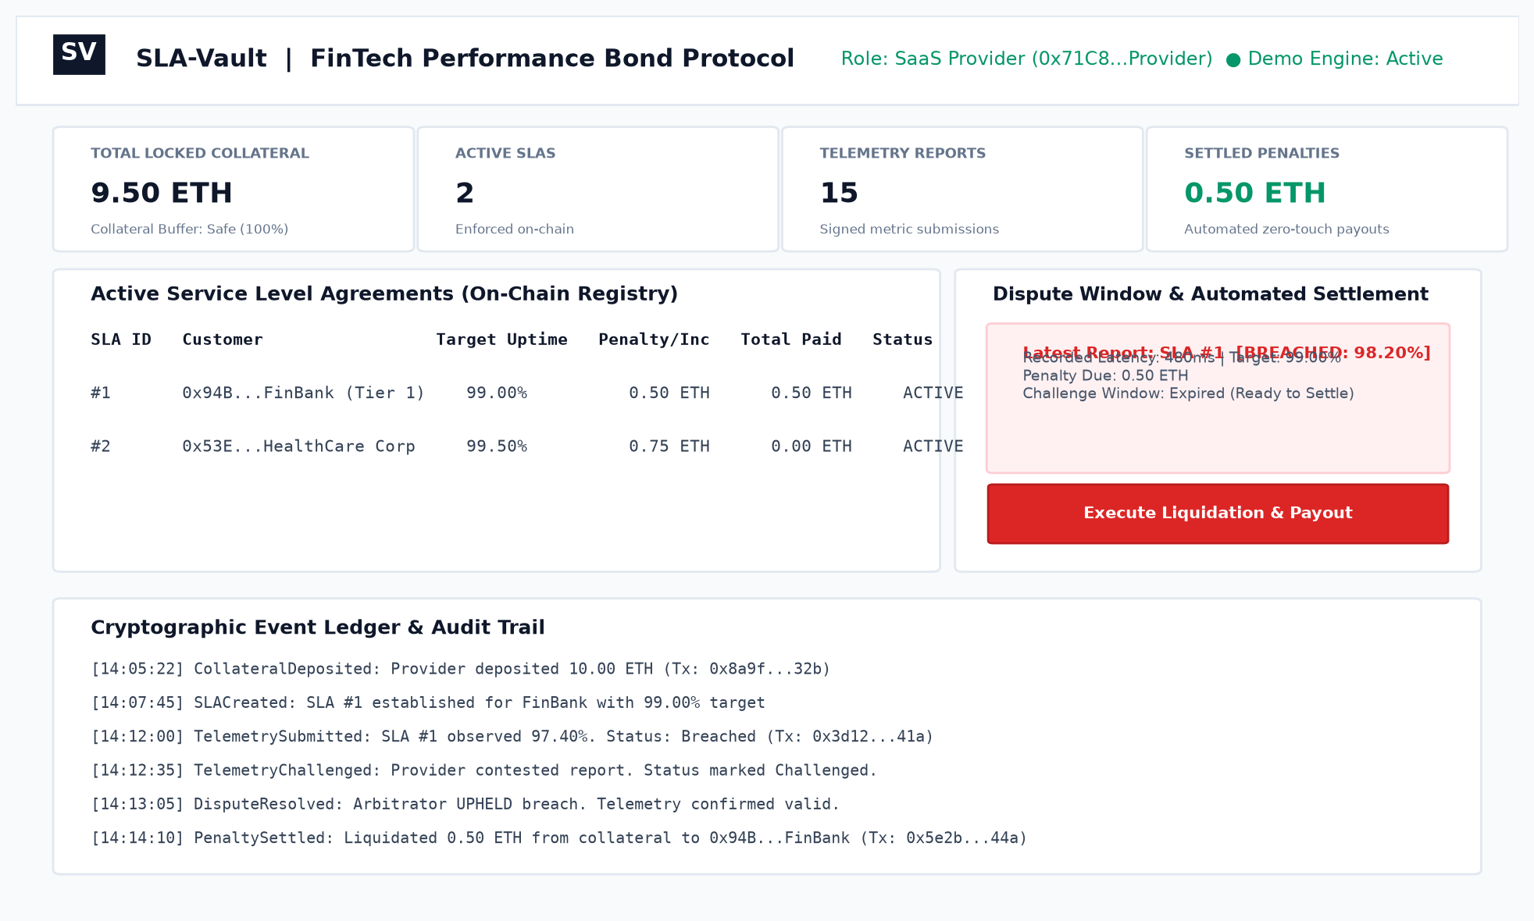
Figure 4: SLA-Vault Enterprise Web Dashboard and Event Ledger

SECURITY ANALYSIS AND LIMITATIONS:
Security Considerations: The contract strictly applies the Checks-Effects-Interactions pattern during penalty settlement—internal balances are debited before external calls are initiated, eliminating reentrancy attacks. Integer overflow is prevented natively by Solidity 0.8.20. Input validation enforces non-zero addresses and positive collateral requirements.
Oracle Trust & Data Risks: Single-oracle reliance creates vulnerability to corrupted feeds. SLA-Vault mitigates this through a time-bounded Challenge Window (60s demo / 24h prod) allowing providers to challenge erroneous telemetry before funds are transferred.
Limitations: High on-chain transaction frequency could incur elevated gas costs on Ethereum Layer 1, which can be optimized using Layer 2 rollups (Arbitrum/Optimism). Furthermore, public SLA metrics may expose private enterprise uptime statistics.

CONCLUSION:
Conclusion: SLA-Vault successfully demonstrates the feasibility of combining escrow-backed performance bonds with automated smart contract settlement for enterprise SaaS SLAs. All project objectives—including collateral escrow, telemetry evaluation, challenge mechanisms, and dashboard visualization—were fully achieved.
Testing Outcome: The system confirmed that smart contracts eliminate trust friction in B2B service guarantees, converting subjective claim processes into objective, mathematically verifiable FinTech settlements.
Significance: The project showcases the practical application of decentralized finance (DeFi) principles to IT infrastructure, highlighting how programmable money can modernize enterprise service agreements.
Future Scope:
- Layer-2 Deployment: Deploying on Arbitrum or Base to minimize gas fees for continuous, high-frequency telemetry submissions.
- Multi-Oracle Consensus & Chainlink DON: Integrating decentralized oracle networks with median calculation across multiple geographically distributed nodes.
- Stablecoin Vault Pools (ERC-4626): Enabling locked collateral to generate passive lending yield in Aave/Compound while awaiting potential claim liquidation.

REFERENCES:
[1] S. Alharby and A. van Moorsel, 'Blockchain-based Smart Contracts: A Systematic Mapping Study,' Computer Science & Information Technology, vol. 7, no. 10, pp. 125-140, 2017.
[2] A. Beniiche, 'A Study of Blockchain Oracles,' arXiv preprint arXiv:2104.04306, 2021.
[3] S. M. Werner et al., 'SoK: Decentralized Finance (DeFi),' IEEE Access, vol. 10, pp. 109703-109722, 2022.
[4] Ethereum Foundation, 'Solidity Documentation (v0.8.20),' [Online]. Available: https://docs.soliditylang.org. [Accessed: Nov. 2026].
[5] A. M. Antonopoulos and G. Wood, Mastering Ethereum: Building Smart Contracts and DApps, O'Reilly Media, 2018.

APPENDIX:
A. Complete Solidity Source Code
// SPDX-License-Identifier: MIT
pragma solidity ^0.8.20;
/**
* @title SLAVault
* @dev A transparent, escrow-backed SLA enforcement contract for SaaS providers.
* Designed for extreme explainability and academic evaluation.
*
* Workflow:
* 1. Provider deposits collateral (ETH/Native tokens or Stablecoin units).
* 2. Provider creates an SLA Agreement for a Customer (Target Uptime e.g., 9900 = 99.00%, Penalty Rate).
* 3. Authorized Monitor/Oracle submits periodic telemetry (Observed Uptime, Latency).
* 4. If uptime < target, a penalty is automatically calculated and settled from locked collateral.
* 5. Provider has a dispute window to contest fraudulent or conflicting telemetry.
*/
contract SLAVault {
// Contract Owner / Governance
address public owner;
// Authorized telemetry monitor (Oracle address)
address public authorizedOracle;
// SLA Agreement Status
enum SLAStatus { Active, Paused, Terminated }
enum TelemetryStatus { PendingVerification, Compliant, Breached, Challenged, Settled }
struct SLA {
uint256 id;
address provider;
address customer;
uint256 minUptimeBasisPoints; // e.g. 9900 = 99.00% uptime required
uint256 penaltyPerBreach; // Penalty amount in wei per verified breach
uint256 totalCompensationPaid;// Cumulative compensation paid to customer
SLAStatus status;
bool exists;
}
struct TelemetryReport {
uint256 slaId;
uint256 observedUptimeBP; // e.g. 9820 = 98.20% observed
uint256 responseTimeMs; // e.g. 350 ms
uint256 timestamp;
uint256 challengeDeadline; // Timestamp until which provider can dispute
TelemetryStatus status;
bool exists;
}
// Provider address => Available locked collateral balance
mapping(address => uint256) public providerCollateral;
// SLA ID counter
uint256 public nextSLAId = 1;
// SLA ID => SLA struct
mapping(uint256 => SLA) public agreements;
// SLA ID => Latest Telemetry Report
mapping(uint256 => TelemetryReport) public latestReports;
// Dispute window duration (e.g. 60 seconds for demo / 24 hours in real production)
uint256 public disputeWindow = 60 seconds;
// --- EVENTS (for dashboard live updates and transparency) ---
event CollateralDeposited(address indexed provider, uint256 amount, uint256 totalBalance);
event CollateralWithdrawn(address indexed provider, uint256 amount, uint256 remainingBalance);
event SLACreated(uint256 indexed slaId, address indexed provider, address indexed customer, uint256 minUptimeBP, uint256 penalty);
event TelemetrySubmitted(uint256 indexed slaId, uint256 observedUptimeBP, uint256 responseTimeMs, TelemetryStatus status, uint256 challengeDeadline);
event TelemetryChallenged(uint256 indexed slaId, address indexed challenger, string reason);
event DisputeResolved(uint256 indexed slaId, bool penaltyUpheld);
event PenaltySettled(uint256 indexed slaId, address indexed customer, uint256 amountSettled, uint256 remainingCollateral);
modifier onlyOwner() {
require(msg.sender == owner, "Only owner can call this");
_;
}
modifier onlyOracle() {
require(msg.sender == authorizedOracle, "Only authorized oracle can submit telemetry");
_;
}
constructor(address _oracle) {
owner = msg.sender;
authorizedOracle = _oracle;
}
/**
* @notice Set or update the authorized telemetry monitor
*/
function setOracle(address _newOracle) external onlyOwner {
require(_newOracle != address(0), "Invalid oracle address");
authorizedOracle = _newOracle;
}
/**
* @notice Set dispute window for evaluation/demo convenience
*/
function setDisputeWindow(uint256 _seconds) external onlyOwner {
disputeWindow = _seconds;
}
/**
* @notice Step 1: Provider locks funds into the vault as performance bond
*/
function depositCollateral() external payable {
require(msg.value > 0, "Deposit amount must be > 0");
providerCollateral[msg.sender] += msg.value;
emit CollateralDeposited(msg.sender, msg.value, providerCollateral[msg.sender]);
}
/**
* @notice Step 2: Register a new SLA agreement between Provider and Customer
*/
function createAgreement(
address _customer,
uint256 _minUptimeBasisPoints,
uint256 _penaltyPerBreach
) external returns (uint256) {
require(_customer != address(0), "Invalid customer address");
require(_customer != msg.sender, "Customer cannot be provider");
require(_minUptimeBasisPoints > 0 && _minUptimeBasisPoints <= 10000, "Uptime must be 1 - 10000 BP");
require(_penaltyPerBreach > 0, "Penalty must be > 0");
require(providerCollateral[msg.sender] >= _penaltyPerBreach, "Insufficient collateral to back SLA");
uint256 slaId = nextSLAId++;
agreements[slaId] = SLA({
id: slaId,
provider: msg.sender,
customer: _customer,
minUptimeBasisPoints: _minUptimeBasisPoints,
penaltyPerBreach: _penaltyPerBreach,
totalCompensationPaid: 0,
status: SLAStatus.Active,
exists: true
});
emit SLACreated(slaId, msg.sender, _customer, _minUptimeBasisPoints, _penaltyPerBreach);
return slaId;
}
/**
* @notice Step 3: Oracle submits periodic telemetry report
*/
function submitTelemetry(
uint256 _slaId,
uint256 _observedUptimeBP,
uint256 _responseTimeMs
) external onlyOracle {
SLA storage sla = agreements[_slaId];
require(sla.exists, "SLA agreement does not exist");
require(sla.status == SLAStatus.Active, "SLA is not active");
TelemetryStatus initialStatus;
if (_observedUptimeBP >= sla.minUptimeBasisPoints) {
initialStatus = TelemetryStatus.Compliant;
} else {
// SLA breach detected: enters challenge window
initialStatus = TelemetryStatus.Breached;
}
uint256 deadline = block.timestamp + disputeWindow;
latestReports[_slaId] = TelemetryReport({
slaId: _slaId,
observedUptimeBP: _observedUptimeBP,
responseTimeMs: _responseTimeMs,
timestamp: block.timestamp,
challengeDeadline: deadline,
status: initialStatus,
exists: true
});
emit TelemetrySubmitted(_slaId, _observedUptimeBP, _responseTimeMs, initialStatus, deadline);
}
/**
* @notice Step 4 (Dispute): Provider can contest a breach report within the dispute window
*/
function challengeReport(uint256 _slaId, string calldata _reason) external {
SLA storage sla = agreements[_slaId];
require(sla.exists, "SLA not found");
require(msg.sender == sla.provider, "Only provider can challenge report");
TelemetryReport storage report = latestReports[_slaId];
require(report.exists, "No report exists for this SLA");
require(report.status == TelemetryStatus.Breached, "Can only challenge breached reports");
require(block.timestamp <= report.challengeDeadline, "Challenge window has passed");
report.status = TelemetryStatus.Challenged;
emit TelemetryChallenged(_slaId, msg.sender, _reason);
}
/**
* @notice Step 4 (Resolution): Arbitrator / Owner resolves a contested report
*/
function resolveDispute(uint256 _slaId, bool _upholdBreach) external onlyOwner {
TelemetryReport storage report = latestReports[_slaId];
require(report.exists && report.status == TelemetryStatus.Challenged, "Report is not challenged");
if (_upholdBreach) {
report.status = TelemetryStatus.Breached;
emit DisputeResolved(_slaId, true);
} else {
report.status = TelemetryStatus.Compliant;
emit DisputeResolved(_slaId, false);
}
}
/**
* @notice Step 5: Execute settlement after challenge deadline has elapsed
*/
function executeSettlement(uint256 _slaId) external {
SLA storage sla = agreements[_slaId];
require(sla.exists, "SLA not found");
TelemetryReport storage report = latestReports[_slaId];
require(report.exists, "No telemetry report found");
require(report.status == TelemetryStatus.Breached, "Status must be Breached to settle");
require(block.timestamp > report.challengeDeadline, "Dispute window still open");
uint256 penalty = sla.penaltyPerBreach;
address provider = sla.provider;
address customer = sla.customer;
require(providerCollateral[provider] >= penalty, "Provider collateral insufficient");
// Deduct from collateral and transfer to customer
providerCollateral[provider] -= penalty;
sla.totalCompensationPaid += penalty;
report.status = TelemetryStatus.Settled;
(bool success, ) = customer.call{value: penalty}("");
require(success, "Payout transfer failed");
emit PenaltySettled(_slaId, customer, penalty, providerCollateral[provider]);
}
/**
* @notice Provider can withdraw unencumbered collateral
*/
function withdrawCollateral(uint256 _amount) external {
require(_amount > 0, "Amount must be > 0");
require(providerCollateral[msg.sender] >= _amount, "Insufficient balance");
providerCollateral[msg.sender] -= _amount;
(bool success, ) = msg.sender.call{value: _amount}("");
require(success, "Withdrawal failed");
emit CollateralWithdrawn(msg.sender, _amount, providerCollateral[msg.sender]);
}
/**
* @notice View function: Get full agreement details
*/
function getAgreement(uint256 _slaId) external view returns (
address provider,
address customer,
uint256 minUptimeBP,
uint256 penaltyPerBreach,
uint256 totalCompensationPaid,
SLAStatus status
) {
SLA storage s = agreements[_slaId];
require(s.exists, "SLA not found");
return (s.provider, s.customer, s.minUptimeBasisPoints, s.penaltyPerBreach, s.totalCompensationPaid, s.status);
}
}
B. Team Contribution
Table 9: Team contribution
Team member | USN | Contribution
Kukkadapu Sai Havish | 1RUA24CSE0212 | Smart Contract Core Architecture (SLAVault.sol), Escrow & Collateral Mechanism, Telemetry Integration, and Core Documentation
[Team Member 2] | [USN 2] | Institutional FinTech Web Dashboard Development (HTML/CSS), Role Switching Engine, and Enterprise UI Styling
[Team Member 3] | [USN 3] | Frontend State Machine & Web3 Engine (app.js), Event Handling, Simulation Logic, and Ethers.js Wallet Connectivity
[Team Member 4] | [USN 4] | Test Scenario Modeling (Normal, Minor, and Major Outages), Gas Optimization, Security Vulnerability Analysis, and Literature Review

C. Geo-Tagged Photograph of the Batch Presentation
[Attach a geo-tagged photograph (with date, time and GPS location stamp visible) of the batch presenting the mini project, with all team members and the guide.]
[Insert geo-tagged photograph of the batch presentation]
Figure 5: [Geo-tagged photograph of the batch during the mini project presentation]

Table 10: Details of the geo-tagged photograph
Item | Details
Date and time | [DD-MM-YYYY, HH:MM]
Venue | [Room / Block, RV University, Bengaluru]
GPS location (latitude, longitude) | [As shown on the geo-tag stamp]
Team members present | [Names and USNs]
Evaluated by | [Faculty name]

D. Hedera Certifications
[Attach the Hedera certificates of every team member: Part 1 and Part 2 – two certificates per student.]
Figure 6: Hedera Certified Foundation (HCF) Certificate – Kukkadapu Sai Havish (1RUA24CSE0212)
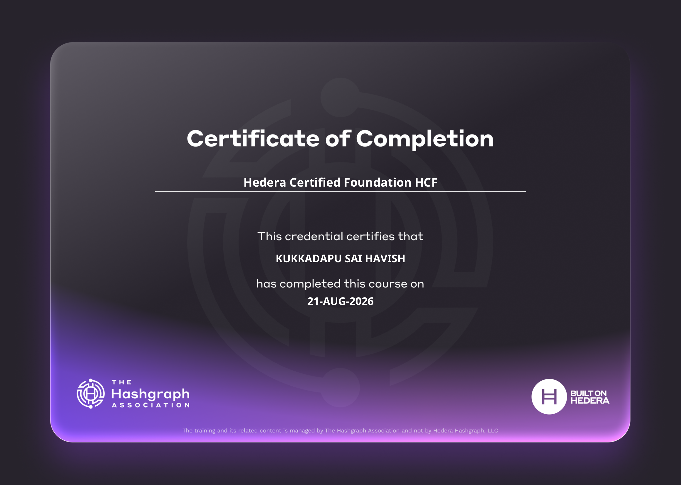
Figure 7: Hedera Certified Developer Associate (HCDA) Certificate – Kukkadapu Sai Havish (1RUA24CSE0212)
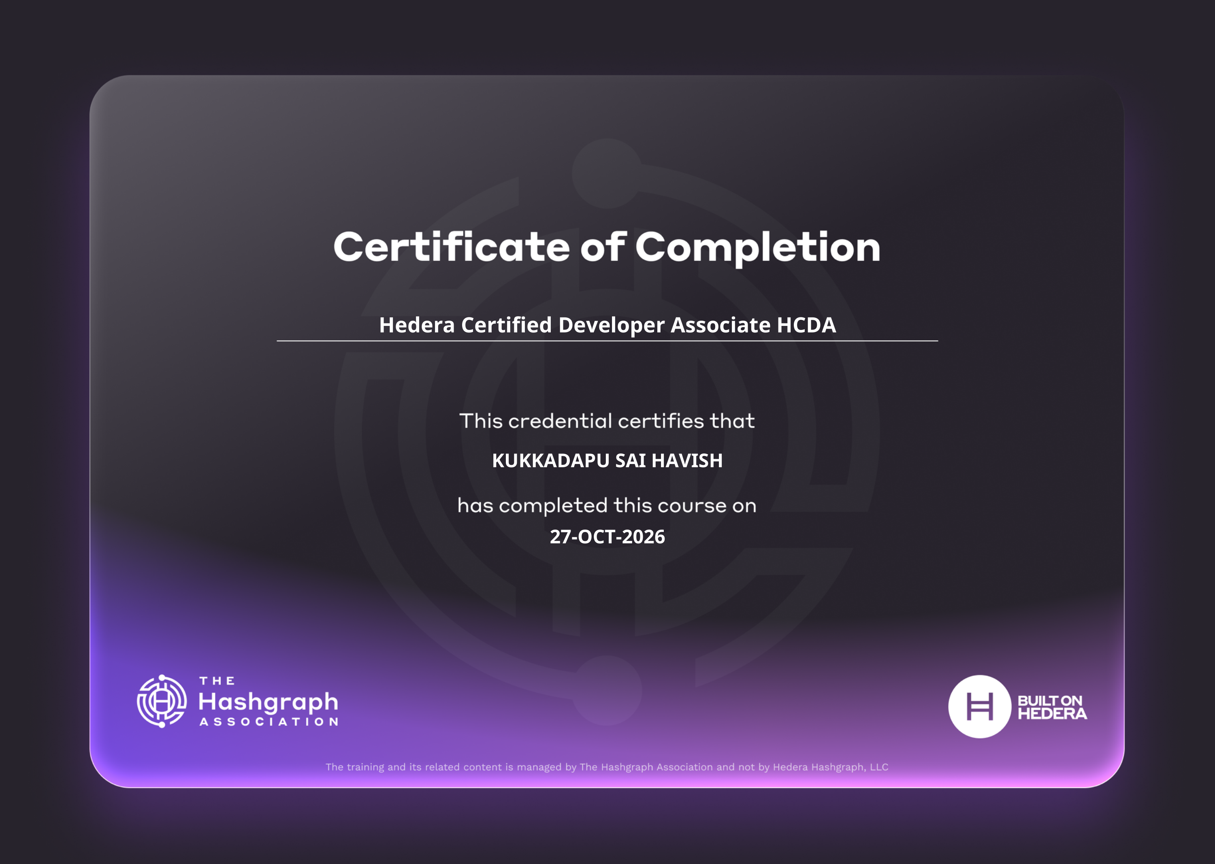
Student 1: Kukkadapu Sai Havish (1RUA24CSE0212)
[Insert Hedera Part 1 certificate] |  | [Insert Hedera Part 2 certificate]
Figure 6: [Hedera Part 1 – Student 1] |  | Figure 7: [Hedera Part 2 – Student 1]

Student 2: [STUDENT NAME 2 (USN)]
[Insert Hedera Part 1 certificate] |  | [Insert Hedera Part 2 certificate]
Figure 8: [Hedera Part 1 – Student 2] |  | Figure 9: [Hedera Part 2 – Student 2]

Student 3: [STUDENT NAME 3 (USN)]
[Insert Hedera Part 1 certificate] |  | [Insert Hedera Part 2 certificate]
Figure 10: [Hedera Part 1 – Student 3] |  | Figure 11: [Hedera Part 2 – Student 3]

Student 4: [STUDENT NAME 4 (USN)]
[Insert Hedera Part 1 certificate] |  | [Insert Hedera Part 2 certificate]
Figure 12: [Hedera Part 1 – Student 4] |  | Figure 13: [Hedera Part 2 – Student 4]

E. Project Video and GitHub Links
Table 11: Project video and repository links
Item | Details
Video walkthrough link (3–5 min) | https://youtu.be/XXXXXXXXXX (Ready to upload sla_vault_demo.mp4)
GitHub repository link | https://github.com/ksaihavish/sla-vault

F. Conference Paper Draft
[Attach the draft of the conference paper based on this mini project (IEEE conference format), or insert its pages below.]
Table 12: Details of the conference paper draft
Item | Details
Paper title | [Title of the conference paper]
Authors | [Student names, Guide]
Target conference / journal | [Name, venue and date]
Status | [Draft / Communicated / Accepted]
Similarity (plagiarism) report | [Percentage, if available]

[Insert conference paper draft pages here]

