Procedural Programming
Definition:
Procedural programming is a programming paradigm (style of programming) that is based on functions, procedures, or routines. The program is divided into small parts (procedures), and each procedure performs a specific task.

Key Points
- Step-by-step approach – Instructions are executed in the order they are written.
- Uses functions/procedures – Code is organized into reusable blocks (functions).
- Data and functions are separate – Data is usually passed into functions as arguments.
- Focus on actions – The main focus is on what to do and how to do it.
- Example languages – C, Pascal, Fortran, BASIC, etc. (Python also supports it).

Advantages
- Simple and easy to understand.
- Code reusability through functions.
- Good for small and medium-sized programs.

Limitations
- Not suitable for very large projects (code becomes complex).
- Harder to manage and maintain compared to OOP.
- Data security is less (data and functions are not bundled together).

Example
# Procedural Programming Example
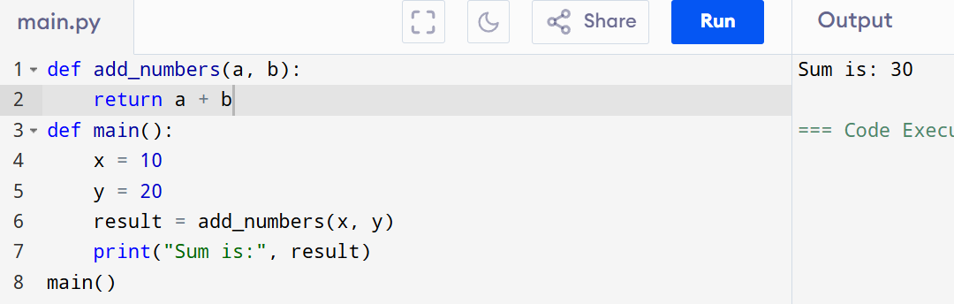

Object-Oriented Programming (OOPs)
Definition:
Object-Oriented Programming (OOPs) is a programming paradigm that is based on the concept of objects.
- An object represents a real-world entity (like a car, student, bank account).
- Objects combine data (attributes/variables) and behaviour (methods/functions) into a single unit.
- OOP focuses on “what objects are” rather than just “what steps to perform” (like in procedural programming).

Advantages of OOPs
- Modularity
  - Code is organized into classes and objects, making it cleaner and easier to understand.
- Reusability
  - Once a class is written, it can be reused in other programs without rewriting.
- Encapsulation (Data Hiding)
  - Data and methods are bundled together, preventing direct access to sensitive information.
- Inheritance
  - New classes can be created by reusing existing classes, reducing redundancy.
- Polymorphism
  - Same function/method name can behave differently depending on the object (increases flexibility).
- Easier Maintenance
  - If a change is required, it can be done in one place (class), and it reflects everywhere.
- Real-World Mapping
  - Programs can be designed to mimic real-world entities, making problem-solving more natural.

Basic definitions
1. Class
A class is a blueprint/template to create objects.
It defines variables (data) and methods (functions) that describe the behaviour of the object.

2. Object
An object is an instance of a class.
It represents a real-world entity.

3. Method
A method is a function defined inside a class that describes the behavior of an object.

4. Variable
variables are used to store the state/data of an object. These are usually defined inside a class.
also called attributes or fields

5. Constructor (__init__)
A constructor is a special method in Python (__init__) that is automatically called when an object is created.
It is used to initialize object variables.

6.self:
- self is a reference to the current instance of the class.
- It is used to access instance variables and methods inside the class.

Example (Python OOPs)
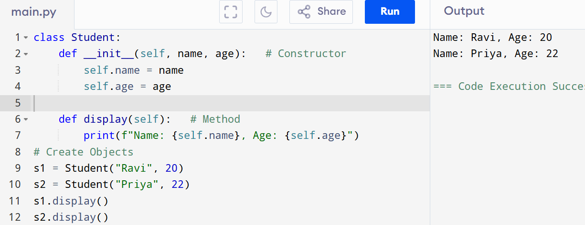

Here:
- Student is a class.
- s1, s2 are objects.
- name, age are attributes.
- display() is a method.

Class and Object
Class
- A class is a blueprint or template for creating objects.
- It defines attributes (variables) and methods (functions) that objects of the class will have.
- Example: A Car class may define attributes like colour, brand, and methods like drive(), stop().

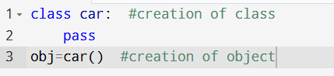

Object
- An object is an instance of a class.
- It is a real entity created from the class blueprint.
- Example: A red Honda car or a blue BMW car are objects of the Car class.
Note: We can create multiple objects for a single class

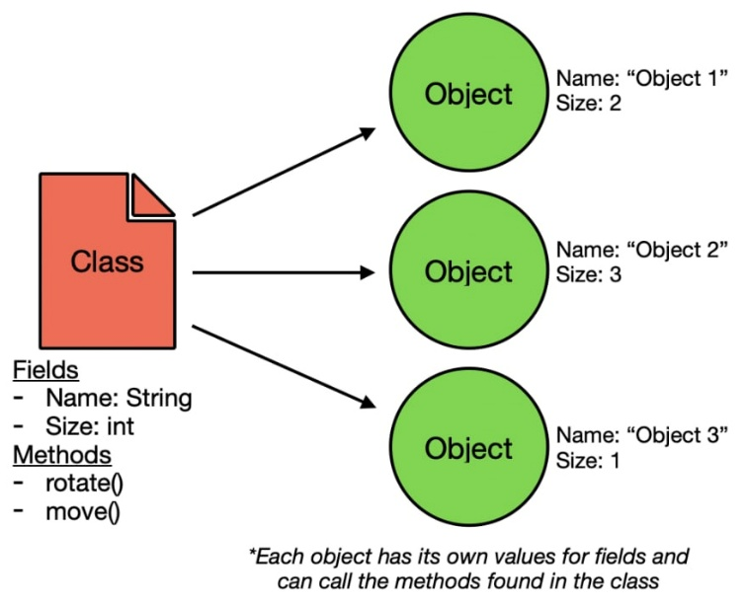

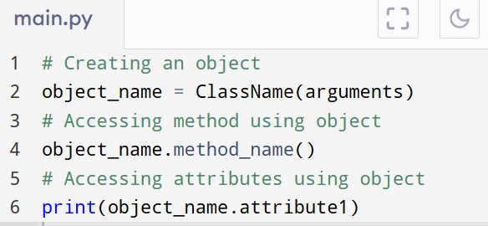
SYNTAX:

Syntax of Class and Object
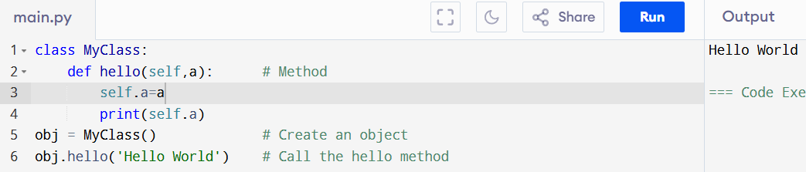

Constructor in Python

- A constructor is a special method in a class that is automatically called when an object is created.
- In Python, the constructor method is always named __init__().
- Its main job is to initialize (assign values to) object attributes.

Key Points
- __init__() runs automatically whenever an object is created.
- self refers to the current object.
- Constructors make object initialization easy and efficient.

Why use a Constructor?
- To set initial values of attributes when an object is created.
- To avoid writing extra method calls just to assign values.
- To make object creation faster and cleaner.

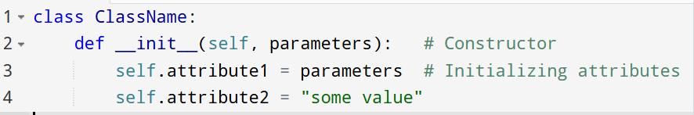
SYNTAX:

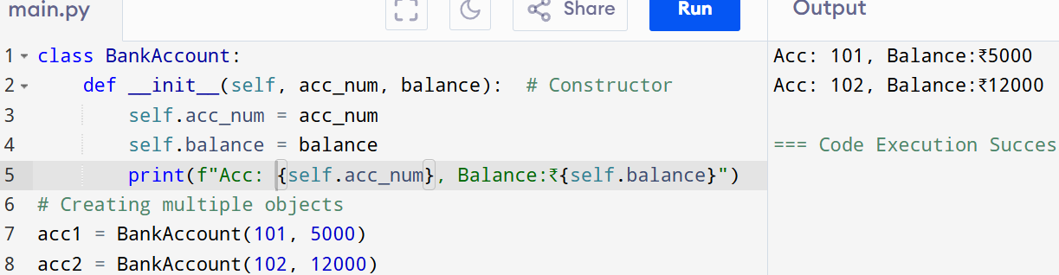
Example:

Types of Constructors in Python
In Python, we mainly use two types of constructors:
- Default Constructor
- Parameterized Constructor

1. Default Constructor
- A constructor that does not take any arguments (except self).
- It simply initializes the object with fixed values.
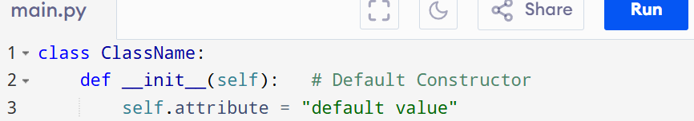
SYNTAX

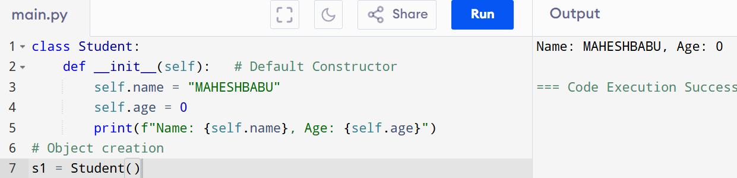
Example

2. Parameterized Constructor
- A constructor that takes arguments from the user while creating an object.
- It initializes the object with different values.

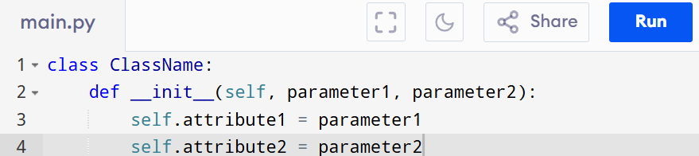
SYNTAX:

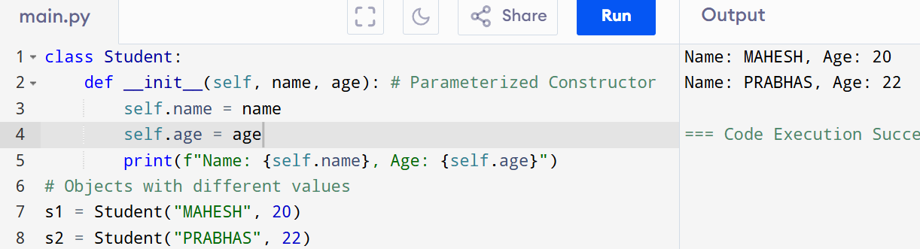
Example

Parent Constructor Calling
- In inheritance, the child class constructor (__init__) does not automatically call the parent class constructor.
- If you want the parent’s constructor logic to run, you must explicitly call it.

Ways to Call Parent Constructor
- Using Parent Class Name
- Using super() (Recommended)

Using Parent Class Name
Syntax:
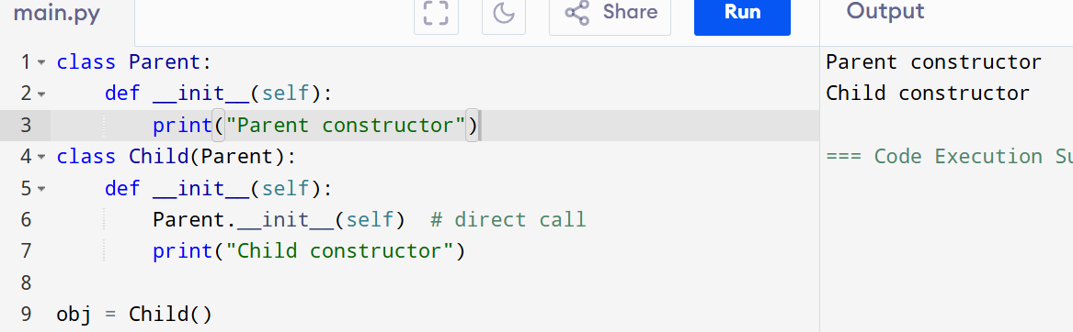
>>>parentclass_name.__init__(self)

Using super() (Recommended)
Syntax:
>>>super().__init__()
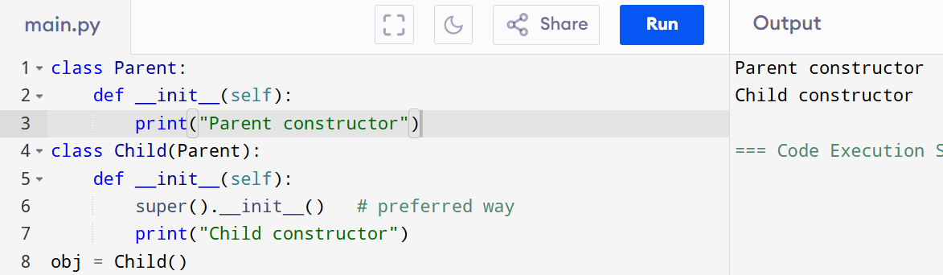

Why is it Important:
- Ensures parent properties/variables are initialized.
- Helps in code reuse.
- Works well with multiple inheritance because super() follows MRO.

TYPES OF VARIABLES in OOP

- Instance variables – Belong to an object (different for each object)
- Class variables/Static Variable – Shared among all instances of the class

Instance Variables
Definition:
Instance variables are variables that belong to a specific object (instance) of a class.
They store the state/data of each individual object separately.

Key Points:
- Defined inside the constructor (__init__) or other instance methods using self.
- Each object has its own copy of instance variables.
- Changing one object’s instance variable does not affect another object.

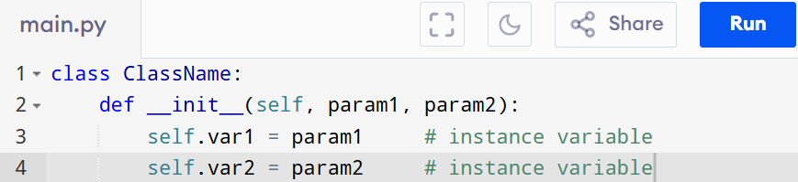
SYNTAX:

Example :
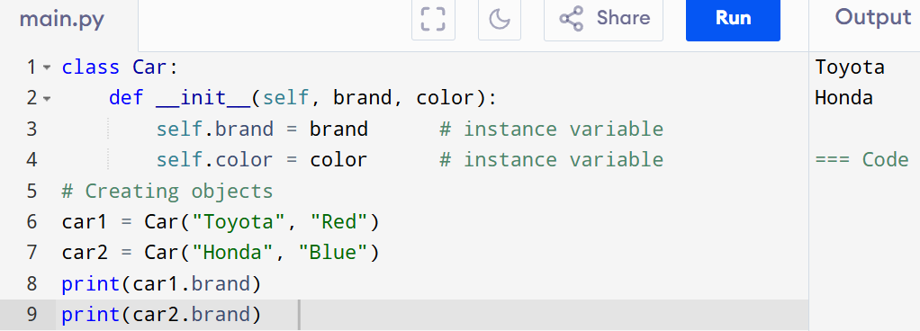
Here:
- brand and colour are instance variables.
- car1 and car2 have different values for these variables.

Feature | Instance Variable
Belongs to | Individual object (instance)
Defined using | self.variable_name
Scope | Exists as long as the object exists
Example | self.name, self.age in a class

Class Variable
Definition:
A class variable is a variable that is shared by all instances of a class.
It is defined inside the class, but outside any instance methods (like __init__).

Key Features:
- Belongs to the class, not to any specific object.
- All objects share the same value (unless overridden).
- Used for common data shared across instances.

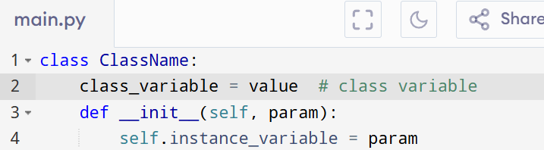
Syntax:

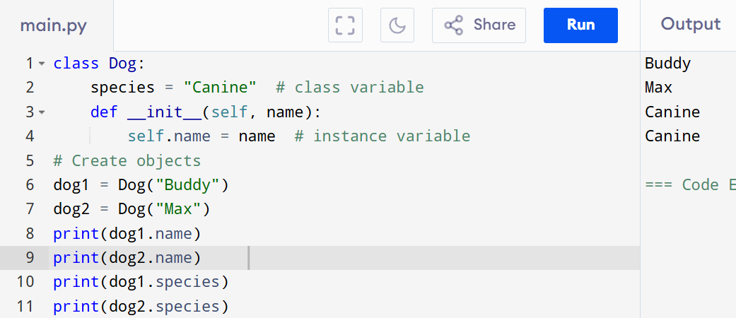
Example:

Calling the Class Variable:
SYNTAX:
>>>class_name.variable_name

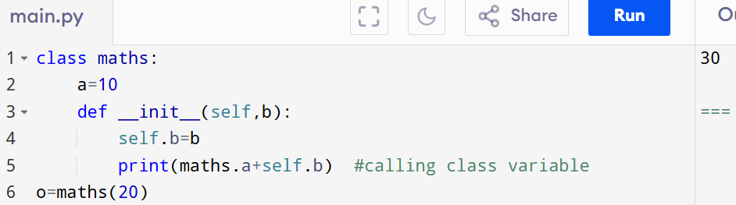
Feature | Class Variable
Belongs to | The class, not individual objects
Shared by | All instances of the class
Defined using | Directly inside class (not in methods)
Accessed by | ClassName.var or object.var

Example:
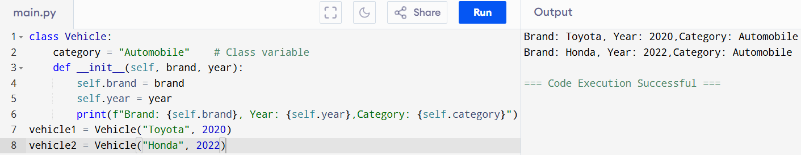

TYPES OF METHODS in OOP
Types:
- Instance methods – Act on instance variables
- Class methods – Work with class variables (@classmethod)
- Static methods – General utility, no access to instance or class data (@staticmethod)
1. Instance Method
- Accessed via object
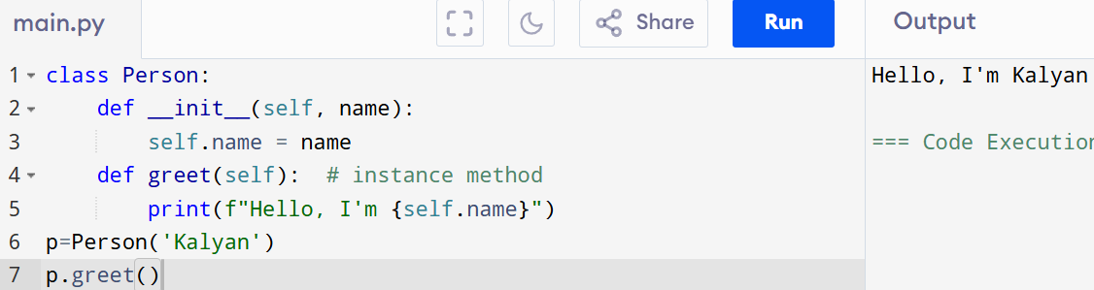
- Takes self as the first parameter

self :
Definition:
In Python's object-oriented programming, self is a reference to the current instance of the class.
It is used to access instance variables and methods inside the class.

Key Points:
- It refers to the object calling the method.
- Allows access to instance(object)-specific data.

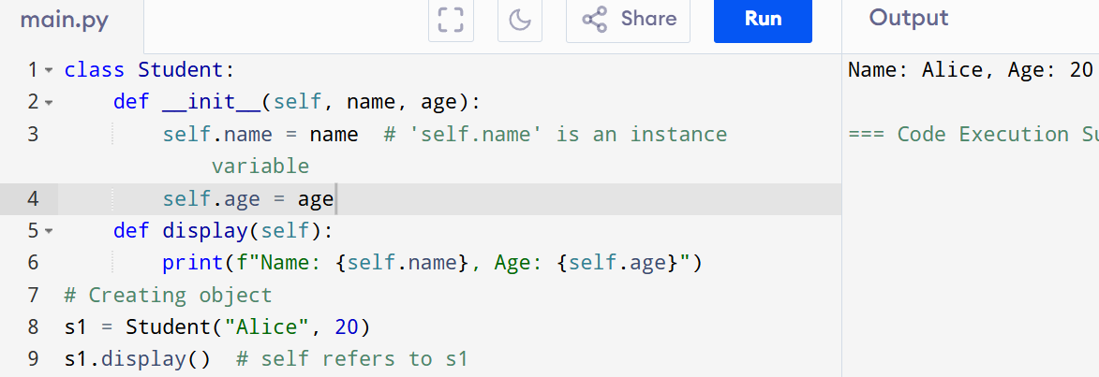
Example:

What self Does:
- In self.name = name, it assigns the parameter name to the instance variable name of that object.
- Without self, Python wouldn’t know which object’s name or age you're referring to.
- self is not a keyword; it’s just a convention (you could name it anything, but using self is standard).
- It is automatically passed when you call an instance method.

Term | Description
self | Refers to the current instance (object)
Used in | Instance methods and constructor
Purpose | Access instance variables & methods

2. Class Method
- Affects the class as a whole
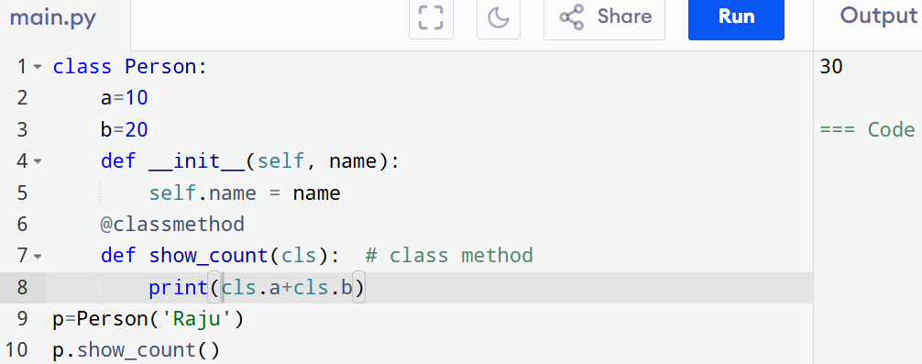
- Takes cls as the first parameter

3. Static Method
- No access to class or instance data
- Used for utility/helper functions
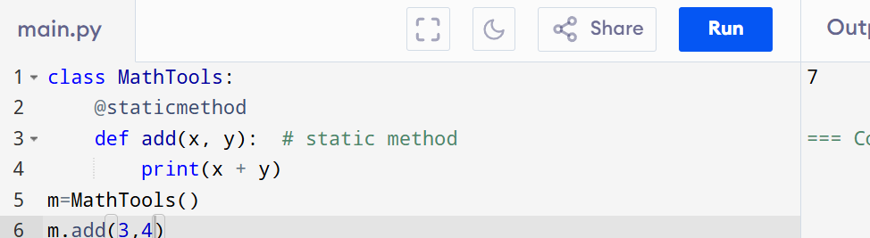
- Does not take self or cls as the first parameter.

Method Type | First Parameter | Accesses | Used For
Instance Method | self | Instance data | Object behavior
Class Method | cls | Class data | Modify class-level state
Static Method | None | No class/object | Utility functions

Inheritance in OOP
- Definition: Inheritance is a mechanism in OOP that allows a child class (derived class) to acquire the properties and behaviors (methods & variables) of a parent class (base class).
- Benefit: Promotes code reusability, extensibility, and supports the concept of hierarchy in classes.

Types of Inheritance in Python
1. Single Inheritance
- A child class inherits from only one parent class.
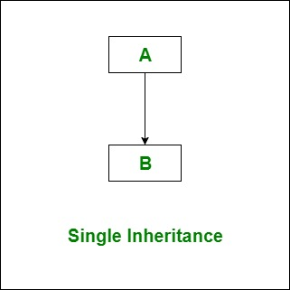
- It is the simplest and most common form of inheritance.
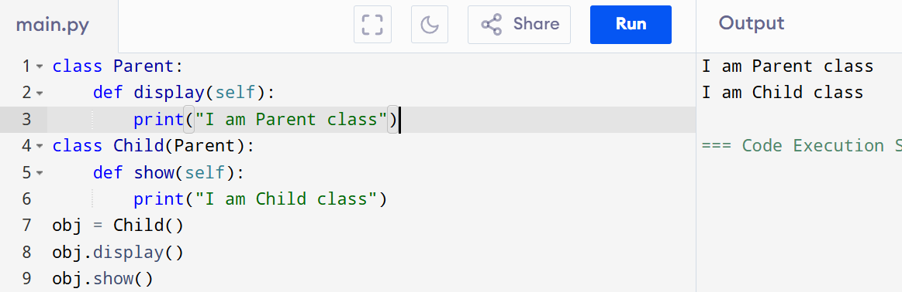
2. Multiple Inheritance
- A child class inherits from more than one parent class.
- This means a child class can use attributes and methods from multiple base classes.
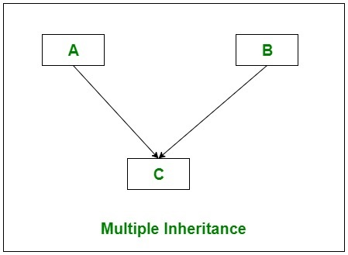

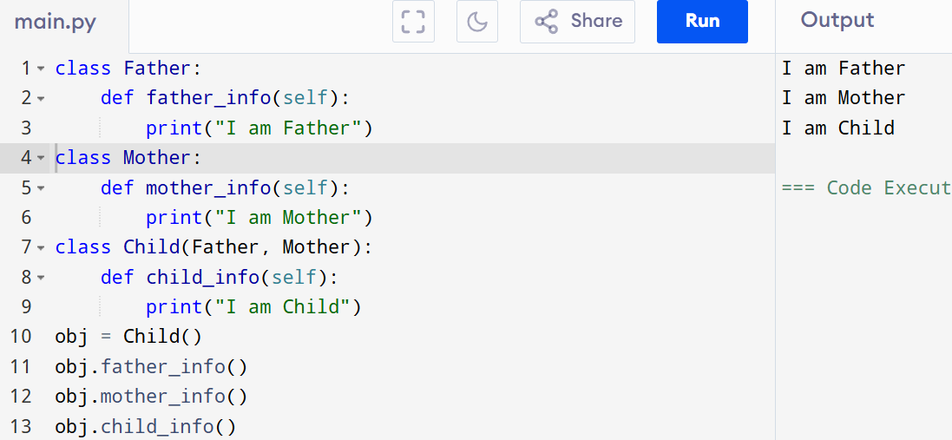
3. Multilevel Inheritance
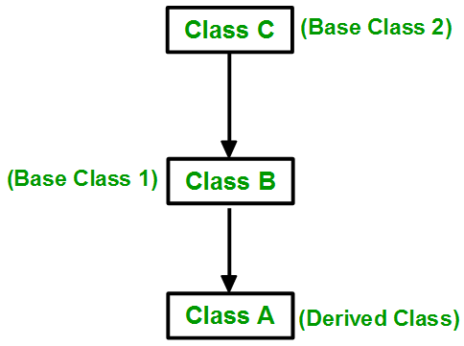
- A child class inherits from a parent class, which in turn is a child of another class. (Grandparent → Parent → Child)
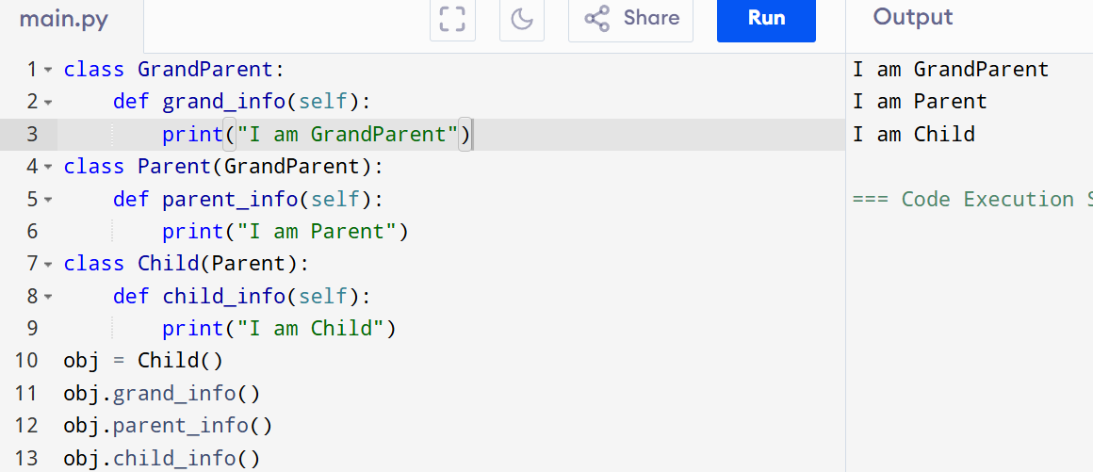

4. Hierarchical Inheritance
- Multiple child classes inherit from the same parent class.
- One parent → many children.
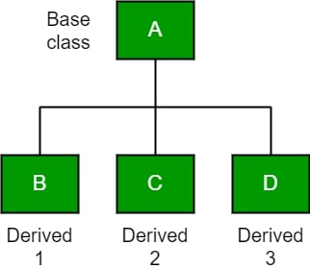
- Each child has access to the parent’s properties and methods but may have its own unique behavior.

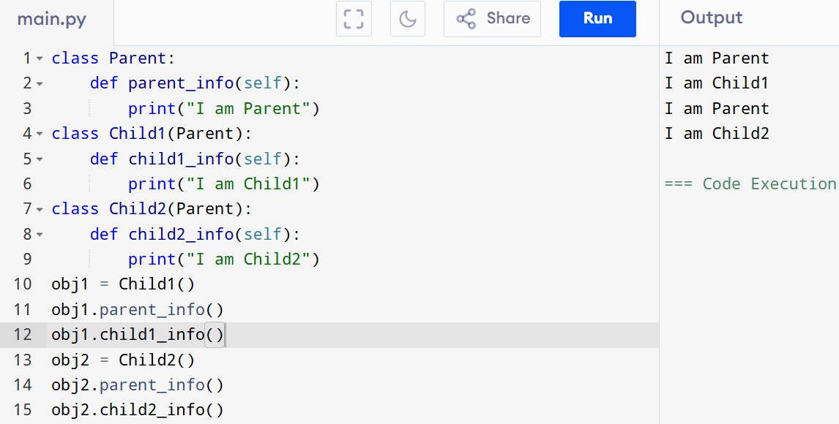
5. Hybrid Inheritance
- A combination of more than one type of inheritance.
Example: Combination of Multiple + Multilevel.
- It forms a complex structure where classes can be related in different ways.
- Often leads to the diamond problem, which Python solves using MRO (Method Resolution Order).
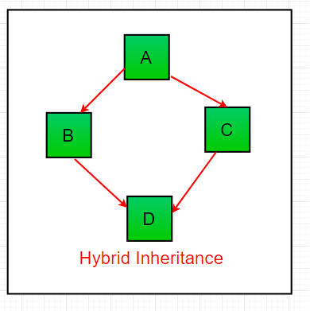

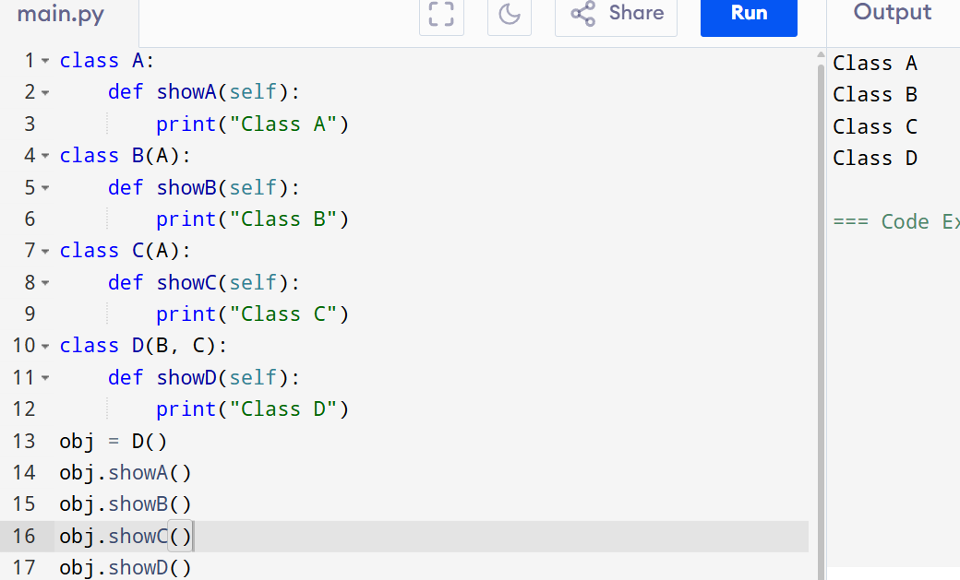

super in Python
Definition
- The super() function in Python is used to call methods from a parent (superclass) in a child (subclass).
- It helps in reusing code and maintaining method resolution order (MRO) in case of multiple inheritance.

Why use super()?
- Code Reusability – Avoids rewriting parent class methods in the child class.
- Extensibility – Child class can extend parent functionality instead of replacing it completely.
- Multiple Inheritance Support – Works well with Python’s MRO (method resolution order).
- Cleaner Code – Makes it easier to maintain and modify.

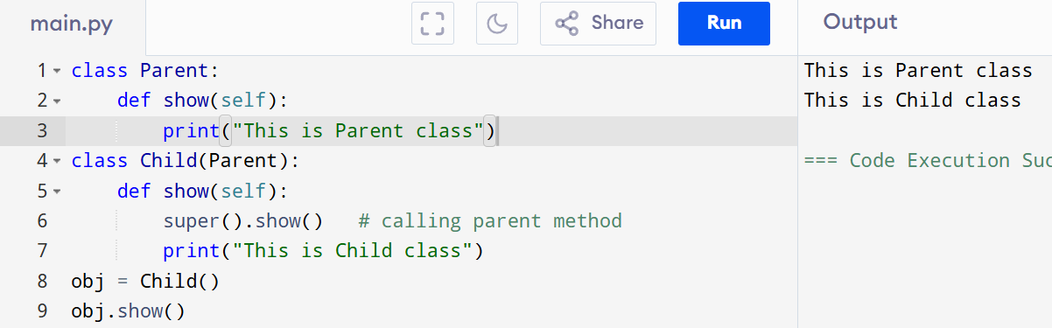
Basic Example

Using super() with __init__
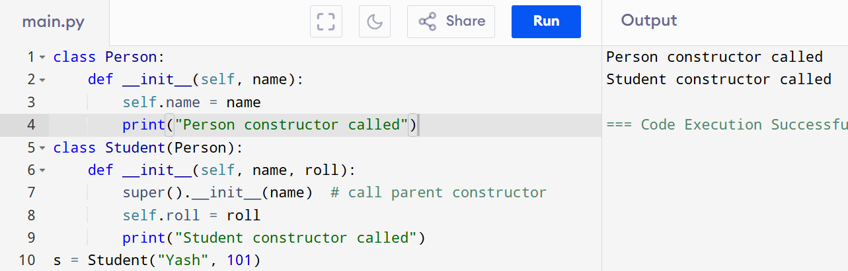

method calling using super:
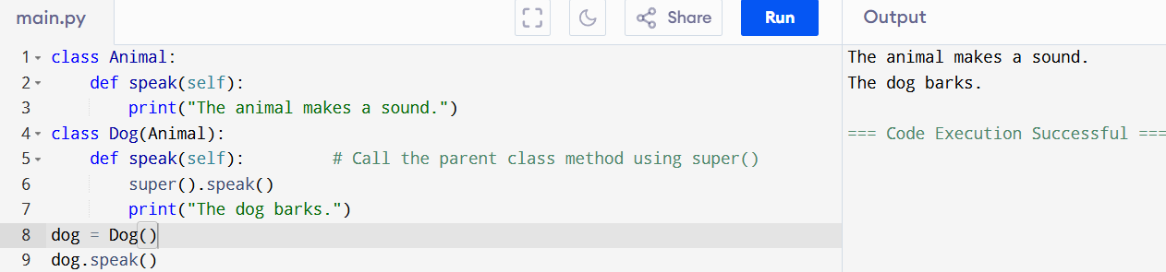

Polymorphism in Python
- Polymorphism means "many forms".
- In programming, it refers to the ability of a single function, operator, or method to behave differently depending on the object or data type.
- It increases code reusability and makes programs flexible.

Types of Polymorphism in Python
  - Duck Typing
  - Method Overloading (simulated)
  - Method Overriding
  - Operator Overloading

1. Duck Typing
- Duck Typing is a concept in Python where the type of an object is less important than the methods or properties it has.
- The phrase comes from:
“If it looks like a duck, swims like a duck, and quacks like a duck, then it is a duck.”
- In other words - If an object behaves like the expected object, Python lets you use it, no matter its actual class.
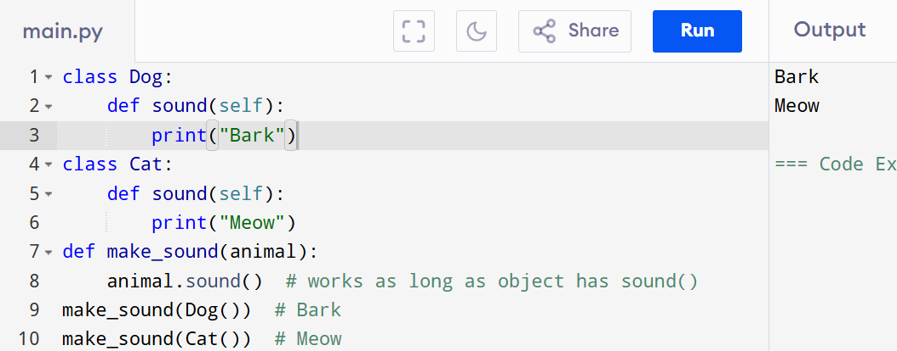

2. Method Overloading (Simulated in Python)
- Method Overloading means having multiple methods with the same name but different parameters.
- In languages like Java/C++, it’s directly supported.
- Python does not support true method overloading — if you define a method multiple times with the same name, the last one overrides the previous ones.

How it is simulated in Python
- Default arguments
- Variable-length arguments (*args)

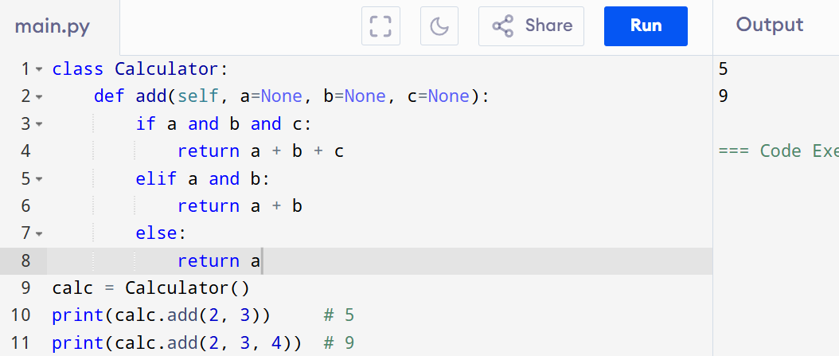
Example 1: Using Default Arguments

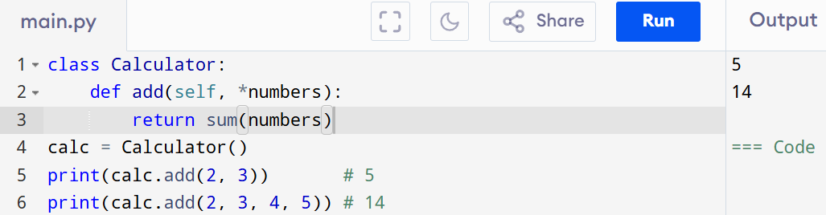
Example 2: Using *args
3. Method Overriding

- Method Overriding occurs when a child class defines a method with the same name as a method in its parent class.
- When called, the child class method will replace (override) the parent class method.
- It is used to modify or extend the behavior of a parent class method.

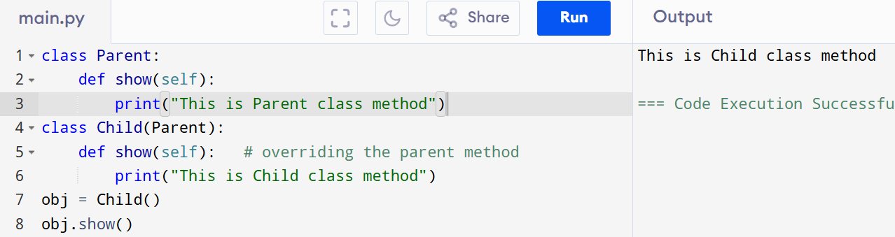
Example

Explanation:
This is Child class method
Here, the Child class overrides the show() method of Parent.

Example with super() (extending parent behaviour)
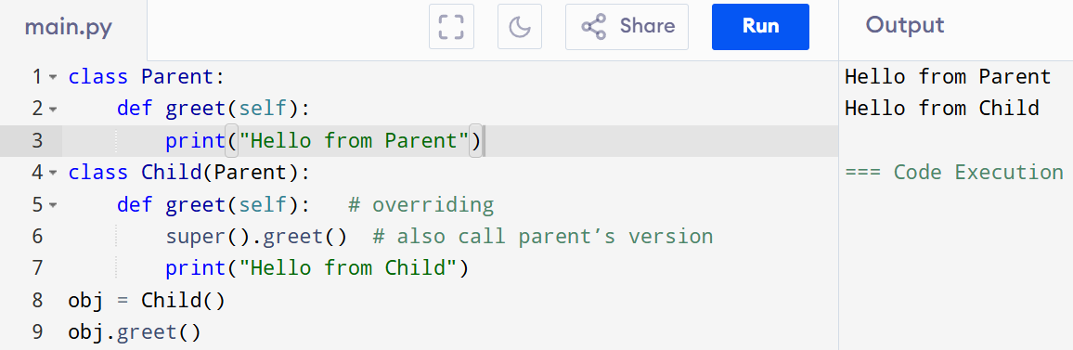
Here, the child extends parent behaviour instead of fully replacing it.

4. Operator Overloading
- Operator Overloading allows us to *redefine how operators (+, -, , >, <, etc.) work for user-defined classes.
- Behind the scenes, operators in Python are implemented using special methods (also called magic methods or dunder methods).
Example:
Operator | Description | Special Method
+ | Addition | __add__()
- | Subtraction | __sub__()
* | Multiplication | __mul__()
/ | Division | __truediv__()
// | Floor Division | __floordiv__()
% | Modulo | __mod__()
** | Exponentiation | __pow__()
> | Greater than | __gt__()
< | Less than | __lt__()
>= | Greater than or equal | __ge__()
<= | Less than or equal | __le__()
== | Equal to | __eq__()
!= | Not equal to | __ne__()

Why use it?
- Makes objects of user-defined classes behave more like built-in types.
- Improves readability and usability of classes.

Example 1: Overloading +
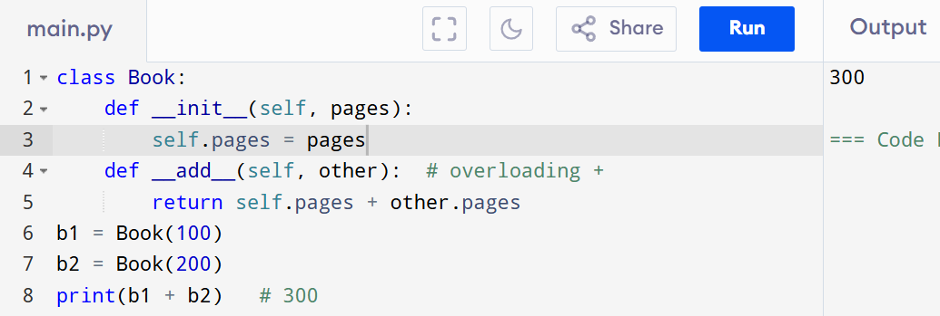

Explanation: We overloaded + operator so that it adds the pages of two books.

Example 2: Overloading >
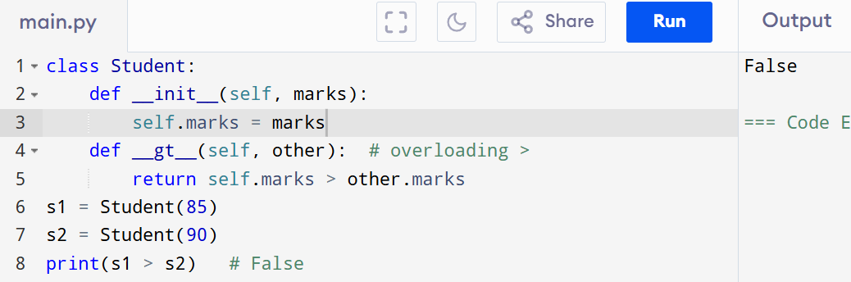

Explanation: We overloaded > operator to compare students based on marks.

Example 3 : Using special methods (dunder methods)
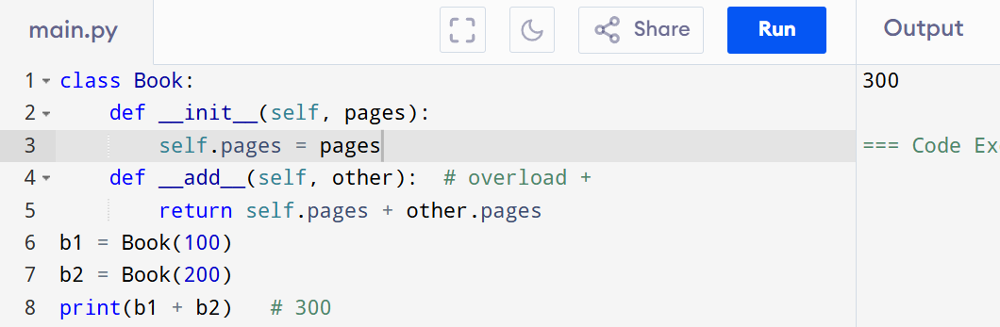
operators can behave differently for user-defined objects.

Abstraction
Abstraction in OOPs is the process of hiding implementation details and only showing essential features to the user.
It focuses on what an object does rather than how it does it.
In Python, abstraction is mainly achieved using abstract classes and abstract methods (with the abc module).

Why Use Abstraction?
- To hide complex implementation details from the user.
- To provide a simple interface for interacting with objects.
- To enforce that subclasses implement certain methods.

Key Points
- Abstract class :- A class that cannot be instantiated (cannot create objects directly).
- Abstract method :- A method declared, but not implemented in the abstract class.
- Subclasses must provide implementation for all abstract methods.

1. Abstract Class → Cannot Be Instantiated
- An abstract class is just like a "blueprint".
- You cannot create objects of it directly.
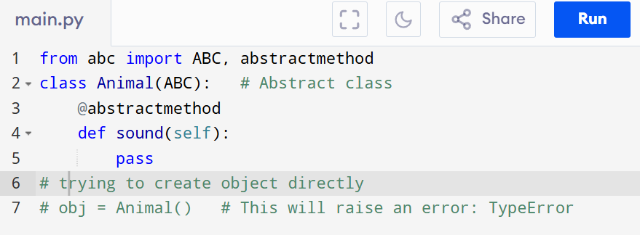

2. Abstract Method → Declared, But Not Implemented
- An abstract method is written in the abstract class, but it has no body (only a declaration).
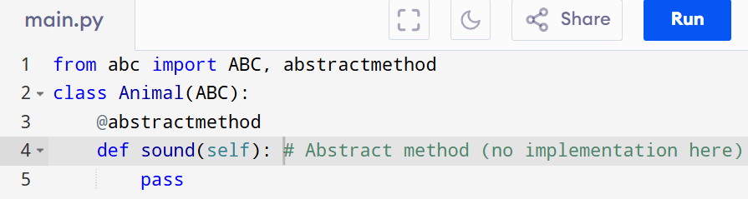

3. Subclasses Must Implement All Abstract Methods
- If a class inherits from an abstract class, it must provide implementation for all abstract methods. Otherwise, that subclass itself will remain abstract and cannot be instantiated.
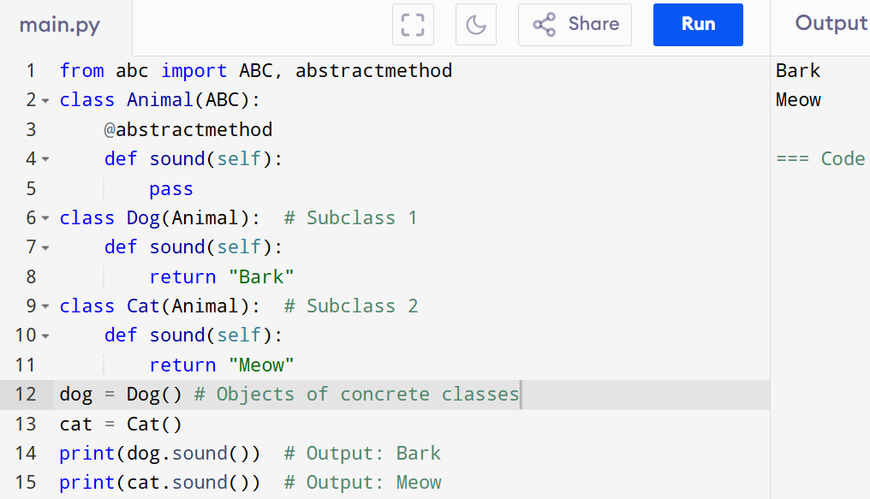

Dunder Methods
- Dunder methods allow classes to define how their objects behave with built-in operators and functions.
- When multiple classes implement the same dunder method, you can use different objects interchangeably with the same interface — this is polymorphism.
- It lets you write flexible code that works with many object types through the same method call or operator.

Example: Polymorphism with __add__ (Addition Operator)
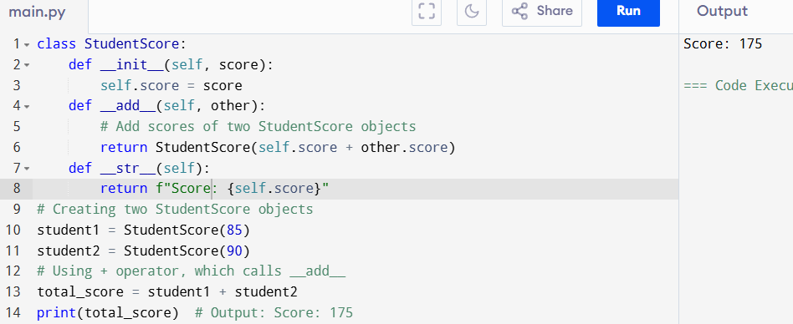
Example 1: Real-Time Example – Payment System
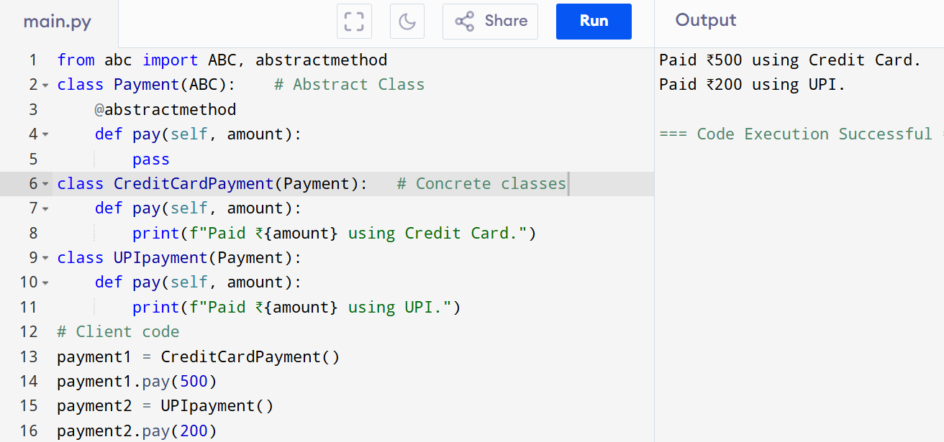

Explanation:
- Payment is an abstract class → Defines the rule: every payment must have a pay() method.
- CreditCardPayment and UPIpayment provide their own implementations.
- The user doesn’t care how the payment is processed, only that pay() works.

What is MRO? ## without usig super
- MRO (Method Resolution Order) is the order in which Python looks for a method in classes when using inheritance.
- In Python, this follows the C3 Linearization Algorithm.
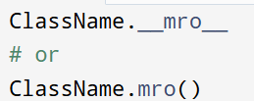
- You can check it using:

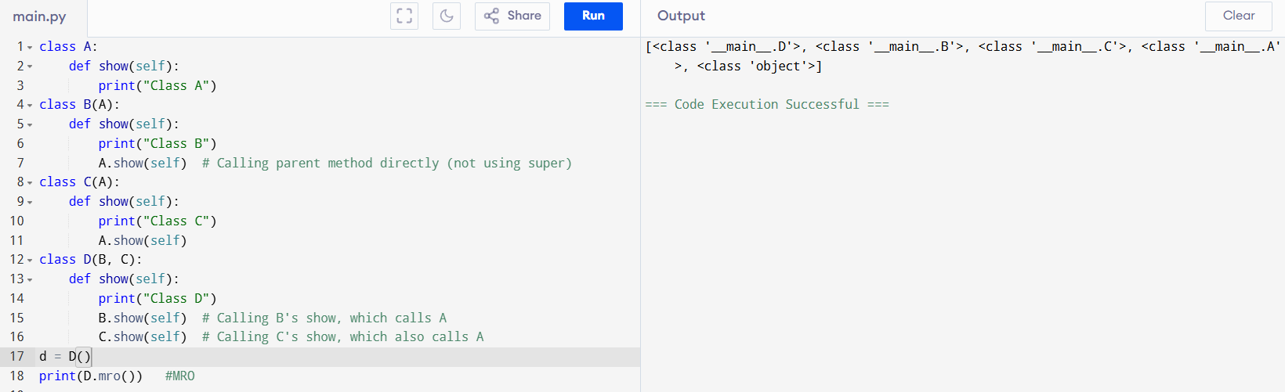
Example:

Explanation
- MRO of class D: D → B → C → A → object
- super() in each class doesn’t just mean “call parent”, but call the next class in the MRO.
- This avoids calling the same parent multiple times in complex hierarchies.

Encapsulation
It means binding data (variables) and methods (functions) into a single unit (class) and restricting direct access to the data.
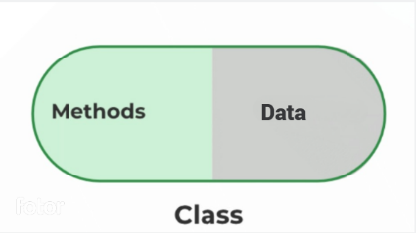
Think of it as putting sensitive data inside a box and providing controlled doors (methods) to access or modify it.
Why Encapsulation is Important?
- Data Hiding → Prevents outside code from directly accessing or changing critical data.
- Security → Only authorized methods can change values.
- Control → You decide what values can be accepted or rejected (via setters).
- Reusability → Encapsulated code can be reused easily.
- Maintainability → Any change inside the class won’t affect outside code (loose coupling).

Access Modifiers in Python
- In Python, access specifiers define the scope and visibility of variables and methods inside a class.
- They control who can access or modify a class’s data.
- Unlike Java/C++, Python doesn’t have strict rules, but uses naming conventions:
conventions:
- Public (default)
  - No underscore (variable)
  - Accessible everywhere
- Protected
  - Single underscore (_variable)
  - Meant to be used inside the class and subclasses (not enforced, but a convention).
- Private
  - Double underscore (__variable)
  - Not directly accessible outside the class (name mangling happens).
Examples
1. Public Access
- Public variables/methods can be freely accessed.
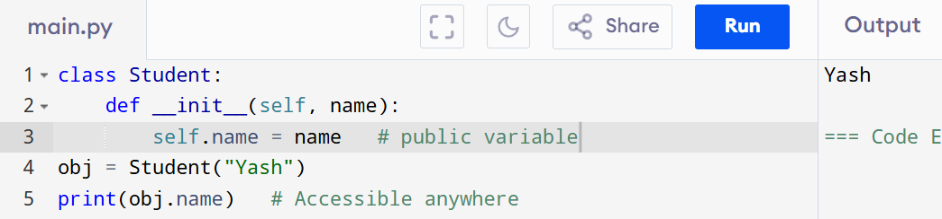

2. Protected Access
- _name is a convention → meant for subclass/internal use.
- technically you can access a protected variable anywhere in Python, even outside the class.
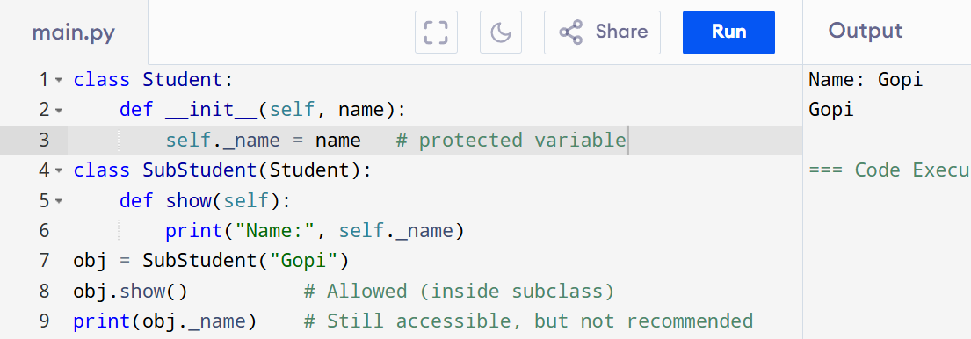

3. Private Access
- __name is private → not accessible outside directly.
- Python changes its name internally (_ClassName__var) → called name mangling.
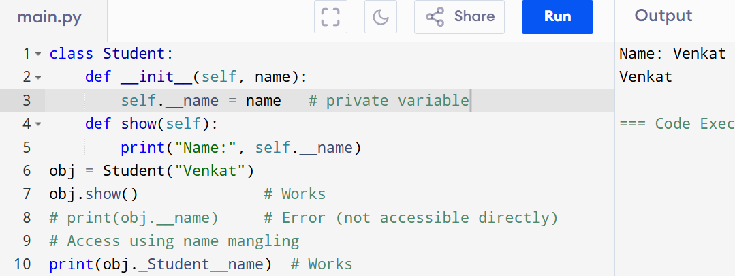

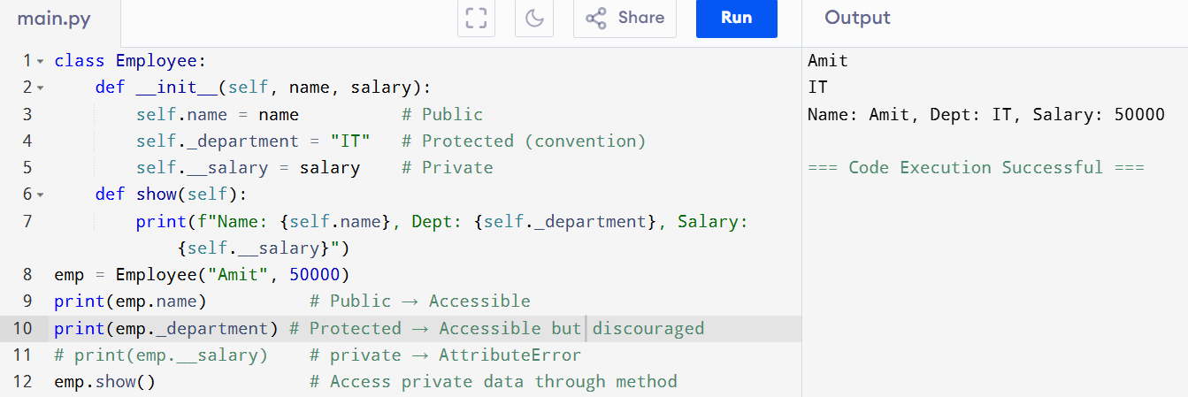
Example 1: Public, Protected, Private

Example 2: Real-Time Analogy – ATM Machine
- ATM machine → Encapsulation
- You only press buttons (methods) like withdraw, deposit, check balance.
- You cannot directly access the bank’s database (hidden data).
