MLOps Experimental Learning Assignment – End-to-End ML System
Course: MLOps (S1-25_AIMLCZG523)
Assignment: I
Group: 66
Team members: KARNATI SAI SHASHANK, SAI SAMEERA VOLETI, GOWTHAM POTLURI, TAMALAPAKULA AKSHARA, AYUSH SINGH VERMA
GitHub Repository:
👉 https://github.com/ksaishashi/MLOPS_ASSIGNMENT/

1. Introduction
This project demonstrates a complete end-to-end MLOps pipeline for predicting the risk of heart disease using patient health data.
The solution follows production-grade MLOps best practices, including:
- Automated data ingestion and preprocessing
- Feature engineering and model training
- Experiment tracking with MLflow
- CI/CD with GitHub Actions
- Model packaging and reproducibility
- Dockerized API serving with FastAPI
- Kubernetes deployment using Helm
- Monitoring, logging, and retraining support
The system is designed to be scalable, reproducible, and production-ready, closely mirroring real-world ML systems.

2. Dataset Description
- Dataset: Heart Disease UCI Dataset
- Source: UCI Machine Learning Repository
- Target Variable: Presence (1) or absence (0) of heart disease
- Features (Raw):
age, sex, cp, trestbps, chol, fbs, restecg, thalach, exang, oldpeak, slope, ca, thal

3. Setup & Installation Instructions
3.1 Prerequisites
- Python 3.10+
- Git
- Docker Desktop (with Kubernetes enabled)
- Helm
- Virtual Environment (recommended)

3.2 Project Setup
git clone https://github.com/ksaishashi/MLOPS_ASSIGNMENT.git
cd MLOPS_ASSIGNMENT
Create and activate virtual environment:
python -m venv venvmlops
venvmlops\Scripts\activate # Windows
Install dependencies:
pip install -r requirements.txt

4. Data Acquisition & Exploratory Data Analysis (EDA)
4.1 Data Download
The dataset is automatically downloaded using:
python src/data_download.py
This script:
- Downloads the dataset ZIP
- Extracts files into data/raw/
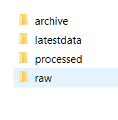
4.2 Data Cleaning & Preprocessing
Implemented in preprocessing_pipeline.py:
- Missing values handled (? → NaN)
- Median / mode imputation
- One-hot encoding (cp, restecg, thal)
- Target binarization
- Processed data saved with timestamp

4.3 Exploratory Data Analysis
EDA performed using:
- Histograms
- Correlation heatmaps
- Class distribution plots
- Boxplots for feature-target relationships

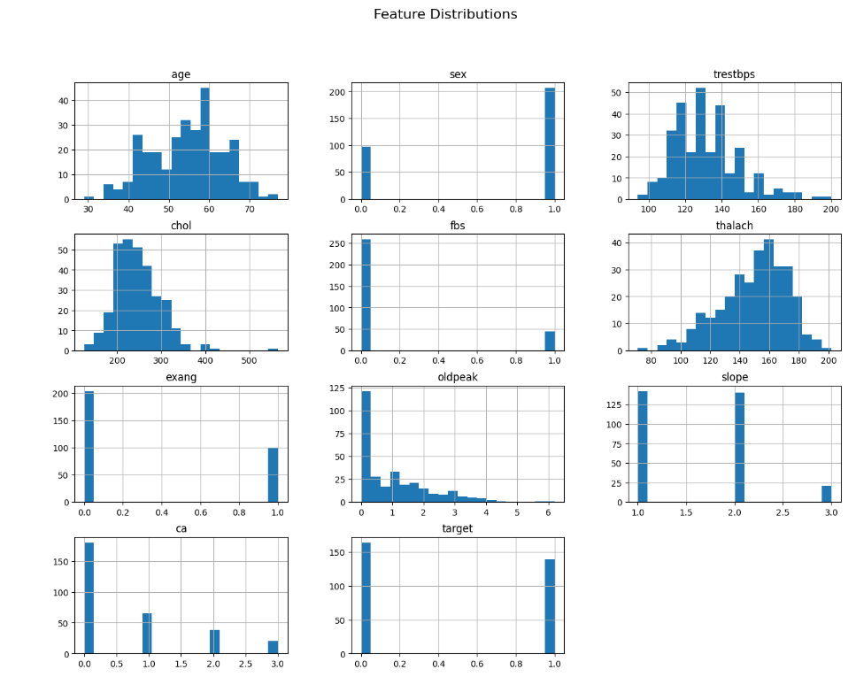

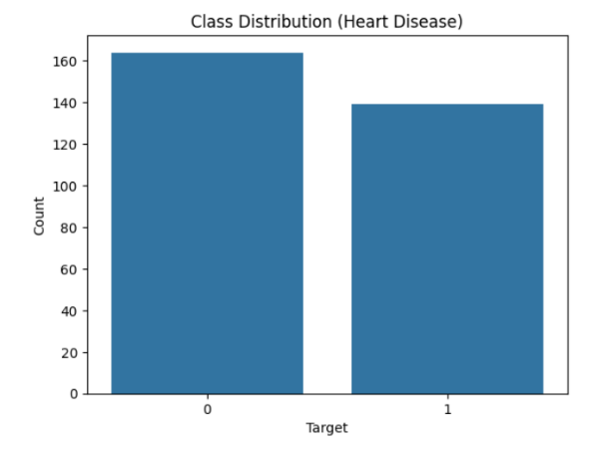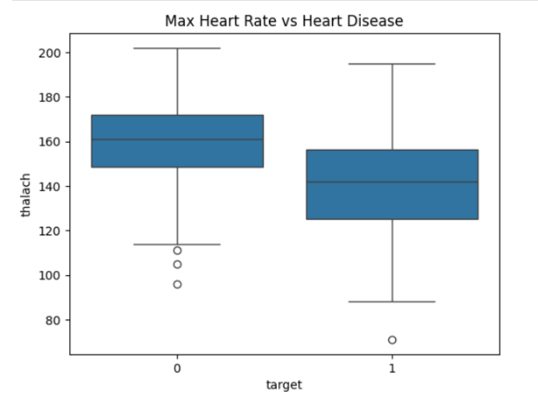

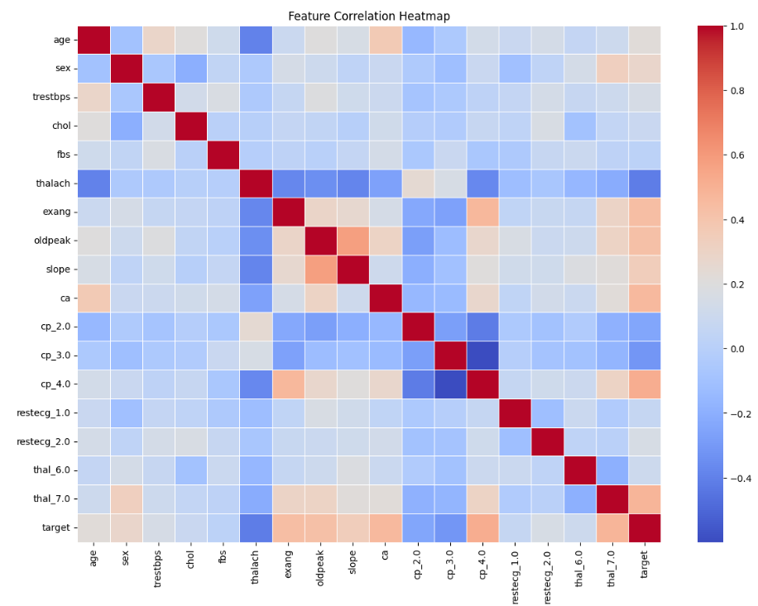

5. Feature Engineering & Model Development
5.1 Feature Engineering
Feature engineering was implemented in preprocessing_pipeline.py to ensure training–serving consistency.
Step 1: Missing Value Handling
- "?" values replaced with NaN
- ca → filled with median
- thal → filled with mode
Why:
Prevents model bias and avoids row drops in a small medical dataset.

Step 2: Target Transformation
df["target"] = df["target"].apply(lambda x: 1 if x > 0 else 0)
- Converts multi-class labels into binary classification
- Aligns with problem statement: presence vs absence of disease

Step 3: Encoding Categorical Features
One-hot encoding applied to:
- cp
- restecg
- thal
Using:
pd.get_dummies(..., drop_first=True)
Why:
- Removes ordinal assumptions
- Prevents multicollinearity
- Ensures compatibility with tree-based models

Step 4: Feature Alignment (Training = Serving)
- Final EXPECTED_FEATURES list is hardcoded
- Missing dummy columns added with zero values at inference time
Why:
Prevents runtime API crashes due to schema mismatch.

A.3 Final Feature Set Used by Model
age, sex, trestbps, chol, fbs, thalach, exang, oldpeak, slope, ca, cp_2.0, cp_3.0, cp_4.0, restecg_1.0, restecg_2.0, thal_6.0, thal_7.0

5.2 Model Training
B.1 Models Trained
Two models were explored:
- Logistic Regression (baseline)
- Random Forest Classifier (final model)
Hyperparameter tuning using:
- Grid search
- Stratified 5-fold cross-validation
Metrics evaluated:
- Accuracy
- Precision
- Recall
- ROC-AUC
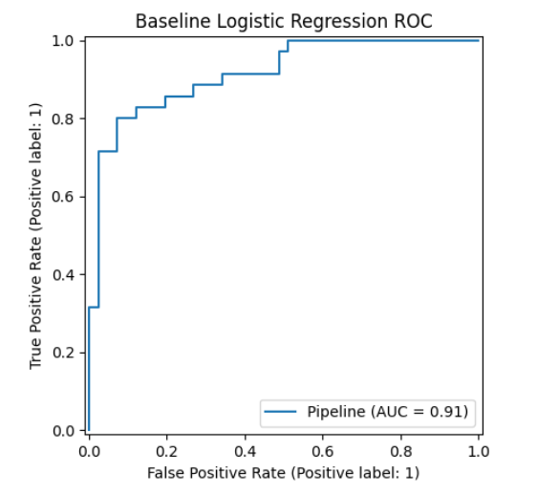
Random Forest was selected based on highest ROC-AUC.
Random Forest outperformed Logistic Regression on:
- ROC-AUC
- Recall (important in medical risk detection)
- Stability across folds
Medical relevance:
False negatives are more dangerous → Random Forest achieved better recall.
B.2 Hyperparameter Optimization
Grid search over:
- n_estimators
- max_depth
- min_samples_split
- min_samples_leaf
Using:
- StratifiedKFold (5 folds)

6. Experiment Tracking with MLflow
MLflow is integrated using a SQLite backend:
- Parameters logged
- Cross-validation metrics logged
- Test metrics logged
- Models and artifacts stored
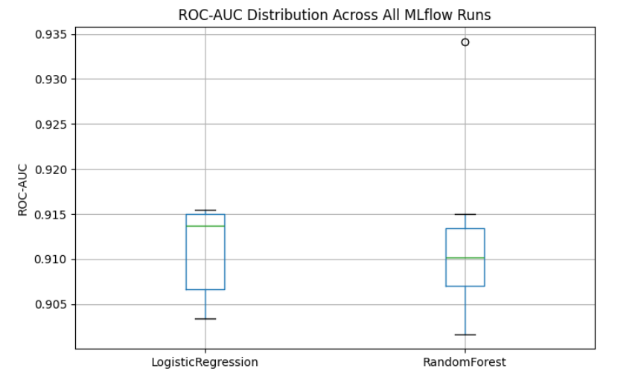

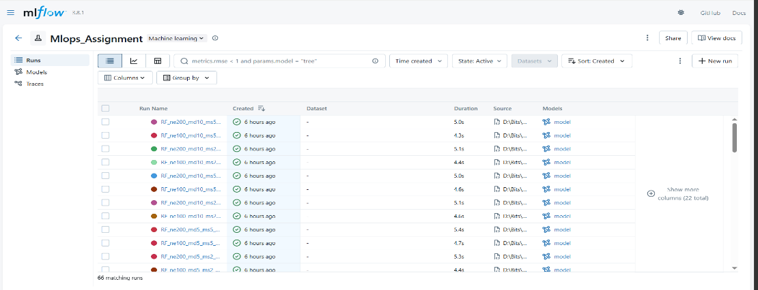

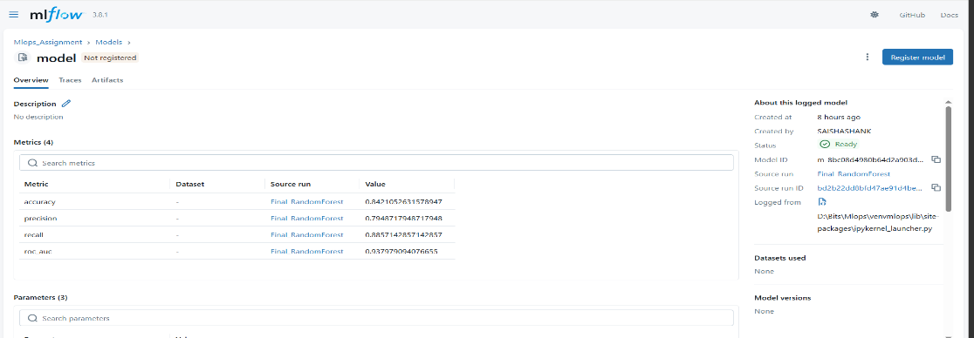

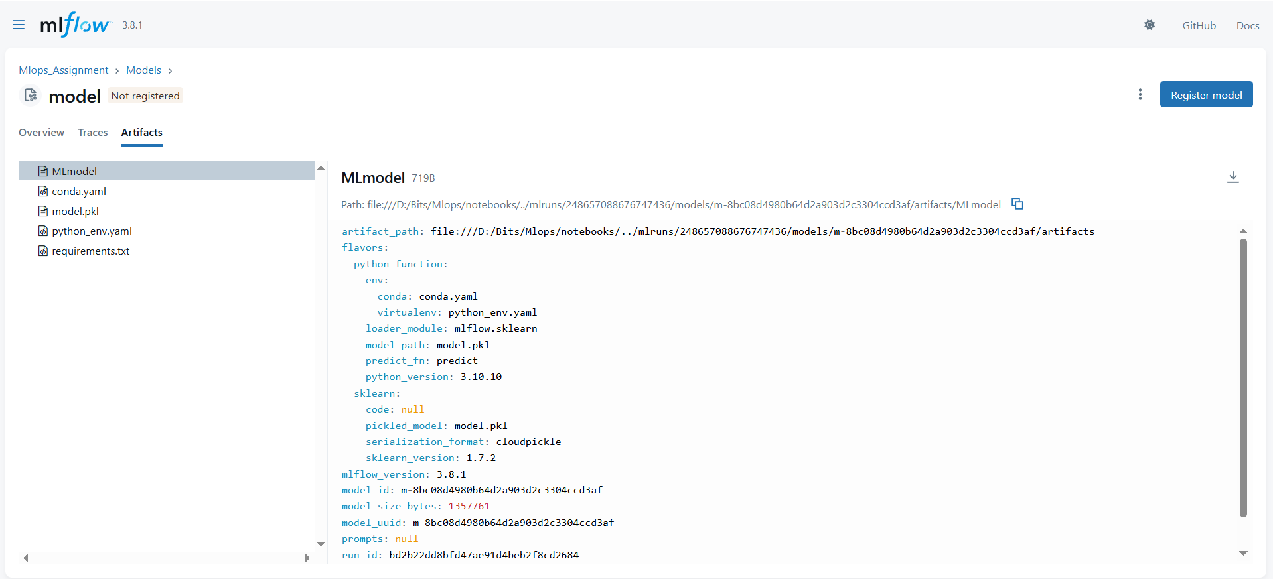

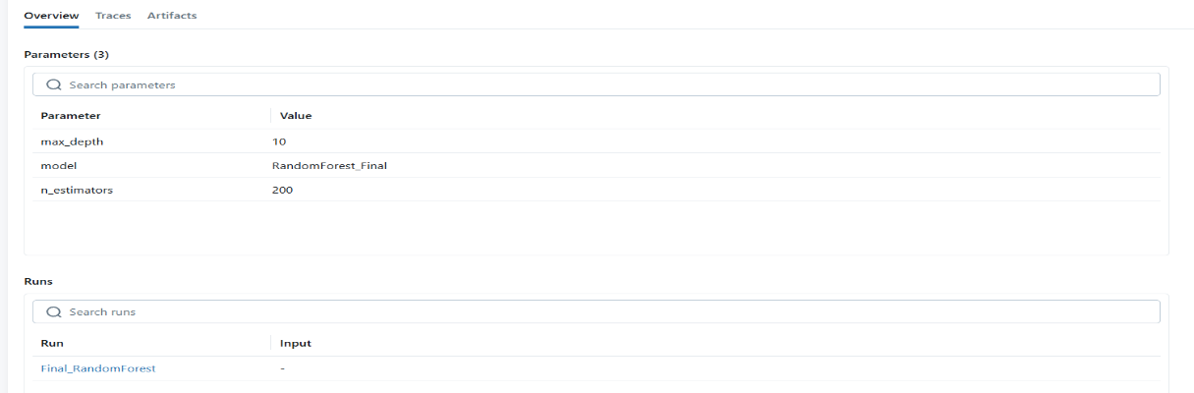

7. Model Packaging & Reproducibility
- Best model saved as pickle
- Metadata stored with metrics and timestamp
- Versioned model storage:
  - models/develop
  - models/latest
  - models/archive
- Clean requirements.txt
- Deterministic preprocessing pipeline

8. CI/CD Pipeline & Automated Testing
8.1 Unit Testing
Pytest used to validate:
- Data preprocessing correctness
- Feature schema
- Model inference
- Artifact availability
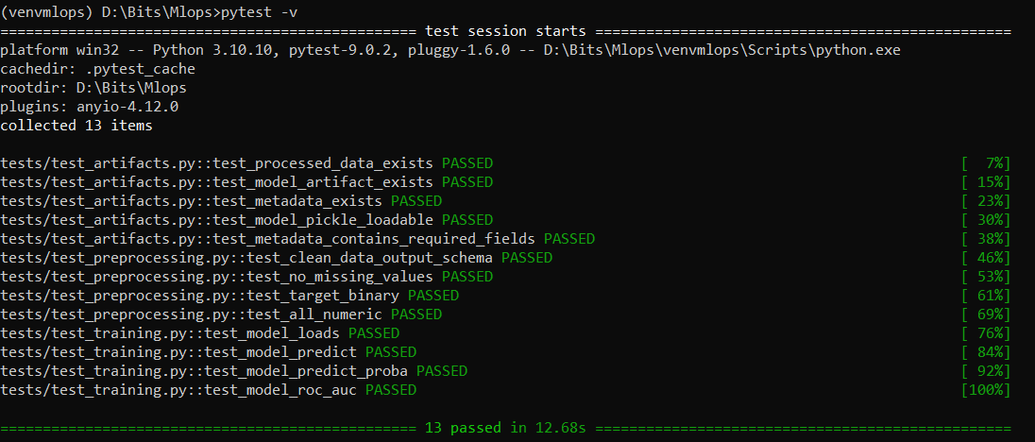
8.2 GitHub Actions CI Pipeline
Pipeline stages:
- Linting (flake8)
- Unit testing
- Training validation
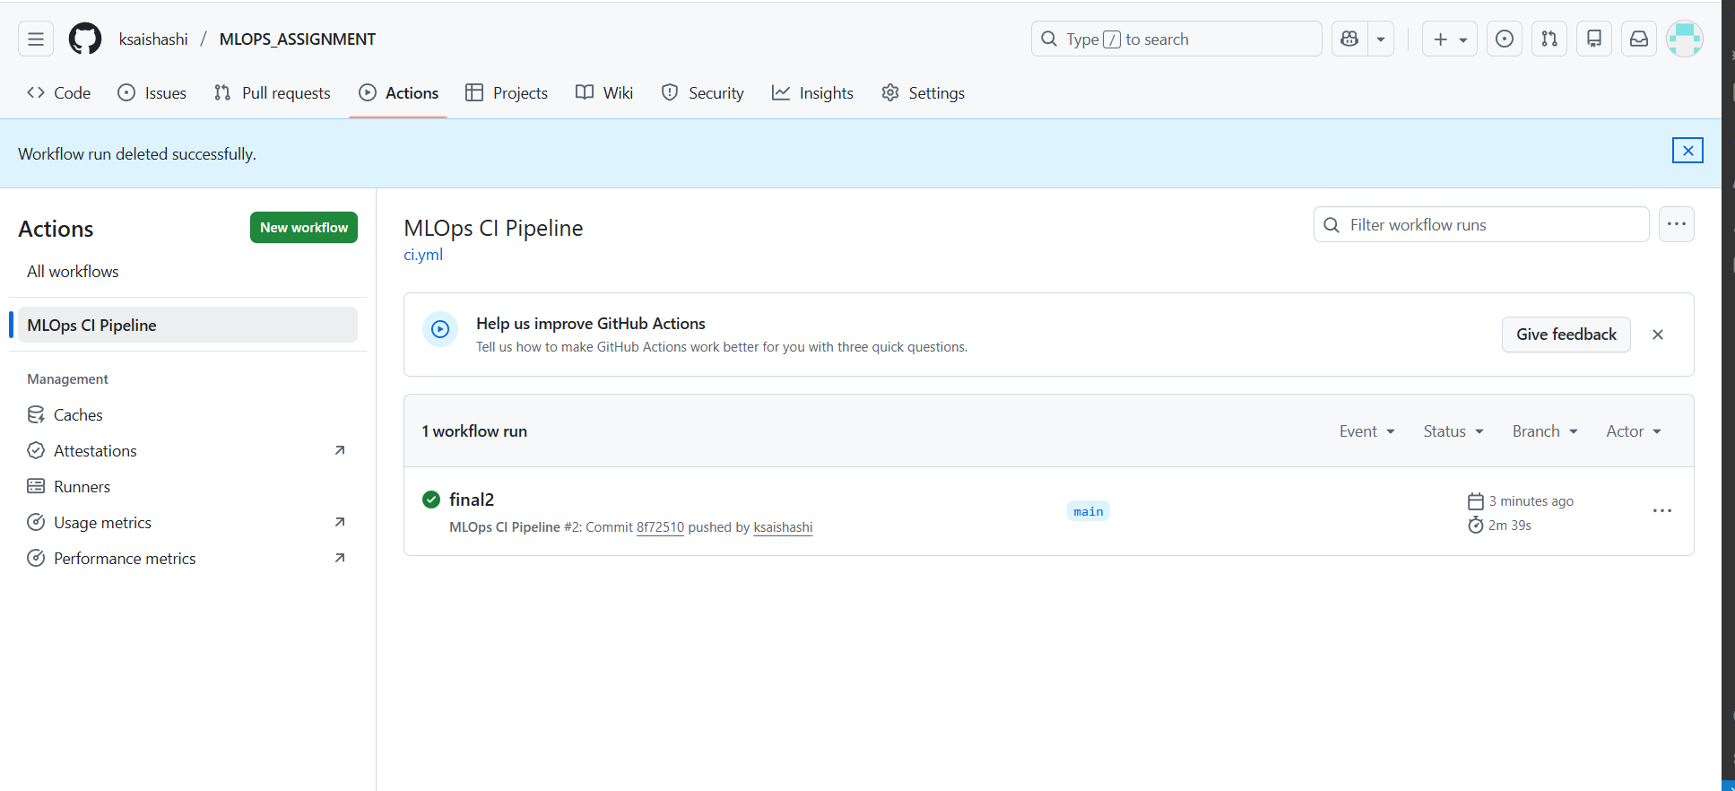
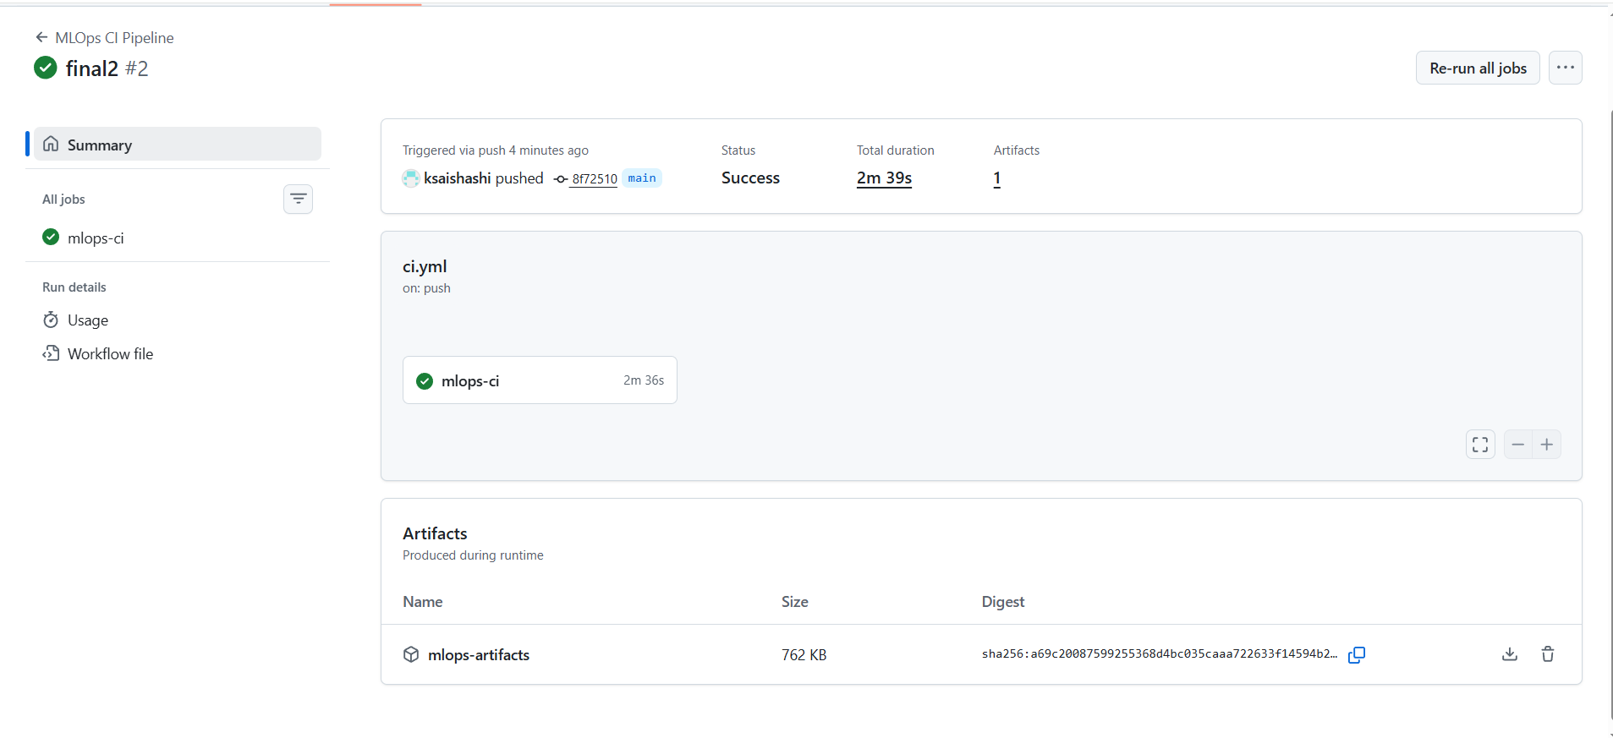
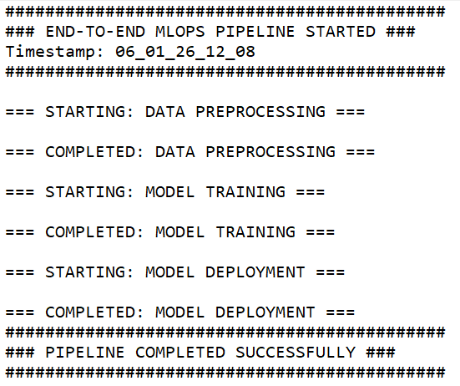

9. Model Containerization
- FastAPI-based model-serving API
- Dockerized using slim Python image
- /predict endpoint returns prediction + confidence
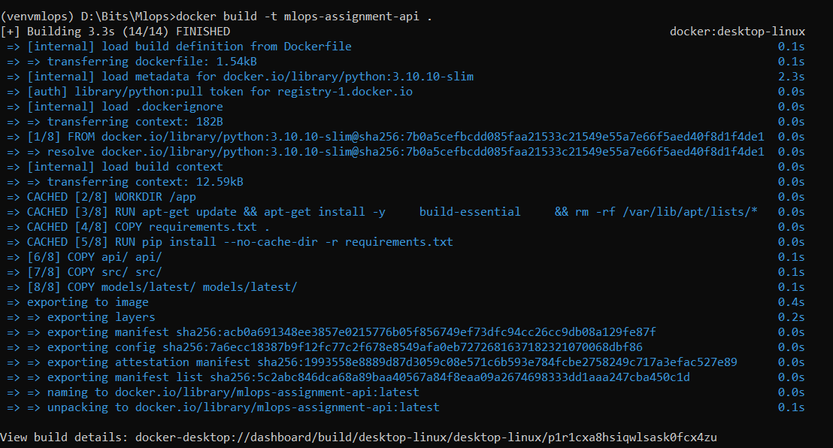
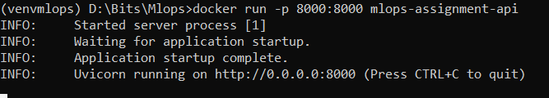

10. Production Deployment with Kubernetes & Helm
- Kubernetes (Docker Desktop)
- Helm chart for deployment
- LoadBalancer service
- Production-ready configuration
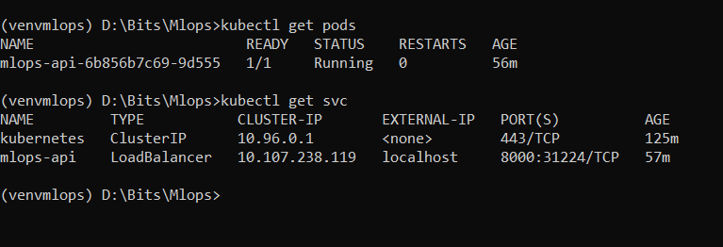
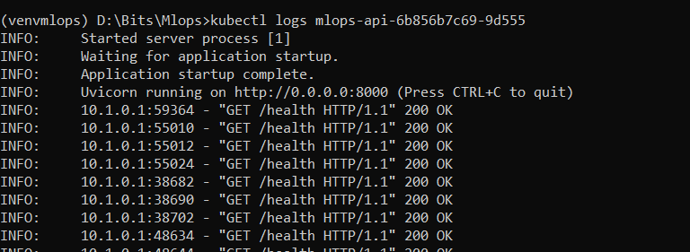

11. Monitoring & Logging
We also saved logs of all pipelines, apis calls, errors loogs has .log files with timestamp in below folder structures
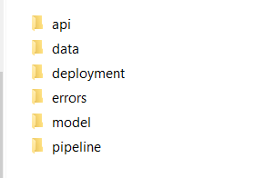

Monitoring Implemented:
- /metrics endpoint
- Request count
- Latency tracking
- Prediction distribution
- Model metadata exposure
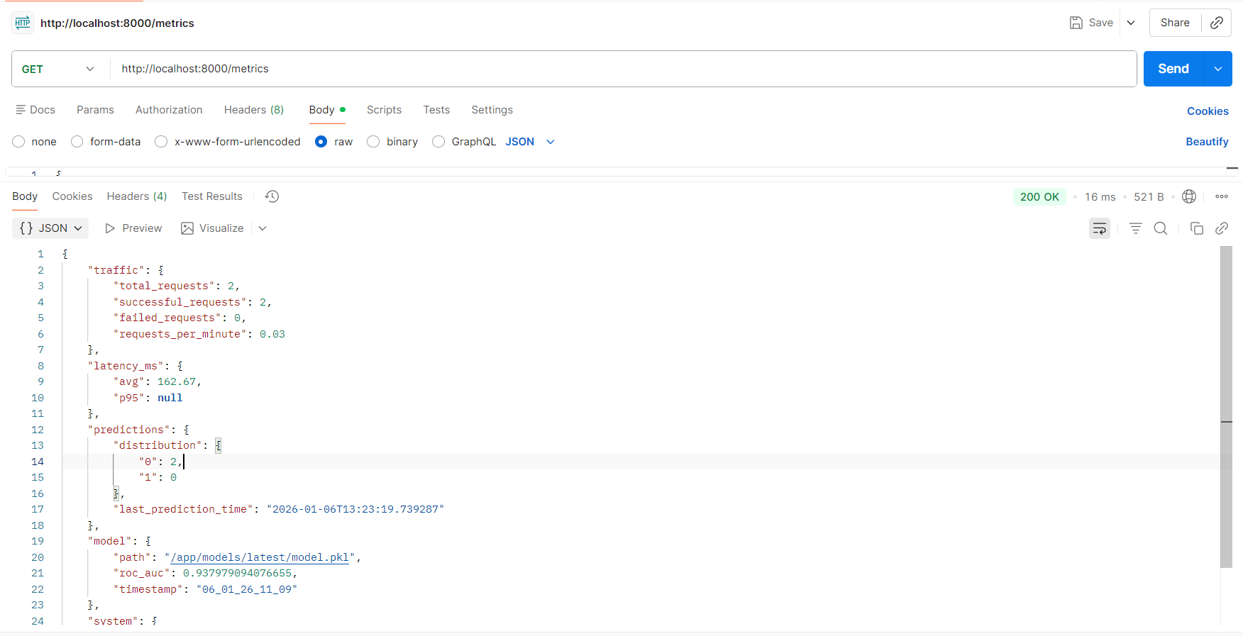
12. Architecture Overview
The system follows a modular MLOps architecture:
- Data → Preprocessing → Training → Deployment → Serving → Monitoring
- Blue-green deployment for model promotion
- Retraining triggered via API

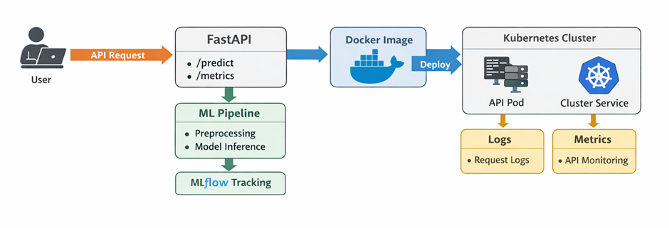
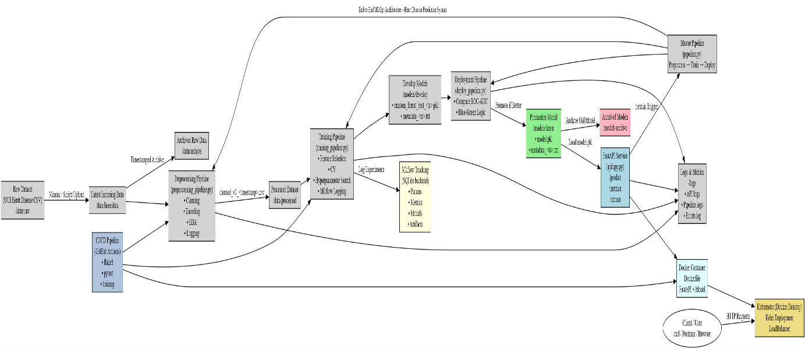

1. Data Flow
- Raw data → Latest folder
- Automatically archived with timestamp
- Cleaned data saved in data/processed
2.Pipelines
- Preprocessing Pipeline: cleaning + EDA + logging
- Training Pipeline: CV + hyperparameter tuning + MLflow
- Deployment Pipeline: ROC-AUC comparison (blue-green)
3.Model Lifecycle
- Trained → models/develop
- Best model → promoted to models/latest
- Old production → archived
4.Experiment Tracking
- MLflow logs:
  - Parameters
  - Metrics
  - ROC curves
  - Models
5.Serving & Monitoring
- FastAPI loads model.pkl
- /predict, /metrics, /retrain
- In-memory monitoring + persistent logs
6.Production
- Docker container
- Helm-based Kubernetes deployment
- LoadBalancer exposure
- flake8 + pytest + training + CICD with github actions
- Pipeline fails on errors

13. API Demonstration

F.1 Available Endpoints
Endpoint | Method | Purpose
/predict | POST | Prediction
/health | GET | Health check
/metrics | GET | Monitoring
/retrain | POST | Trigger retraining

F.2 Prediction API Example
POST /predict
{
"age": 55,
"sex": 1,
"cp": 3,
"trestbps": 140,
"chol": 240,
"fbs": 0,
"restecg": 1,
"thalach": 150,
"exang": 0,
"oldpeak": 1.2,
"slope": 2,
"ca": 0,
"thal": 3
}
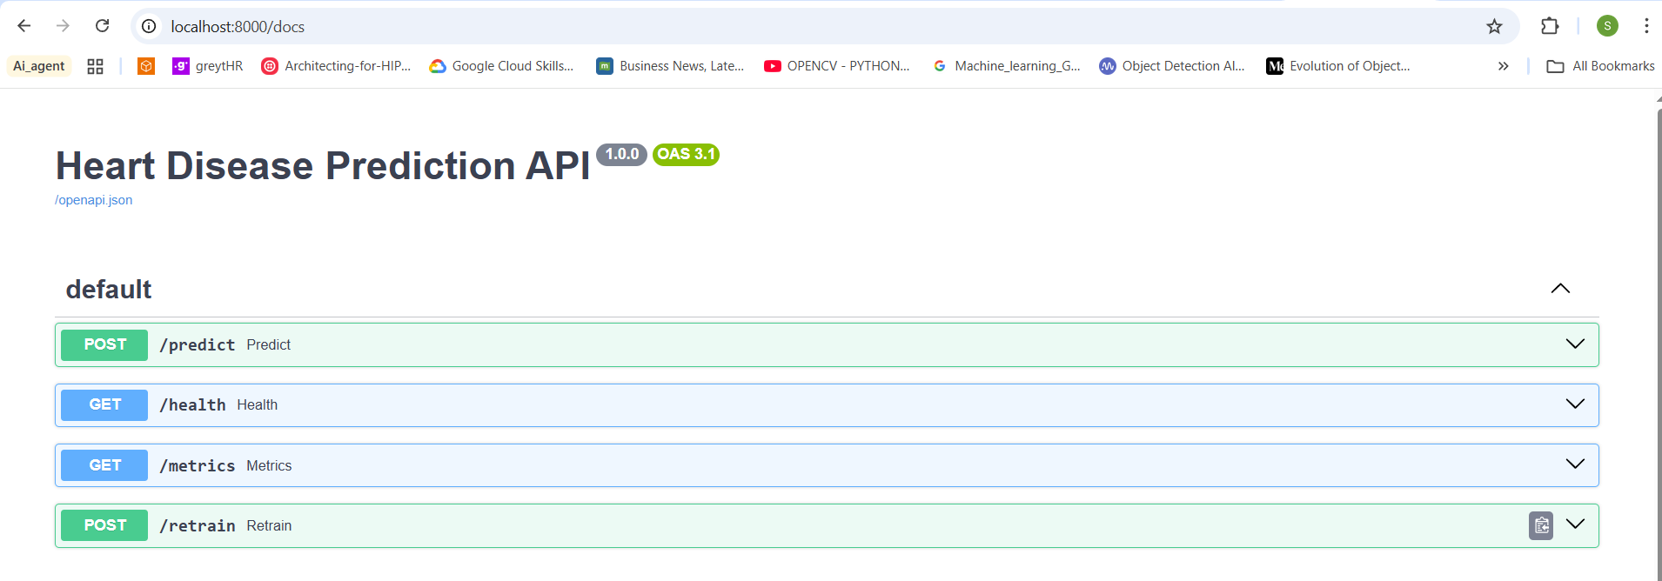
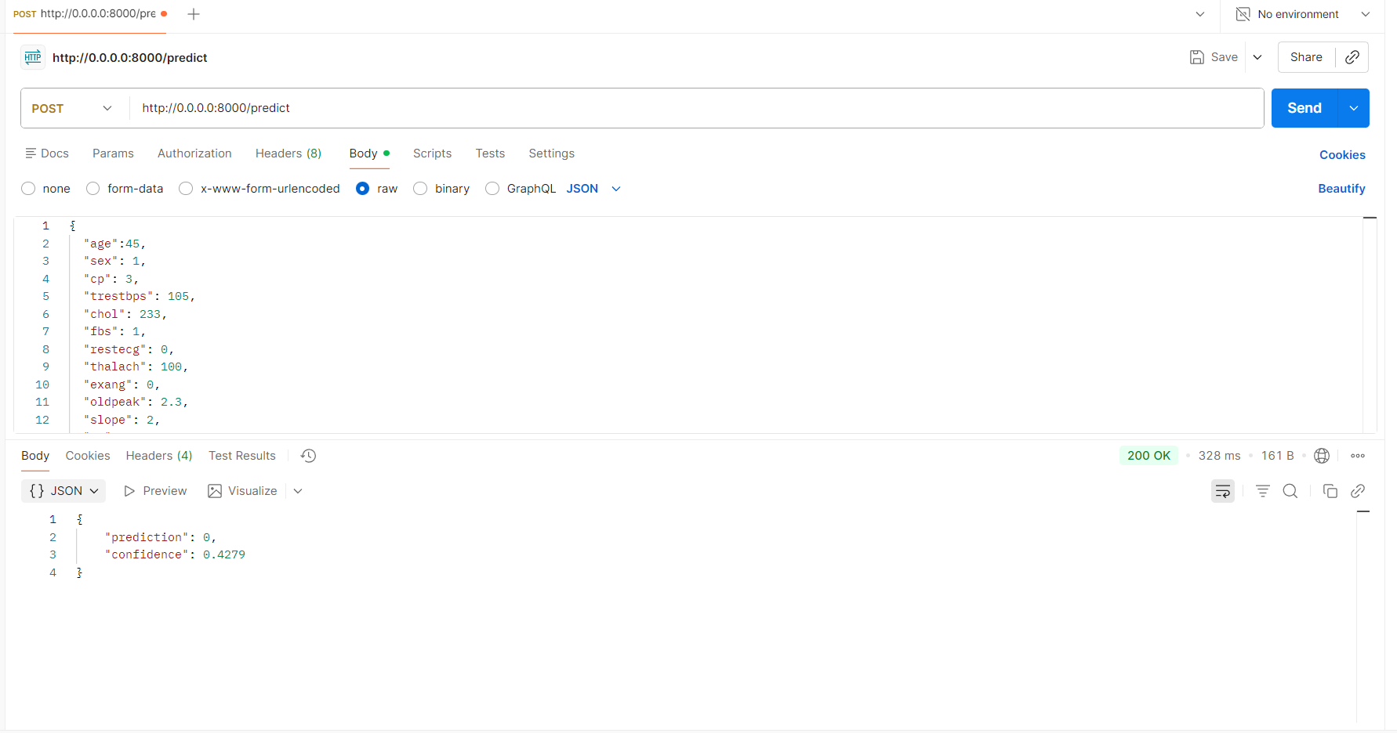

F.3 Monitoring API
GET /metrics
Returns:
- Request counts
- Prediction distribution
- Latency (avg, p95)
- Model ROC-AUC
- Uptime
F.4 Retraining API
POST /retrain
Triggers:
- Preprocessing
- Training
- Model comparison
- Deployment (if better)
Retraining is controlled & logged, not automatic — production-safe.

G. Logging & Monitoring – How It Works
G.1 Logging Locations
Log Type | Folder
API logs | logs/api/
Data pipeline | logs/data/
Training logs | logs/model/
Deployment logs | logs/deployment/
Errors | logs/errors/

14. Technology Stack
Layer | Technology
Language | Python 3.10
ML | Scikit-learn
Tracking | MLflow
API | FastAPI
Container | Docker
Orchestration | Kubernetes
Deployment | Helm
CI/CD | GitHub Actions
Testing | Pytest

15. GIT Repository
Link: https://github.com/ksaishashi/MLOPS_ASSIGNMENT
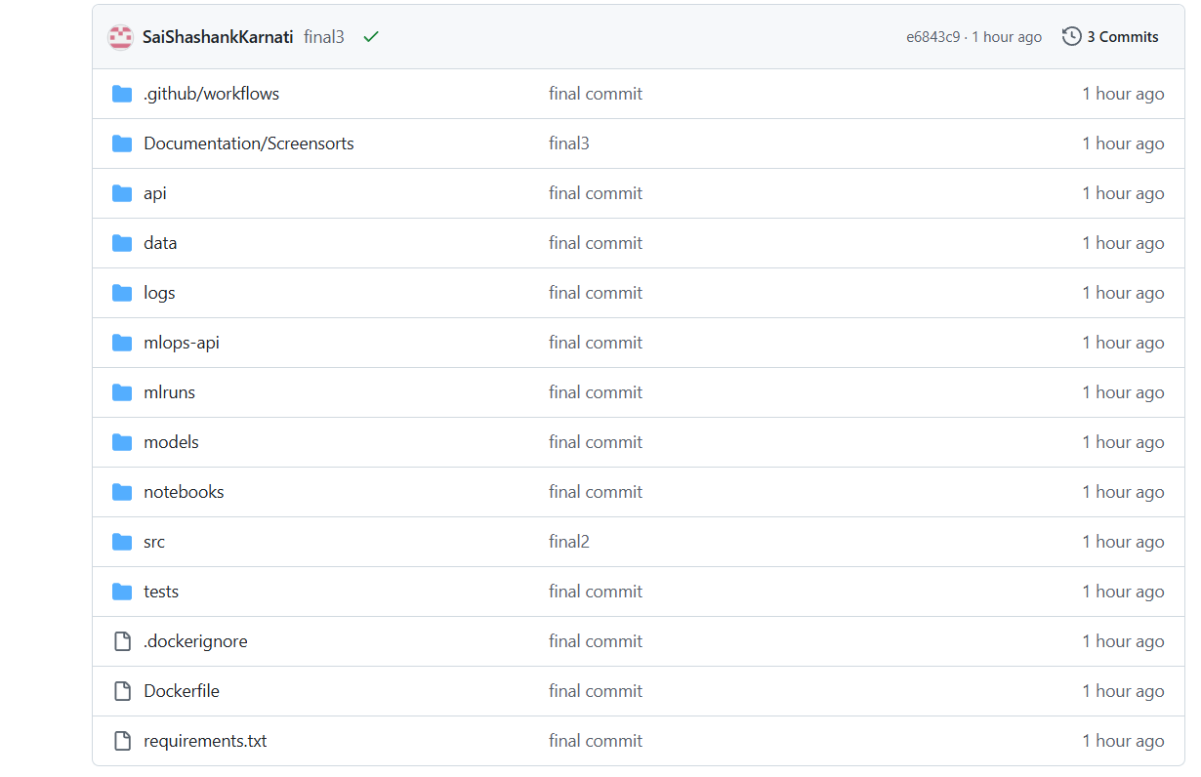

16. Folder Structure
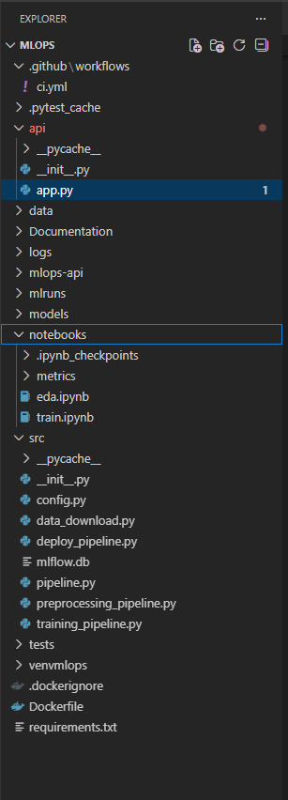

16. Conclusion
This project successfully implements a full production-grade MLOps system, covering the entire ML lifecycle with automation, reproducibility, monitoring, and deployment.
The solution aligns strongly with industry best practices and meets all assignment requirements.

