**Recombination variation crosses plan**

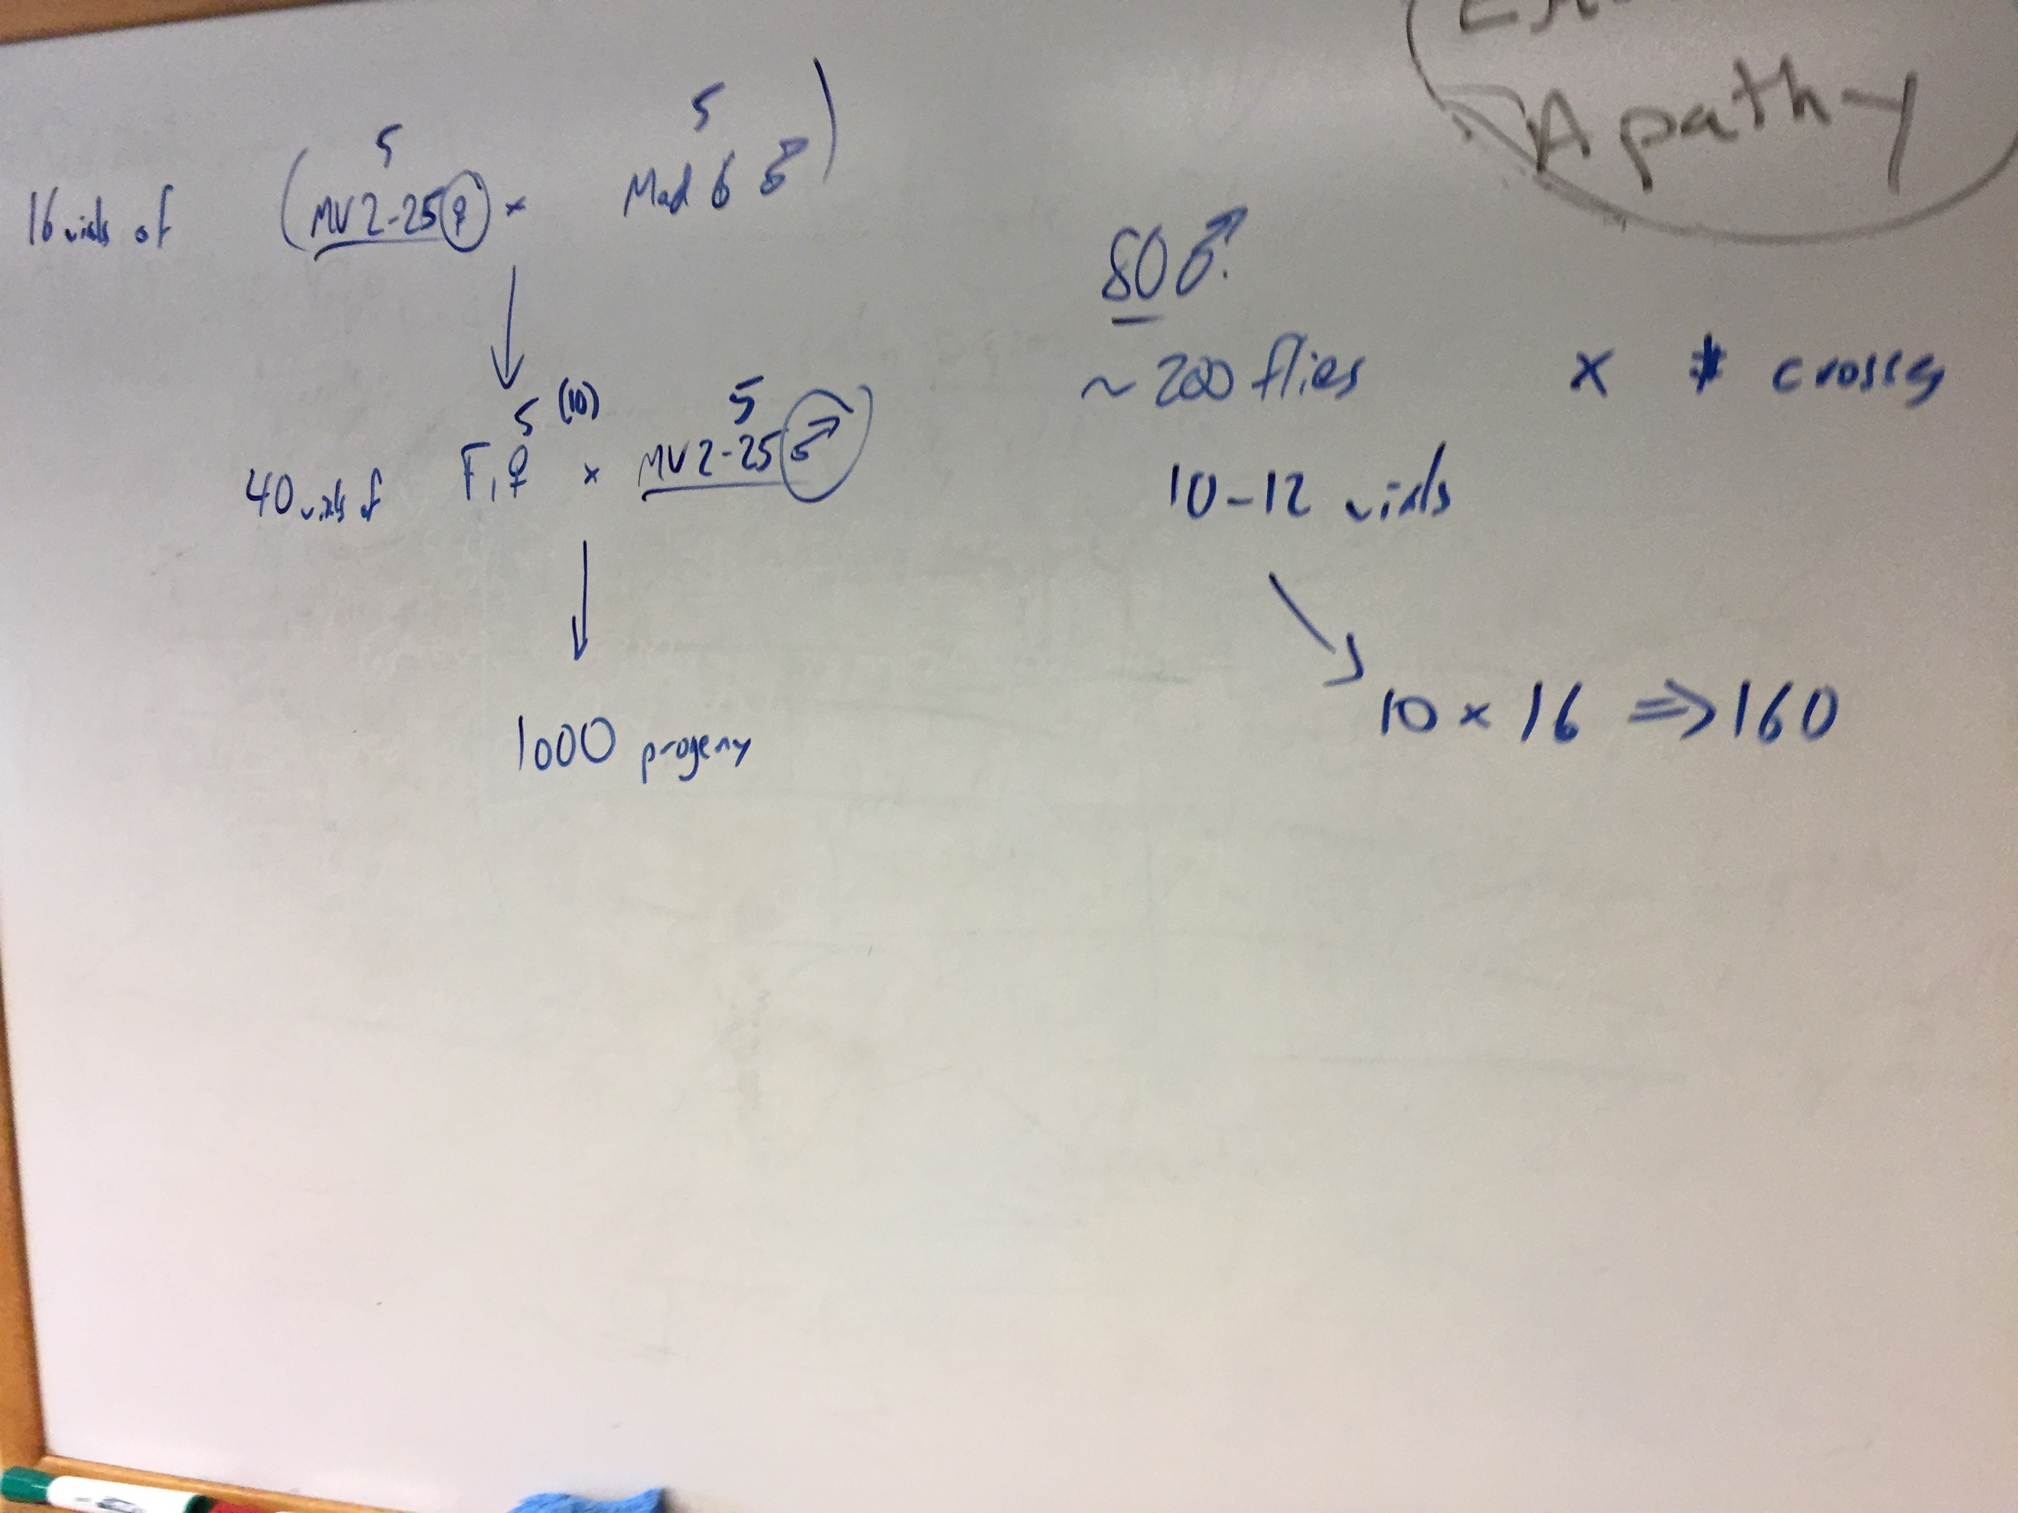

(picture from Noor/Samuk meeting on Nov 22/2016. We since decided to include Flag 14 as the second tester cross to ensure we maximize informative markers in the F2s)

**General design:**

16 x Grandparent crosses: 5 Males from each line X 5 Female MV2-25 or YV

40 x F1 Parents cross: Female F1s X Male Flagstaff 14

~1000 F2 progeny

Sequence all the things

**Schedule:**

* Start isolating MV2-25 virgins ASAP. Need a total of 16 x 20 = 320
* 5 females per vial, wait one week, if any larvae toss
* ALSO 5 males in a vial, but resting time doesn’t matter (just > 2 days).
* Probably will roll out crosses over the next few weeks.
* OK to make crosses opportunistically.
* Talk with Brenda about