**Supplementary material for “Indiscriminate care of offspring predates the evolution of sociality in alloparenting social spiders”**

**Journal: Behavioral Ecology and Sociobiology**

**Authors: Samuk K, Avilés L.   
Corresponding Author:** Kieran Samuk, University of British Columbia, Department of Zoology, 6270 University Blvd., Vancouver, British Columbia, Canada, V6T 1Z4.

E-mail: [samuk@zoology.ubc.ca](mailto:samuk@zoology.ubc.ca).

**Simulation of estimate accuracy in alloparental care assays**

We simulated the effect of the number of females in a colony on the accuracy of our switching rate assay using an individual-based simulation in R (R core team 2011). The simulation code is available from the authors upon request.

**Simulation details**

We simulated 20 “colonies” of spiders for each switching level selected (this is equivalent to simulating a single colony with 20 times the number of observations, but was included for interpretive similarity to our empirical results). Each simulated colony contained 5 – 800 females, and a maximum of 40 eggs (note: the number of eggs and the ratio of eggs to females does not bias estimates of egg switching; data not shown). Before the simulation is run, a switching rate is chosen. This rate corresponds to the quantity we attempted to estimate in our study, i.e. the probability that the identity of a female caring for an egg sac changes in a subsequent observation.

The simulation then functions as follows:

1. The number of females is initialized. We simulated the following number of females: 5, 10–100 by 10s, 150, and 200–800 by 100s.
2. A matrix of marked egg sacs and females is constructed (always indexed as eggs 1-5 and females 1-5).
3. The switching round: for each egg sac, a random number is generated between 0 and 1. If this number is less than or equal to the chosen switching probability, a new female is assigned to this egg. Only females not already clutching eggs are assigned to new eggs.
4. The checking round: each egg is checked to see if the same female has remained with the egg after the switching round. This is scored as a “0”; any other meaningful change (unmarked -> marked, marked -> unmarked, marked -> marked) is scored as a “1” (this is the same scheme used in our study in Chapter 2). As in the real dataset, ambiguous observations (e.g. unmarked -> unmarked) were ignored.
5. Steps 3-4 are iterated 100 times for each of 20 colonies.
6. Steps 2-5 are iterated for each number of females described in 1. The simulation is run once for each manual parameter setting of switching rate.
7. The simulated dataset is formatted and the switching rate is estimated using a logistic regression model with a probit error function.
8. Results are plotted using ggplot2.

**Discussion of simulation results**

We found that for simulated switching rates under 0.7, our sampling method produces consistent underestimates of switching rate (Figure A.1). The degree of this underestimate increases with the number of females in the colony. That is, in the absence of all other forces we should generally expect estimated female switching rate to be underestimated in large colonies. Thus for the social species we assayed, our estimates of alloparental care are conservative.

**The effect of paint marks on spider maternal care behaviour**

We conducted an experiment to test for the effects of a i) paint mark on a female’s abdomen and ii) a paint mark on an egg sac on a female spider’s care behaviour. After performing our study of egg sac preference described in Chapter 2, we set aside 20 female spiders with egg sacs. Ten of these were *A. elegans*, and ten were *A. guacamayos*. We randomly chose 5 females from each species (10 total) to receive abdominal paint marks as well as have their egg sacs painted. Using the painted and unpainted spiders, we assayed the probability of accepting one’s own egg sac when presented with it, and the probability of clutching the egg sac 1 hour and 2 days after receiving the mark (or not).

**Results**

All twenty *A. elegans* and *A. guacamayos* females immediately accepted the egg sac presented to them, regardless of whether it had been marked (χ2 = 0, df=1, p=1). Further,there was no significant difference in the probability of clutching egg sacs between painted and unpainted treatments at 30 minutes or 48 hours [Table S1; 30 minutes: χ2 = 0, df=1, p=1 (both species), 48 hours: χ2 = 0.42, df=1, p=0.52 (*A. elegans*); χ2= 0.62, df=1, p=0.43 (*A. guacamayos*)].

**Discussion**

These results suggest that female spiders do not alter their maternal care behaviour in response to paint marks on their egg sacs. This is consistent with our field assays of subsocial females (described in the main text), in which we painted single females with egg sacs and observed clutching behaviour in nearly every case (See Figure 2).

**Table S1** Counts of number of marked and unmarked females of two species of cobweb spiders clutching egg sacs at two time points. Clutching was scored as the female holding the egg sac with her palps and/or chelicerae.

|  |  |  |  |  |  |
| --- | --- | --- | --- | --- | --- |
|  |  | Time / Behaviour | | | |
|  |  | 30 minutes | | 48 hours | |
| Species | Treatment | Clutching | Not clutching | Clutching | Not clutching |
|  |  |  |  |  |  |
| *A. elegans* | Not painted | 5 | 0 | 3 | 2 |
| Painted | 4 | 1 | 3 | 2 |
| *A. guacamayos* | Not painted | 5 | 0 | 3 | 2 |
| Painted | 5 | 0 | 5 | 0 |
|  |  |  |  |  |  |

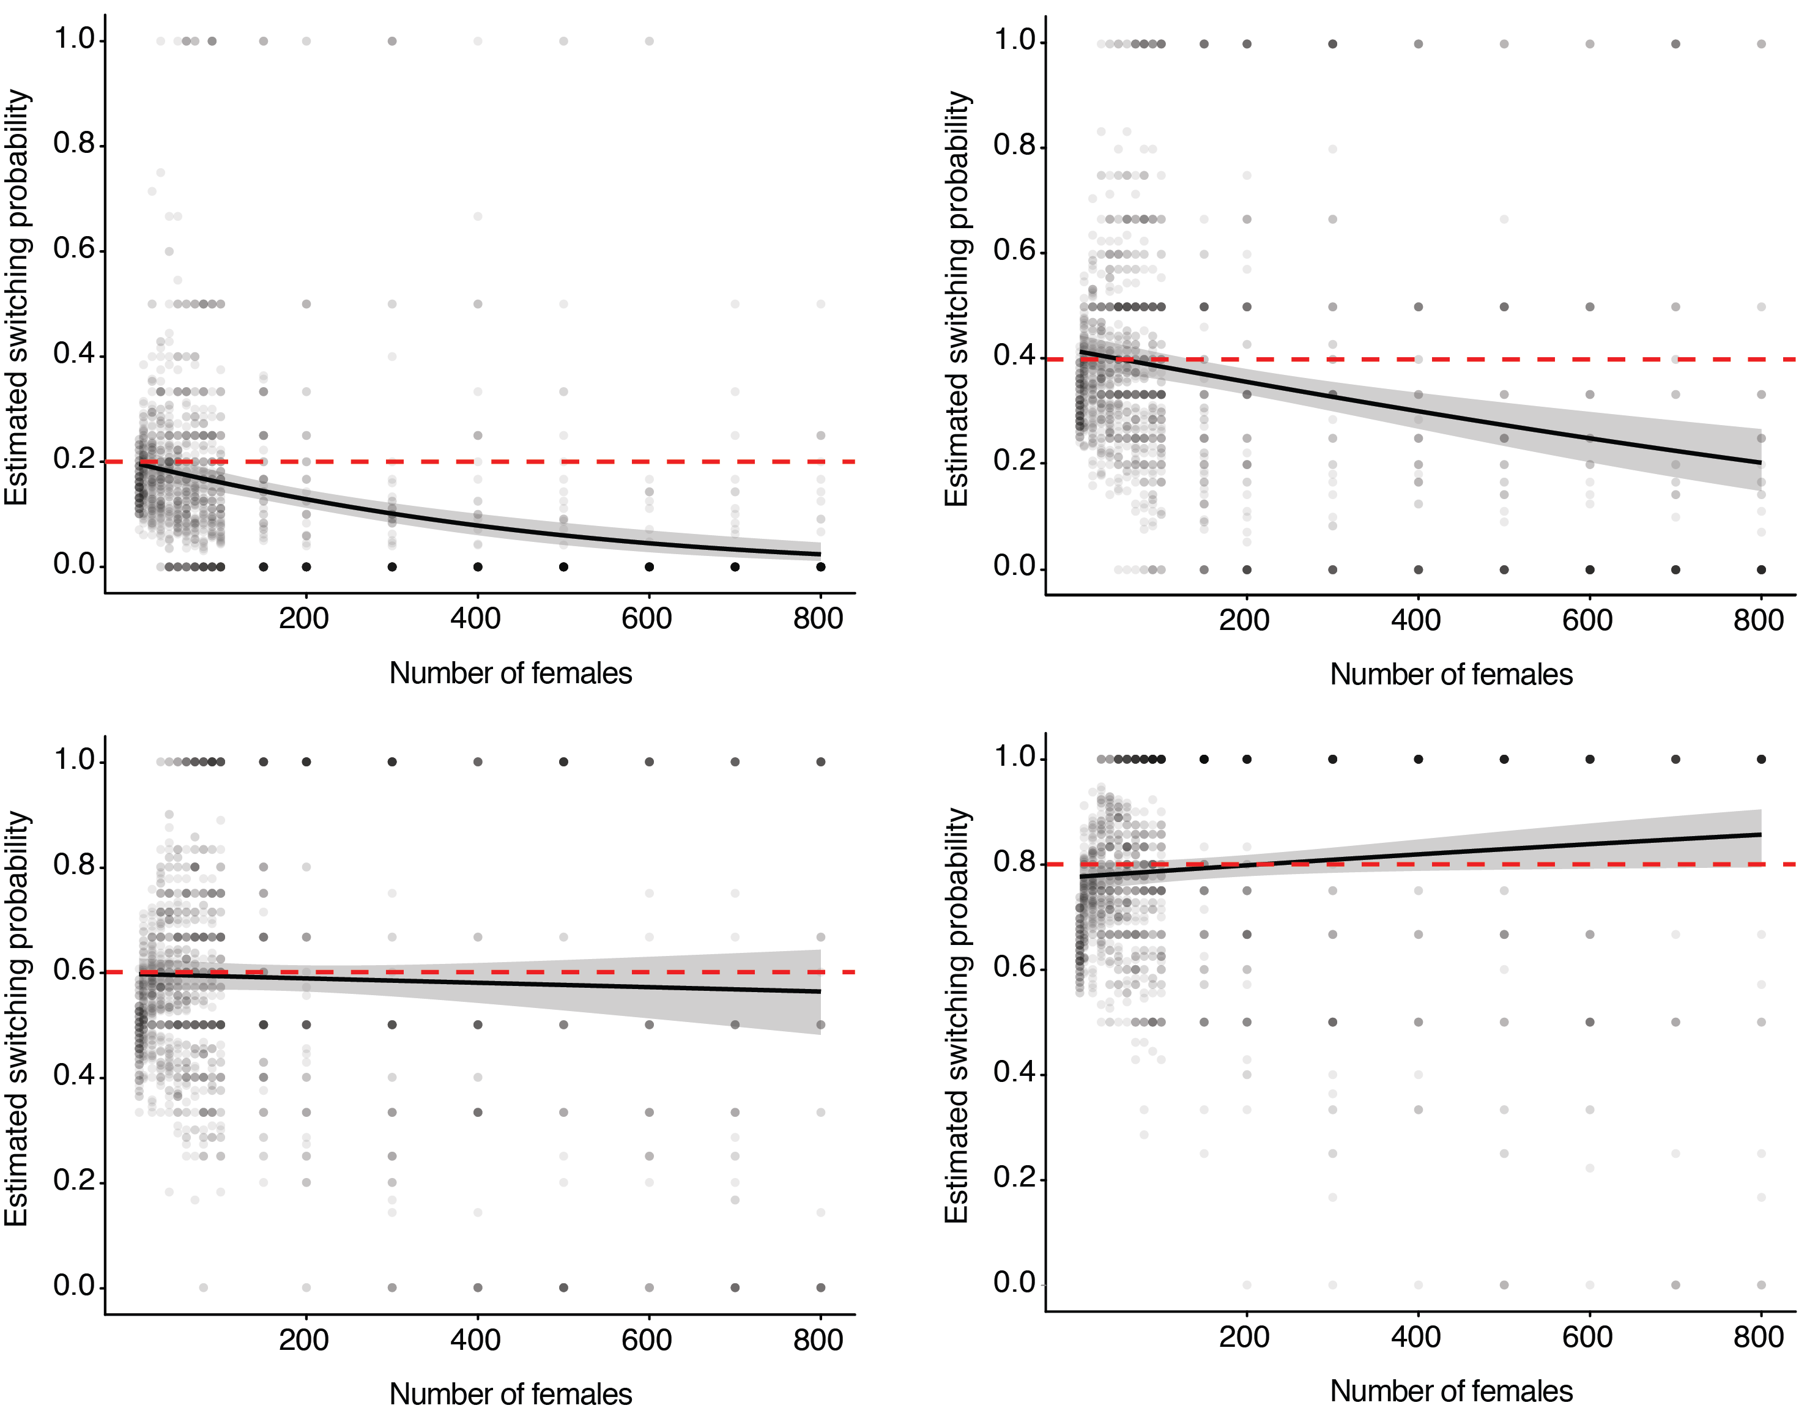

**Figure S1** The relationship between number of females and estimated switching probability in simulations for four egg-sac switching rates (0.2, 0.4, 0.6, and 0.8, set as a model parameter, in graphs a, b, c, and d, respectively). Red lines show the true switching rate; black lines and confidence intervals correspond to estimates of this quantity derived from simulated data. Each value of “number of females” has 2000 simulated “switch” events (n= 58000 total).