SOFTWARE ENGINEERING
LAB – 1

Name : Anand
SRN : PES1UG24AM341
Section : F

Requirements Table :
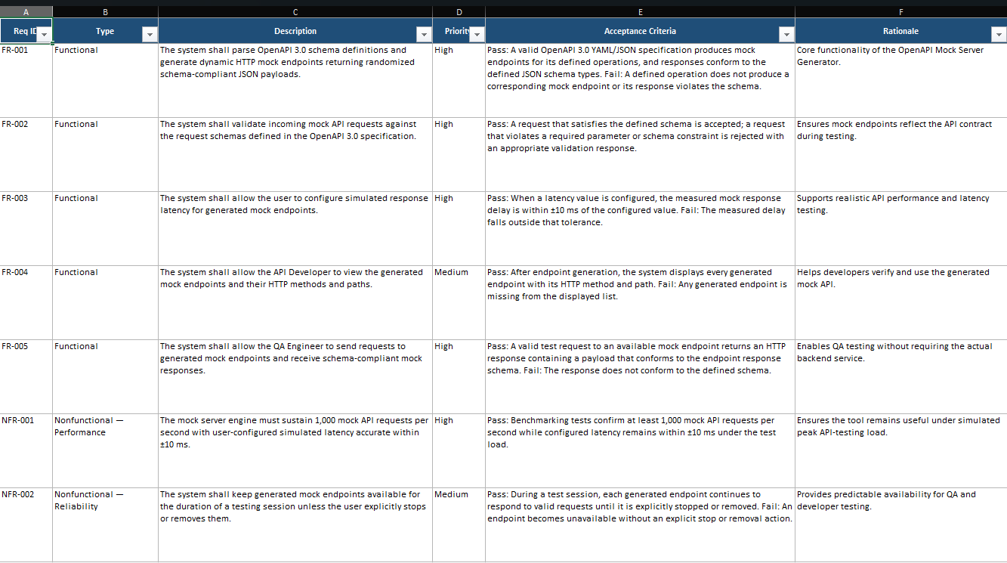

User Flow :
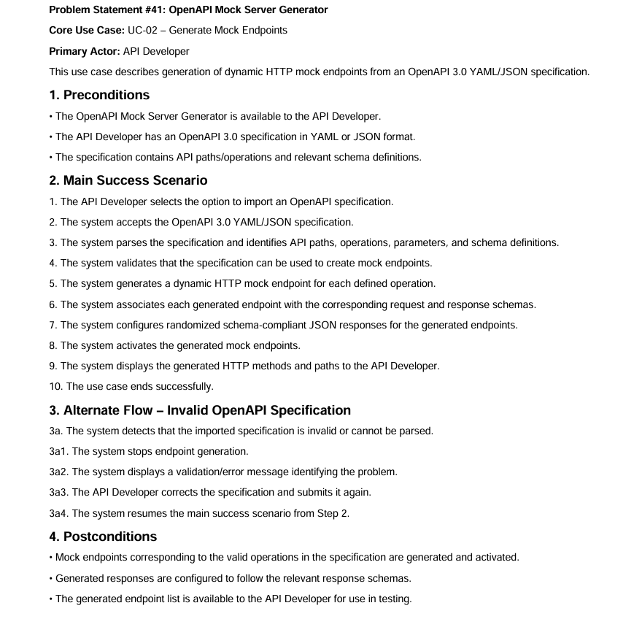

Use Case Diagram :
