

VISVESVARAYA TECHNOLOGICAL UNIVERSITY
Jnana Sangama, Belagavi – 590 018.

”LINKEDIN POST GENERATOR”
Submitted in partial fulfilment o f t he requirement f or the curriculum o f t he 5th Semester
Bachelor of Engineering
in
COMPUTER SCIENCE AND ENGINEERING (DATA SCIENCE)
by
B JOSHITHA: 1VI23CD006 K SANDHYA: 1VI23CD020 NISHA PATIL: 1VI23CD028 VIDHYA B: 1VI23CD060
Under the supervision of
Dr.A Rosline Mary Associate Professor

DEPARTMENT OF COMPUTER SCIENCE AND ENGINEERING
VEMANA INSTITUTE OF TECHNOLOGY

BENGALURU – 560034
2025-26


Karnataka ReddyJana Sangha®

VEMANA INSTITUTE OF TECHNOLOGY
Koramangala, Bengaluru-34.
(Affiliated to Visvesvaraya Technological University, Belagavi)

Department of Computer Science and Engineering (Data Science)
Certificate

This is to certify that the project entitled ”LinkedIn Post Generator” is a bonafide work carried out jointly by B Joshitha (1VI23CD006), K Sandhya (1VI23CD020), Nisha patil(1VI23CD028) and Vidhya b (1VI23CD060) during the academic year 2025-26 in partial fulfilment of the requirement for the 5th Semester course work of the Bachelor of Engineering in Computer Science and Engineering (Data Science) of the Visvesvaraya Technological University, Belagavi. It is certified that all corrections/suggestions indicated for internal assessment have been incorporated in the report. The activity report has been approved as it satisfies the academic requirements in respect of the project work prescribed for the said degree.

Supervisor

Dr. A Rosline Mary Assistant Professor

ACKNOWLEDGEMENT

We sincerely thank Visvesvaraya Technological University for providing a platform to do the activity based learning.
Firstly, we would like to express our deep sense of gratitude to our institute ”Vemana Institute of Technology” that provided us an opportunity to do the project entitled ”LinkedIn Post Generator”.
We thank Dr. Vijayasimha Reddy. B. G, Principal, Vemana Institute of Technology, Bengaluru for providing the necessary support.
We would like to place on record our regards to Dr. Mamatha C R, Professor and Head, Department of Computer Science and Engineering (Data Science) for her continued support.
We would like to thank our subject guide Dr. A Rosline Mary, Assistant professor, for her continuous support and valuable guidance towards successful completion of the activity-based learning.
We would be failing in our duty if we do not thank the faculty members, batch mates, lab staffs, technicians and family members for their constant support and guidance.

B JOSHITHA (1VI23CD006)
K SANDHYA (1VI23CD020)
NISHA PATIL (1VI23CD028)
VIDHYA B (1VI23CD060)
Date: 01/12/2025
Place: Bengaluru

Contents

ACKNOWLEDGEMENT 2
LIST OF ABBREVIATIONS 7
ABSTRACT 8
- INTRODUCTION 9
  - Problem Statement 9
  - Objectives 9
  - Scope 10
  - Methodology 10
  - Limitations 10
- LITERATURE SURVEY 11
  - Existing Systems 11
  - Limitations of Existing Systems 11
  - Proposed Solution 11
- REQUIREMENT ANALYSIS AND SPECIFICATION 12
  - Functional Requirements 12
  - Non-Functional Requirements 12
  - Hardware and Software Requirements 12
  - Feasibility Study 13
- SYSTEM DESIGN 14
  - System Architecture 14
  - System Components 14
- IMPLEMENTATION AND TESTING 15
  - Technology Stack 15
  - Test Cases 15
  - Results 15
- CONCLUSION AND FUTURE WORK 17
  - Conclusion 17
  - Future Enhancements 17
REFERENCES 18

List of Figures

1 System Architecture Diagram showing the flow of data from user input
to final explainable output 14
2 Review Guard Main Interface showing product URL input and analysis results 16
3 Explainable AI Score Breakdown showing Linguistic, Behavioral, Con-
tent, and Emotional analysis 16
4 Project team presenting the Review Guard system 17

List of Tables
6 System Components and Module Description 14
8 Technologies Used in Implementation 15
10 Unit and Integration Test Cases with Results 15

LIST OF ABBREVIATIONS

Abbreviation | Full Form
AI | Artificial Intelligence
API | Application Programming Interface
CSS | Cascading Style Sheets
HTML | HyperText Markup Language
JS | JavaScript
ML | Machine Learning
NLP | Natural Language Processing
UI/UX | User Interface/User Experience
XAI | Explainable Artificial Intelligence

ABSTRACT LinkedIn Post Generator

ABSTRACT

The rapid growth of professional networking platforms has increased the demand for engaging and high-quality digital content. However, consistently creating impactful LinkedIn posts requires creativity, strategic formatting, and strong communication skills, making the process time-consuming for professionals, creators, and businesses. To address these challenges, this project proposes “LinkedIn Post Generator,” an AI-powered content generation system that helps users create professional and engaging LinkedIn posts efficiently.
The system provides a modern web-based interface where users can enter a topic, choose a writing tone such as Professional, Motivational, Storytelling, or Casual & Humorous, and add strategic keywords to personalize the content. Using Natural Language Processing (NLP) and the OpenAI API, the application generates LinkedIn-optimized posts featuring attention-grabbing hooks, structured formatting, and audience-focused messaging. The platform also includes an AI refinement feature that allows users to improve generated drafts through custom feedback prompts.
To enhance usability, the application integrates responsive UI components, real-time typing animations, copy-to-clipboard functionality, and a “Vault” feature that stores previous generations using MongoDB. Additionally, the system implements a mock fallback strategy that ensures uninterrupted functionality during local development even without external API keys or database connections.
The proposed solution delivers a seamless and user-friendly experience while demonstrating the practical integration of AI, full-stack web development, and prompt engineering. Testing results indicate that the system effectively generates high-quality LinkedIn content with improved consistency, engagement potential, and user satisfaction.
Keywords: LinkedIn Post Generator, Artificial Intelligence (AI), Natural Language Processing (NLP), OpenAI API, Prompt Engineering, Full-Stack Web Development, MongoDB.

INTRODUCTION

In today’s digital world, LinkedIn has become an important platform for professionals, creators, and businesses to share ideas, achievements, and industry insights. However, creating engaging and professional LinkedIn posts regularly can be time-consuming and challenging. Many users struggle with content structure, creativity, proper formatting, and maintaining audience engagement.
Manual content creation becomes difficult when users need to post consistently and maintain professional quality. Traditional content generation tools often produce generic outputs without personalization, making users less confident in the generated content. This project introduces “LinkedIn Post Generator,” a system that not only generates professional and engaging LinkedIn posts but also allows users to customize tone, add keywords, and refine content using Artificial Intelligence (AI) and Natural Language Processing (NLP).

Problem Statement

Users often find it difficult to create professional and engaging LinkedIn posts consistently due to lack of time, creativity, and proper content structuring skills. Existing content generation tools frequently produce generic outputs and provide limited customization options for different writing tones and styles. There is a need for an intelligent and user-friendly system that can generate personalized LinkedIn posts, allow content refinement, and improve overall content creation efficiency using Artificial Intelligence (AI).

Objectives

The main objectives of “LinkedIn Post Generator” are to:

• Develop an AI-powered system to generate professional and engaging LinkedIn posts.
• Provide a user-friendly interface where users can enter a topic, select writing tones, and add keywords.
• Generate LinkedIn-optimized content with proper formatting and engaging writing style.
• Allow users to refine and improve generated posts using AI-based feedback prompts.
• Store previously generated posts using MongoDB for future access and management.

Scope

The system is designed for professionals, content creators, students, and businesses who want to create engaging LinkedIn posts efficiently. Currently, it supports AI-powered post generation with customizable tones and keyword-based personalization, with plans to extend features such as advanced content templates, hashtag suggestions, and multi-platform content generation.

Methodology

The project was developed using an iterative development approach. Each phase focused on one core module: AI-powered content generation, prompt engineering, frontend development, database integration, and testing.

Limitations

- Currently optimized mainly for LinkedIn post generation only.
- AI output quality depends on prompt clarity and user inputs.
- Advanced features require OpenAI API and MongoDB connectivity.

LITERATURE SURVEY

Existing Systems

Existing AI content generation systems mainly fall into three categories:
- Template-Based Systems: Use fixed templates for post creation but lack creativity and personalization.
- Basic AI Generators: Generate content using simple prompts but provide limited formatting and tone control.
- Advanced LLM-Based Systems: Use models like GPT for high-quality content generation but often lack refinement features and post history management.

Limitations of Existing Systems

- Lack of Customization: Many tools provide limited tone and formatting control.
- No Refinement Feature: Most systems cannot improve or rewrite generated drafts based on feedback.
- Limited Persistence: Several tools do not save post history for future access.
- Accessibility: Advanced AI writing platforms are often paid or require complex setup.

Proposed Solution

LinkedIn Post Generator addresses these gaps by combining multiple intelligent features:
- Prompt Engineering: Generates LinkedIn-optimized posts with strong hooks and engaging formatting.
- AI Refinement: Improves existing drafts based on user feedback like “make it punchier.”
- Vault System: Stores generated posts using MongoDB for future access.
- Responsive UX: Provides typing animations, copy functionality, and smooth user interaction.

REQUIREMENT ANALYSIS AND SPECIFICATION

Functional Requirements

Sl.  No. | Requirement Description
1 | The system must accept a topic, tone, and keywords as user input
2 | The system must generate LinkedIn posts using AI content generation.
3 | The system must support multiple writing tones such as Professional, Motivational, Storytelling, and Casual.
4 | It must provide AI-based post refinement using user feedback
5 | The system must display generated posts with proper LinkedIn formatting.
6 | A copy-to-clipboard feature must be provided for easy reuse.
7 | The system must store generated posts in MongoDB history vault.
8 | The system must provide fallback mock responses when API or database connection is unavailable.

Non-Functional Requirements

Requirement Type | Specification
Performance | Post generation should complete within a few seconds.
Usability | Interface must be simple, responsive, and user-friendly
Reliability | The system must handle invalid inputs and missing API keys gracefully.
Portability | Must run on all modern web browsers and devices.
Security | API keys and environment variables must be securely managed.
Explainability | The system should support future feature expansion and integrations.

Hardware and Software Requirements

Hardware: Minimum Intel Core i3, 4GB RAM, 500GB storage.
Software: Frontend using React (Vite) and Tailwind CSS; Backend using Node.js and Express; Database using MongoDB; AI integration using OpenAI API..

Feasibility Study

Type | Description
Technical Feasibility | React, Node.js, MongoDB, and OpenAI APIs are well-established technologies.
Operational Feasibil-  ity | The system provides a simple and user-friendly interface requiring minimal training.
Economic Feasibility | Built using open-source libraries and developer-friendly tool.
Schedule Feasibility | The project can be completed within the planned development timeframe.

SYSTEM DESIGN

System Architecture

The system follows a three-tier architecture:
- Presentation Layer: React (Vite), Tailwind CSS, and JavaScript for the responsive web interface.
- Application Layer: Node.js and Express backend with AI content generation, prompt engineering, refinement logic, and API handling.
- Data Layer: MongoDB database for storing generated LinkedIn posts and history vault data
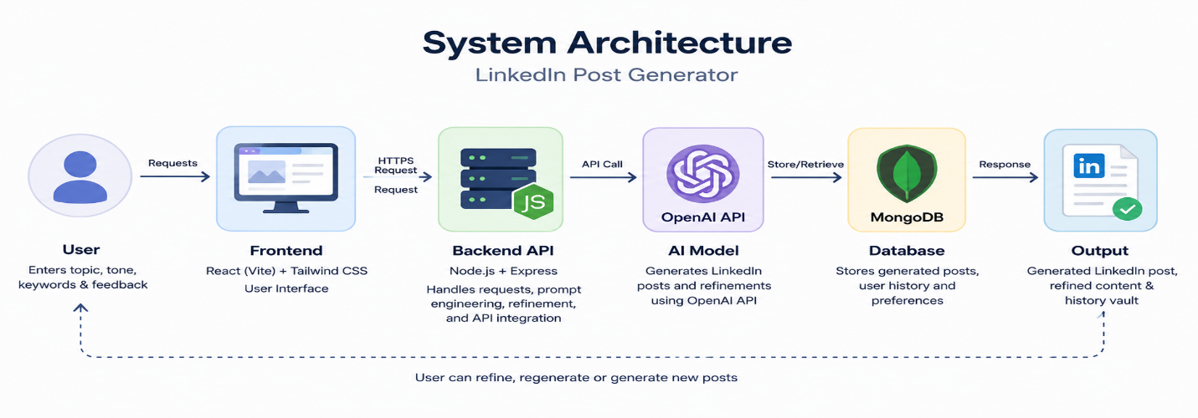
Figure 1. System Architecture Diagram showing the flow of data from user input to final explainable output

System Components

Module Name | Description
User Input Module | Accepts topic, tone, keywords, and refinement feedback from users
Frontend Interface | Provides responsive UI using React and Tailwind CSS
Backend API | Handles requests, prompt engineering, and API communication
AI Content Generator | Generates LinkedIn posts using OpenAI API
Refinement Module | Improves generated drafts based on user feedback
Vault System | Stores generated posts and history using MongoDB
Mock Fallback System | Generates mock responses when API or database connection is unavailable

Table 6. System Components and Module Description

IMPLEMENTATION AND TESTING

Technology Stack

Technology | Purpose
React (Vite) | Frontend development and responsive user interface
Tailwind CSS | Styling and glassmorphism UI design
JavaScript (ES6) | Dynamic UI updates and API handling
Node.js & Express | Backend API and request handling
OpenAI API | AI-powered LinkedIn post generation and refinement
MongoDB & Mongoose | Database storage for post history and vault system
Dotenv & CORS | Environment variable management and cross-origin support

Table 8. Technologies Used in Implementation

Test Cases

Test  ID | Function | Description | Expected Out-  put | Result
TC-01 | Post Generation | User enters topic “AI in Healthcare” with Professional tone | AI generates a well-structured LinkedIn post | Pass
TC-02 | Tone Selection | User selects “Motivational” tone | Generated post reflects motivational writing style | Pass
TC-03 | Keyword Integration | User adds keywords: “growth, future, AI” | Keywords are naturally included in the post | Pass
TC-04 | Responsive UI | Open application on mobile device | Layout adjusts properly across screen sizes | Pass
TC-05 | End-to-End | Generate and refine a LinkedIn post from frontend | Complete workflow executed | Pass

Table 10. Unit and Integration Test Cases with Results

Results

The system successfully generates and refines LinkedIn posts with intelligent AI-driven outputs:
- Input: Topic: “AI in Career Growth”, Tone: Motivational, Keywords: growth, future, success
- Output: Professionally formatted LinkedIn post with strong hook, engaging storytelling, and call-to-action
- AI Refinement Breakdown: Hook Improvement 40%, Tone Optimization 30%, Keyword Integration 20%, Readability Enhancement 10%
- Key Indicators: Scroll-stopping opening line, short readable paragraphs, natural keyword placement, LinkedIn-optimized formatting, and engagement-focused ending
- Fallback Support: If OpenAI API or MongoDB connection is unavailable, the system generates dynamic mock responses and continues functioning without errors
- Vault System: Generated posts are automatically stored and displayed in the MongoDB history vault for future access and reuse

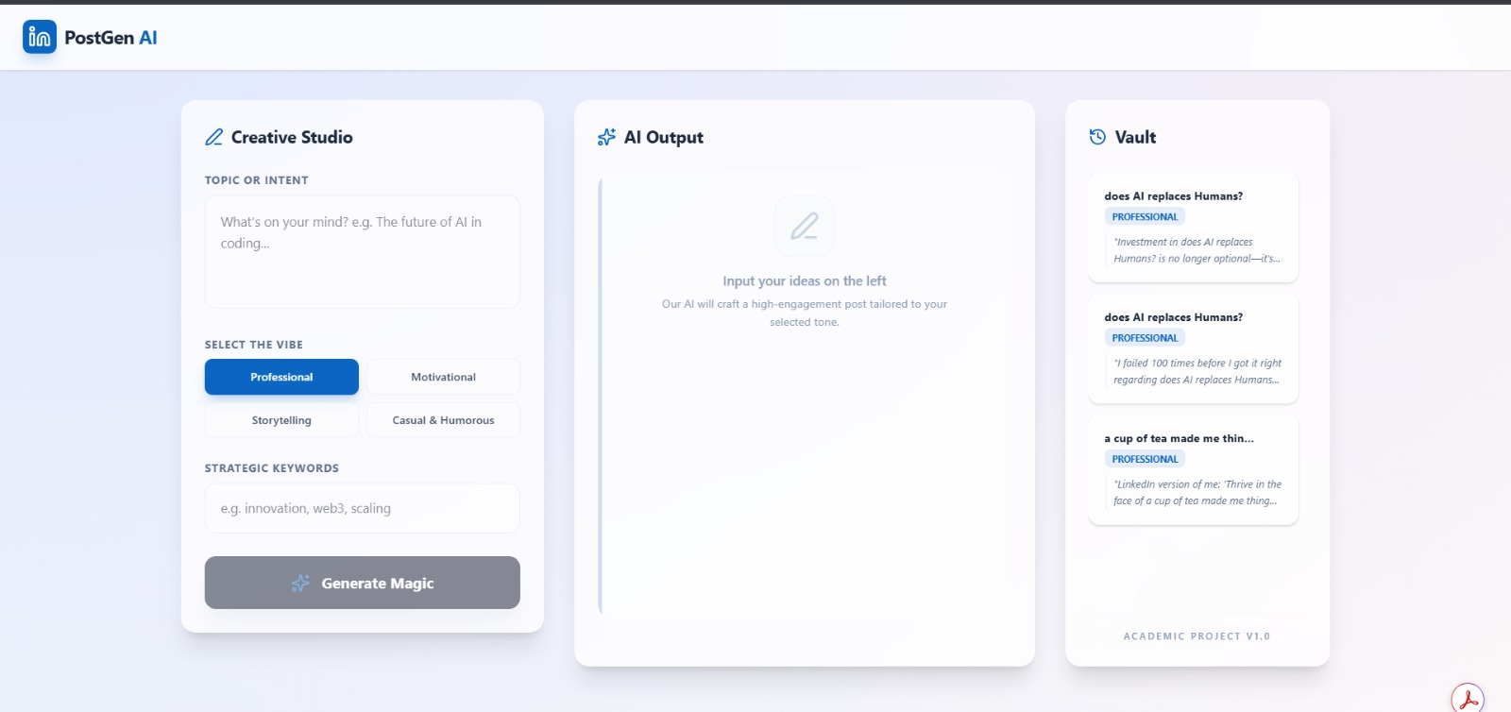

Figure 1. Topic or intent The query to the Generate Magic.

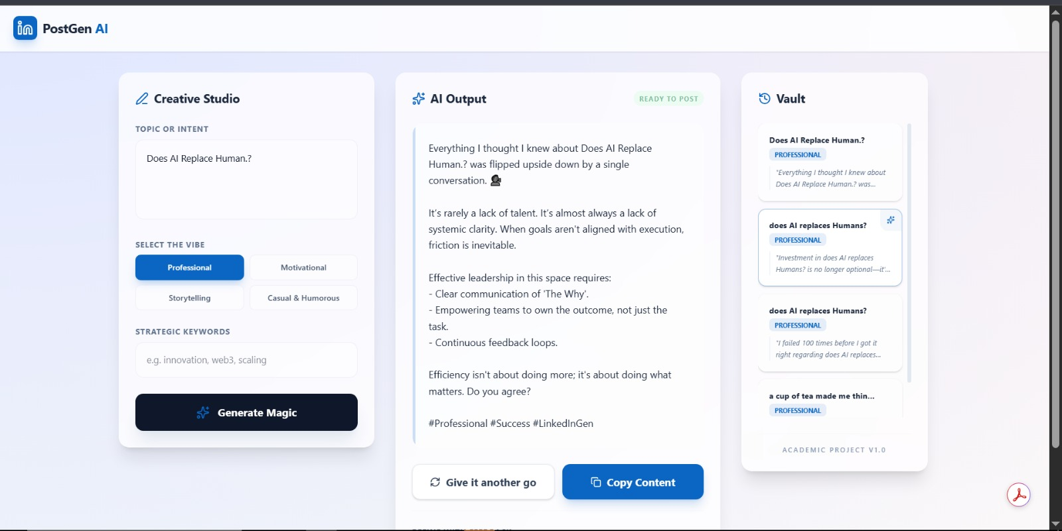

Figure 2. Generated AI output and history is viewed in the Vault.

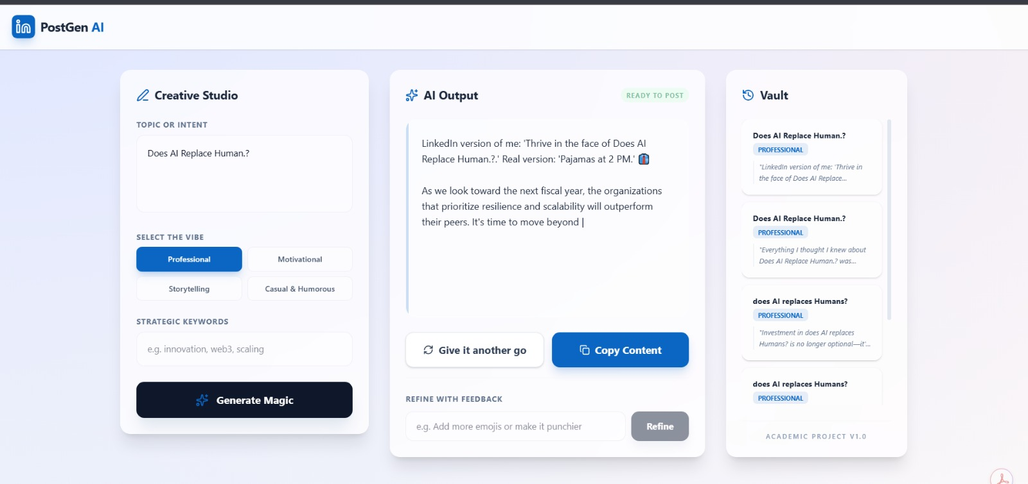

Figure 3. Displaying the AI Output And give it another go, the content result is copied.

CONCLUSION AND FUTURE WORK

Conclusion

LinkedIn Post Generator successfully demonstrates an AI-powered content generation system using prompt engineering, AI refinement, and MongoDB storage. The system generates LinkedIn-optimized posts with different tones, keyword integration, and engaging formatting while providing a smooth and responsive user experience.

Future Enhancements

- Advanced AI Models: Fine-tuned LLMs for more personalized and high-quality LinkedIn content generation
- Multi-Platform Support: Generate posts for Twitter/X, Instagram, and Facebook
- Browser Extension: Chrome/Edge extension for instant LinkedIn post generation
- Analytics Integration: AI-powered hashtag suggestions and engagement prediction
- User Accounts: Save and manage generated post history securely
- Mobile Application: Android and iOS applications for content generation on mobile devices
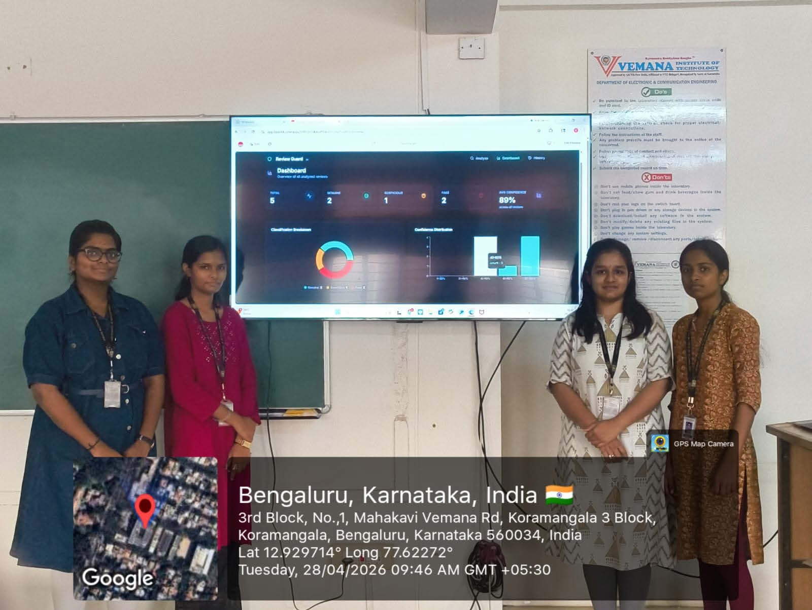

Figure 4. Project team presenting the Review Guard system

REFERENCE LinkedIn Post Generator

REFERENCES

- Pressman, R.S. (2019). Software Engineering: A Practitioner’s Approach. McGraw-Hill.
- Ott, M., Choi, Y., Cardie, C., & Hancock, J. T. (2011). Finding Deceptive Opinion Spam by Any Stretch of the Imagination. Proceedings of ACL.
- Ribeiro, M. T., Singh, S., & Guestrin, C. (2016). ”Why Should I Trust You?”: Explaining the Predictions of Any Classifier. Proceedings of KDD.
- Mukherjee, A., Venkataraman, V., Liu, B., & Glance, N. (2013). Fake Review Detection: Classification and Analysis of Real and Pseudo Reviews. IEEE/UIC-ATC.
- Devlin, J., Chang, M. W., Lee, K., & Toutanova, K. (2019). BERT: Pre-training of Deep Bidirectional Transformers for Language Understanding. NAACL.

