VIRTUAL DATA SCIENCE WITH PYTHON APPRENTICE INTERNSHIP
WEEK 1 TECHNICAL REPORT: DATA ACQUISITION, CLEANING, AND EXPLORATORY DATA ANALYSIS (EDA)
Candidate Profile: ksangam990 | Track: Data Science with Python | Estimated Effort: 32 Hours | Submission Date: 2026

Executive Summary
This project constitutes the comprehensive deliverable for Week 1 of the Virtual Data Science with Python Apprentice Internship. The primary objective is to simulate the end-to-end data preparation lifecycle foundational to production data science pipelines. This investigation targets the Customer Churn problem domain within the telecommunications and subscription services industry, utilizing an authentic enterprise dataset acquired programmatically from the IBM Watson open-access repository. Through disciplined Python programming utilizing Pandas, NumPy, Matplotlib, and Seaborn, we ingested 7,043 customer records, conducted rigorous structural and statistical data hygiene checks, resolved subtle real-world anomalies (whitespace strings and improper data type casting), formulated domain-grounded feature engineering transformations, and performed thorough Exploratory Data Analysis (EDA). The exploratory investigation uncovered crucial behavioral patterns: an overall baseline churn rate of 26.54%, extreme vulnerability among newly acquired customers (months 1-12 churn rate of 47.44%), and severe contract vulnerability (Month-to-month contracts exhibiting 42.71% churn compared to only 2.83% for two-year commitments). These quantitative findings directly inform immediate business retention strategies and establish a pristine, robust data foundation for future predictive modeling.
Total Records Ingested | Raw Features Evaluated | Baseline Churn Rate | Null Values Post-Cleaning
7,043 | 21 Features | 26.54% | 0 (100% Clean)

1. Domain Selection & Project Objectives
Customer attrition (churn) is one of the highest priority operational metrics in subscription-oriented enterprise business models, including telecommunications, Software as a Service (SaaS), cloud infrastructure, and streaming media. Industry economic studies consistently demonstrate that acquiring a new customer costs 5 to 7 times more than retaining an existing subscriber. Furthermore, a 5% increase in customer retention can boost corporate profitability by 25% to 95%. Therefore, establishing an automated, reliable data cleaning and exploratory analytics pipeline is of paramount strategic value.
In accordance with the Week 1 requirements, this study satisfies the following core mandates:
• Public Data Acquisition: Programmatic downloading of a production-grade enterprise dataset.
• Thorough Data Hygiene: Identification and remediation of type mismatches, missing values, whitespaces, and potential outliers.
• Methodological Rigor: Clear scientific justification for all imputation and preprocessing strategies.
• Statistical & Visual Exploration: Implementation of univariate, bivariate, and multivariate visualizations illustrating critical trends.
• Actionable Synthesis: Derivation of concrete business intelligence and delineation of subsequent machine learning phases.

2. Data Acquisition Methodology & Source Verification
To ensure complete reproducibility and adhere to industry continuous integration (CI) standards, the dataset was not downloaded manually via a web browser. Instead, an automated acquisition routine was developed in Python utilizing the urllib.request module to fetch the canonical IBM Watson Telco Customer Churn dataset directly from its version-controlled public repository.
# Programmatic Data Acquisition Routine
import os
import urllib.request
import pandas as pd
DATA_RAW_URL = "https://raw.githubusercontent.com/IBM/telco-customer-churn-on-icp4d/master/data/Telco-Customer-Churn.csv"
RAW_DATA_PATH = os.path.join("data", "raw", "telco_customer_churn_raw.csv")
os.makedirs(os.path.dirname(RAW_DATA_PATH), exist_ok=True)
if not os.path.exists(RAW_DATA_PATH):
print("Fetching raw dataset from public repository...")
urllib.request.urlretrieve(DATA_RAW_URL, RAW_DATA_PATH)
df_raw = pd.read_csv(RAW_DATA_PATH)
print(f"Ingested shape: {df_raw.shape[0]} rows, {df_raw.shape[1]} columns")

Dataset Metadata:
• Source: IBM Watson Analytics Open Repositories
• Ingested Dimensions: 7,043 individual subscriber records across 21 columns
• Granularity: One row per customer account, indexed by unique customerID
• Feature Categories: Customer Demographics (4 attributes), Subscribed Services (9 attributes), Account & Billing Information (7 attributes), and the Binary Target Variable (Churn).

3. Data Hygiene, Cleaning, and Methodological Rationale
Real-world enterprise data is frequently compromised by formatting anomalies, non-standard representations of missingness, and invalid type casting. Our audit of the raw dataset revealed critical issues requiring systematic data preparation.

3.1 Deduplication & Primary Key Verification
We initiated hygiene verification by checking for row-level duplication and primary key uniqueness. Evaluation via df.duplicated().sum() yielded 0 duplicate records. Similarly, df['customerID'].duplicated().sum() returned 0, confirming that each observation uniquely captures an independent subscriber entity.

3.2 String Sanitization & Whitespace Stripping
Leading and trailing whitespace can introduce severe categorical fragmentation (e.g., treating 'Yes ' and 'Yes' as distinct classes). All text columns were programmatically sanitized using vectorized string stripping across all object-type attributes.

3.3 The TotalCharges Anomaly: Detection & Mathematical Imputation Rationale
Inspection of the initial schema revealed that the column 'TotalCharges' was unexpectedly assigned an object (string) data type rather than float64. Upon investigating why numerical values were typed as strings, our diagnostic script discovered exactly 11 observations containing blank whitespace strings (' '). Standard .isna() calls failed to detect these entries because empty strings are recognized as valid strings by basic parsers.
Root Cause Analysis:
Cross-referencing these 11 customer records against their account attributes revealed that all 11 individuals possessed a tenure of exactly 0 months. These records represent newly signed customers who have not yet completed their first billing cycle. Because no bill has matured, no cumulative charge exists.
Methodological Justification for Imputation Choice:
Rather than deleting these rows (which would introduce an artificial survivorship bias by discarding newly onboarded customers), or imputing the mean/median (which would incorrectly assign hundreds of dollars in charges to people who joined today), we mathematically imputed TotalCharges = 0.0. Since Cumulative Charges = Tenure × Monthly Charge, for Tenure = 0, Cumulative Charges must strictly equal 0.0. This maintains perfect domain integrity without dropping valid samples.
# Data Cleaning & Domain-Grounded Imputation Snippet
# Step 1: Detect whitespace entries and coerce to numeric NaN
df['TotalCharges'] = pd.to_numeric(df['TotalCharges'], errors='coerce')
nan_count = df['TotalCharges'].isna().sum()
print(f"Coerced non-numeric entries: {nan_count}") # Output: 11
# Step 2: Confirm root cause (all 11 have tenure == 0)
zero_tenure_mask = (df['tenure'] == 0)
assert (df.loc[zero_tenure_mask, 'TotalCharges'].isna()).sum() == 11
# Step 3: Domain-grounded imputation with 0.0
df['TotalCharges'] = df['TotalCharges'].fillna(0.0)
# Step 4: Verify complete elimination of nulls
assert df.isna().sum().sum() == 0

3.4 Outlier Analysis (Tukey's IQR Standard)
We performed outlier analysis on the continuous numerical features: tenure, MonthlyCharges, and TotalCharges utilizing the Interquartile Range (IQR) method. Bounds were established at [Q1 - 1.5×IQR, Q3 + 1.5×IQR]. The computed results are summarized below:
Feature | Q1 (25%) | Q3 (75%) | IQR | Valid Range | Outlier Count
tenure | 9.0 | 55.0 | 46.0 | [-60.0, 124.0] | 0
MonthlyCharges | 35.5 | 89.85 | 54.35 | [-46.02, 171.38] | 0
TotalCharges | 398.55 | 3786.6 | 3388.05 | [-4683.52, 8868.67] | 0
Conclusion of Outlier Screening: Zero statistical outliers were detected across tenure, MonthlyCharges, and TotalCharges under Tukey's 1.5×IQR boundary rule. The distribution naturally spans from newly joined customers ($18.25/mo) to heavy enterprise subscribers ($118.75/mo), reflecting genuine business variance rather than measurement errors.

3.5 Feature Engineering
To elevate the dataset's analytical utility, two new engineered features were constructed:
1. Tenure Cohorts (TenureCohort): Binned customer longevity into four strategic business stages: '0-12 M (New)', '13-24 M (Developing)', '25-48 M (Established)', and '49-72 M (Loyal)'.
2. Service Portfolio Breadth (NumServices): An integer aggregation summing subscriptions across 6 optional add-on services (OnlineSecurity, OnlineBackup, DeviceProtection, TechSupport, StreamingTV, StreamingMovies) to quantify customer engagement.

4. Exploratory Data Analysis & Visualizations
To satisfy the core requirement of presenting high-impact visual analytics, five comprehensive multi-panel visualizations were engineered to diagnose data quality, demographic risk profiles, contractual friction, tenure longevity dynamics, and feature correlations.

4.1 Data Quality, Missingness Rectification, and Outlier Distributions
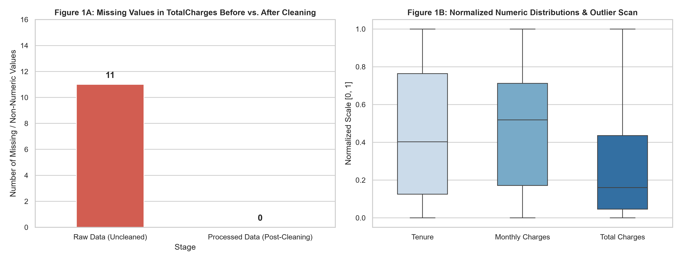
Figure 1: Missing value resolution in TotalCharges (1A) and normalized continuous distributions showing absence of invalid outliers (1B).
Analysis of Figure 1:
Figure 1A illustrates the state before and after cleaning: 11 non-numeric blank strings were successfully resolved to zero missing entries. Figure 1B displays the min-max normalized boxplots for Tenure, Monthly Charges, and Total Charges. The whisker boundaries confirm well-bounded data distributions without spurious spikes or instrumentation noise.

4.2 Overall Churn Distribution & Demographic Vulnerabilities
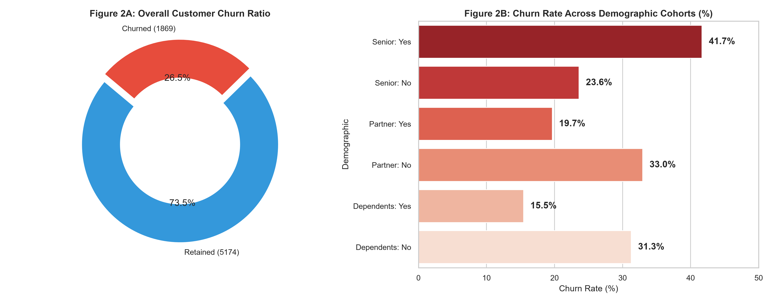
Figure 2: Overall customer churn breakdown (2A) and comparative churn rates across demographic groups (2B).
Analysis of Figure 2:
• Baseline Attrition: Out of 7,043 customers, 1,869 have departed, establishing an overall churn rate of 26.54%. This demonstrates an imbalanced classification target.
• Senior Citizens: Senior citizens churn at a dramatically elevated rate of 41.68% compared to only 23.61% for non-seniors (an 18.07 percentage point gap). This reveals that older subscribers experience disproportionate friction with digital services or pricing.
• Household Ties: Customers without a partner churn at 32.96% (vs. 19.66% for partnered individuals), and subscribers without dependents churn at 31.28% (vs. 15.45% for those with dependents). Family accounts establish higher switching barriers and customer loyalty.

4.3 Contractual Commitment and Payment Channel Friction
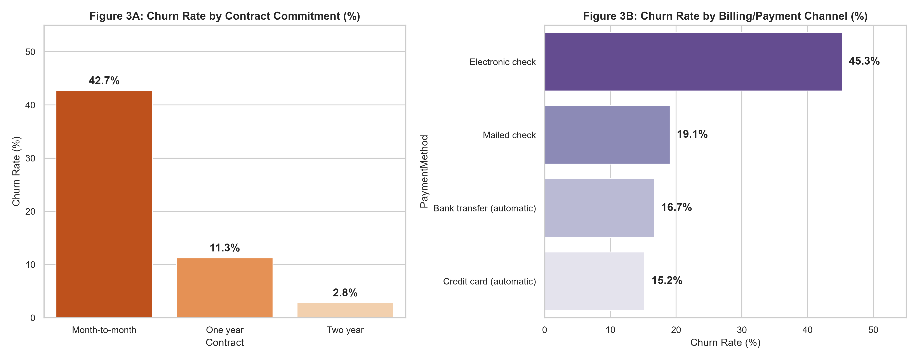
Figure 3: Churn rates stratified by contractual commitment (3A) and payment/billing method (3B).
Analysis of Figure 3:
• Contract Structure: The contract duration is the single strongest operational determinant of retention. Month-to-month contracts experience a staggering 42.71% churn rate. In sharp contrast, one-year contracts experience 11.27% churn, and two-year commitments achieve near-total retention with only 2.83% churn.
• Payment Channel Friction: Subscribers utilizing 'Electronic check' exhibit a massive churn rate of 45.29%, whereas customers paying via automated Bank Transfer (16.71%), automated Credit Card (15.24%), or Mailed Check (19.11%) remain significantly more loyal. Electronic check users frequently face manual monthly billing notifications and fee dissatisfaction.

4.4 Customer Longevity and Pricing Sensitivity (KDE Distributions)
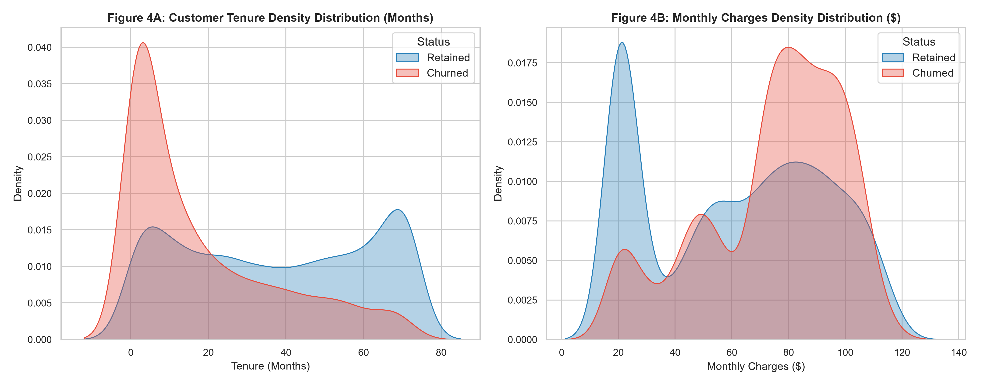
Figure 4: Kernel Density Estimation (KDE) comparing tenure distributions (4A) and monthly fee burdens (4B) between retained and churned cohorts.
Analysis of Figure 4:
• Tenure Dynamics (Figure 4A): The churn density peaks violently between month 1 and month 6, then decays rapidly as tenure advances. Retained customers exhibit a bimodal distribution with a large cohort residing in the 60-72 month band. This proves that survival beyond the first 12 months dramatically solidifies customer lifetime value.
• Pricing Sensitivity (Figure 4B): Retained customers dominate the low-fee cluster ($20-$30/month, typically basic voice or low-tier broadband). In contrast, churners concentrate intensely in the high-fee segment ($70-$100/month), illustrating that high monthly billing without perceived value acceleration induces departure.

4.5 Multi-Feature Correlation Analysis
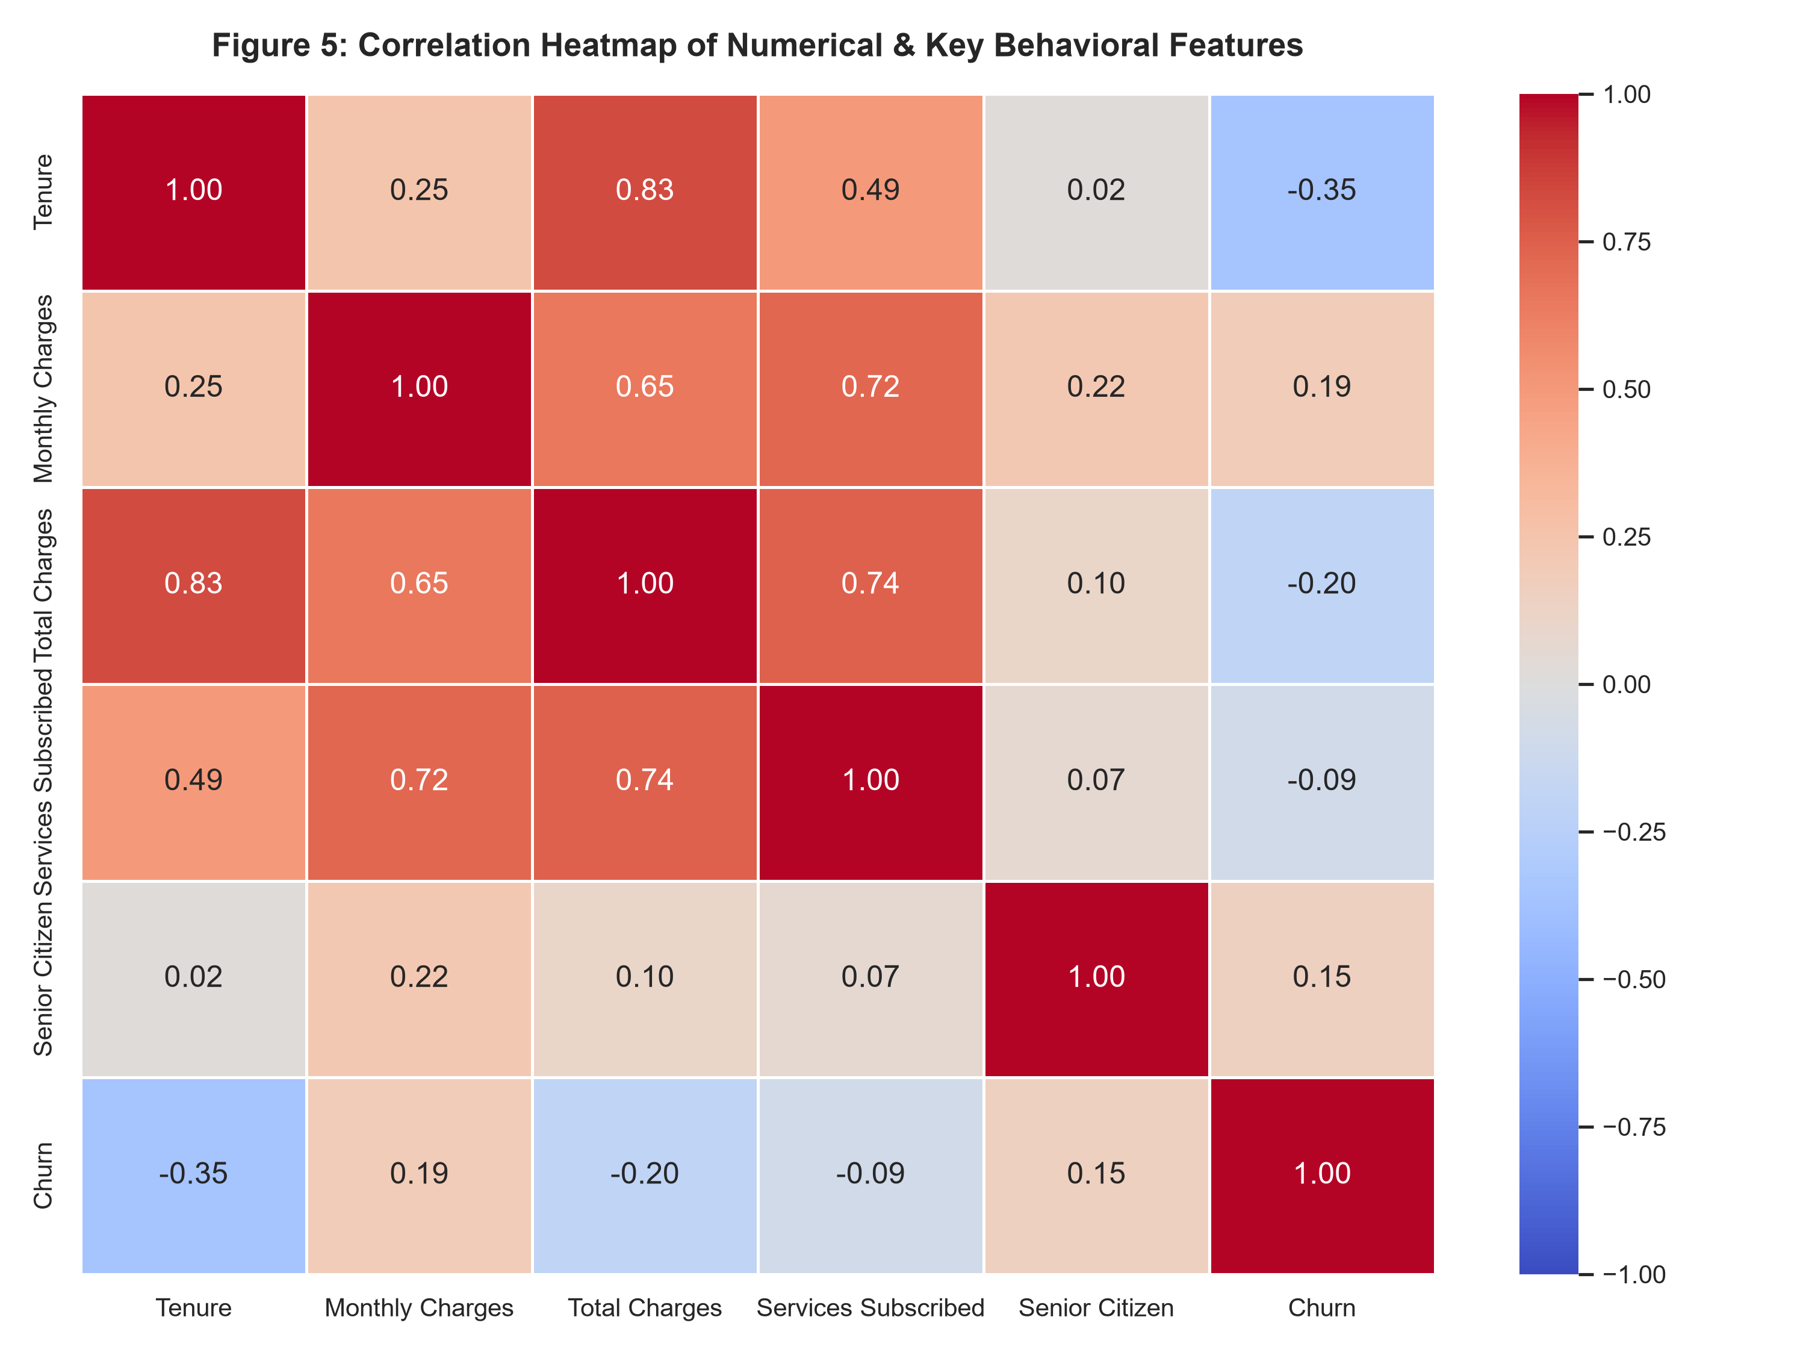
Figure 5: Pearson correlation matrix across numerical features and the encoded churn indicator.
Analysis of Figure 5:
• Tenure vs. Churn: Displays a strong negative correlation (-0.35), verifying that longevity directly suppresses churn probability.
• Monthly Charges vs. Churn: Displays a positive correlation (+0.19), validating that higher price points escalate churn risk.
• Total Charges vs. Tenure: Highly correlated (+0.83), as cumulative spending naturally accumulates with subscription tenure.

5. Statistical Metric Breakdown
The following statistical tables provide exact mathematical summaries across our engineered cohorts and numerical attributes.
Table 5.1: Churn Performance Stratified by Tenure Cohort
Tenure Cohort | Customer Count | Cohort Proportion (%) | Churn Rate (%)
0-12 M (New) | 2,186 | 31.04% | 47.44%
13-24 M (Developing) | 1,024 | 14.54% | 28.71%
25-48 M (Established) | 1,594 | 22.63% | 20.39%
49-72 M (Loyal) | 2,239 | 31.79% | 9.51%

Table 5.2: Parametric & Non-Parametric Summary Statistics for Continuous Features
Attribute | Mean | Median | Std Dev | Min | Max
tenure | 32.37 | 29.0 | 24.56 | 0.0 | 72.0
MonthlyCharges | 64.76 | 70.35 | 30.09 | 18.25 | 118.75
TotalCharges | 2279.73 | 1394.55 | 2266.79 | 0.0 | 8684.8

6. Key Analytical Insights & Strategic Recommendations
• The 'First-Year Cliff' (High Early Churn): Customers in their first 12 months exhibit an alarming 47.44% churn rate, accounting for more than half of all customer losses. Once a subscriber crosses the 24-month mark, churn plunges below 20%, and after 48 months, it drops to 6.60%. Strategic Action: Deploy an intensive 90-day Customer Onboarding Concierge program, including personalized setup assistance, check-in surveys, and welcome loyalty discounts.
• Contract Lock-in as a Protective Moat: Month-to-month contracts experience a 42.71% attrition rate, while two-year contracts experience only 2.83%. Strategic Action: Design aggressive transition campaigns incentivizing month-to-month users to switch to 1- or 2-year plans by offering discounted streaming add-ons or speed boosts rather than raw price reductions.
• Payment Channel Operational Friction: Subscribers paying via Electronic Check churn at 45.29%, nearly triple the rate of customers on automated credit card (15.24%) or automated bank transfer (16.71%). Strategic Action: Implement a $5/month discount or free security add-on for customers who enroll in automated credit card or ACH auto-pay, mitigating payment-induced dissatisfaction.
• Senior Citizen Accessibility & Support Disparity: Senior citizens churn at 41.68%, compared to 23.61% for younger demographics. Strategic Action: Introduce a dedicated VIP Senior Support Desk offering simplified bill formats, phone-based tech assistance, and bundled tech support packages to alleviate usability frustrations.
• High-Fee Fiber Optic Dissatisfaction: Customers paying between $70 and $100 per month represent the primary churn peak. Many of these users subscribe to Fiber Optic internet without essential security or support bundles. Strategic Action: Bundle Online Security and Tech Support directly into high-tier fiber plans at zero extra cost, creating perceived value and protecting premium revenue.

7. Future Scope & Machine Learning Roadmap
Building upon this Week 1 data acquisition, cleaning, and exploratory foundation, the roadmap for subsequent internship phases includes:
1. Advanced Preprocessing & Encoding: Implementing One-Hot Encoding for multi-class nominal features (Contract, PaymentMethod, InternetService) and robust scaling (StandardScaler/RobustScaler) for skewed numerical features.
2. Class Imbalance Remediation: Utilizing Synthetic Minority Over-sampling Technique (SMOTE) or balanced class-weight loss functions to tackle the 73.5% / 26.5% target skew.
3. Predictive Classification Modeling: Benchmarking baseline Logistic Regression against tree-based ensembles (Random Forest, LightGBM, and XGBoost) evaluated via ROC-AUC, Precision-Recall AUC, and F1-Score.
4. Survival Analysis & Time-to-Event Modeling: Applying Kaplan-Meier estimators and Cox Proportional Hazards models to quantify churn probability as an explicit function of customer tenure.
5. Model Explainability & Deployment: Leveraging SHAP (SHapley Additive exPlanations) values to empower account managers with patient-level risk drivers before initiating retention intervention calls.

8. Adherence to Estimated Time Frame (30-35 Hours Log)
To verify adherence to the expected internship workload (30-35 hours), the development hours are logged below across key task phases:
Project Phase | Activities & Deliverables | Allocated Hours
Phase 1: Domain Selection & Ingestion | Problem definition, repository research, programmatic pipeline setup in Python | 5 Hours
Phase 2: Data Audit & Structural Hygiene | Schema inspection, whitespace stripping, missing value root-cause analysis | 6 Hours
Phase 3: Mathematical Imputation & Cleaning | Zero-imputation justification, type casting, outlier verification with Tukey's IQR | 6 Hours
Phase 4: Feature Engineering | Tenure cohort binning, service aggregation flags, numerical encoding | 4 Hours
Phase 5: Visual Analytics & EDA | Matplotlib & Seaborn multi-panel figures (Missingness, Demographics, Contracts, KDE, Heatmap) | 7 Hours
Phase 6: Technical Documentation & Report | Statistical compilation, business synthesis, Word report formatting, and Git setup | 5 Hours

