NALASHAA DIGITAL
Synapse Integration Platform
Business Requirements Document & Developer Handover
Version 1.0
Date: 4 May 2026
Classification: Internal
BU: Nalashaa Digital (GLOBAL)

Prepared for: Incoming Developer + Project Manager
Prepared by: Synapse Product Team

Table of Contents

[Right-click → Update Field in Word to populate the TOC]

1. Document Control
1.1 Version History
Version | Date | Author | Summary of Changes
0.1 | 2026-04-22 | Product Team | Internal status note (PRODUCT_STATUS.md) drafted.
0.5 | 2026-04-30 | Product Team | Charter v2.1 published (Synapse_Product_Charter_v2.pdf).
1.0 | 2026-05-04 | Product Team | Initial BRD release for developer handover.
1.2 Distribution List
Role | Name | Purpose
Product Owner | Sandeep (Synapse initiator) | Author of charter; ratifies scope changes
Incoming Developer | TBD | Will pick up implementation of Phase 2+ features
Project Manager | TBD | Will run the day-level project plan companion workbook
Engineering Lead | TBD | Reviews architecture decisions, code merges
1.3 Companion Documents
- Synapse_Product_Charter_v2.pdf — original product vision and feature definitions (read first if new to the product).
- Synapse_Project_Plan_v1.xlsx — day-level project plan and WBS for the project manager.
- PRODUCT_STATUS.md — in-repo developer-facing module status notes (kept up to date as code changes).
- CLAUDE.md / IMPLEMENTATION.md / SHAREPOINT_MODULE.md — in-repo developer playbooks for Claude Code (vibe coding) workflows.

2. Executive Summary
Synapse is a self-hosted integration middleware platform that connects disparate systems — APIs, databases, file shares, SaaS applications — through a visual, drag-and-drop interface. The platform separates design-time activities (connector creation, entity modelling, transformation scripting) from runtime operations (connection setup, field mapping, deployment, monitoring), so non-technical Operators can build integrations in under 30 minutes without writing code.
Today the platform connects Jira (source) to SharePoint (destination) end-to-end with credential encryption, scheduling, delta sync, and a 35-field mapper. The next phase expands it into a multi-source / multi-destination adapter platform supporting Dynamics 365, Jira, TARA, PostgreSQL, Excel, Keka as sources and TFS, SharePoint, Holiday Tracker, Ahrefs, GSC, Google Adwords as destinations — alongside a Connector Studio, Master Entity Catalog, AI Auto-Mapping, Trading Network Console, RBAC, Web Scraping, Alerting, and Help System.
2.1 Why This Document Exists
This BRD has a single purpose: equip an incoming developer (working with Claude Code / vibe coding) to pick up the codebase cold and deliver Phases 2, 3, and 4 of the charter. It captures three things in one place: (a) the product vision, (b) what is actually built today and how it is wired, and (c) every feature still to be built — with acceptance criteria, dependencies, and the phase it belongs in.
2.2 30-Second Read
- Stack: React 19 + Vite (frontend), Express 5 + TypeScript + Drizzle (backend), PostgreSQL 16, Redis 7 + BullMQ (queues), Playwright (browser auth).
- What works end-to-end: Jira → SharePoint (35-field mapping, OAuth2 + API token, AES-256 credentials, cron schedules, delta sync, dedup).
- What is stubbed: 10 of 11 frontend pages use mock data; Studio is disabled; auth/RBAC/audit/alerts/multi-tenancy not enforced.
- Next milestones: wire the frontend to real APIs, ship Connector Studio, add new connectors (Dynamics 365, PostgreSQL, Excel, Keka, TARA), then TFS / Ahrefs / GSC / Holiday Tracker / Google Adwords destinations.
- Pace: aggressive day-level plan (in companion Excel) — vibe-coded by 1 developer + Claude.

3. Vision & Business Drivers
3.1 Vision Statement
Build connectors once, use them many times with zero code. Any team member — regardless of technical skill — should be able to connect two systems, map their data, test the pipeline, and deploy it to production within 30 minutes.
3.2 Problems Solved
- Every integration today is custom-built from scratch, consuming significant engineering time and creating duplication of effort.
- Credentials are stored insecurely — hard-coded in scripts, shared via email, or scattered across teams.
- There is no centralised monitoring — integration failures are typically discovered by end users, not by the system.
- Integration logic lives in undocumented individual scripts with no handover support, making team transitions painful.
- Adding a new data source requires developer involvement every time, creating a scale bottleneck.
3.3 Strategic Drivers
Driver | Outcome
Reduce integration delivery time | From 2–4 weeks per integration to under 30 minutes for an Operator using a pre-built connector.
Eliminate hard-coded credentials | 100% of credentials managed via encrypted vault or runtime prompt — auditable code base.
Reduce error detection latency | From end-user reports to under 5 minutes via real-time monitoring and break-fix alerting.
Enable non-engineers | Business analysts and team leads can self-serve integrations through the visual wizard.
Centralise governance | Per-client usage tiers, RBAC, action audit trail, and credential lifecycle in one console.

4. Personas & Roles
Four personas drive every workflow. Their access is governed by RBAC (see §7.8).
Persona | Role | Skill Level | Primary Activities | Frequency
Designer | Integration Engineer / Developer | High | Creates connector templates, defines entities, writes transformation scripts, manages API registrations. | Per new system onboarding
Operator | Business Analyst / Team Lead / PM | Low to None | Picks pre-built connectors, maps fields visually, deploys integrations, monitors health. | Daily / Weekly
Administrator | IT Admin / Platform Owner | Medium | Manages client registrations, credentials, user access, platform health, approvals. | As needed
Consumer App | External system calling Synapse API | N/A (machine) | Sends or receives data via registered API credentials. | Continuous (automated)

5. Current State — What Is Built Today
This section is the most important part of this document for an incoming developer. It is the ground truth of what runs today, sourced from a fresh codebase walkthrough on 4 May 2026 and reconciled against the in-repo PRODUCT_STATUS.md.
5.1 Module Status Matrix
Module | Status | Notes
Jira Source — REST API (Red Gold) | Built | Basic Auth + JQL search, retries, custom-field parsing, normalizer.
Jira Source — Browser Automation (Flatiron) | Built | Playwright SSO/MFA, TOTP, 8h cookie session cache.
SharePoint Destination | Built | OAuth2 client credentials, Graph API site/list resolution, 35-field push, batched 20/req.
Field Mapping (Jira → SharePoint) | Built | 12 standard + 23 derived fields (CycleTimeDays, IsOverdue, SprintNumber, etc.).
Credential Encryption | Built | AES-256-GCM, expiry timestamp, store-only (no GET/decrypt endpoint yet).
Integration CRUD | Built | Zod-validated, real DB queries, JSONB mappings + retry policy.
Run Tracking | Built | Status pending → running → success/error, record counts, error log JSONB.
Cron Scheduling | Built | BullMQ repeatable jobs via SchedulerService; PATCH /connected/:id/schedule.
Delta Sync | Built | Watermark-based, 3 modes (RESYNC, EXTEND_TO_TODAY, CUSTOM), terminal-status detection.
3-Layer Dedup | Built | pushLog → jiraItemCache → SharePoint direct query.
Connection Wizard | Partial | 6-step UI shell; only Step 2 (Test Connection) is wired to real APIs.
Mapping Canvas | Partial | Pure-frontend UI with simulated AI auto-map; not persisted to backend.
Push Page | Partial | Form-based; talks to /api/sharepoint/push.
Connector Studio | Stub | Buttons disabled (StudioPage.jsx:86); no backend endpoints.
Health Dashboard / Registry / Monitor / Alerts / Vault / Catalog / Connected / Admin | Stub UI | Beautifully built UI shells, all on mock data.
RBAC + User Auth | Missing | users + role enum + organizations tables exist; never enforced.
Multi-Tenancy | Missing | organizations table + hardcoded UUID; no isolation.
Alerts System | Missing | DB table + queue declared; no creation/dispatch logic.
Audit Log | Missing | DB table exists; no writer.
Web Scraping (Apify / Playwright actor) | Missing | Charter Phase 2; not started.
Database / File Share / Message Queue connectors | Missing | Charter Phase 2; not started.
AI Auto-Mapping | Missing | Stub UI in Canvas; no LLM integration.
Help System | Missing | HelpPanel widget exists; no content engine.
5.2 Working End-to-End Journey: Jira → SharePoint
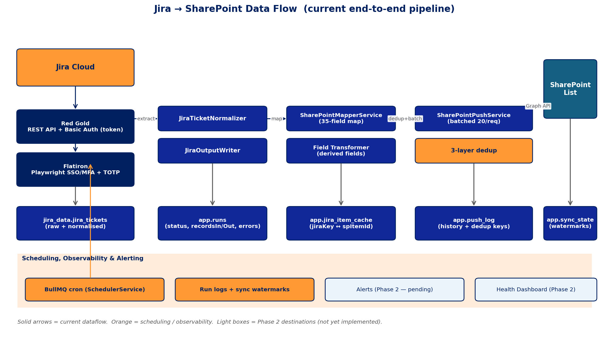
Figure 1 — Synapse current data flow: Jira extraction (REST or Playwright) → Normalizer → Mapper → Push with 3-layer dedup → SharePoint, plus persistence and observability.
- Operator hits POST /api/jira/test-connection (or /browser-auth for SSO clients) — backend validates credentials.
- Operator hits POST /api/integrations to register an integration with field mappings, schedule cron, retry policy.
- BullMQ scheduler enqueues a job per cron tick (or POST /api/integrations/:id/run for manual).
- integration-runner worker fetches Jira via Red Gold REST or Flatiron browser path, normalises to NormalizedJiraTicket.
- SharePointMapperService transforms 12 standard + 23 derived fields per the integration's fieldMappings JSONB.
- SharePointPushService deduplicates against pushLog → jiraItemCache → live SharePoint query, then creates / updates list items in batches of 20 via Microsoft Graph.
- Run row updated with recordsIn / recordsOut / status; sharepoint_push_runs row updated with progress; sync_state watermarks advanced.
- Operator polls GET /api/sharepoint/progress/:pushRunId or GET /api/runs to see results.
5.3 Tech Stack Snapshot
Layer | Technology | Version | Notes
Frontend framework | React + React Router | 19 / 7 | JavaScript (no TypeScript), Vite 8 dev server.
UI styling | Plain CSS + CSS variables | — | No MUI / Tailwind / Ant; light/dark via variables.
State management | React Context API | — | Theme, Toast, DetailPane, Sidebar.
API client | Fetch wrapper | services/api.js | Base URL http://localhost:4000; null on error → mock fallback.
Backend runtime | Node.js + TypeScript | 20+ / 6.0 | CommonJS.
Backend framework | Express | 5 | CORS + JSON body parser.
ORM / DB | Drizzle / PostgreSQL | 0.45 / 16 | 2 schemas (app, jira_data); 14 tables.
Queue | BullMQ + Redis | 5.73 / 7 | 3 active workers + 2 declared-but-empty (alert-dispatcher, credential-rotator).
Browser automation | Playwright | 1.59 | Jira SSO/MFA via TOTP (otplib 13.4).
Encryption | AES-256-GCM | Node crypto | CredentialService module.
Validation | Zod | 4.3 | All POST endpoints validated.
Tests | Vitest | 4.1 | 10 e2e + unit test files.
Containerisation | Docker Compose | — | Postgres + Redis services in docker-compose.yml.
5.4 Data Model — All 14 Tables
Schema.Table | Purpose | Status
app.organizations | Multi-tenant root | Created, hardcoded UUID
app.users | User accounts (admin/designer/operator/viewer) | Created, never read
app.credentials | Encrypted credential payloads | Active
app.connectors | Connector templates (catalog) | Created, never used
app.integrations | Integration instances (mappings, schedule, retry) | Active
app.runs | Execution history with counts and error log | Active
app.run_messages | Per-message tracking inside a run | Created, never written
app.alerts | Break-fix alerts queue | Created, never written
app.audit_log | Permission-sensitive action history | Created, never written
app.sharepoint_push_runs | Per-push progress + counts + errors | Active
app.push_log | Push history + dedup keys (cliendId, projectKey, date range) | Active
app.sync_state | Delta-sync watermarks per integration | Active
app.jira_item_cache | JiraKey ↔ SharePoint item ID + terminal-status flag | Active
jira_data.jira_tickets | Raw + normalised Jira issues per run | Active
Active: 8. Created-but-unused: 6. Wiring up the unused six is part of Phase 2 and Phase 3 work.
5.5 API Surface — 8 Route Groups
Mount | Routes | Notes
/api/integrations | GET, POST, GET :id, PATCH :id, DELETE :id, POST :id/run | CRUD + manual execution trigger.
/api/runs | GET, GET :id | Run history.
/api/credentials | POST | Store-only — no decrypt endpoint yet.
/api/jira | POST /test-connection, /browser-auth, GET /browser-auth/status, POST /fetch, GET /projects, POST /discover-entities, /discover-projects, /entity-fields | Both Red Gold + Flatiron paths.
/api/sharepoint | POST /test-connection, /list-fields, /push, GET /progress/:pushRunId | Auth + push + progress polling.
/api/push | POST / | Direct push without integration.
/api/sync | POST /:integrationId/start | Trigger delta sync (RESYNC / EXTEND_TO_TODAY / CUSTOM).
/api/connected | GET /, PATCH /:integrationId/schedule | Integration dashboard + cron management.
Health probe: GET /health → { status: 'ok' }.
5.6 Authentication & Security Posture Today
- Credential storage: AES-256-GCM in app.credentials.encryptedPayload; expiry timestamp supported.
- OAuth2: SharePoint client credentials flow (token cached + refresh logic).
- Browser auth: Playwright with TOTP for Jira SSO; 8-hour cookie session cache, file-backed.
- User authentication: NOT enforced. There is no login screen and no JWT validation; backend trusts every request.
- Multi-tenancy: hardcoded organization UUID; no isolation boundary — Phase 3 work.
- Audit: app.audit_log table exists but no middleware writes to it — Phase 2 work.
- CORS: open to all origins (development setting); needs locking down before any external exposure.

6. Target State — Conceptual Architecture
The platform is organised into nine functional modules. Each module is independently deployable and testable. The architecture is tech-stack-agnostic at the requirements level, but the implementation stack (React 19 + Express 5 + PostgreSQL + Redis + Playwright) is now locked-in for Phase 2 and beyond.
6.1 System Architecture
The diagram below shows how the four logical tiers — external systems, frontend, backend, and persistence — communicate. Source systems are on the orange row at top-left; destination systems are on the teal row at top-right. The React frontend talks only to the backend via the Fetch wrapper in services/api.js. The Express backend exposes 8 route groups, delegates to a service layer, and delegates long-running work to BullMQ workers backed by Redis. PostgreSQL holds all state.
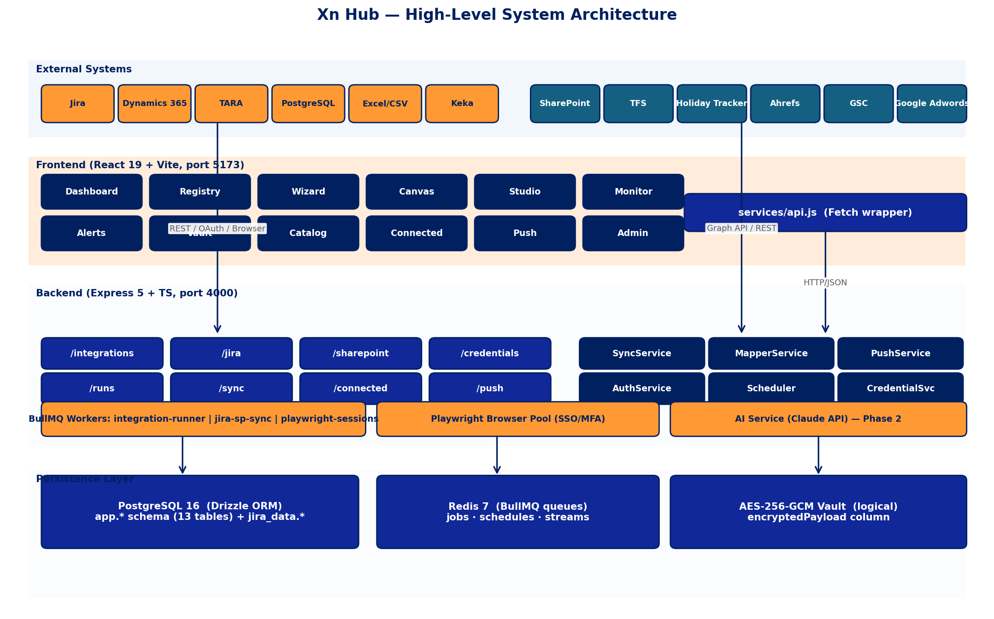
Figure 2 — High-level system architecture across the four tiers.
6.2 Module Communication (Request Flow)
A typical Operator-triggered run, traced as a sequence: the React page calls api.js, which posts to the Express route. The route validates input with Zod, calls a service, which writes a 'pending' row to runs and enqueues a BullMQ job. The route returns 202 Accepted immediately. The worker picks up the job asynchronously, executes the extract → normalise → map → push pipeline, updates run status, and the page sees the result via SSE or polling.
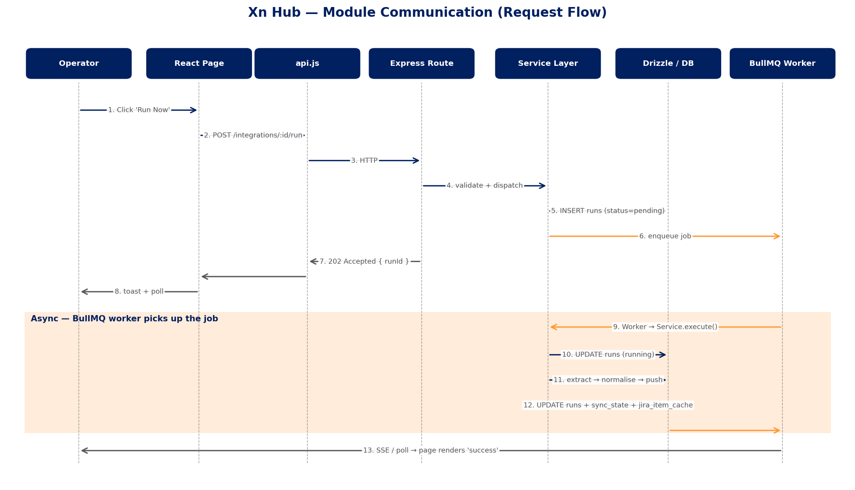
Figure 3 — Request flow for an Operator-initiated run, including async worker handoff.
6.3 Module Catalog
Module | Purpose | Status Today
Connector Studio | Design-time creation and configuration of connector templates | Stub UI
Connection Wizard | Runtime guided setup of source-to-destination integrations | Step 2 wired; rest stub
Mapping Engine | Visual and AI-assisted field mapping between entities | Manual UI; AI missing
Integration Registry | Catalog of all published adapters and their instances | Stub UI on mock data
Health & Monitoring | Real-time observability of all running integrations | Stub UI on mock data
Administration | Platform governance — users, credentials, master data, approvals | Stub UI; no auth backend
Alerting & Notifications | Proactive incident communication to stakeholders | Missing
Help System | In-app guidance and documentation for all user personas | HelpPanel widget only
Web Scraping Engine | Fallback data extraction when APIs are unavailable | Missing

7. Functional Requirements (Future Features)
Each subsection below uses the same template: Description / User Stories / Acceptance Criteria / Backend impact / Frontend impact / DB / Dependencies / Phase.
7.1 Connector Studio (Designer Only)
Description
Design-time workspace where a Designer onboards a new external system into the platform. One-time activity per system type. Once published, Operators can create unlimited instances. Sub-flows: System Registration → Authentication Configuration → Operation Selection → Entity Modelling → Publish & Version.
User Stories
- As a Designer, I select a system category (REST API, Database, File Share, SaaS, Message Queue, Webhook) and provide an OpenAPI/Swagger spec or DB connection string.
- As a Designer, I can group raw fields into entities with human-friendly labels and link them to master entities.
- As a Designer, I can publish a versioned connector template that Operators see in the Integration Registry.
Acceptance Criteria
- Selecting REST API + uploading an OpenAPI 3.0 spec discovers all endpoints and lists them as selectable operations.
- Selecting Database + providing a Postgres connection string introspects the schema and lists tables.
- Each operation can be tagged Read / Write / Both and restricted from Operator visibility.
- Connector cannot be published until at least one successful test call with sample credentials.
- Updating a connector creates a new version; existing instances stay on prior version until explicitly upgraded.
Backend Impact
- New routes: POST /api/connectors, GET /api/connectors, POST /api/connectors/:id/discover, POST /api/connectors/:id/test, POST /api/connectors/:id/publish.
- OpenAPI parser service (use 'openapi-types' or 'swagger-parser').
- Database introspection service (Drizzle Kit's introspect or a custom pg metadata reader).
- Versioning logic: clone-on-publish, immutable past versions.
Frontend Impact
- Studio page: enable Test Connection + Publish buttons (currently disabled at StudioPage.jsx:86).
- Sub-screens: System Registration form, OpenAPI uploader, schema introspection viewer, entity grouping drag-and-drop, publish confirmation modal.
- Spider/bot icon for web scraping connectors in registry.
Database
app.connectors becomes active. Add connector_versions table, connector_operations table, entity_definitions table.
Dependencies
Phase 2 (Connector Studio backbone for new sources). OpenAPI parser, DB introspection libraries.
Phase
Phase 2 — required before adding Dynamics 365, PostgreSQL, Excel, Keka, TARA connectors at scale.
7.2 Connection Wizard (Operator)
Description
Guided 6-step flow with a visual stepper. Operator's primary workflow for creating an integration instance from published connectors.
User Stories
- As an Operator, I pick a Source and Destination from icon grids and toggle direction.
- As an Operator, I provide credentials with masked input and click Test Connection on each side.
- As an Operator, I select entities to map, then transition to Mapping Canvas.
- As an Operator, I configure schedule (cron-friendly UI), load strategy (full / incremental), retry policy.
- As an Operator, I run a dry-run with real sample data and see a split preview before clicking Publish.
Acceptance Criteria
- Stepper shows Step X of 6 highlighted; cannot skip ahead.
- Test Connection per side independently with green ✓ / red ✗ result.
- Direction toggle: Source-to-Destination / Destination-to-Source / Bi-directional.
- Cron builder shows next-run preview in human language ('Every Mon 9:00 AM').
- Publish button disabled until dry-run passes — hard gate, no bypass.
- Confetti animation on successful Publish (charter §6.2 step 11).
Backend Impact
- Wizard step 4 currently redirects to Canvas — replace with inline mapping iframe / route preserving wizard state.
- Step 6 currently shows JSON preview — wire to actual dry-run endpoint POST /api/integrations/:id/dry-run.
- Persist wizard state to localStorage so refresh does not lose progress.
Frontend Impact
- Backing endpoints already exist for Step 2; need /dry-run for Step 6.
- Integrate with Connector Studio output (entities, operations, credentials schema).
Database
Reuses app.integrations and runs tables — no new schema.
Dependencies
Phase 2 — directly user-facing. Depends on Connector Studio (§7.1) and Mapping Canvas (§7.3).
Phase
Phase 1 baseline → completed via Phase 2 wiring.
7.3 Mapping Canvas (with AI Auto-Map)
Description
Full-screen drag-and-drop interface where source fields connect to destination fields via drawn lines. AI Auto-Map suggests mappings with confidence scores. Operator confirms, rejects, or adjusts. Transformation panel slides up from the bottom for selected lines.
User Stories
- As an Operator, I click AI Auto-Map and see dashed suggestion lines with confidence percentages.
- As an Operator, I confirm a suggestion (line goes solid green), reject it (line removed), or drag to a different target.
- As an Operator, I select preset transformations (date format, upper/lower, trim, concat, split) for any mapping.
- As an Operator, I describe a complex transformation in natural language and AI generates the JS.
- As an Operator, I can escalate an unmapped field as a task to the Designer with full context.
Acceptance Criteria
- Lines colour-coded: green AI-confirmed, blue manual, amber pending review.
- AI mapping accuracy ≥70% in Phase 2 success metric.
- Validate button checks: all required dest fields mapped, types compatible, no circular dependencies.
- Mapping persists to integrations.fieldMappings JSONB on save.
Backend Impact
- New service: MappingAIService — wraps Claude API (anthropic SDK) for auto-map suggestions and NL→JS transforms.
- POST /api/integrations/:id/mappings/auto-map → returns suggestions with confidence scores.
- POST /api/integrations/:id/mappings/transform/nl → returns generated JS snippet.
- Sandbox JS evaluation for transformations (use vm2 or QuickJS) — never eval untrusted code on the main process.
Frontend Impact
- Replace simulated AI in Canvas with real API calls.
- Connection lines via SVG with colour state machine.
- Slide-up transformation panel with preset dropdowns + Monaco/CodeMirror editor for advanced.
- Task escalation modal: pick Designer, attach source field + sample, send.
Database
No new tables — fieldMappings JSONB on app.integrations holds the structure.
Dependencies
Anthropic Claude API key (env: ANTHROPIC_API_KEY). Sandbox library for JS eval.
Phase
Phase 2 — high-impact UX feature.
7.4 Integration Registry
Description
Searchable catalog of all published integration adapters and their running instances. Card-based layout with sparklines, status, and quick actions.
User Stories
- As an Operator, I search adapters by system type, department, status, or entity.
- As an Operator, I see message volume sparkline (last 7 days) and last run timestamp at a glance.
- As an Administrator, I bulk-pause or bulk-resume multiple adapters and export the registry as CSV.
Acceptance Criteria
- Cards show source icon → destination icon, adapter name, status dot, sparkline, last run.
- Filters: system type, department, active/paused/error, entity involved.
- Detail expand shows: full config, mapping summary, schedule, recent run history, error log.
- Actions: Pause / Resume / Edit Mapping / Clone / Delete (with confirm) / View Logs.
Backend Impact
- Wire RegistryPage to GET /api/integrations + GET /api/runs?limit=7d for sparklines.
- Add POST /api/integrations/bulk-pause + bulk-resume.
- Add GET /api/integrations/export?format=csv.
Frontend Impact
- Replace mock data import with services/api.js calls.
- Add charting library (Recharts recommended) for sparklines.
- Multi-select chip filtering already in mock UI — wire to query params.
Database
Reuses existing tables. Add view registry_view aggregating runs counts per integration.
Dependencies
Charting library decision (Phase 2 Week 1).
Phase
Phase 2 — primary Operator landing experience.
7.5 Master Entity Catalog
Description
Central registry of all data entities defined across the platform, organised by department or use case (Engineering, HR, Finance, etc.). Supports merge with impact analysis and field-level evolution with cascade preview.
User Stories
- As a Designer, I see all entities in a Department > Entity tree.
- As a Designer, I select two overlapping entities, preview a side-by-side diff, and merge them — affected adapters are flagged for re-testing.
- As a Designer, I add a field to an entity and see which adapters need mapping updates before committing.
Acceptance Criteria
- Tree navigation grouping by Department.
- Field-level usage statistics (used vs unused across adapters).
- Merge: side-by-side diff view, impact preview, post-merge re-test flag.
- Global search across all entities and fields.
Backend Impact
- New tables: entities, entity_fields, entity_field_versions.
- Endpoints: GET /api/entities (tree), POST /api/entities/:id/merge, POST /api/entities/:id/fields.
- Impact analysis service: query integrations.fieldMappings for usages.
Frontend Impact
- Wire CatalogPage to GET /api/entities; replace inline hardcoded data.
- Tree component (use react-arborist or build from CSS).
- Side-by-side diff modal for merge preview.
Database
New tables (entities, entity_fields). Backfill from existing fieldMappings JSONB.
Dependencies
Phase 2 (catalog read) + Phase 3 (merge / evolution).
Phase
Phase 2 (read) → Phase 3 (write/merge).
7.6 Trading Network Console (Message Monitor)
Description
Real-time and historical view of all data transactions flowing through the platform. Expandable rows show payload sent/received, field-level mapping trace, and transformation applied.
User Stories
- As an Administrator, I watch transactions in real-time with auto-refresh.
- As an Administrator, I expand an error row to see stack trace + which field caused failure.
- As an Administrator, I create a task for a Designer in one click from a failed row.
- As an Administrator, I export filtered results as CSV or JSON.
Acceptance Criteria
- Table columns: Timestamp, Source, Destination, Adapter, Direction, Status, Records, Duration.
- Real-time toggle uses SSE (or polling every 5s).
- Filters: adapter, date range, status, source/dest, record count threshold.
- Error rows red-highlighted; expand reveals payload (JSON syntax-highlighted) + mapping trace.
Backend Impact
- Activate app.run_messages — write a row per message inside a run.
- Add SSE endpoint GET /api/messages/stream or polling endpoint GET /api/messages?since=.
- Add POST /api/tasks for one-click escalation.
Frontend Impact
- Wire MonitorPage to live endpoint; replace mock monitorData.js.
- JSON viewer (react-json-view) with syntax highlighting.
- Pause button to freeze auto-refresh.
Database
app.run_messages becomes active. Add tasks table for escalation.
Dependencies
Phase 2.
Phase
Phase 2.
7.7 Health Dashboard
Description
System-wide health at a glance. Landing page for Administrators, quick-check for Operators. KPI tiles, volume charts, client tier breakdown, error trend with anomaly detection.
User Stories
- As an Administrator, I see Total Adapters / Messages Today / Uptime / Active Alerts at the top.
- As an Administrator, I spot red adapter tiles in the grid (pulsing if unresolved).
- As an Administrator, I drill from any tile or chart to the relevant detail screen.
Acceptance Criteria
- Time range selector (24h, 7d, 30d, custom).
- Volume chart: stacked bar (sent / received / errors) per adapter or aggregated.
- Client tier ribbon: Heavy / Moderate / Light usage.
- Error trend line with anomaly highlights.
Backend Impact
- Endpoints: GET /api/dashboard/summary, GET /api/dashboard/volume, GET /api/dashboard/errors-trend, GET /api/dashboard/client-tiers.
- Materialised views or scheduled aggregations to keep response time <500ms.
Frontend Impact
- Wire DashboardPage to real endpoints; replace dashboardTiles.js mock.
- Charts: Recharts for volume bar, line for trend.
- Anomaly highlights: simple z-score per data point on the server.
Database
Add materialised view dashboard_volume_daily, dashboard_error_trend_hourly.
Dependencies
Phase 2.
Phase
Phase 2.
7.8 Client & User Management + RBAC
Description
Registration and governance for external applications and internal users. Layered RBAC with four predefined roles (Administrator, Designer, Operator, Viewer) and granular per-resource overrides.
User Stories
- As an Administrator, I register a Consumer App and issue a client ID + secret.
- As an Administrator, I assign roles to users and override per-adapter permissions.
- As any user, I see my role badge and adapter ownership in the user directory.
Acceptance Criteria
- RBAC matrix exactly as charter §5.8.2.
- Resource-level overrides: e.g., grant an Operator Designer access on one connector only.
- Action audit trail: append-only entries for publish, deploy, rotate, role change, alert ack.
- Session timeout: 30 min on vault, 8h general; force-logout for Administrators.
Backend Impact
- Auth middleware: JWT verify, decode user, load role, attach to req.user.
- Per-route guards using a withRole(['admin', 'designer']) decorator.
- Endpoints: POST /api/auth/login, POST /api/auth/refresh, GET /api/users, PATCH /api/users/:id/role, POST /api/clients/register.
- Activate app.audit_log via middleware on every state-changing route.
Frontend Impact
- Login page (wire to /api/auth/login).
- AdminPage Users tab + Client Apps tab — replace mocks with real data.
- RBAC-aware nav: hide / disable nav items per role.
- Audit timeline view (filtered by user, entity, action).
Database
Activate app.users, app.organizations (real records), app.audit_log. Add app.user_overrides for resource-level grants.
Dependencies
Choose JWT lib (jose recommended). Decide IdP (none for MVP — local accounts).
Phase
Phase 2 (basic RBAC) → Phase 3 (resource overrides + audit trail UI).
7.9 Credential Vault
Description
Centralised AES-256 storage with three modes: Runtime Prompt (never stored), Encrypted Vault, Browser Passthrough (OAuth). Eye-icon mask/reveal with audit logging on every reveal.
User Stories
- As an Operator, I store new credentials in the encrypted vault and see them masked by default.
- As an Operator, I click the eye icon to reveal a credential for 10s; the action is audit-logged.
- As an Administrator, I rotate or revoke credentials; expiry warnings appear at 7/3/1 days.
Acceptance Criteria
- Reveal auto-hides after 10s or on blur.
- Copy-to-clipboard works without revealing.
- Sensitive values never appear in logs, exports, or error messages.
- Health report flags expiring + unused credentials.
Backend Impact
- Add GET /api/credentials/:id (returns metadata + decrypted value when authorised; logs the reveal).
- Rotate endpoint: PATCH /api/credentials/:id/rotate.
- Compliance report endpoint: GET /api/credentials/compliance.
Frontend Impact
- VaultPage already has masked-reveal UI in mock — wire to real endpoints.
- Expiry countdown badge.
- Compliance report export (CSV) for audits.
Database
Add credential_reveals audit child of audit_log (or use audit_log with action='reveal').
Dependencies
Encryption already implemented (AES-256-GCM). Need decrypt endpoint + audit hook.
Phase
Phase 2.
7.10 Help System
Description
Microsoft-style integrated help: searchable library, contextual '?' icon per screen, tooltips, first-time walkthroughs. AI Help Assistant scheduled for Phase 3+.
User Stories
- As any user, I open the right-side help panel and search 'how do I map a date field'.
- As a first-time user, I see a guided walkthrough overlay with numbered callouts on each major screen.
- As a Designer, I see inline info icons on complex form fields explaining expected formats.
Acceptance Criteria
- Help panel slides in from right, pinnable.
- Search returns ranked results with highlighted matches.
- Tooltips on every icon and non-obvious UI element.
- First-visit walkthroughs are dismissable + re-accessible from Help menu.
Backend Impact
- Static help content as Markdown files in repo (charter §12 decision).
- Search index built at app build time (lunr.js or fuse.js).
- AI Assistant (Phase 3): wraps Claude API with screen state + recent actions context.
Frontend Impact
- HelpPanel component already exists — wire to content engine.
- Walkthrough component (use shepherd.js or build with React portals).
- '?' icon on every page header, pre-filtered to current screen articles.
Database
No DB tables — Markdown in repo + build-time index.
Dependencies
Markdown content authoring (Phase 1 Week 4 per charter open decision).
Phase
Phase 2 (search + tooltips) → Phase 3 (AI Assistant).
7.11 Alerting & Notifications (Break-Fix)
Description
Proactive incident communication. Triggers cover integration failure, degraded performance, credential expiry, schema change, scraping breakage. Multi-channel delivery, escalation chain, auto-pause on unacknowledged criticals.
User Stories
- As a Designer, I receive an in-app + email alert when my connector fails on a schema change.
- As an Operator, I see unresolved critical alerts as a banner at the top of every screen.
- As an Administrator, I configure custom thresholds (e.g., volume drops below 100 daily).
Acceptance Criteria
- In-app bell with severity-sorted feed (critical > warning > info).
- Email: immediate critical, daily digest warnings, off info.
- Escalation: 30 min unacknowledged → admin; 2h → adapter auto-pause.
- Acknowledge / Create Task / View Logs from each alert detail.
Backend Impact
- Activate alert-dispatcher BullMQ worker.
- AlertService.create() called from run failure paths in integration-runner + sync workers.
- Email transport: nodemailer + SMTP env config (or SES / SendGrid).
- Endpoints: GET /api/alerts, POST /api/alerts/:id/acknowledge, POST /api/alerts/configure-thresholds.
Frontend Impact
- AlertsPage already designed — wire to /api/alerts.
- Top-of-page banner component.
- Threshold config UI (per adapter or globally).
Database
Activate app.alerts. Add alert_thresholds, alert_subscriptions tables.
Dependencies
SMTP credentials. nodemailer.
Phase
Phase 2 (in-app + basic email) → escalation chains + thresholds.
7.12 Web Scraping Engine
Description
Fallback data extraction when APIs are unavailable. Two sub-paths: Apify cloud actor and Playwright self-hosted automation. Output JSON entity matching API connector format so downstream mapping/monitoring is identical.
User Stories
- As a Designer, I select Web Scraping category and configure either Apify (target URL + selectors + schedule) or Playwright (recorded flow).
- As an Operator, I see scraping connectors flagged with a spider/bot icon in the registry.
- As a Designer, I receive a screenshot-diff alert when a scraping job fails on a UI change.
Acceptance Criteria
- Both Apify and Playwright outputs match the entity schema produced by API connectors.
- Scheduled scrape jobs run on the same cron infrastructure.
- On scrape failure, alert includes a screenshot diff at the failure point.
- Anti-detection basics: rotating user agents, configurable delay between actions.
Backend Impact
- ApifyClient wrapper (uses official apify-client npm package).
- Playwright actor service (already have Playwright runtime for Flatiron).
- Worker: scrape-runner — separate concurrency limit (slow + IO-heavy).
- Failure path stores last screenshot for diff next run.
Frontend Impact
- Studio: Scraping category sub-form (Apify config vs Playwright recorder).
- Spider/bot icon overlay on registry cards.
Database
Add scrape_jobs, scrape_runs, scrape_failures (with screenshot blob refs) tables.
Dependencies
Apify account (env: APIFY_TOKEN). Object storage for screenshots (S3-compatible).
Phase
Phase 2.

8. Non-Functional Requirements
8.1 Security
- All credentials encrypted at rest with AES-256-GCM. Plaintext credentials never persisted, never logged.
- Eye-icon reveal events written to immutable audit log with user, timestamp, IP.
- RBAC enforced server-side on every state-changing route. Frontend role-gating is UX, not security.
- Session timeout: 30 min on vault screens, 8h on general screens. Force-logout for Administrators.
- CORS locked to known origins in production (currently open).
- Rate limiting at the Express layer (express-rate-limit) — 100 req/min per IP for unauthenticated, higher per-user post-auth.
8.2 Performance
- Operator setup time < 30 minutes for an integration with pre-built connectors.
- Designer onboarding time < 2 hours for a new system type.
- Error detection latency < 5 minutes from failure to alert.
- Dashboard summary endpoint < 500 ms via materialised views.
- Mapping canvas remains interactive at ≥60 fps with 200+ field pairs.
8.3 Reliability & Observability
- All BullMQ workers idempotent — re-running the same job must not produce duplicate SP items (already enforced by 3-layer dedup).
- Run history retained for 90 days; aggregated metrics retained for 1 year.
- Health endpoint /health and a dedicated /metrics (Prometheus format) for ops scraping.
- Structured logging (JSON lines) — pino recommended for backend.
8.4 Accessibility & Browser Support
- Colour is never the only indicator (always paired with icon or text).
- Keyboard navigable (WCAG 2.1 AA target).
- Screen-reader compatible (semantic HTML, aria attributes).
- Browsers: Chrome, Edge, Firefox latest two versions.
8.5 Scalability
- 100 concurrent integrations per organisation with no degradation in dashboard responsiveness.
- 10,000 messages/hour throughput at the worker level.
- Horizontal scale: add worker replicas without code change (BullMQ supports this natively).

9. Source / Destination Coverage Matrix
The screenshot accompanying this BRD shows the target system grid. Each row below maps that grid to an integration approach and the phase in which it will be built.
9.1 Sources
System | Approach | Auth | Status | Phase
Jira | REST API + Browser fallback | Basic Auth + SSO/MFA via Playwright | Built | Done
Dynamics 365 | REST API (Web API + OData) | OAuth2 (Azure AD) | Not started | Phase 2
TARA | REST API (or scraping fallback) | API Token | Not started | Phase 2
PostgreSQL | DB introspection + SQL | Connection string + role | Not started | Phase 2
Excel | File parser (CSV / XLSX) | Local / SharePoint / SFTP | Not started | Phase 2
Keka | REST API | API Key | Not started | Phase 2
9.2 Destinations
System | Approach | Auth | Status | Phase
SharePoint | Microsoft Graph API | OAuth2 client credentials | Built | Done
TFS / Azure DevOps | REST API | Personal Access Token / OAuth | Not started | Phase 2
Holiday Tracker | REST API or DB write | TBD per implementation | Not started | Phase 2
Ahrefs | REST API | API Token | Not started | Phase 3
Google Search Console | REST API + service account | Service Account / OAuth | Not started | Phase 3
Google Adwords | Google Ads API | OAuth2 + developer token | Not started | Phase 3

10. Phased Roadmap (Aggressive — Days)
All durations are in working days for one full-time developer using Claude Code (vibe coding). The companion Synapse_Project_Plan_v1.xlsx breaks each item into a day-by-day sprint plan with goals, files touched, and tests-that-prove-done.
Phase | Theme | Approx Duration | Headline Outcomes
Phase 1 (Done) | Core pipeline (Jira → SharePoint) | Already complete | AES-256 vault, cron sync, 35-field mapper, delta sync, 3-layer dedup.
Phase 2 | Intelligence & Monitoring + multi-source | ≈ 35–45 days | Studio backbone, RBAC, AI Auto-Map, Trading Console, Health Dashboard, Master Catalog (read), Web Scraping, alerts, Dynamics/PostgreSQL/Excel/Keka/TARA + TFS/Holiday Tracker connectors.
Phase 3 | Scale & Governance | ≈ 25–30 days | Client App Registration, entity merge/evolution, self-healing, webhooks, bulk ops, audit log UI, AI Help Assistant, Ahrefs / GSC / Google Adwords destinations.
Phase 4 | Polish & Distribution | ≈ 15–20 days | Theme engine, Mobile PWA, onboarding wizard, Docker packaging, full handover documentation.

11. Open Decisions & Risks
11.1 Risk Register
Risk | Likelihood | Impact | Mitigation
External API access not obtainable for some destinations | Medium | High | Three-tier fallback: browser passthrough → Apify cloud → Playwright self-hosted. Scraping connectors flagged with bot icon.
Web scraping connectors break on UI changes | High | Medium | Screenshot-diff alerting on scrape failures; designer notified immediately.
Scope creep expands beyond planned phases | High | High | Lock scope per phase; change request process; MVP-first discipline.
AI mapper produces poor suggestions | Medium | Medium | Always require human confirmation; log decisions for tuning; graceful fallback to manual mapping.
Non-technical users find mapping too complex | Medium | High | Extensive UX testing; progressive disclosure; task escalation to Designer.
Credential vault security vulnerability | Low | Critical | AES-256-GCM, security review before any external exposure, no raw credential display anywhere.
10 of 11 frontend pages on mock data — silent regressions when wired | High | Medium | End-to-end Playwright test per page added at the time of wiring (test-first per page).
No auth enforcement today — accidental public exposure if deployed | Medium | Critical | Lock to localhost / VPN until auth ships in Phase 2 RBAC story.
Single-developer bus factor + vibe-coding velocity dependence | Medium | High | Strong PRODUCT_STATUS + this BRD + day-level plan keep the project transferable; Claude session history saved with the repo.
11.2 Open Decisions
Decision | Options | Recommendation | Decide By
AI provider for mapping | OpenAI / Claude API / Local model | Claude API (already used elsewhere; cost-effective for the volume). | Phase 2 Day 1
Charting library | Recharts / Chart.js / D3 | Recharts — works cleanly with React 19, declarative. | Phase 2 Day 1
Web scraping provider | Apify (cloud) / Playwright (self) / Both | Both — Apify for quick setups, Playwright for complex flows. | Phase 2 Week 1
Auth strategy | Local (JWT) / SSO (Azure AD) / Both | Local JWT first; pluggable adapter for SSO in Phase 3. | Phase 2 Day 1
Help content authoring | Markdown in repo / CMS / Wiki | Markdown in repo; index built at build-time. | Phase 2 Week 4
Email transport | SMTP / SES / SendGrid | Start SMTP via env; swap for SES in Phase 4. | Phase 2 alerts kick-off
JS sandbox for transformations | vm2 / QuickJS / WASM | QuickJS — modern, sandboxed, low overhead. | Phase 2 mapping kick-off

Appendix A — Folder Structure
Frontend (packages/frontend/src)
Folder | Purpose
components/admin | User and client-app management UI
components/alerts | Alert cards, severity filtering, action buttons
components/canvas | Field mapping UI (pair source/dest fields)
components/catalog | Entity browser with tree navigation
components/connected | Integration dashboard, schedule and sync modals
components/dashboard | KPI tiles, status filters, time-range selector
components/layout | Topbar, Sidebar, DetailPane, HelpPanel, Toasts
components/monitor | Run history with expandable JSON payload viewer
components/push | Two-column form, integration selector, dedup modal
components/registry | Integration cards with sparklines, search, detail panes
components/studio | Connector builder shell (currently disabled buttons)
components/vault | Credential table with mask/reveal timer
components/wizard | 6-step integration setup stepper
contexts/ | React context providers (Theme, Toast, DetailPane, Sidebar)
data/ | Mock data files (replace with real API as wiring progresses)
hooks/ | Custom hooks (useDetailPane, etc.)
services/api.js | Centralised API client wrapper
Backend (packages/backend/src)
Folder | Purpose
api/ | Express route handlers (8 route modules)
db/schema.ts | Drizzle table and enum definitions (14 tables)
db/client.ts | Database connection initialisation
db/repositories/ | Data access objects per entity
integrations/jira/ | Red Gold REST + Flatiron browser clients
integrations/sharepoint/ | Type definitions + push service
services/ | SyncService, SharePointPushService, PlaywrightAuthService, SchedulerService, MappingEngine, etc.
mappers/ | 35-field Jira ↔ SharePoint mapping logic
queues/ | BullMQ queue declarations
workers/ | integration-runner, jira-sp-sync, playwright-sessions
__tests__/ | Vitest test suite (e2e + unit)

Appendix B — Glossary
Term | Definition
Adapter | A deployed instance of a connector with credentials, mapping, and schedule. Created by Operators.
Connector | A reusable template that knows how to talk to a system type (Jira, SharePoint, Postgres). Created by Designers.
Entity | A logical grouping of related fields (Project, Sprint, Issue). Lives in the Master Entity Catalog.
Designer | Persona who builds connector templates and entities. Technical.
Operator | Persona who deploys integrations using pre-built connectors. Non-technical.
Administrator | Persona who governs the platform — users, credentials, approvals.
Run | A single execution of an integration — has start, finish, status, record counts.
Push log | History row written every time data is pushed to a destination — used for dedup.
Sync state | Watermark row per integration tracking last successful sync.
Trading network | Charter term for the live message-flow console (think: airport tower view of all transactions).
Break-fix alert | Notification fired when an integration fails or degrades.
Vibe coding | AI-assisted development using Claude Code — the velocity model assumed by this plan.

Appendix C — Setup & Run
Prerequisites
- Node.js 20+
- PostgreSQL 16 (local or via docker-compose)
- Redis 7 (local or via docker-compose)
- Playwright browsers installed (npx playwright install)
First-Time Setup
- git clone the repo
- cp .env.example .env and fill in DATABASE_URL, REDIS_URL, ENCRYPTION_KEY (32-byte hex)
- docker-compose up -d (starts Postgres + Redis)
- npm install at the repo root (workspaces install both packages)
- Run drizzle migrations: cd packages/backend && npm run db:migrate
Daily Run
- npm run dev — starts backend (port 4000) and frontend (port 5173) concurrently
- Visit http://localhost:5173
- Health probe: curl http://localhost:4000/health

Appendix D — Environment Variables
Variable | Required | Purpose
DATABASE_URL | Yes | Postgres connection string (e.g. postgres://localhost:5432/xnhub)
REDIS_URL | Yes | Redis connection string for BullMQ
ENCRYPTION_KEY | Yes | 32-byte hex key for AES-256-GCM credential encryption
PORT | No (default 4000) | Backend HTTP port
JIRA_BASE_URL | Per integration | Provided at runtime; not a global env
SHAREPOINT_TENANT_ID / CLIENT_ID / CLIENT_SECRET | Per integration | Stored in vault, not env
ANTHROPIC_API_KEY | Phase 2 | For AI Auto-Mapping and AI Help Assistant
APIFY_TOKEN | Phase 2 | For Apify scraping connectors
SMTP_HOST / SMTP_USER / SMTP_PASS | Phase 2 | Email alerts transport
NODE_ENV | Yes | development | production

