**Question 1:**

X+2Y-3Z=5

2X+Y-3Z=13

-X+Y=-8

We will solve it Using Gauss Elimination Method as:

|  |  |  |  |
| --- | --- | --- | --- |
| 1 | 2 | -3 | 5 |
| 2 | 1 | -3 | 13 |
| -1 | 1 | 0 | -8 |

R3=R3+R1

|  |  |  |  |
| --- | --- | --- | --- |
| 1 | 2 | -3 | 5 |
| 2 | 1 | -3 | 13 |
| 0 | 3 | -3 | -3 |

R2=2*R1 – R2

|  |  |  |  |
| --- | --- | --- | --- |
| 1 | 2 | -3 | 5 |
| 0 | 3 | -3 | -3 |
| 0 | 3 | -3 | -3 |

R3=R3-R2

|  |  |  |  |
| --- | --- | --- | --- |
| 1 | 2 | -3 | 5 |
| 0 | 3 | -3 | -3 |
| 0 | 0 | 0 | 0 |

R2=R2/3

|  |  |  |  |
| --- | --- | --- | --- |
| 1 | 2 | -3 | 5 |
| 0 | 1 | -1 | -1 |
| 0 | 0 | 0 | 0 |

So the equations will be:

X+2Y-3Z=5

Y-Z=-1

And Z is a free variable, so let’s assume that Z=1

Then, Y-Z=-1

Y=-1+Z=-1+1 =0

Y=0

Then, X will be,

X+2(0)-3*1=5

X=5+3 = 8

So one set of the values for (X,Y,Z)=(8,0,1)

**Question3:**

Solve AB

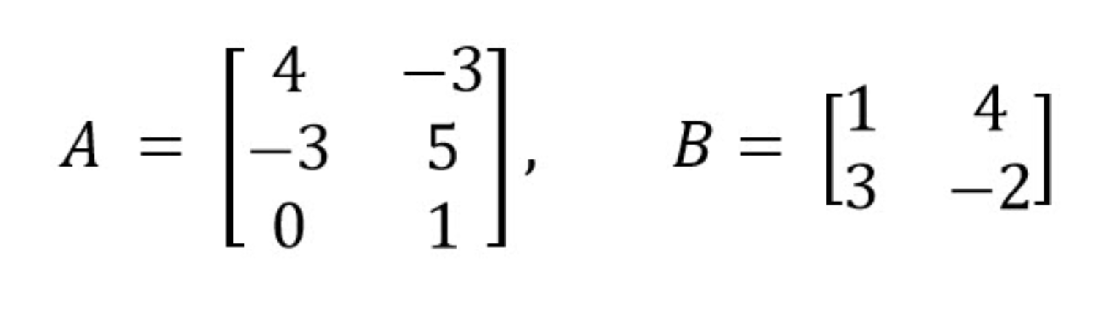

[(4*1+-3*3) (4*4+-3*-2)]

AB =[(-3*1+5*3) (-3*4+5*-2)]

[(0*1+1*3) (0*4+1*-2)]

[-5 22]

AB =[12 -22]

[3 -2]