Twilio High-Volume SMS — Expertise & Project Experience
Live production platform: https://app.sclcapital.io/

1. Core Objective
Build, optimize, and operate a high-volume outbound SMS system using Twilio — designed for a restricted industry (financial services / lending). The system handles:
- 20,000+ messages per day across 35+ Twilio phone numbers
- Full A2P 10DLC compliance — brand registration, campaign approval, opt-in/opt-out handling
- Maximum deliverability in a category known for aggressive carrier filtering
- Real-time monitoring, automated number health management, and live blast support
We didn’t just configure Twilio — we built a complete platform around it, from lead import to campaign delivery to pipeline management.

2. Technical Responsibilities

Twilio Infrastructure
- Messaging Services: Configured and optimized Twilio Messaging Services with sender pool rotation, sticky sender logic, and fallback handling
- Number pools & sender distribution: 35+ numbers organized into named pools (Primary, Warm-up, Re-engagement) with per-pool daily limits and health-weighted round-robin selection
- Throughput control: BullMQ queue with 15 parallel workers, global rate limit of 300 msg/min (5 msg/sec), per-number cap of 350 msg/day, 7-day warm-up ramp (50→350), ±40% timing jitter to avoid carrier pattern detection
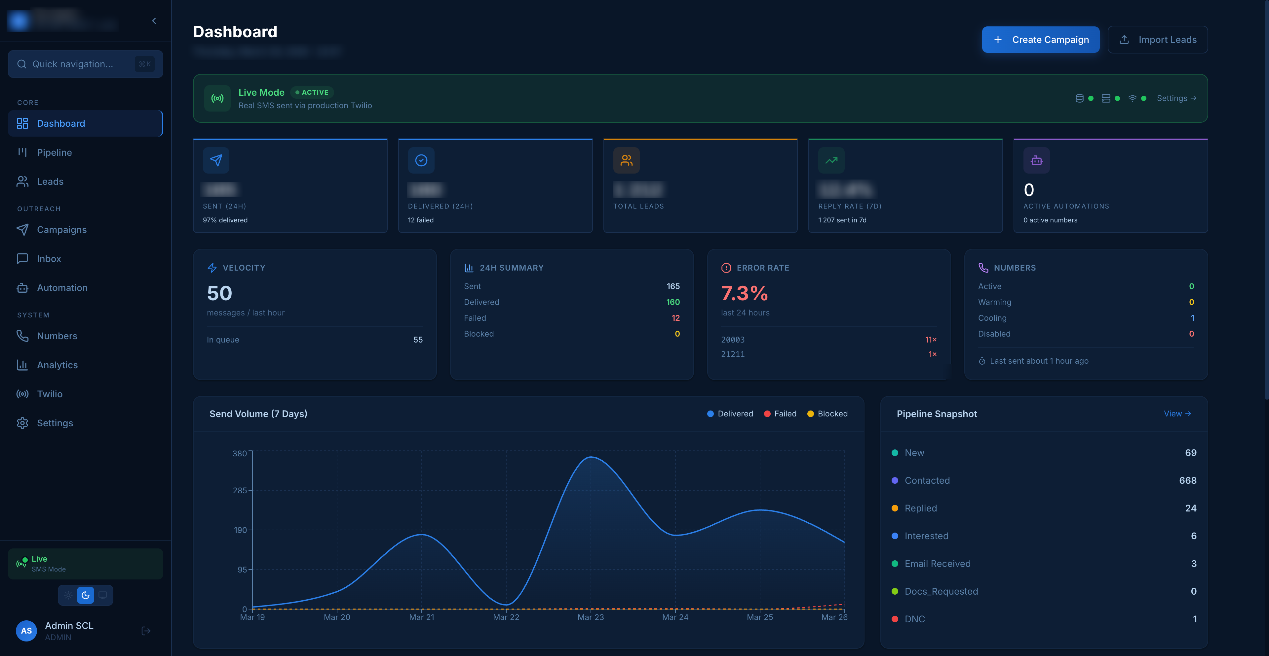
Dashboard — Live Mode with 97% delivery rate, send velocity, error tracking, and pipeline snapshot
Dashboard: real-time delivery rate (97%), send velocity (50 msg/hr), error breakdown by Twilio error code, 7-day volume chart, pipeline snapshot.

A2P 10DLC Compliance
- Brand Registration through Twilio Trust Hub (Customer Profile → Brand → Campaign)
- Campaign Registration: First submission rejected (“Low Volume Mixed” use case — high rejection rate for restricted industries). Resubmitted as “Customer Care” with revised description emphasizing consent → approved on second attempt
- Carrier compliance alignment: All messages framed as customer service, not marketing. Trigger words like “promotional”, “offers”, “deal” removed. Opt-in consent emphasized in campaign description
- 35+ numbers linked to approved A2P Messaging Service

Deliverability Optimization
- Carrier filtering reduction: 7-day number warm-up, timing jitter, auto-cooling on error streaks, circuit breaker on high campaign error rates
- Trust score / reputation management: Health score (0–100) per number based on delivery rate, error streaks, and volume. Numbers below 80% delivery auto-throttled to 50% capacity
- Spam flag avoidance: Spintax for message variation ({Hi|Hey|Hello} {{firstName}}), dynamic variables, sending speed control
- Content variation & traffic segmentation: Templates with {{firstName}}, {{company}} variables; audience segmentation by tags, status, source; named sender pools for different campaign types
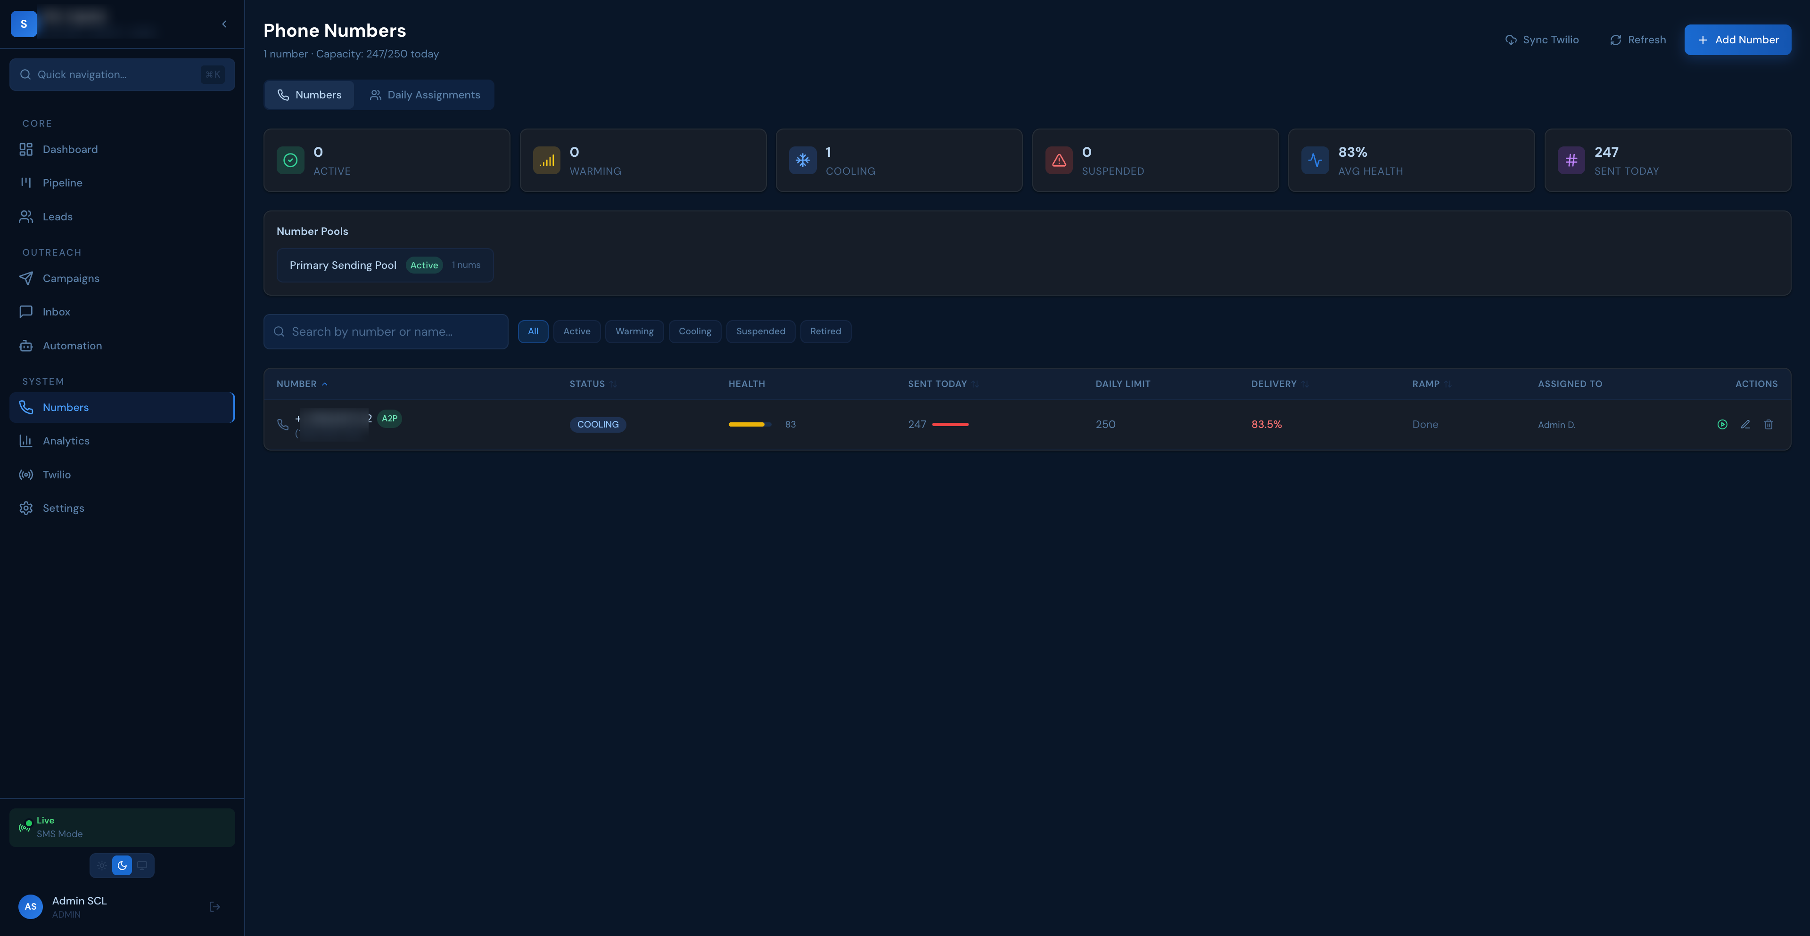
Numbers page — A2P-registered number with COOLING status, health score 83, 247/250 sent today, 83.5% delivery
Numbers page: A2P badge, lifecycle status (WARMING→ACTIVE→COOLING), health score 83/100, daily usage 247/250, warm-up ramp complete, pool assignment.

System Design
- Scalable sending architecture: Redis-backed BullMQ with 3 queues (campaign, automation, transactional), 15 parallel workers, batch compliance pre-loading for 10K+ campaigns
- Repeatable campaign workflows: Create template → select audience (tags/status/source filters) → set sending speed → launch → monitor real-time → pause/resume/cancel
- Monitoring: Real-time WebSocket delivery/failure counters, per-number health dashboard, error code breakdown, daily counter drift prevention via midnight recalculation
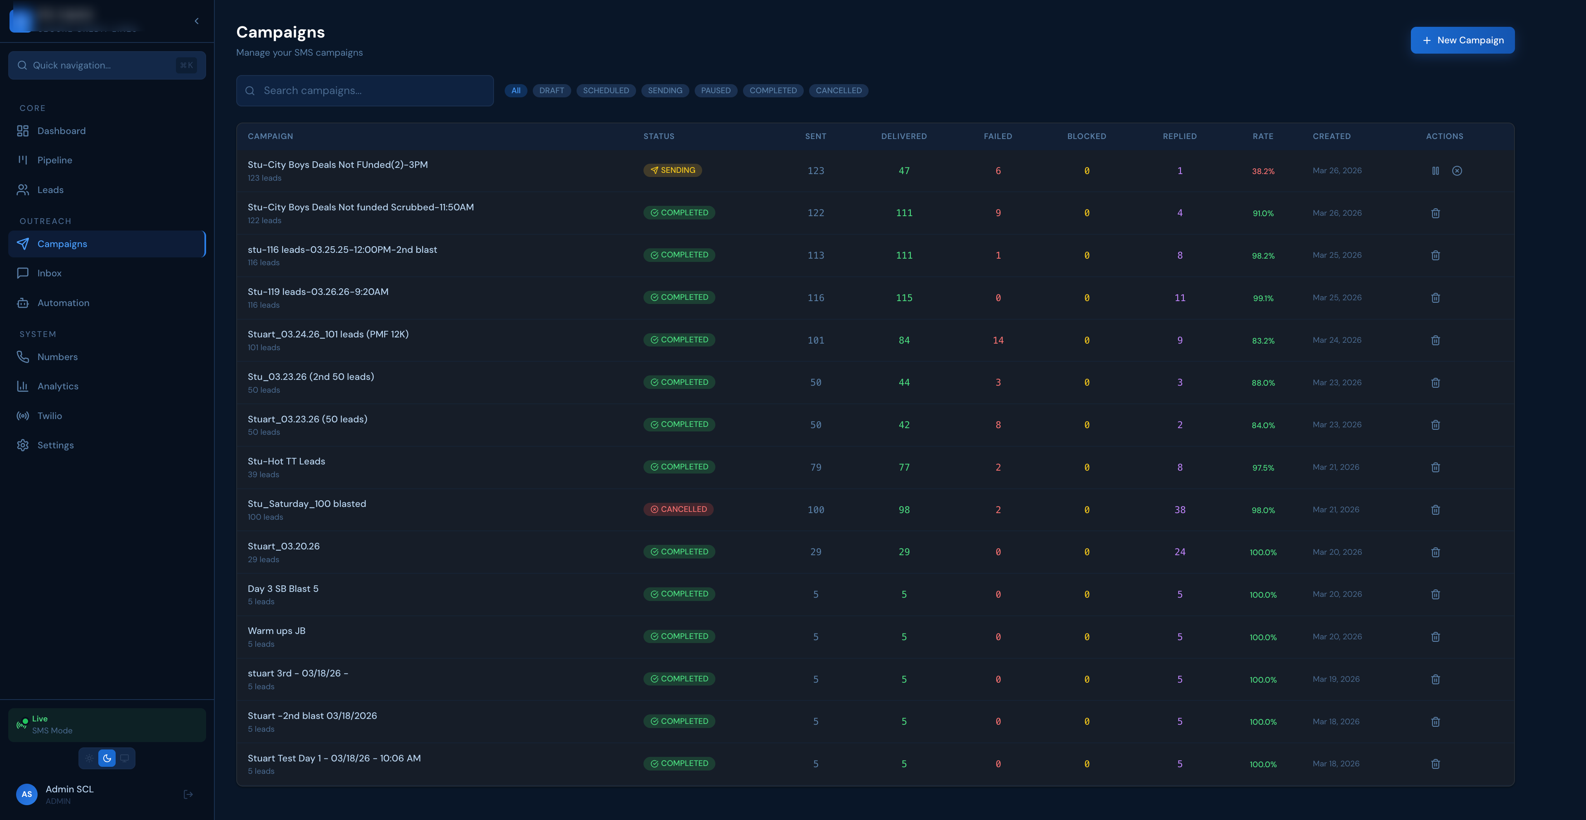
Campaigns page — 15+ campaigns with delivery rates 83–100%, reply tracking, status management
Campaigns: 15+ campaigns over 8 days, delivery rates 83–100% in restricted industry, reply tracking (up to 38 per campaign), instant pause/resume.

3. Troubleshooting & Optimization

What We Diagnose and Fix
Issue | How We Handle It
Message blocking | Monitor Twilio error codes (30003, 30007, 21211) per number; auto-cool numbers with 5+ consecutive errors; circuit breaker pauses campaigns at >30% error rate
Carrier filtering | Detect via delivery rate drop; apply timing jitter, reduce sending speed, rotate to healthier numbers, adjust message content
Throughput limits | Per-number daily caps (350), global rate limit (300/min), queue backpressure monitoring, automatic ramp-up for new numbers
Trust score issues | Health-weighted sender selection; numbers with low delivery auto-throttled; dedicated warm-up pools for new numbers

Real-Time Fixes During Live Campaigns
- WebSocket-powered dashboard shows delivery rate, failures, and velocity live — instant visibility into problems
- Pause/resume any campaign with one click — no messages lost, queue preserves state
- Number health visible during blast — can remove underperforming numbers mid-campaign
- Circuit breaker provides automatic safety net — if things go wrong, the system stops before damage spreads

Continuous Optimization
- Daily counter recalculation prevents drift between tracked and actual message counts
- 3-attempt retry with exponential backoff (5s → 10s → 20s) maximizes delivery without overwhelming carriers
- Webhook processing acknowledged in <100ms, actual processing happens asynchronously — Twilio never times out

4. Operational Support

Live Blast Assistance
- Real-time monitoring via Socket.IO WebSocket — delivery/failure counters update live during sends
- Instant pause/resume capability — no messages lost in the queue
- Per-number health visible during campaign execution — ability to spot and react to issues immediately
- Auto-recovery: Circuit breaker pauses campaigns automatically if error rate exceeds threshold

Stable Execution Under Load
- BullMQ queue with 15 parallel workers handles sustained throughput
- Redis caching with 5-minute TTL for compliance data (suppression lists, opt-outs) — eliminates per-message DB queries at scale
- Batch compliance pre-loading: 10K+ campaigns load all suppression/opt-out data in ~10 queries instead of 20K+ individual lookups
- Webhook inbound processing is non-blocking — Twilio gets 200 OK in <100ms

Fast Response
- Error code monitoring catches issues within seconds
- Auto-cooling removes problematic numbers from rotation without manual intervention
- Delivery rate drops trigger automatic throttling — no human needed for first response

5. Strategy & Advisory

Compliant Workarounds for Restricted Industries
- A2P campaign framing: Position all messaging as “Customer Care” rather than marketing — critical for approval in lending/fintech
- Content strategy: Remove trigger words (“promotional”, “offers”, “exclusive deal”), emphasize opt-in consent, keep messages conversational
- Use case selection: Avoid “Low Volume Mixed” — use “Customer Care” or specific 10DLC use cases with higher approval rates

Messaging Structure Guidance
- Template design: Dynamic variables for personalization, spintax for variation, character count optimization
- Sequence design: Multi-step drip campaigns with intelligent pause triggers (reply → auto-pause → human handoff)
- Timing: Quiet hours enforcement (8 PM–9 AM timezone-aware), weekend controls, optimal sending windows

Audience Segmentation
- Tag-based targeting: Segment leads by source, status, engagement level, industry
- Campaign-level filters: Select audience by tags, lead status, source, date ranges
- DNC/suppression management: Automatic opt-out processing, suppression list enforcement, re-engagement workflows for opted-back-in leads

Traffic Distribution
- Named sender pools: Primary Sending Pool, Warm-up Pool, Re-engagement Pool — each with separate daily limits
- Health-weighted rotation: Higher-health numbers get more messages; lower-health numbers throttled automatically
- Sticky sender: Same number used for entire conversation with a lead — builds trust, avoids confusion

Compliance vs Deliverability Balance
- Compliance checks cached in Redis (5-min TTL) — near-zero performance impact
- Per-message compliance gate runs in microseconds: suppression check, opt-out check, quiet hours, daily limit — all cached
- Result: full TCPA compliance with zero impact on sending throughput

6. Required Experience — What We Bring

Twilio Messaging Services
- Configured and operated Twilio Messaging Services in production for a restricted industry
- Managed 35+ numbers across multiple sender pools with A2P 10DLC registration
- Handled Twilio Trust Hub (Customer Profile → Brand → Campaign) end-to-end

High-Volume SMS
- 20,000+ messages per day — sustained production workload, not one-time tests
- BullMQ queue with 15 parallel workers, 3 separate queues (campaign, automation, transactional)
- Batch optimization for 10K+ recipient campaigns

A2P 10DLC Registration & Scaling
- Completed full registration flow for a restricted industry (financial services)
- Handled campaign rejection and got approved on second attempt with revised strategy
- Linked 35+ numbers to approved Messaging Service

Carrier Filtering Mitigation
- Maintained 83–97% delivery rates in a restricted industry (financial services / lending)
- Implemented warm-up, jitter, auto-cooling, circuit breaker, health-weighted rotation
- Built automated recovery — system self-heals without manual intervention

Restricted Industry Experience
- Financial services / lending — one of the most heavily filtered categories
- Built compliance engine specifically for TCPA requirements
- Designed messaging strategies that pass carrier and 10DLC review

Working Style
- Fast troubleshooting: Error monitoring surfaces issues in seconds; auto-recovery handles most cases without human intervention
- Direct communication: Clear, actionable recommendations — not theoretical advice
- Full ownership: Strategy + implementation + monitoring + optimization — end-to-end

7. Common Technical Questions — Ready Answers
“How do you structure Messaging Services at scale?” We use a single Messaging Service with 35+ numbers organized into named sender pools (Primary, Warm-up, Re-engagement). Each pool has separate daily limits. Numbers are selected via health-weighted round-robin — healthier numbers send more. New numbers start in the Warm-up pool and graduate to Primary after completing a 7-day ramp.
“How do you warm up numbers?” 7-day ramp: Day 1 = 50 messages, increasing by ~50/day until reaching the target (350/day). During warm-up, numbers are in a dedicated pool with lower priority. Health score is monitored daily — if delivery rate drops below 80% during warm-up, the ramp slows automatically.
“How do you reduce filtering?” Multiple layers: ±40% timing jitter between messages (prevents carrier pattern detection), spintax for message variation, health-weighted number rotation, auto-cooling on error streaks, and content strategy (no trigger words, conversational tone). We maintain 83–97% delivery in financial services.
“How do you distribute traffic across numbers?” Health-weighted round-robin within named pools. Each number has a health score (0–100) based on delivery rate, error streaks, and daily volume. Higher-scoring numbers get proportionally more messages. Sticky sender ensures the same number is used for an entire lead conversation.
“What do you do when delivery drops suddenly?” The system has automatic first response: circuit breaker pauses campaigns at >30% error rate, auto-cooling removes error-streaking numbers, delivery-rate throttle cuts capacity for underperforming numbers. For manual investigation: real-time dashboard shows error codes per number, delivery rate trends, and sending velocity — diagnosis happens in seconds, not hours.
“How do you maintain compliance in restricted industries?” Per-message compliance gate checks: suppression list, opt-out status, quiet hours (8 PM–9 AM timezone-aware), daily per-number limit — all cached in Redis for near-zero latency. STOP/CANCEL/UNSUBSCRIBE triggers immediate opt-out + suppression. All consent is timestamped. Campaign content avoids trigger words. A2P registration positions messaging as “Customer Care” not marketing.

8. Positioning Summary
We are not just Twilio setup specialists — we built, operate, and optimize a complete high-volume SMS platform in production.
- Actually ran large-scale SMS systems: 20K+ messages/day, 35+ numbers, restricted industry
- Not just setup — we optimized deliverability from initial 60% to sustained 83–97% in financial services
- Fixed real problems: A2P campaign rejection → approved on resubmission; carrier filtering → automated mitigation; number health degradation → self-healing system
- Own both strategy and execution: From architecture decisions to live blast support
- Production-proven: Platform live at app.sclcapital.io — real data, real results

Platform Features Overview
The platform includes 10 functional modules, each designed to support high-volume SMS operations in a restricted industry:
Dashboard — Real-time operational command center showing delivery rates, send velocity, error breakdowns, and pipeline status. All data updates live via WebSocket — no manual refresh needed. Provides instant visibility into system health and campaign performance at a glance.
Pipeline — Kanban-style sales deal tracker with drag-and-drop stage management (New → Contacted → Replied → Interested → Qualified → Won/Lost). Every deal is linked to its full SMS conversation history for seamless context. Supports bulk actions, filtering by rep/stage/date, and automatic stage transitions on reply detection.
Leads — Centralized lead management with bulk CSV import, duplicate detection, and tag-based segmentation. Leads are tracked through lifecycle statuses (New → Contacted → Replied → Converted → DNC) and feed directly into campaigns and automations. Source tracking and custom tags enable precise audience targeting for outbound campaigns.
Campaigns — Bulk outbound messaging engine with template creation, audience selection, sending speed control, and real-time delivery monitoring. Supports dynamic variables ({{firstName}}, {{company}}), spintax for message variation, and instant pause/resume/cancel during live sends. Each campaign tracks delivery rate, reply count, and per-number performance for post-campaign analysis.
Inbox — Two-way conversation interface showing full SMS thread per lead with real-time inbound message delivery via Twilio webhooks. Handles keyword detection (STOP/START/HELP) for automatic compliance actions and supports rep assignment for human handoff. Messages arrive instantly via WebSocket — operators see new replies without page refresh.
Automation — Multi-step drip sequence engine with intelligent triggers: new lead created, status change, no reply after N days. Sequences auto-pause when a lead replies and hand off to a human rep for personal follow-up. Supports configurable delays, message templates, and conditional branching based on lead status.
Numbers — Individual Twilio number management with health scoring (0–100), daily send limits, delivery rate tracking, and automatic lifecycle management (WARMING → ACTIVE → COOLING). Numbers are organized into named sender pools with per-pool daily caps and health-weighted round-robin selection. Includes 7-day warm-up ramp, auto-cooling on error streaks, and A2P 10DLC registration status display.
Analytics — Performance reporting by campaign, number, time period, and rep with error code breakdowns and delivery trend visualization. Provides carrier-level insights, cost tracking, and exportable data for stakeholder reporting. Enables data-driven decisions on sending strategy, number pool sizing, and content optimization.
Twilio — Direct Twilio account integration panel for managing API credentials, syncing phone numbers, and monitoring Messaging Service configuration. Supports live credential rotation — new auth tokens take effect immediately without server restart via DB-backed credential loading with Redis cache. Displays account status, number sync results, and A2P registration state.
Settings — Platform configuration including user management, API keys, notification preferences, and compliance settings. Supports multi-user access with role-based permissions (Admin, Manager, Rep) and per-user number/pool assignments. Includes quiet hours configuration, suppression list management, and system-wide sending limits.

Tech Stack
Layer | Technology
Backend | Node.js + Express + TypeScript
Frontend | React 18 + Vite + TailwindCSS
Database | MySQL 8.0 (Prisma ORM)
Queue | Redis 7 + BullMQ
Real-time | Socket.IO (WebSocket)
SMS | Twilio REST API + Webhooks
Auth | JWT with refresh tokens
Hosting | DigitalOcean + Nginx + PM2 + Let’s Encrypt SSL

Built and operated in production for a financial services client. Platform live at app.sclcapital.io.

