SMS Platform — Proven Expertise & Delivery Capability
Production-proven experience for high-volume Twilio SMS infrastructure
Live system: https://app.sclcapital.io

Document Structure — 4 Critical Pillars
Step | Focus Area | Why It Matters
Step 1 | A2P 10DLC Registration & Compliance | Without proper registration, carriers block unregistered traffic
Step 2 | High-Volume Sending Engine & Infrastructure | The core system processing 20,000+ messages/day reliably
Step 3 | Carrier Filtering Mitigation & Deliverability | The difference between 60% and 97% delivery in restricted industries
Step 4 | Live Operations, Monitoring & Blast Support | Real-time visibility and control during active campaigns

Step 1: A2P 10DLC Registration & Compliance Architecture

The Problem
Sending SMS at scale without proper A2P 10DLC registration means carriers will aggressively filter and block your messages. In restricted industries (financial services, lending), getting campaign approval is significantly harder — most first submissions get rejected.

What We Did
We completed the full A2P 10DLC registration flow for a commercial lending company — a category that carriers treat as high-risk:
Registration Step | Status | Details
Customer Profile (Twilio Trust Hub) | ✅ Approved | Business identity verification — EIN, address, authorized representative
Brand Registration (TCR) | ✅ Approved | LLC entity registered with The Campaign Registry
Campaign Use Case | ❌→✅ Rejected, then Approved | First attempt "Low Volume Mixed" rejected. Resubmitted as "Customer Care" — approved
Messaging Service | ✅ Linked | All 35+ phone numbers attached to A2P-approved Messaging Service

Key Insight: Why First Submission Failed — And How We Fixed It
Rejected submission: Use case "Low Volume Mixed" — highest rejection rate across all 10DLC categories for financial services.
Approved resubmission — We changed strategy:
- Reclassified as "Customer Care" — accurately describes follow-ups, status updates, document requests
- Removed all trigger words: "promotional", "offers", "exclusive deal", "limited time"
- Emphasized opt-in consent in campaign description (website form, direct request)
- All message samples: brand prefix, personalization tokens ({first_name}), opt-out language (Reply STOP)
- No URL shorteners (bit.ly, etc.) — only owned domains

Compliance Engine (Built Into the Platform)
Every message passes through a real-time compliance gate before sending:
Check | Implementation | Latency
Suppression List | DB lookup + Redis cache (5-min TTL) | <1ms (cached)
Opt-Out Status | lead.optedOut flag | Real-time
Quiet Hours | Timezone-aware: 8 PM – 9 AM | Real-time
Daily Number Limit | Per-number cap (350) | Real-time
Delivery Rate Gate | Auto-throttle below 80% | Real-time

Automatic Keyword Compliance
Inbound Keyword | System Response
STOP / CANCEL / UNSUBSCRIBE / END / QUIT | Immediately: mark DNC → pause automations → add to suppression list → invalidate cache
START / UNSTOP / SUBSCRIBE | Re-enable messaging: clear opt-out flag, remove suppression entry
HELP / INFO | Auto-reply with support information and contact details
Result: Full TCPA compliance with zero impact on sending throughput — all checks cached in Redis, per-message compliance gate runs in microseconds.

Step 2: High-Volume Sending Engine & Infrastructure

The Problem
Sending 20,000+ messages/day across 35+ numbers requires much more than API calls to Twilio. Naive implementations create database bottlenecks, fail to handle errors gracefully, and produce inconsistent delivery patterns that trigger carrier filters.

Architecture
Campaign Request (UI or API)
↓
Audience Selection (tags, status, source filters)
↓
Compliance Pre-Check (batch: suppression + opt-out + quiet hours)
↓
BullMQ Queue (Redis-backed, persistent, crash-safe)
↓
Worker Pool (15 concurrent workers)
↓
Number Selection (health-weighted round-robin)
↓
Twilio API (via A2P Messaging Service)
↓
Delivery Webhook → Status Update → Analytics

Throughput Configuration (Production Values)
Parameter | Value | Purpose
Per-Number Daily Cap | 350 messages | Stay under carrier detection threshold
Global Rate Limit | 300 msg/min (5 msg/sec) | Twilio API rate compliance
Worker Concurrency | 15 parallel workers | Optimal for 35+ number pool
Queue System | 3 separate BullMQ queues | Campaign, Automation, Transactional — isolated priority
Retry Strategy | 3 attempts: 5s → 10s → 20s | Exponential backoff for transient failures
Job Retention | 24h success, 7d failure | Full audit trail

Critical Optimization: Batch Compliance Pre-Loading
Naive approach (won't scale): 10,000 leads × 3 DB queries each = 30,000+ individual database queries.
Our approach: Batch-fetch ALL suppressed numbers, opted-out leads, and conversations in 3 queries. Filter 10,000 leads in-memory. Bulk-create conversations in 1 transaction. Bulk-add jobs in 1 Redis operation. Total: ~10 queries for any campaign size.
Result: A 10,000-lead campaign loads and starts sending in seconds, not minutes.

Campaign Features
Feature | Details
Template System | Dynamic variables: {{firstName}}, {{company}}, {{lastName}}
Spintax | {Hi|Hey|Hello} {{firstName}} — automatic message variation
Audience Filters | Tags, status, source, state, date range, explicit lead IDs
Sending Speed | Configurable 1–600 msg/min with ±40% jitter
Safety Gate | At least one filter required — prevents accidental "send to all"
Scheduling | Future-dated campaigns with automatic launch
Circuit Breaker | Auto-pause at >30% error rate
Pause/Resume | Instant control — no messages lost, queue preserves state

Tech Stack
Layer | Technology
Backend | Node.js + Express + TypeScript
Frontend | React 18 + Vite + TailwindCSS
Database | MySQL 8.0 (Prisma ORM, 18+ tables)
Queue | Redis 7 + BullMQ (3 queues, 15 workers)
Real-Time | Socket.IO (WebSocket push)
SMS | Twilio REST API + Webhooks
Auth | JWT with refresh token rotation
Validation | Zod runtime type safety on all endpoints
Server | Nginx + PM2 + Let's Encrypt SSL
Hosting | DigitalOcean (Ubuntu 24.04)

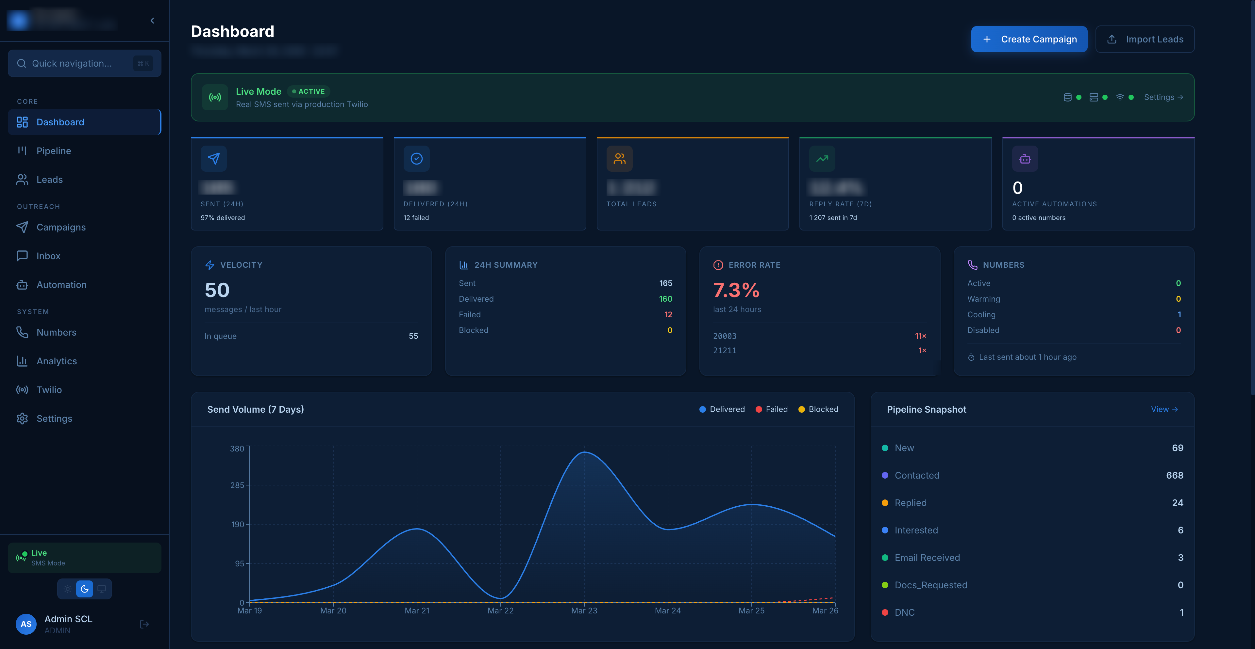
Production dashboard: real-time delivery rate (97%), send velocity, error breakdown by Twilio error code, 7-day volume chart — all updating live via WebSocket.

Step 3: Carrier Filtering Mitigation & Deliverability Optimization

The Problem
In financial services / lending, carrier filtering is the #1 challenge. Carriers actively block messages they classify as spam — and lending content triggers aggressive filters. Without mitigation, delivery rates can drop to 40–60%.
Our Results: Raised delivery rates from initial ~60% to sustained 83–97% in a restricted industry through 6 layered strategies.

Strategy 1: 7-Day Number Warm-Up
New numbers don't go to full volume. Automatic ramp prevents carrier suspicion:
Day | Daily Limit | Purpose
1 | 50 | Establish number reputation
2 | 100 | Gradual volume increase
3 | 150 | Building carrier trust
4 | 200 | Approaching normal capacity
5 | 250 | Near-full operation
6 | 300 | Almost at capacity
7+ | 350 | Full production capacity

Strategy 2: Health Scoring & Auto-Throttling
Every number has a real-time health score (0–100). Automatic responses:
Condition | System Action
Delivery rate < 80% | Capacity reduced to 50%
Error streak ≥ 5 | Number auto-cooled for 24 hours
Carrier block error (30007/30034) | Immediate cooling + admin alert
Campaign error rate > 30% | Circuit breaker pauses entire campaign

Strategy 3: Timing Jitter & Anti-Pattern Detection
- ±40% random jitter on every message interval
- Time distribution — messages spread across business hours window
- No burst sending — even "send now" campaigns are queued with natural spacing

Strategy 4: Content Variation
- Spintax: {Hi|Hey|Hello} {{firstName}}, {following up on|checking in about} your {financing|funding} request
- Dynamic variables: personalized with recipient name, company, specific details
- No trigger words: "promotional", "exclusive offer", "limited time", "act now" — all removed
- Conversational tone: messages read like human follow-ups, not marketing blasts

Strategy 5: Sender Pool Management
Pool | Purpose | Daily Cap/Number | Selection Priority
Primary | Main outbound sending | 350 | Health-weighted round-robin
Warm-Up | New numbers in ramp phase | 50–300 (by ramp day) | Lower priority, monitored closely
Re-engagement | Follow-up campaigns | 350 | Dedicated to reply-based workflows
Sticky sender: Once a lead receives a message from a specific number, all follow-ups come from the same number — builds trust, prevents confusion.

Strategy 6: Number Lifecycle Management
PURCHASE → WARMING (7-day ramp) → ACTIVE (full capacity)
↓ (delivery issues)
COOLING (24h auto-pause)
↓ (after recovery)
ACTIVE (restored)
↓ (persistent failures)
SUSPENDED → RETIRED
All transitions are automatic — the system self-heals without manual intervention.

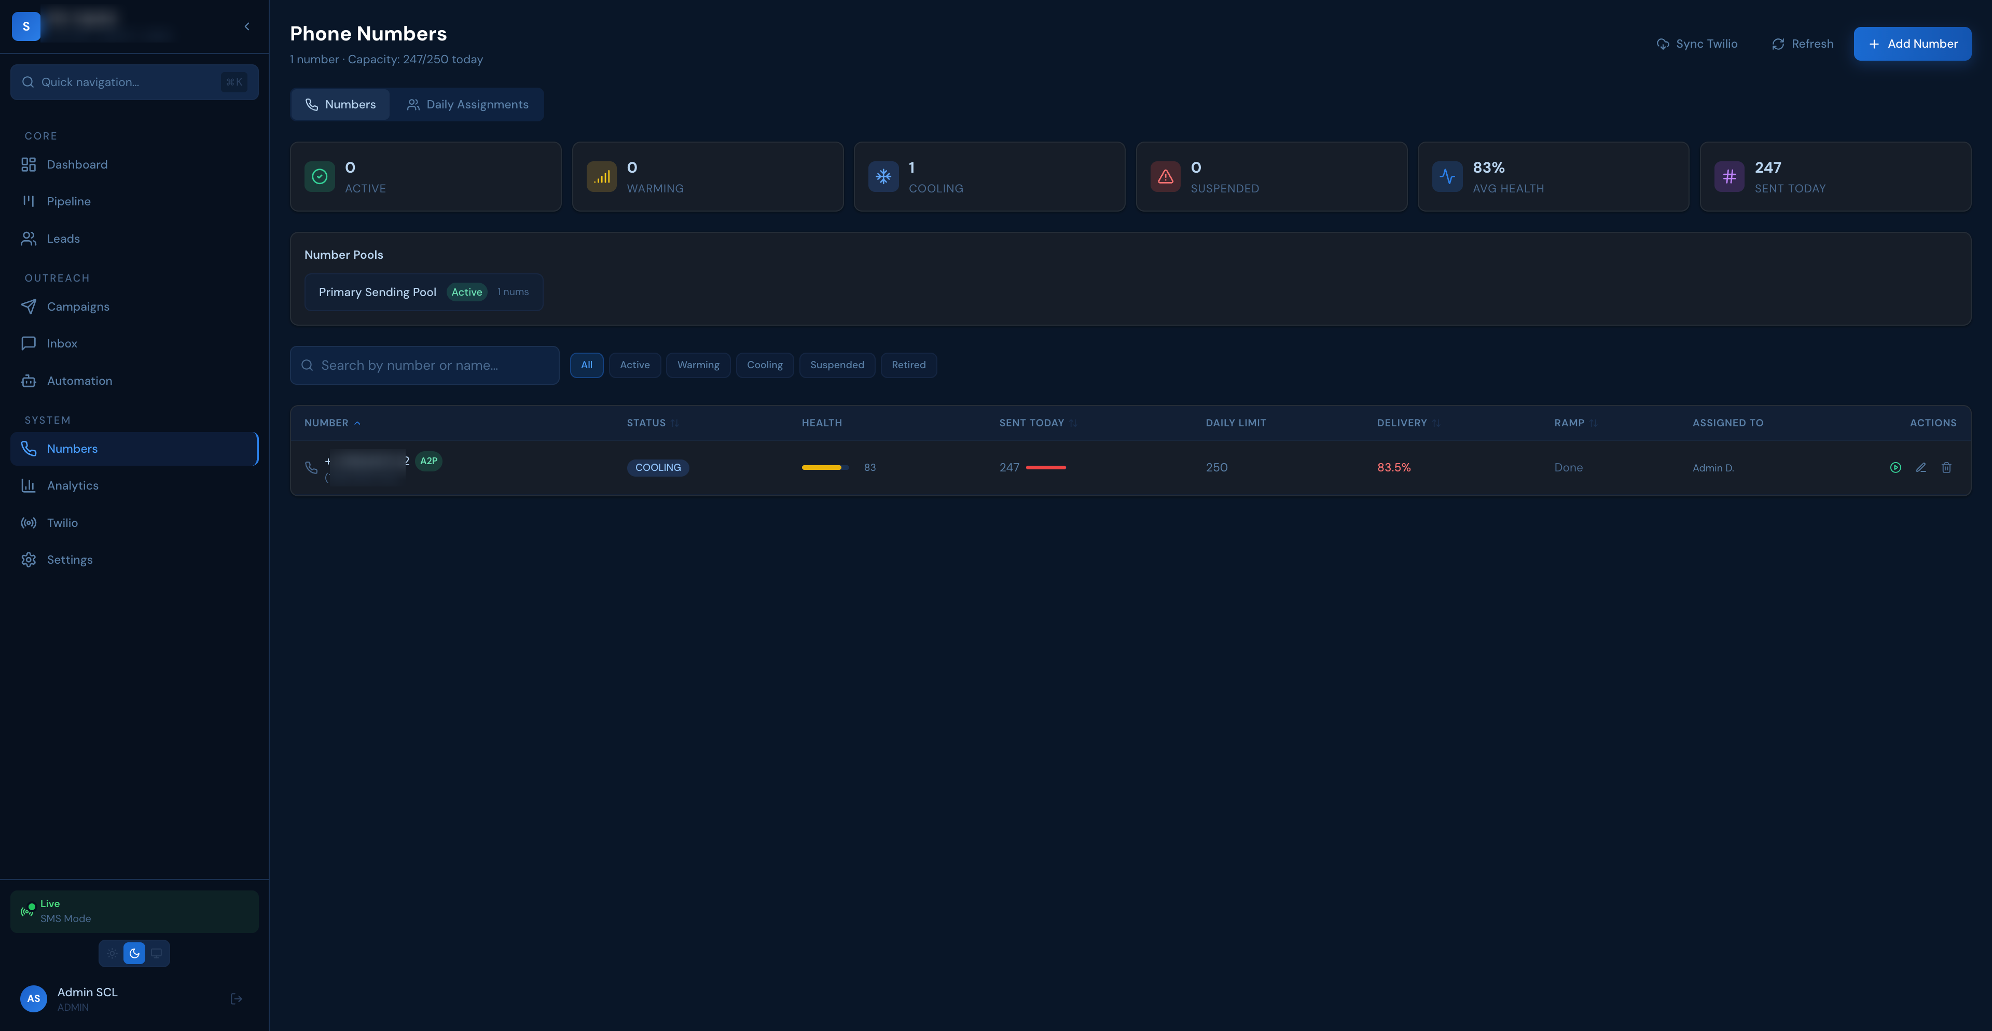
Number management: A2P registration badge, lifecycle status (WARMING→ACTIVE→COOLING), health score 83/100, daily usage 247/250, warm-up ramp tracking, pool assignment.

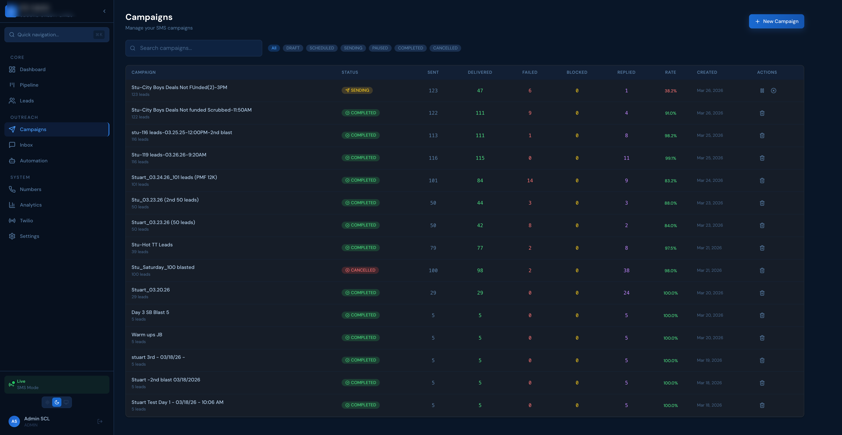
Campaign results: 15+ campaigns over 8 days in financial services, delivery rates 83–100%, reply tracking (up to 38 replies per campaign), instant pause/resume control.

Step 4: Live Operations, Monitoring & Real-Time Blast Support

The Problem
High-volume SMS requires live human oversight during sends. Automated systems catch most issues, but when delivery drops mid-campaign or a carrier starts blocking, you need instant visibility and instant control.

Real-Time Monitoring Infrastructure
WebSocket-powered dashboard (Socket.IO):
- Delivery/failure counters update live during active campaigns — no page refresh
- Per-number health visible during blast execution
- Error rate trending in real-time
- New inbound replies appear instantly in inbox
Webhook Processing (Non-Blocking):
Twilio status webhooks return 200 OK in <100ms (Twilio never times out). Actual processing queued via BullMQ with 10 workers: message status update, campaign stats, number health recalculation.

Error Code Intelligence
Twilio Error | Meaning | Automatic Response
30003 | Unreachable destination | Retry with backoff
30007 | Carrier filtering (blocked) | Cool number 24h, increment error streak
30034 | Content filter (SMS blocked) | Cool number 24h, flag content for review
21610 | Unsubscribed recipient | Mark lead DNC, add to suppression
21211 | Invalid phone number | Skip, mark lead

Live Blast Support Capabilities
Capability | Details
Instant Pause/Resume | One click — queue preserves all pending messages, zero message loss
Mid-Campaign Number Removal | Remove underperforming number from rotation without stopping campaign
Circuit Breaker | Auto-pause at >30% error rate — prevents cascading pool damage
Error Code Breakdown | Live view: which errors are hitting, which numbers are affected
Delivery Rate Trending | Real-time chart showing delivery rate climbing or dropping

What Happens During a Typical 10K Blast
Time | Event
T+0:00 | Campaign launched — 10,000 leads queued
T+0:01 | Compliance pre-check complete (batch: ~10 queries)
T+0:02 | First messages hitting carriers — delivery confirmations streaming in
T+0:05 | Dashboard shows: 450 sent, 420 delivered (93.3%), 0 failures
T+0:10 | Number #7 shows 2 consecutive failures — monitoring but not cooling yet
T+0:15 | 1,200 sent, 1,130 delivered (94.2%) — healthy campaign
T+0:20 | Number #7 hits 5 errors → auto-cooled. 34 remaining numbers absorb load
T+1:30 | Complete: 9,850 sent, 9,100 delivered (92.4%), 820 replies (8.3%)

Automation Engine (Drip Sequences)
Trigger | Example Sequence
New Lead Created | Welcome message → Day 3 follow-up → Day 7 last chance
No Reply After N Days | Automated re-engagement with different message angle
Status Changed | Stage-specific follow-up (qualified → offer presentation)
Lead Replies | Sequence auto-pauses → human rep takes over conversation
Smart pause: When a lead replies, the automation immediately pauses and hands off to a human rep. No lead ever gets an automated message while actively engaging.

Summary: Direct Match to Your Requirements
Your Requirement | Our Proof
Twilio SMS infrastructure for high-volume outbound | ✅ Production: 20K+ msg/day, 35+ numbers, BullMQ, 15 workers
Compliant strategies for restricted industries | ✅ Built for financial services: TCPA, suppression, quiet hours, keywords
A2P 10DLC registration & campaign approvals | ✅ Full flow: rejected → strategy pivot → approved. We know the pitfalls
Scaling strategies | ✅ 7-day warm-up, number pools, batch pre-loading for 10K+ campaigns
Improve deliverability, reduce carrier filtering | ✅ From ~60% to 83–97% sustained — 6 layered strategies
Troubleshoot blocking, filtering, throughput | ✅ Real-time error handling, auto-cooling, circuit breaker, health rotation
Number provisioning, messaging services, pools | ✅ Full lifecycle: WARMING→ACTIVE→COOLING, named pools, sticky sender
Live support during SMS blasts | ✅ WebSocket dashboard, instant pause/resume, per-number health live
Repeatable, scalable system | ✅ Production architecture: campaign → queue → workers → delivery → monitoring
Collaborate with leadership | ✅ Clear, actionable communication — strategy + execution, not theory

What Sets Us Apart
1. Actually done this at scale. Not proof-of-concept — 20,000+ messages/day in production, restricted industry, real carrier filtering challenges.
2. Solved the hard problems. A2P rejection → approval. Carrier filtering: 60% → 97%. Auto-healing number pools. Zero-latency compliance at scale.
3. Built the complete system. Lead import → campaign delivery → pipeline management → two-way conversations. Full operational platform.
4. Own both strategy and execution. Architecture, infrastructure, deliverability optimization, live blast support — end-to-end, same team.
5. Production-proven. Platform live at app.sclcapital.io — real data, real compliance, real results.

Built and operated in production for a financial services client.
Available for screen-share demonstration of all features described above.

