**The Battle of Neighbourhoods**

**Introduction**

Having access to health care is an important part of the modern age life. The goal of the project is to create platform for exploring medical centres in the city of Melbourne. We are trying to answer the following questions:

1. What are the available facilities in a certain neighbourhood.
2. Where is the closest place that provides a specific service (like an eye doctor)

**Data**

We will use the Foursquare database to get geographical location of different facilities.

Australian Postcode Location Data has been used, which is available at: <http://www.corra.com.au/australian-postcode-location-data/>

Department of Health and Human Services hospital database has been used, which is available at: <https://discover.data.vic.gov.au/dataset/hospital-locations-spatial>

**Methodology**

We have used foursquare data to create a map containing medical centres in a certain neighbourhood. Below is a map of hospitals and pharmacies in Melbourne:

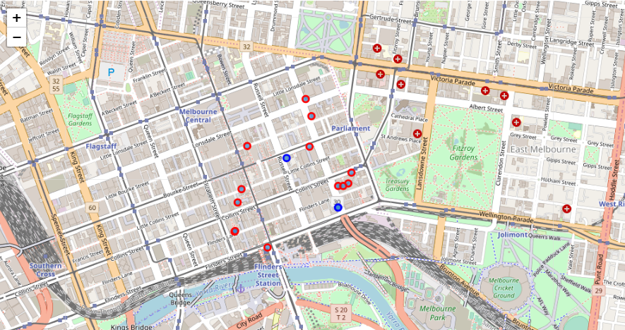

We have also created a list of closest centres to any given location. A list of closest hospitals as an example:

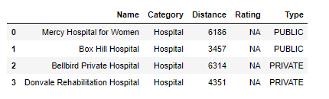

## Results

We have retrieved the required information using various databases. This includes creating a map of healthcare centres in a suburb and creating a list of closest service providers.

## Discussion

There seems to be not enough information about medical centres on Foursquare. Most of the venues seem to be unranked. Adding another database which is more popular amongst users, and has a wider range of information on user experience, might be useful.

## Conclusion

The goal of this project was to aid users in finding the best medical centre near them. We did this by providing a list of different centres in each neighbourhood and creating a list of closest centres to each location.