Solar Electric Power System Design

Simulation Program and Models

5 Aug 2009

by

Ken Sarkies

Preface

Copyright (C) 2007 by Ken Sarkies (www.jiggerjuice.net)
This work is licenced strictly under the Creative Commons Attribute-ShareAlike 2.5 licence (http://creativecommons.org/licenses/by-sa/2.5/).
This document is distributed in the hope that it will be useful, but WITHOUT ANY WARRANTY; without even the implied warranty of MERCHANTABILITY or FITNESS FOR A PARTICULAR PURPOSE.
Ken Sarkies, 19 January 2007

Contents
1 Introduction 4
1.1 Solar Radiation Characteristics 4
1.2 Photovoltaic Module Characteristics 4
2 Collector Model Description 5
2.1 Assumptions and Limitations 5
2.2 The Irradiance Model 5
2.3 Air Density Model 6
2.4 Geometry of Ray Paths 6
2.4.1 Slant Distance 6
2.4.2 Angle of Sun to Module 7
3 Configurations 10
3.1 Upper Bound 10
3.2 Following Module 10
3.3 Fixed Module 10
3.4 Horizontal Module 10
4 Return from Grid-Connected Solar Power System 11
4.1 Cloud Cover Model 11
4.2 Financial Model 12
4.3 Electronics 12
4.4 Results 12
5 Description of Program 13
5.1 Variables and Constants 13
5.2 Integration 13
5.3 Computational Functions 13
5.3.1 computeAnnualReturnFixedMPP 14
5.3.2 computeDailyFixedMPPReturn 14
5.3.3 solarFollowingCharge 14
5.3.4 solarFixedCharge 15
5.3.5 dailySolarEnergyFixed 15
5.3.6 dailySolarEnergyFollowing 16
5.4 General Functions 16
5.4.1 pathLoss 16
5.4.2 dayLength 17
5.4.3 airDensity 17
5.4.4 moduleCurrent 17
5.4.5 OptimalModuleVoltage 18

Introduction
The purpose of this work is to create a model of the daily global solar exposure at any location and time at the Earth's surface, for the purpose of determining the expected daily electrical energy collected by a solar power system, which in turn can be used to design a suitable system.
The model described here is based on specific atmospheric conditions, notably clear sky, rather than on conditions averaged over periods of time. The latter tends to blur over a wide range of atmospheric conditions and does not lead to a precise understanding of the system we are trying to design. We must ultimately include cloudy conditions, however we should do this in a more precise manner in order to adapt our design to a variety of requirements.
As an example, if we have a system that is to provide power to a remote station that is occupied continually, we would have a backup power source such as a wind or carbon-fuel generator which would be switched in on cloudy days. We may not need to consider cloudy conditions at all and can get by with a basic design. On the other hand if the station is unoccupied for periods of up to a week say, and the continuity of power is essential, then we need to determine how to enhance the system to deal with potential continuous cloud. For a station that is effectively unoccupied, we need to consider what level of risk of power failure we can tolerate, and what the probability of continuous cloudy days of differing periods will be in the region in order to complete our design. Averages of solar irradiance do not give us the precision that we need.

Solar Radiation Characteristics
The Sun's rays arrive at the outer atmosphere with a nominal power density of 1366Watt/metre². This solar constant varies slightly over the year due to the eccentricity of the Earth's orbit. In passing through the atmosphere the radiant energy suffers significant absorption. When the sun is on a vertical axis to the Earth's surface, the measured solar irradiance (power per square metre) in dry, still conditions is approximately 1.06kW/m². This is reduced as water vapour content and the turbidity of the atmosphere increases. Diffuse radiation scattered from the atmosphere is a little more difficult to predict. In still conditions it is about 0.06kW/m², and reduces with the Sun's Zenith angle.

Photovoltaic Module Characteristics
Photovoltaic modules are specified to have a given peak power output when the solar irradiance is 1000WH/m². When the solar irradiance falling on the module is reduced the actual power output is reduced correspondingly. This reduction is independent of collecting area and efficiency, although it should be noted that the latter drops slightly over a period of time after exposure to the Sun (a quality module would over-specify the output to account for this reduction).
The better quality modules available today are known as polycrystalline silicon modules. These do not degrade as much as amorphous silicon modules, and are much more efficient.

Collector Model Description
The model is based on determining the amount of absorption of solar radiation power at oblique angles over the period of a day. This begins with the amount of absorption measured for vertical rays in known clear sky conditions, and extends it to slant paths.

Assumptions and Limitations
- The atmospheric condition considered is cloudless, dry and still air.
- Atmospheric conditions along a slant path are the same as those along the vertical path.
- The incremental absorption of solar radiant power is directly proportional to the density of air in the atmosphere.
- Diffuse radiation is neglected.

The Irradiance Model
With our assumption that incremental absorption is directly proportional to the air density, we get along a slant path:

where P is the solar irradiance at height h, r(h) is the density of air, A is a positive constant to be determined, h is the height above sea level and s is the distance along the slant path. This gives:
(1)
where P₀ is the solar constant and f is the angle of the Sun's rays to the vertical at a given latitude and time of day. This is our fundamental equation. The rest is geometry needed to determine s(h,f).
Since we are given a nominal value for the irradiance at the Earth's surface as P(0,1)=1060kWH/m², we can get a value for A that can be precomputed and used in a range of calculations:
(2)

Air Density Model
We make use of a very simple empirically fitted model for the air density that is used to find the drag on satellites and aircraft (see the Glenn Research Centre site http://www.grc.nasa.gov/WWW/K-12/airplane/atmos.html ).
(3)
where h is the height in metres, T_{a} is the absolute temperature in degrees Kelvin , p is the pressure in kg/m² and r is the density in kg/m³. Other more comprehensive models are available which could be tried. These will add substantially to the execution time of the model but may not add a great deal to the accuracy of the results.

Geometry of Ray Paths
We can actually deal very simply with the geometry of the ray paths despite the onerous (exciting for some maybe) prospect of having to cope with Spherical Geometry that looms in the literature. The Sun is far enough distant from the Earth compared to the Earth's radius that we can assume it to be at an infinite distance. We only need to use some three dimensional vector analysis.

Slant Distance
Firstly we need an expression for the distance s(h) and its derivative.
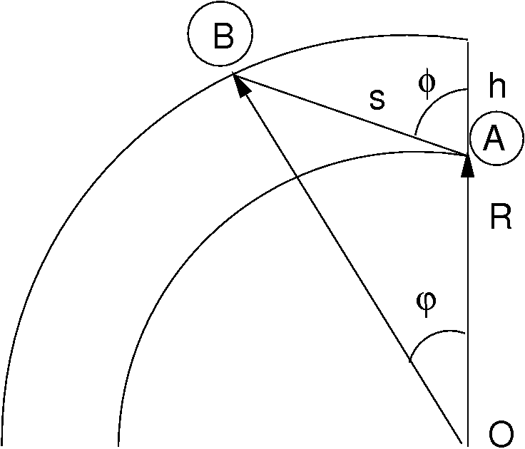
Figure 1. Slant distance
The diagram shows a section of the Earth cut perpendicularly to its axis at the given latitude. We wish to determine the length of the slant path AB given by the angle f to the vertical. The ray through AB is given by the vector:

where s is the distance parameter along the ray from the point A. The line OB has the vector:

The intersect point is at b=R+h giving us the equation:

Solving this for s and eliminating j gives:

This gives
(4)
the latter form being numerically better conditioned. The derivative is now:
(5)
This is sufficient to enable us to do some numerical integrations.

Angle of Sun to Module
Consider an equatorial plane, orthogonal to the Earth's axis containing the equator. Set an x axis in this equatorial plane whose orientation is in the longitudinal plane of the Earth's axis and the Sun, and set the z axis to be oriented northward along the Earth's axis. Let O be the Earth's centre, B the location on the Earth's surface of the module and S the location of the Sun (B is not necessarily in this longitudinal plane).
Consider a latitudinal plane as shown in Figure 2 below, orthogonal to the Earth's axis and containing the latitude circle of B. The line in the latitudinal plane between the Earth's axis and B subtends an angle q to the xz plane as shown. This line moves in a circle as the Earth rotates and q has the form:
(6)
where t is the time in hours from midday (we refer to this as the hour angle).
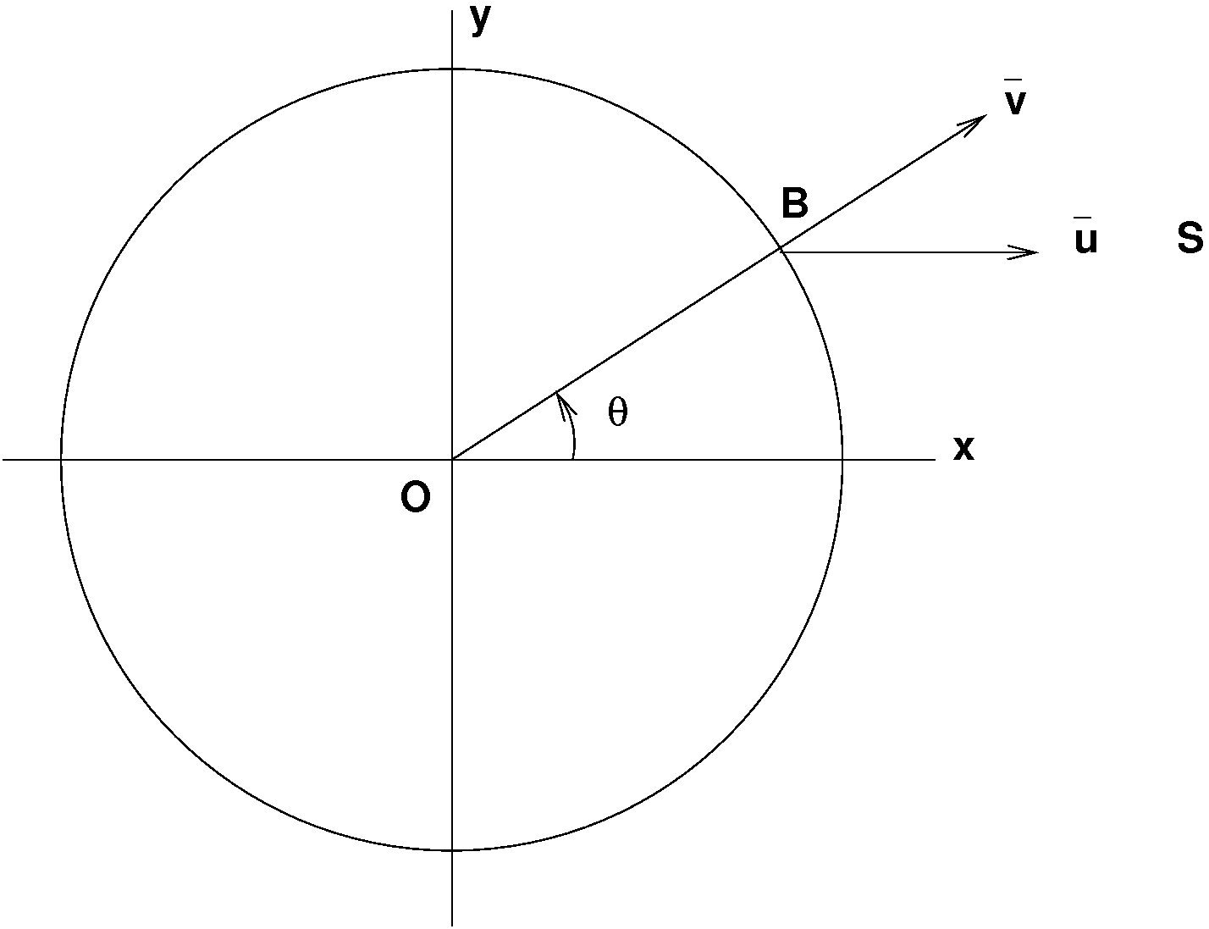
Figure 2. Time development of OB in the Latitudinal Plane

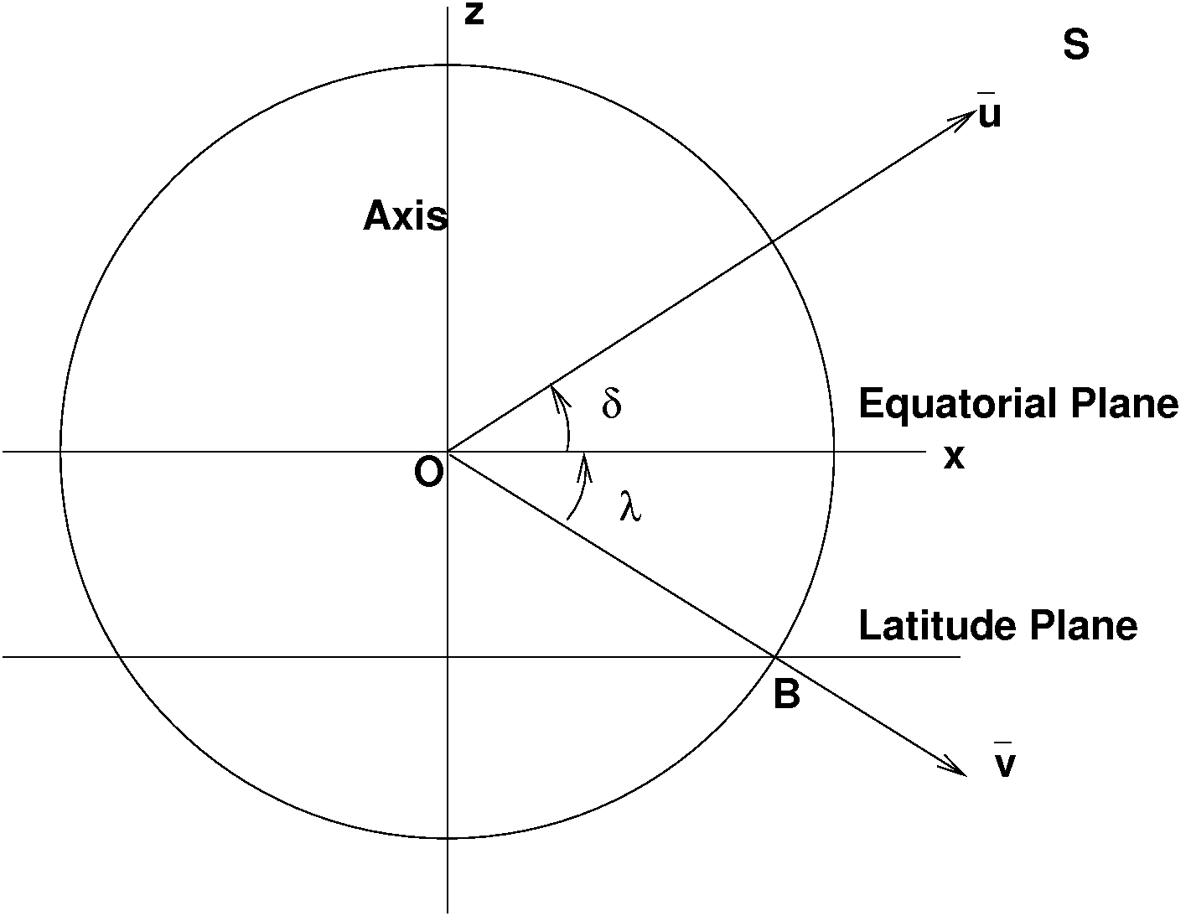
Figure 3. Declination and Latitude Angles
In the longitudinal plane, the line OS to the Sun subtends an angle d (the declination) to the equatorial plane. Similarly in a plane containing the z axis and OB the line OB subtends an angle l (the latitude) to the equatorial plane as shown above. To find unit vector expressions for OS and OB we first project the vectors onto the z axis and the equatorial plane. Then we project the resultant vectors in the equatorial plane onto the x and y axes. The unit vectors of OB and OS are then respectively:

Now we can easily obtain the expression for the angle f of the Sun to the vertical at the location B (the vertical is given by the vector OB) from the dot product of these two:
(7)
This expression is familiar from the literature and can be used to find the length of the day at any latitude and time of the year, that is, the time taken for f to change from -p/4 to +p/4.
Now let the orthogonal to the module surface have an angle w to the equatorial plane. In the same way as above we obtain the vector for the orthogonal to the module:

The angle α of the Sun's rays to the orthogonal of the module is then given by:
(8)
The collecting area of the module must be adjusted by multiplying it with cos(α), which will change with time of day. We consider three cases:
1. A module following the Sun
In this case the module always faces towards the Sun, but will be at a varying angle to the vertical as the day progresses. The Sun's rays always strike the module vertically so no geometric reduction factors need be applied to the model.
2. A module fixed facing the Sun at noon
In the second case the module is fixed at an angle w=d and the orthogonal to the module is in the longitudinal plane of B and the Earth's axis.
The angle of the module orthogonal to the vertical is then positive for a module facing towards the north of vertical. This angle ψ=w- l.
3. A module fixed at an arbitrary angle
This can be extended for modules that have orientations other than longitudinal, such as those on a fixed roof for example. The module is fixed as above at an angle w and is also offset from the north by ξ. This means that it faces the Sun at a time other than noon. This can be taken into account by replacing q with q+ ξ. This will result in positive angle offsets for a module facing towards the east.

Configurations
We can now look at a variety of ways of orienting the module, and make a prediction of the daily output that we would expect. The total energy E delivered by a module over the daytime period 2T is obtained by integrating the instantaneous power output, multiplied by the collecting area adjustment factor cos(a), over the daytime hours. T is the solution of the equation (7) for cos(f) = 0 and represents the time from sunrise to midday, or midday to sunset. In the following equations it is possible for cos(a) to fall to negative values during daylight hours for certain orientations of the module. In such a case the power output of the module must be set to zero in that range of cos(a).
Let the specified power output of the module be W watts. This is the output power for an irradiance of P(0,1) = 1060 W/m².
Firstly we obtain an upper bound on module daily energy output for comparison with the other results.

Upper Bound
Suppose we are able to extract the full specified power output of the module over the entire daytime period. Then the total energy E delivered over the daytime period T is simply:

Following Module
A module that is automated to follow the Sun will always have its orthogonal in the direction of the vector OS. Thus cos(a) is always 1. We would expect this to give us the maximum realistic output from the module. Thus:

Fixed Module
This scenario refers to a module that is fixed oriented towards the Sun at midday. Thus w is set to d.

Horizontal Module
This is another reference scenario. A horizontal module will receive from the Sun's rays a daily energy per square metre that is given by the standard Daily Global Solar Exposure G. This measure will allow us to compare our theoretical results with actual Bureaux of Meteorology measurements where they are available. This is obtained by setting w = l.

Return from Grid-Connected Solar Power System
This scenario is of particular interest, particularly where it is possible to sell excess power back into the national grid. Returns from the system are then financial returns; offsets to actual power used and excess power sold on.

Cloud Cover Model
Because of the non-linearity of the model described above, a somewhat detailed meteorological model is needed. It is possible to obtain daily statistics regarding cloud cover from the local Bureau of Meteorology. Readily available statistics consist of the following parameters:
- Average number of sunny days per month, i.e. cloud free days.
- Average number of cloudy days per month, i.e. days of total cloud cover.
- Average daily cloud cover measure. This is the portion of cloud cover in eighths of sky area, called oktas, where total cloud cover is 8 oktas and totally cloud free is zero oktas. The measures are taken only twice per day so they don't necessarily represent an average condition over a full day.
The model proposed uses the assumption that cloud cover measures represent the condition over a full day, so that we obtain the proportion of sunlight that generates power during a day. This essentially says that the returns are chopped up between periods of full sunlight and full cloud, in a random fashion over the day. As the average cloud cover is given over a monthly period, we would obtain a fraction of sunlight presence as follows:
- Use the average number of sunny days ds to obtain a fraction 1.
- Use the average number of cloudy days dc to obtain a fraction 0.
- Compute the average cloud cover in oktas on each of the remaining days as:

where m is the number of days in the month and c is the average cloud cover in oktas. This equation removes the sunny and cloudy day parts that were added into the average cloud cover measure.
Applying these results linearly gives a fractional return from the system

This is a rather long-winded way to get a rather obvious result, but it does show up the assumptions a bit more clearly. In addition to the assumptions of linearity and constancy of cloud cover over a day, there is an additional assumption that any cloud cover results in zero return. This is not quite accurate, and a correction could be added if we had a measure of the return from a panel in diffuse light. My personal observations show this to be roughly 10% of full power during most of the day (obviously varying with cloud density and also dropping away in morning and evening). A fudge term added to the model gives a fractional return:

In general however this would be considered a lower bound. More accurate modelling would require more precise weather statistics, or possibly detailed average solar irradiation data.

Financial Model
To make the results financially meaningful the instantaneous return value of the power generated is taken into account. This is likely to be different for power exceeding the instantaneous usage compared to that which offsets the normal grid power input. If it is assumed that during daylight the power consumption is constant, then we would compute the instantaneous return from the equations above with a step-valued function:

where H(x) is the Heaviside step function, taking values 0 for x < 0 and 1 for x > 0, ro is the offset return value per kWH, re is the excess return value per kWH, P is the instantaneous power from the system in full sunlight and PT is the instantaneous power consumption. P will vary according to the configuration of the panels, the time of day and the day of year as modelled above. This says that the return will be Pro while the power returned is less than the instantaneous power consumption, and then PTro + (P-PT )re beyond that.

Electronics
The modules do not normally feed batteries in a grid-connect system unless operation during blackouts is required. The inverters would most likely be MPP types. Efficiencies near 90% would be expected.

Results
The total daily return from the system is then given by:

The measure that is interesting to us is the annual return, which will tell if the long term investment in the system is worthwhile, so this needs to be summed over all months of the year.

Description of Program
The program is written in C++ and developed using the Eclipse IDE on Linux.

Variables and Constants
- lossConstant = 0.253617853024622586/pathLoss(1). This is the solar radiant power decay rate constant giving the scale factor for path loss.
- solarConstant = 1366. Value in W/m² of solar radiation incident on the Earth's atmosphere.
- solarStandard = 1000. Value in W/m² of solar radiation used as a standard value for solar panel specifications.
- latitude = -34.929. Current latitude of site (Adelaide).
- declination. The angle between the rays of the Sun and the plane of the Earth's equator.
- maxDeclination = 23.45. The maximum value of the declination, this value of declination occurs for the northern hemisphere in the northern mid summer.
- moduleAngle. The angle of the orthogonal to the module to the plane of the Earth's equator. Setting it to this value means the module is fixed, facing the Sun at midday. Note that the sign of this quantity should match that of the latitude.
- moduleOffset. The angle by which a fixed module is offset from the North, positive angles are towards the East.

Integration
The integration over time is done by summing the integrand at each minute over the relevant period of time when the Sun's rays are incident on the module.

Computational Functions
The functions used to perform the integrations in different configurations make use of a certain number of global constants.
Configurations used are as follows:
- Following module. In this configuration the module tracks the Sun during the day, so that the orthogonal to its surface is always oriented towards the Sun.
- Fixed module. The module does not move. The orientation is either determined by an existing structure such as a roof, or it is set so that the orthogonal to its surface is oriented towards the Sun at midday. Normally in practice this is done in mid-winter to capture most energy at that time of the year, as excess energy is available in summer and optimization of input is not so important.
- Full power. The module delivers the maximum possible power into the batteries. This is not a realistic model but it can server as an upper bound.
- Battery voltage constraint. The module's output voltage is held to the battery's voltage. This is a basic regulator type which only cuts off battery charging when it is fully charged. Power into the battery is determined by the VI characteristic of the module.
- MPP. A maximum power point tracking regulator will attempt to up or down convert the module voltage and attempt to ensure that the module voltage and current is held at the point where maximum power is delivered. Such regulators experience some losses and may deliver 93% or less efficiency.

computeAnnualReturnFixedMPP
Computation of annual return for a module system feeding an MPP tracking regulator, with offset and feed-in tarrifs provided for usage offset and excess.
Function parameters are:
- Input: Latitude in degrees, positive north of equator
- Input: Angle of the module to the equatorial plane
- Input: Offset angle of the module to a northerly direction.
- Input: Cost (c/kWH) of power used on the premises.
- Input: Cost (c/kWH) of power purchased from the premises.
- Average power usage in kW during the daylight hours
- Output: Total energy per square metre over a day arriving at the module's surface.
- Dependencies: pathLoss(cosangle) integral of air density over a slant path

computeDailyFixedMPPReturn
This is identical to computeIncomeFixedMPP, but provides income for a specific day of the year. It has the same parameters as the above with one additional parameter:
- Input: Declination of the sun in degrees

solarFollowingCharge
This uses a following module. The model uses the angle of the Sun to the vertical to determine the atmospheric loss. This is multiplied by the full specified power of the module to get an upper bound of output power. Integration is done by a simple sum over small elements given in minute increments and over half a day. The result is converted to WH by dividing by 60 and multiplying by 2 for the second half of the day.
The parameters are
- Input: Latitude in degrees, positive north of equator .
- Input: Declination of the sun in degrees .
- Input:Module model number (1 = module delivering full power to the battery., 2 = module output voltage held to battery voltage, 3 = module following Maximum Power Point).
- Output: Total charge delivered to the battery over the day in AH.

solarFixedCharge
This uses a fixed module. The model uses the angle of the Sun to the vertical to determine the atmospheric loss.
The cosine of the incidence angle of the Sun to the panel is determined from the module angle, which is the angle of the orthogonal to the module at midday, and the offset angle of the module from the North towards the East.
The parameters are:
- Input: Latitude in degrees, positive north of equator .
- Input: Declination of the sun in degrees .
- Input: Angle of the module to the equatorial plane.
- Input: Offset angle of the module to a northerly direction.
- Input:Module model number (1 = module delivering full power to the battery., 2 = module output voltage held to battery voltage, 3 = module following Maximum Power Point).
- Output: Total charge delivered to the battery over the day in AH.

dailySolarEnergyFixed
This function performs integration of the incident solar power in W/m2 to give the total kWH/m2 over a day at a given latitude.
Integration is done by a simple sum over small elements given in minute (time) increments and over half a day. The result is converted to kWH by dividing by 60,000 and multiplying by 2 for the second half of the day.
The computation represents a fixed module.
Function parameters are:
- Input: Latitude in degrees, positive north of equator.
- Input: Declination of the sun in degrees.
- Input: Angle of the module to the equatorial plane.
- Input: Offset angle of the module to a northerly direction.
- Output: Total energy per square metre over a day arriving at the module's surface.
- Dependencies: pathLoss(cosangle) integral of air density over a slant path

dailySolarEnergyFollowing
This function performs integration of the incident solar power in W/m2 to give the total kWH/m2 over a day at a given latitude.
Integration is done by a simple sum over small elements given in minute (time) increments and over half a day. The result is converted to kWH by dividing by 60,000 and multiplying by 2 for the second half of the day.
The computation represents a following module always facing the sun.
Function parameters are:
- Input: Latitude in degrees, positive north of equator
- Input: Declination of the sun in degrees
- Output: Total energy per square metre over a day arriving at the module's surface
- Dependencies: pathLoss(cosangle) integral of air density over a slant path

General Functions
A variety of model functions are provided to allow a range of computations to be performed.

pathLoss
This function performs numerical integration of air density over a sloping solar ray path to obtain a quantity proportional to the path loss. This is used in ratios of path loss over that for the direct vertical, for which loss is known.
The angle of the path to the vertical is phi. To integrate density ρ(h) as a function of height, over the path length a, we compute the slope of the path with respect to the height from ground level to get the integral from 0 to infinity of ρ(h) by (da/dh) dh
Function parameters are:
- Input: cosine of angle of the path to vertical phi in degrees
- Output: Path loss. Units are arbitrary as this appears only in ratios.

dayLength
Computes the length of the daylight period day in hours for given latitude and solar declination. There is 15 degrees per hour movement of the sun.
Function parameters are:
- Input: Latitude in degrees, positive north of equator
- Input: Declination of the sun in degrees
- Output: length of day sunrise to sunset in hours.

airDensity
This function computes the density of air from a model taken from the Glenn Research Centre http://www.grc.nasa.gov/WWW/K-12/airplane/atmos.html. The units of the model are imperial, so we convert to metric when the computation is complete.
Function parameters are:
- Input: height above Earth's surface in metres
- Output: air density in kg/m^3

moduleCurrent
This is an electrical model for a solar module in which no regulator is used. The parameters given here are for the BP3125 120W polycrystalline module. It uses a pn junction model matching three current/voltage points to obtain the characteristic parameters. For the BP3125 the parameters used are theshort circuit current Isc = 8.02, the diode dark current I0 = 0.000185 and a model parameter voltage Vk = 2.071. The model is correct only at the points (short-circuit, open-circuit and maximum power).
Solar current generated is proportional to the short circuit current portion only, the second term is the diode loss term.
Function parameters are:
- Input: solarEnergy is the incident solar radiation given as a percentage of the standard incident solar radiation used to define the module characteristics (ie 1000 W/m2).
- Input: Voltage is that which is imposed by the system, generally the battery voltage, and which sets the operating point.
- Output: Module Current

OptimalModuleVoltage
This is another electrical model of a solar module in which the regulator is a maximum power point tracker. It will allow comparisons of the basic and MPP regulator performance. Panel parameters are the same as those used in the moduleCurrent function.
This uses a simple hill-climbing search for maximum power starting at the open-circuit voltage and stepping back to the peak.
Function parameters are:
- Input: solarEnergy is the incident solar radiation given as a percentage of the standard incident solar radiation used to define the module characteristics (ie 1000 W/m2).
- Output: Module Voltage.

