XBee Acquisition Network Design Notes
Table of Contents
1 Introduction 3
2 Xbee Setup 3
2.1 Network Setup 4
2.2 XBee Settings 4
2.2.1 Sleep Time 4
2.2.2 Router 5
2.2.3 End Point 5
2.2.4 Coordinator 6
2.3 Unbrick XBee 7
3 Base Station 8
3.1 Configuration 8
3.2 Software 8
3.3 Structure 9
3.4 Command Line Interface 9
3.5 Internet Interface 9
4 Remote Nodes 10
4.1 Sleep Modes 10
4.1.1 Configuration 11
4.1.2 Bootloader 11
5 Communication Protocols 11
5.1 Bootloader 11
5.2 Base Station to Remote Node Interactions 12
5.3 Data Transfer Protocol 12
5.3.1 Protocol 12
5.3.2 Message types 13
5.4 Parameter Change Command 14
5.5 External Interface 14
6 Software Development 14
6.1 Base Station 14
6.2 XBee-GUI 15
6.2.1 Linux Installation 15
6.2.2 Windows Installation 15
6.3 Remote Node Firmware Arduino Development 16
6.4 Bootloader for ATMega 16
6.5 Bootloader for ATTiny and ATMega48 17
6.6 Remote Node Firmware 17
6.6.1 Definitions 17
6.6.2 Data Transmission Protocol Implementation 18
6.6.3 Pseudocode 22
6.6.4 Flowcharts for remote protocol process 24
6.6.5 Firmware for Watermeter 26
6.7 Testing 26
6.7.1 Error free test 26
6.7.2 Message received in error by base station 26
6.7.3 Base station acknowledge lost 27
6.7.4 Base station acknowledge excessively delayed 27
6.7.5 Extreme range tests 27
7 Testing 28
7.1 Remote Node with ATMega48 28
7.2 Remote Node with ATTiny4313 28
7.3 Remote PC Attached Node 29
7.4 Watermeter Board 29
7.5 Node Test Firmware 30
7.6 PC Based Emulated Node Test Firmware 30
7.6.1 mainprog-test.cpp 30
7.6.2 mainprog-firmware.cpp 30
7.6.3 Adaptation to Other Test Code 30
7.6.4 Watermeter Count Test 31
7.6.5 Watermeter Echo Test 31
8 Example System Setup 32
9 Notes 32

Introduction
This describes a project to build a support base for a data acquisition network in which the communication between nodes of the network uses XBee devices in Zigbee mode.
The document describes the various design parameters and decisions, and documents the protocols and interfaces between components.
The concept involves a Linux based coordinator processor, referred to as the base station, intended to be a small headless platform such as the Raspberry Pi, BeagleBone or similar. By means of a background base station process this provides a control, configuration and collection point for incoming data via an attached an XBee in coordinator mode. It also provides a network interface to a Linux, OS/X or Windows based user interface program on the same or different machine.
The remote nodes provide the data acquisition facilities. The remote nodes can be of two types: XBee end devices and XBee routers. The latter must be always on and powered with an uninterruptible supply, while the former may be battery operated and use sleep states extensively to conserve power. As the XBee is capable of performing a small number of analogue measurements and provides basic digital I/O, it can operate as a standalone device. Alternatively, and preferably for flexibility, it can operate in conjunction with a small microcontroller. The latter configuration has a number of advantages in that each can monitor the other and provide some additional fault recovery functionality, such as remote reset, firmware uploads for the microcontroller, watchdog timer reset and remote configuration of the XBee.
Most remote nodes will use battery operation and thus they will make use of various XBee sleep states. Most modern microcontrollers can also use sleep states. As the microcontroller is likely to wake from sleep on various local events, it can also wake the XBee when transmission is required.
A number of items of software are developed for this work:
- Base station program for monitoring, data collection and buffering, and interface to an external control program.
- Data acquisition and control program for the remote node microcontroller.
- Bootloader for the remote node microcontroller to allow firmware uploads.
- External GUI program for connection to the base station over the Internet or local LAN, for monitoring, control and data access.
The remote node for the watermeter is described in another document.

Xbee Setup
The XBee can be setup initially with the Digi X-CTU tool. This is available for Windows, OS/X and Linux http://www.digi.com/products/xbee-rf-solutions/xctu-software/xctu.
In Linux, the downloaded file has a .run suffix. Make executable and execute as root, eg

$ chmod +x 40002881_B.run
$ sudo ./40002881_B.run
If it is installed to the default directory /opt/Digi/, it can be run as:

$ /opt/Digi/XCTU-NG/app
Also change the ownership of the /opt/Digi/XCTU-NG/ directory and its contents to the current user.
Connect an XBee to a USB port. It will normally then appear as /dev/ttyUSB0 (although the number will be higher if other devices or disk drives have already been attached). Perform a search for the attached XBee. If not found, widen the search to different serial settings. The XBee cannot communicate its serial settings so a search must be done.
When the XBee is found, click on its entry to read all parameters. These can be changed and written back to the XBee. To change the XBee type, new firmware must be loaded.
Some debug information is available at the bottom of the parameters screen. This can indicate reasons for the XBee not joining the network for example.

Network Setup
- If the XBees have been set with the correct network parameters as described below, install the coordinator on a PC with X-CTU installed. Check that it is recognised and the parameters are correct. The coordinator should have
- Connect the router Xbees to a suitable power source. Each of these should start up (connect to the network) after a few seconds. If LEDs are present, the “associate” LED (pin 15) should blink at a rate twice per second once the XBee has joined the network.
- In X-CTU clink on the “Discover Radio Nodes” button for the coordinator entry. All nodes should be found.

XBee Settings
These are the settings available from the X-CTU tool.
The network PAN ID is selected as 55 for this system. This is set in all XBees to be used in the network.

Sleep Time
The coordinator and routers are set to never sleep. These must always be powered on by an uninterruptible power source. The end devices are required to sleep to conserve battery power, and cannot be set to never sleep. They may be woken from sleep via the SLEEP_RQ pin being pulsed high then low.
The sleep time setting in the coordinator and routers refers to the maximum time that end devices are expected to sleep. If an end device does not respond during this time it is purged from the list of child devices. The setting therefore must be a larger value than the end device sleep setting to ensure that the end device remains in the child table and is not expired. Any end point should wake at least once per day.
The sleep setting in end devices will be pin hibernate or cyclic sleep plus pin wake. For power reduction the sleep time must be as long as possible. For safety the cyclic sleep setting plus pin wake should be used to ensure the XBee wakes up regularly to refresh the network connectivity. The sleep options are set to allow a sleep holdoff time to be defined and to enable extended sleeping.
The maximum wake period can be set to 65 seconds. The maximum cyclic sleep setting can be set to 28 seconds multiplied by an integer that can be as high as 65535 (32 days).
When the end device XBee wakes, an setting can be used to allow it to remain awake for a fixed period to allow remote devices and processes to send any pending messages. The end device XBee must receive and respond to these messages before sleeping. The setting only applies to cyclic sleep mode and not for pin sleep mode, although it appears to be active for pin wake when pin plus cyclic sleep mode is used.

Router
- NJ – Node join time. If less than FF the device assumes the network doesn't allow joining and attempts to rejoin. This allows it to join a network with the same PAN ID. If this fails, or NJ is FF, it joins by association.
- PAN ID – set to the selected PAN ID of the coordinator. If set to zero, the XBee will pick up the PAN ID from the coordinator (as long as only one coordinator is around).
- NW = 1. Network Watchdog Timeout in minutes to cause the XBee to check for a coordinator and leave if not found (0 is disabled). This is normally set to a higher value.
- JV = 1. Channel verification causes the XBee router to check for a coordinator on power up and search for one if not found.
- JN = 1. Join notification causes the XBee to send a node identifier packet on power up. This is needed to ensure it is entered into the software table.
- BD = 5. Set the baud rate to 38400.
- D7 = 1 Enable CTS flow control.
- D6 = 1 Enable RTS flow control.
- AP = 1 Use API mode without break characters.
- SM = 0. Set the sleep mode to disable.
- SP = 0xAF0. Set the sleep period to the maximum 28 seconds.
- SN = 0xB60. Cyclic sleep periods, up to FFFF. Set to just over 1 day.
- PR = 0x1FBF. Set the pullup resistors to exclude CTS (which is an output) and SLEEP_RQ which needs an external pull down of large value.

End Point
- PAN ID – set to the selected PAN ID of the coordinator. If set to zero, the XBee will pick up the PAN ID from the coordinator (as long as only one coordinator is around).
- NJ – Node join time. If less than FF the device assumes the network doesn't allow joining and attempts to rejoin. This allows it to join a network with the same PAN ID. If this fails, or NJ is FF, it joins by association.
- NW = 1. Network Watchdog Timeout in minutes to cause the XBee to check for a coordinator and leave if not found (0 is disabled). This is normally set to a higher value.
- JN = 1. Join notification causes the XBee to send a node identifier packet on power up. This is needed to ensure it is entered into the software table.
- MP – Parent address (0 for coordinator, or address of router).
- NT – Node discovery backoff time (3C about 6 seconds).
- NO – Node discovery options (3).
- BD = 5. Set the baud rate to 38400.
- D7 = 1 Enable CTS flow control.
- D6 = 1 Enable RTS flow control.
- AP = 1 Use API mode without break characters.
- SM = 5. Set the sleep mode to cyclic sleep plus pin wake.
- SP = 0xAF0. Set the sleep period to the maximum 28 seconds.
- SN = 0xB40. Cyclic sleep periods, up to FFFF. Set to about 1 day.
- ST = 0x1F4. Set the sleep holdoff time to 0.5 seconds. Only for cyclic sleep.
- SO = 6. Enable extended sleep (4) and sleep for full ST time (2).
- PR = 0x1FBF. Set the pullup resistors to exclude CTS (which is an output) and SLEEP_RQ which needs an external pull down of large value.

Coordinator
- ID – set to the selected 16 bit PAN ID. If set to zero, the XBee will pick a random number.
- SC – Scan channels bitmask for up to 16 channels. Coordinator will select a channel when forming the network. Defaults to FFFF.
- SD – Scan duration. How long the coordinator spends scanning for PAN ID or energy scan. The setting is an exponent (3) in units of 15.3ms per channel.
- ZS – Zigbee stack profile. Same on all devices on the network. This is related to specialised applications. Normally set to 0.
- NJ – Node join time. Time allowed for remote nodes to join. If set to FF it will have no time limit. After the limit has expired, remote nodes are unable to rejoin until the coordinator is reset or NJ is changed.
- OP – Operating PAN ID (should match the nonzero value in ID).
- OI – Operating 16 bit PAN ID.
- CH – Operating channel.
- NC – Number of children remaining (routers and end-points directly accessing the coordinator).
- SH, SL – Serial Number high and low.
- MY – 16 bit network address (0 for coordinator).
- DH, DL – Destination address (0000 FFFF for coordinator).
- NI – Node identifier ASCII name.
- NH – Maximum number of hops. Default 1E is about 1.6 seconds, 8 hops
- BH – Broadcast radius. For maximum number of hops set to 0.
- AR – Aggregate routing notification. Time between consecutive aggregate broadcasts.
- DD – Device type identifier (30000).
- NT – Node discovery backoff time (FF).
- NO – Node discovery options (3).
- NP – Maximum number of RF payload bytes (FF).
- CR – PAN conflict threshold (3). Not mentioned in documentation.
- BD = 5. Set the baud rate to 38400.
- D7 = 1 Enable CTS flow control.
- D6 = 1 Enable RTS flow control.
- AP = 1 Use API mode without break characters.
- SM = 0. Set the sleep mode to disable.
- SP = 0xAF0. Set the sleep period to the maximum 28 seconds.
- SN = 0xB60. Cyclic sleep periods, up to FFFF. Set to just over 1 day.
- PR = 0x1FBF. Set the pullup resistors to exclude CTS (which is an output) and SLEEP_RQ which needs an external pull down of large value.

Unbrick XBee
The Xbees are XB24-ZB product family. To force a firmware update, use an interface board with a reset button.
- Go to "Tools – XBee Recovery",
- Select interface and modem type from list,
- Select function set and firmware version,
- Click on the "Recover" button. After a few seconds of trying to read the modem, you will get an Info box that says Action Needed. Reset the modem using the reset button on the interface board.

Base Station
The base station processor being used for this project may be almost any Linux based PC or processor board. This interfaces to the local WiFi or Ethernet LAN to allow external control and data transmission. It may use a HDD or SD card for data buffering.
The base station is attached to the coordinator XBee.

Configuration
The configuration of the base station processor depends rather on its hardware features. A full PC needs little configuration as it will be able to respond to almost any load demand from the network. A small processor board however may need some work to improve performance.

Software
It is intended that the processor be set to start a background monitoring process to control the network, gather incoming data, pass it to storage buffers and interact with an Internet GUI control and display program. The program is written in C and uses libxbee3 by Attie Grande for XBee support.
The program starts by querying all nodes on the network and building a table of information for each one, including libxbee connections to allow reception of data streams from the device.
The program also sets up an Internet TCP port 58532 for connection externally by a user interface program.
The requirements for the program are:
- On startup, initialise an Internet socket for attachment by an external user interface program. This socket shall listen on TCP port 58532.
- For each remote node in the table, make a data connection on which incoming data for each remote node will be received.
- Create an “Identify” connection to receive identification packets from remote nodes when they power on or join the network. Note: all stand-alone XBee nodes should have the Join Notification setting enabled to allow new nodes to identify themselves to the network. The software in the remote node microcontroller shall force the sending of the Identify packet when powering up.
- Send out an XBee Node Discovery command via the attached coordinator XBee to query all remote nodes in the network. From the responses build a table of node information.
- On receiving Identify packets the program shall check against the existing table and add the remote node if it is not already present.
- Interact with the remote node via data connections, to retrieve and store transmitted data using a reliable application level protocol (see section on communication below).

Structure
The libraries libxbee3 provide for callback functions to be invoked to deal with various message types from the XBee.
- nodeIDCallback. Callback for the ND and Identify command, to load up the node list. It is invoked when an identify packet is received. This checks for existence of the node information and adds a new node if not present. Data, I/O and AT command connections are added. If a device powers off and back on again it will be dealt with adequately by this callback. Connections are only added if the entry is not valid or is a new entry.
- dataCallback. This interprets incoming packets on the remote node data connection, and for process data passes it on to an external file. Other packets are responses to commands to the node AVR sent over the same connection. The response is stored in a global array. This should be read before any other node AVR command is sent to any node.

Command Line Interface
When invoking the program on the base station machine, the following options are available:
-d directory to store results file (default /data/XBee)
-P port (default is /dev/ttyUSB0)
-b baudrate (default 38400 baud)
-D debug mode, printing out actions as they occur to standard output.
The program when run with the debug option will announce the results filename. The default filename will be time-stamped, but this can be overriden by the above command line option. It will then loop waiting for communication from the network. Debug information is written to /var/log/syslog.

Internet Interface
Commands received over the Internet connection from an external user interface program have the following format:
1-byte length, 1-character command, 1-byte row number, arbitrary parameters (0-255)
For transmission to remote nodes, the row number points to a table entry with the node information and connections.
The commands (n represents the remote node's row number) are:
- N - return the number of rows in the table
- In - return the textual and numerical information in the node entry.
- Sn... - send a string to the remote node over its data connection.
- s - ask for any response returned by the remote node to an S command on the data connection. A value of zero returned as the first character indicates that a response had not been received. The first character of a valid response will be an ASCII 'S' to indicate that a response was received.
- Rn... - send a remote AT command plus its parameters to the remote node.
- r - ask for any response returned by the remote node to an R command on the data connection. A value of zero returned as the first character indicates that a response had not been received. The first character of a valid response will be an ASCII 'R' to indicate that a response was received.
- Ln... - send a local AT command plus its parameters to the attached coordinator XBee.
- l - ask for any response returned by the remote node to an L command on the data connection. A value of zero returned as the first character indicates that a response had not been received. The first character of a valid response will be an ASCII 'L' to indicate that a response was received.
- X – close down the XBee network and, after a 20 second delay, restart it. This has presented a number of issues with remote nodes not being recognised, and is not recommended to be used.
- Q – close down the selected remote node data, I/O and command connections, and rebuild them.
- D – Delete a selected remote node from the node table.
The convention used is upper case letters to represent a direct command and a lower case letter used to request any response.

Remote Nodes
These devices shall use sleep modes to reduce power drain to a minimum. The XBee can be placed in “pin sleep” and await the microcontroller action on a specific pin to wake it up. Alternately it can be made to wake periodically so that in the event of a non-responding microcontroller, it can force the latter to be reset. The microcontroller can also force a hardware reset on the XBee if the latter fails to respond. The microcontroller shall be placed in a sleep mode also.

Sleep Modes
The XBee shall be set to Sleep Mode 1 (pin sleep). This allows the XBee to sleep until awoken by the action of the SLEEP_RQ pin, controlled by the microcontroller.
Note the controller and all routers must have their sleep options set to the same value or greater to ensure they retain end device messages until the latter awakes. These sleep options refer to the time allowed for end devices to remain asleep (the coordinator and routers never sleep).
The microcontroller shall be placed in sleep mode until data becomes available or until the XBee wakes it. The XBee ON/SLEEP output can be used to a wakeup the microcontroller. An AVR microcontroller shall use the power save sleep mode if the timer/counter is to be used, otherwise power down mode shall be used. Both can be woken with a pin change interrupt.

Configuration
When configuration of the XBee is to be done, a message shall be sent to the XBee to perform the appropriate action. This must occur when the XBee is woken by the remote node microcontroller.
To account for the case where the AVR hasn't been given the ability to change the XBee sleep state, an XBee command will need to be sent by the controller to change the sleep mode to pin sleep. The XBee will then need to have its SLEEP_RQ pin grounded to ensure that it remains awake indefinitely in this mode. The XBee end devices cannot be set to remain permanently on, and must use one of the sleep modes.

Bootloader
The need to reset the AVR when activating the bootloader results in the SLEEP_RQ pin of the XBee being forced high during the reset, as all I/O ports on the AVR are changed to inputs. This puts the XBee to sleep and cuts off communication. To overcome this, a 1M or larger resistor is used as a pull-down and the pull-up on the XBee SLEEP_RQ pin is disabled.

Communication Protocols
On top of the Xbee networking protocol is needed a specific application protocol to communicate between the remote node microcontroller and the base station process. This shall be done by means of a command/response mechanism consisting of a command or response code word possibly followed by data. A code word that doesn't belong to the following list shall result in an error response.
The protocol shall consist of an ASCII command character followed by a string of ASCII hexadecimal characters representing numerical data, or other ASCII characters representing non-numerical data.

Bootloader
The following commands apply to interaction with the bootloader only.
- : (semicolon). The following data shall be a single record of iHex formatted hexadecimal characters, pairs of which represent a data byte, and having maximum length 16 data bytes. The record types 00 and 01 (end of file) are recognised. Error responses include invalid hex character, checksum, record length and record type.
- Q. Quit the bootloader and enter application program at address zero.
- X. Erase all application memory.
Responses
- Y no error.
- E unspecified error response.
- B out of bounds (bootloader has been asked to write over itself).
- L invalid iHex record length
- H invalid hexadecimal character
- X invalid checksum
- I invalid command (including invalid data where appropriate)
- J a jump to the application has been made from the bootloader.

Base Station to Remote Node Interactions
As specified above, in the remote node, both the microcontroller and the XBee will sleep. The microcontroller will wake at intervals and will then wake the XBee to check for waiting messages and to send data. Regardless of any data to be sent the base station must receive a message from the remote node and respond. Then the remote node may return to sleep.
For safety the remote node must wait for a limited period of time for a response, and resend the message if no response has been received. The following protocol shall be followed to improve the reliability of communication in the presence of possible errors.
If no response has been received, then the remote node may check the XBee for valid status, to determine if it is still joined to the network. If not, then the XBee shall be restarted. Otherwise the remote node shall return to sleep on the assumption that the network is not responding. Accumulated data shall be retained for subsequent attempts.

Data Transfer Protocol
A reliable protocol is required to ensure that the collected data is transferred accurately to the system.
If data is transferred correctly, then the old data must be cleared to make room for a new set.

Protocol
Successful error recovery requires careful design. However it is not possible to anticipate all possible errors. These can arise from corruptions in the communications at the Xbee-AVR interface, or in the XBee network itself.
The protocol in summary is as follows. More detail is given in the flowcharts.
- When the XBee is ready to send, wake up and send a contact message with the collected data and a checksum.
- Receive an acknowledgement, or negative acknowledgement if data was received in error by the base station.
- If timeout, repeat the contact message until the acknowledgement is received or until three attempts have failed.
- If any other error occurs, resend the data message up to three times.
- On failure send a signal to indicate that the results should be discarded.
- On success, reset the data and send a signal to store the result.
The length of the data field can be inferred from the message length. All fields shall consist of printable ASCII characters for readability and error checking. Because of limited memory in the AVR, the messages shall have limited length.
If the remote gives up, then it shall send a final message stating that it is giving up and will not reset the count. The base station shall discard the result if it has not received a definite acknowledgement. This protocol will never guarantee that data will not be lost, but will cover most situations.

Message types
The messages from the XBee contain the data to be sent. xx represents checksum, aa represents data:
- 'C' xx xx aa aa … (11 bytes) Original message with application data.
- 'E' xx xx aa aa … (11 bytes) Repeat message in response to reception errors.
- 'N' xx xx aa aa … (11 bytes) Repeat message in response to a NAK.
- 'T' xx xx aa aa … (11 bytes) Repeat message in response to a timeout.
- 'S' xx xx aa aa … (11 bytes) Repeat message in response to a status frame.
- 'X' (1 byte) Remote will abandon the communication attempt.
- 'A' (1 byte) Remote agrees that the communication is successful.
- 'D' aa aa … (unlimited bytes) Debug message.
The messages from the system to the XBee are:
- Acknowledgement: 'A' (1 byte).
- Negative acknowledgement: 'N' (1 byte).
- Parameter change command: 'P' aa aa ... (n+1 bytes).
- Keep awake until further notice: 'W'.
- Sleep: 'S'.
Any additional commands to the XBee must not use 'X' or 'N' as these will be confused with the ACK and NAK messages.

Parameter Change Command
If a parameter change operation is required, the parameter change command must be transmitted by the base station immediately after the reception of the data command. This will ensure that the operation takes place before the remote node returns to sleep.
The remote node must respond with an acknowledgement of the parameter change command.

External Interface
The best place for the external interface is in the base station. Data can be collected during the message exchange and stored ready to pass to an external PC. All that is needed for configuration is the way that data is stored for each sensor.
Data storage shall be made firstly in a global data structure that contains only one result for each of the remotes in the network. Following a signal from a remote that the data transmission is successful, the result will be written to a permanent data file. The temporarily stored datum will be overwritten by subsequent transmissions, therefore if the acknowledgement was not received from the remote, the datum would be lost. To avoid this loss, the old datum shall be written to the file with a marker indicating that its status is dubious.

Software Development

Base Station
The base station program is intended to be run on a Linux machine which can range from a single card computer such as the Raspberry Pi to a full PC. Most likely a low to medium range PC can be used as the performance demands would not be very great.
The base station program is not intended to interface to a user. Rather it communicates via an Internet socket with an external user program such as the XBee-GUI program described below.
The program is developed in C and uses only standard POSIX libraries plus the libxbee libraries created by Attie Grande. The latter must be installed in a suitable location and compiled to produce a libxbee.a archive file. If the system install procedure has not been used as described in the libxbee documentation, then libxbee.a must be copied along with the xbee.h file to the base station program source directory. The base station program can then be compiled using “make” to produce a xbee-acqcontrol executable.
When the xbee-acqcontrol program is run from the command line, it produces a one-line output and then waits for responses from the Xbee network and the user interface program. Error messages are printed to the /var/log/syslog file, labelled clearly as originating from the base station program. Typical errors that cause the program to end prematurely might be unable to open a file for printing of remote node results messages. If the debug setting is used when compiling, the program will also print to stdout. If the network is operating correctly messages should be seen from the remote nodes.
Command line options for xbee-acqcontrol are
-d directory to store results file
-P port (default is /dev/ttyUSB0)
-b baudrate (default 38400 baud)

XBee-GUI
The GUI program is developed in C++ using the QT4 graphical libraries.

Linux Installation
For Linux use, the following QT4 development libraries should be installed: qt4-designer, qt4-dev-tools, qt4-doc, qt4-qmake.
The program otherwise only uses the standard POSIX libraries.
Build the program with
- qmake
- make clean
- make

Windows Installation
For development or compilation, download the QT opensource version 4.8.4 for Mingw 4.4 (http://qt-project.org/downloads). Install to its default folder .
Download the Mingw install GUI (http://www.mingw.org/wiki/Getting_Started). Also install to its default folder, as that will be used by default by QT. Copy the source files for XBee-GUI to a folder C:\XBee-GUI. From the start menu, open the QT 4.8.4 command prompt in the QT by Digia v4.8.4 entry. In the window, change directory to C:\XBee-GUI and issue the commands:
- qmake
- make clean
- make
The executable will appear in the “release” folder. To make it distributable, add copies of the following files found in the MinGW\bin and QT\4.8.4\bin folders:
- libgcc_s_dw2-1.dll
- libstdc++-6.dll
- mingwm10.dll
- QtCore4.dll
- QtGui4.dll
- QtNetwork4.dll
The resulting set of files can then be bundled into a zip file for distribution and should run on any Windows 7 installation without additional actions needed.

Remote Node Firmware Arduino Development
For development of code on the remote node microcontroller it may be sufficient to make use of the Arduino IDE without the upload feature. This needs to be modified to ensure that the Intel iHex formatted binary file appears in an accessible place and is not deleted. To the Arduino IDE preferences configuration file (this file can be found as described in http://arduino.cc/en/Hacking/Preferences) add the following lines:
export.delete_target_folder=false
build.path=build
The former prevents deletion of the generated build files, and the latter places all build files into a local directory called “build”.
Once the hex file is available it can be uploaded using the XBee-GUI program.

Bootloader for ATMega88/ATMega168/ATMega328
The bootloader is useful for updating the firmware in FLASH memory over the radio link. It shall sit in the allocated bootloader area of memory. On reset the microcontroller will start in this region automatically. The bootloader shall test the XBee bootloader output. If active, it shall wait for commands on the data channel to clear the Flash memory program area and to program pages of instructions. Otherwise it shall jump to the start of application code.
The bootloader must perform necessary hardware initialisation. For AVR devices this means disabling the watchdog timer (which remains enabled after a hardware reset).
The firmware data format shall be Intel iHex, which is compatible with many linker outputs. Reception of an iHex line will result in a block of data being programmed to Flash. Since an iHex line starts with a colon, that character will be taken as a command to program the line. A small number of other commands may be used to allow some additional functionality if space permits. The maximum length of a line shall be 16 byte of data.
As mentioned earlier, the bootloader will test the chosen bootloader output pin of the XBee at intervals and will jump to the application area if it is active.
Once a command to load memory has been received, the relevant memory block will be erased. A lock variable shall be set to indicate that this has happened as it must not be done again for the same block.
Because of the limited memory in the bootloader region, code shall be optimised for size.
The serial interface with the XBee should support flow control to take advantage of buffering in the XBee itself. This allow the bootloader to perform the lengthy erase and write operations with reduced probability of loss of frames. The protocol used in the base program should repeat frames if a negative acknowledgement is received.
The Bootloader requires close to 2K of FLASH, so the selected microcontroller will need to support this.

Bootloader for ATTiny and ATMega48
These AVRs do not have a separate bootloader region and therefore the process of programming the FLASH over the radio link becomes more complicated.
The XBee can produce a digital output that can be used to reset the AVR and also specify that a bootloader block be entered. At the start of the program, test for the bootloader demand signal and jump to the bootloader if it is set.

Remote Node Firmware
The microcontroller application shall make use of a data communication channel to transmit acquired data to the base station. The software must perform the following functions:
- The microcontroller application shall implement regular timed sleeps, to be woken either by an external event or after a given time. When it wakes it may wake the XBee also, and transmit a status message to the base station as part of the data connection. The XBee need not be woken if only count events are occurring.
- The microcontroller application shall implement a command interface to allow the base station to make configuration changes.
- For timed A/D measurements, use a timer to wake the AVR and perform A/D conversions and other polled input measurements. Configuration settings will be used to select which of these is activated, if any. It may be preferable to use the XBee to perform the analogue conversions as it has its own internal reference voltage. If no ports are identified to provide measurements, the interrupt is disabled.
- The AVR is set to wake the XBee regularly, as required to ensure continuity of connection to network XBee routers. It will then transmit any measurements made in the interim, if any.
- Set the watchdog timer to a given (configurable) value. When it fires, check the XBee and wake it up. Check the communication with the base station. If failures occur, reset the XBee. This may result in a NI (node identify) message being sent by the latter.
- Bootloader for firmware upgrades to be sent over the air. The XBee shall provide two outputs, one to reset the microcontroller and the other to indicate to the bootloader to wait for programming instructions (rather than jump directly to the application). The bootloader shall regularly test the XBee bootloader output and effect a jump to the application when it is deactivated.
Configuration settings:
- Configure ports to convert analogue signals.
- Configure ports to read digital signals.
- Configure frequency of polled measurements.
- Enable the counter measurements by pin change interrupt.

Definitions
- txStatusReceived: boolean indicating that a status frame with delivery status information has been received from the base station.
- txDelivered: boolean indicating that the base station acknowledged successful receipt of a transmission (in terms of frame integrity and checksum).
- cycleComplete: boolean indicating that the protocol cycle has ended successfully or has been abandoned.
- transmit: boolean permitting a data transmission to be made to the base station.
- retry: Number of retries already made to try to get a successful base station response A maximum of three tries is preset into the firmware.
- messageState: the current state of reception of a frame. This increments as each stage of the message is parsed:
  - 0: no meaningful reception has occurred.
  - 1: a 7E frame sync character received
  - 2,3: message length high and low bytes
  - 4: frame type: 0x90 data frame or 0x8B status frame.
  - >4: remainder of message; length less 3 bytes.
- messageStatus: a byte representing the status of the message
  - NO_DATA: nothing received,
  - CHECKSUM: error detected,
  - COMPLETE: a message has been completely received and has the correct format.
- timeResponse: a timeout counter used to track non-reception of a base station response.
- packetError: boolean indicating that the packet received is errored or unexpected.
- packetReady: boolean indicating that the packet received is ready to be processed.

Data Transmission Protocol Implementation
The data transmission protocol is designed to minimize the probability that any data will be lost. When the remote sends data it will clear the count once it has been convinced that the base station has received it correctly. The base station will store the count when it is certain that the remote knows it has been received.
In any part of this protocol the base station will reject the communication if it has not successfully completed.
In the event of messages not being received by the base station, a timeout will be implemented to prepare the base station for the next transmission from the remote. This timeout period must be longer than the longest time that the remote needs to complete the protocol, even in the presence of errors or missing messages. This is essential as the next transmission session can be confused with the current session in certain instances.
Initial remote data transmission
The network protocol starts with transmission of a data packet from the remote with command C plus counts from the watermeter sensor. There are three outcomes:
- If after three attempts the message is not delivered (as given by delivery failure status messages via the coordinator XBee) then the session is abandoned. The counts are retained and accumulated over the following period.
- A timeout while waiting for a response from the base station. The message is repeated up to three times by the remote using a T command. If no response is received then an X status command is returned indicating that the attempt is being abandoned. If the base station is not receiving messages from the remote it will abandon the session anyway and not record any data. If it is receiving messages but the remote is not receiving its responses then the X status command will definitely terminate the session. If the base station doesn't receive the X status command then it will abandon the session and not record the result .
- The message is delivered. The base station is expected to reply with a data message containing N (NAK) calling for a repeat, or A (ACK) indicating success.
Base station response to faulty received data command
The base station sends an N (NAK) command if it detects a data message with a checksum or message length error. The remote then repeats the original message but using an N command to indicate to the base station that is has been repeated as requested.
- If the N command is not correctly received by the remote it will ignore it. The timeout procedure will then take effect.
- After three failed requests for repetition, the remote will abandon the session and send an X status command.
- The base expects either a repeated message or an X status command. If neither arrive the base must abandon session and not record the result.
Base station response to unknown message
If the base station receives a message from the remote that it doesn't recognise, it simply ignores it. This should then trigger a timeout and retransmission in the remote.
Base station response to successfully received data command
In this case the base station sends an ACK command.
- The remote is expected to respond with an A command indicating agreement has been reached between both sides. As this is the only response expected at this stage, the base will accept any corrupted data message as an A command.
- If the A command isn't received then the timeout process will be invoked.
- The protocol will fail if the final A command sent by the remote reaches the base station but is misinterpreted as not being a data command. In that case the remote will delete the collected counts but the base station will not record them.
To reduce the probability of failure the A command from the remote can be transmitted a number of times. There will be no feedback from the base station.
Remote response to faulty received status command
If the status command from the base is faulty, the remote repeats the original data message as an E command to indicate that it didn't understand the base station's response as either an A or N command. The base station will then repeat the previous status command or, if the newly received message is received correctly, an A command. If this fails after three attempts, an X command is sent to abandon the session.
The base station is not required in this design to perform any form of error recovery by retransmission. This would complicate the protocol without adding much value. It is important to note that the decision at the final acknowledgement stage to accept any data response from the remote as a valid acknowledgement, will be the key to reducing the probability of failure. Otherwise if only an A command is acceptable, then the probability of failure will be no different to a simple transmission of the data count. This requires the base station to be aware of the protocol state.
In extreme error situations it is possible for the protocol to not complete a cycle. The protocol state is automatically reset when a data command of any type is received to avoid confusion. The previous cycle is then aborted by the base station.
In addition to the protocol process there is a need to send commands to the remote from an application layer. These must be sent only when the data transmission protocol has completed its cycle, otherwise the command and responses may interfere. The remote firmware will nevertheless attempt to recognise such commands if they occur.

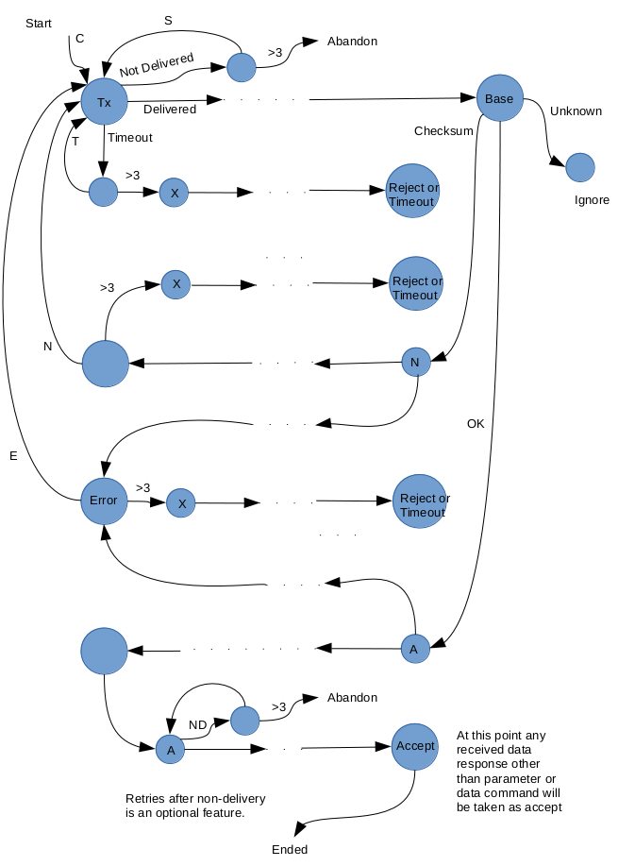Illustration 1: Network flow diagram for data transmission protocol.

Pseudocode
Pseudocode for the firmware :
- Loop 1. Outer.
  - sleep until interrupt. Wake on count or WDT interrupt.
- Loop 2.
  - set lastCounter = counter and wait 1ms. If count hasn't changed, drop out.
  - if WDT counter has reached the preset time, initiate transmission sequence.
- Loop 3.
  - send C transmission of data (counts).
  - continue looping while waiting for the cycle of communication to complete.
- Loop 4
  - Wait for a message to be received.
  - Count up timeResponse if nothing comes.
  - messageStatus indicates where we are in reception and if errors occurred.
Once this set of code has completed, the processing phase will begin using the booleans txStatusReceived, txDelivered, cycleComplete, packetError, packetReady to determine actions to be taken.
messageStatus
COMPLETE
- XBee receive frame has data. Copy and set packetReady = true.
- XBee status frame. This will indicate if the transmitted frame was received.
NONZERO (error)
- XBee receive frame has data. Discard.
- XBee status frame. Assume delivery occurred.
TIMEOUT awaiting status.
- Assume received but not delivered correctly.
TIMEOUT awaiting base station response.
- Signal a timeout has occurred.
Transmission delivered
- response received from base station. Look into contents of response.
  - NAK. Continue up to three times, then return an N message.
  - ACK. Adjust counter by subtracting the number already sent, and finish.
- response errored. Continue up to three times, then return an E message.
Status indicates not delivered
- Continue up to three times, then abandon whole process.
Status indicates timeout occurred
- Continue up to three times, then return a T message.
A message arrives outside the transmission protocol, that is, independently of the txStatusReceived and txDelivered messages that refer to a previous transmission. Interpret as a higher level application message.
Finally if the retry limit has been exceeded, return an X command indicating abortion of the transmission attempt. A new transmission will be attempted next period with previous period counts included.
Otherwise send acceptance.

Flowcharts for remote protocol process
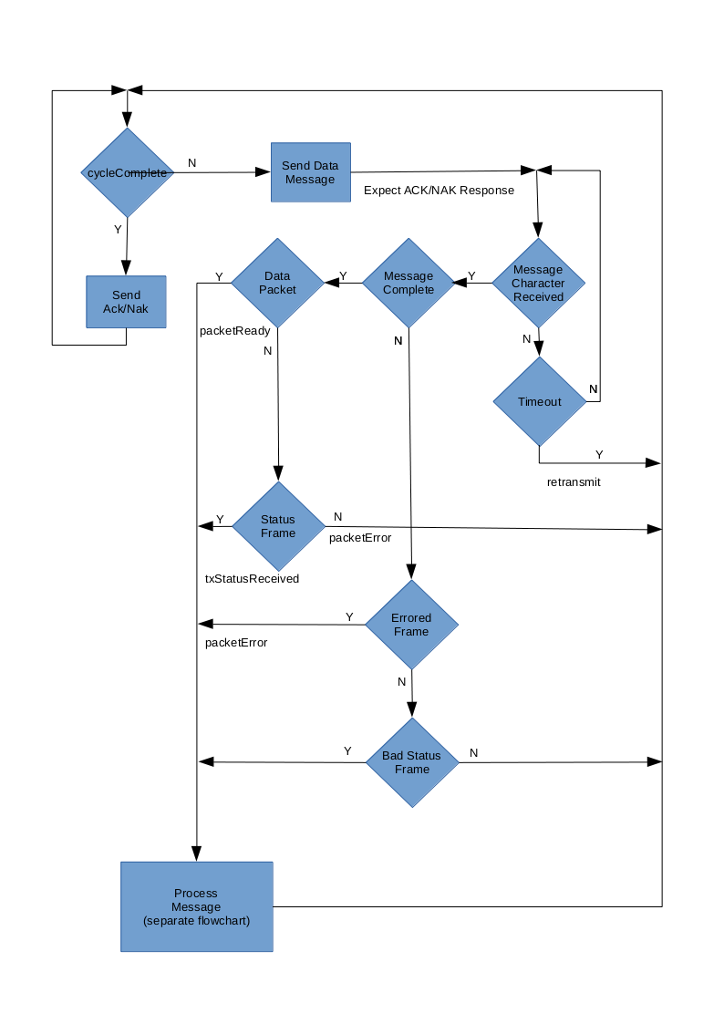Illustration 2: Flowchart for detection of messages.
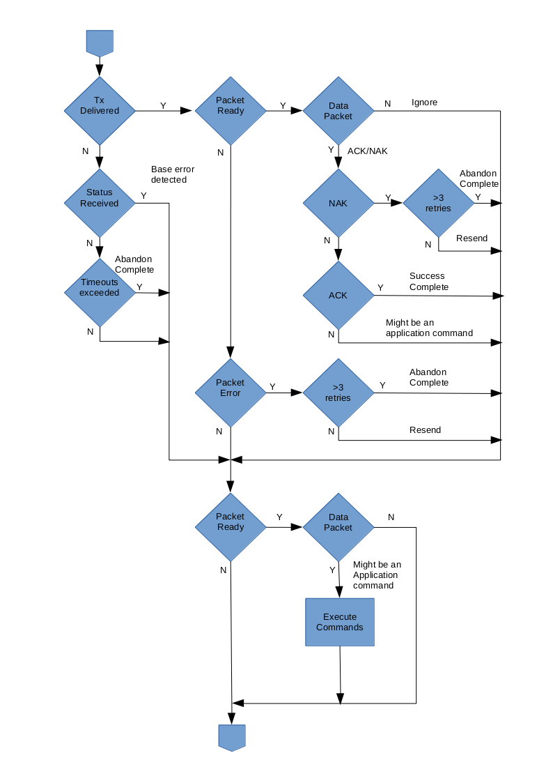Illustration 3: Flowchart for processing of messages.

Firmware for Watermeter
This has a very low power requirement. Since the only measurements are counts, the firmware uses a slightly different approach for managing sleep and interrupts. See the watermeter document.

Testing of Firmware
The tests must verify that the protocol is able to handle all error conditions and ensure delivery of the counts accurately. Any network error conditions may result in the remote node and the base station having different ideas about what data was communicated.
There is only a limited debugging capability in the AVR microcontrollers so code may be verified by running it on a Linux machine and setting the AVR specific instructions to stubs. This then communicates with an XBee mounted on a board with a serial interface. The code being run may provide extensive debug printout. The procedures for doing this are described in the next chapter.
Testing on the AVR itself is somewhat more challenging. All behaviour must be determined from the messages received by the base station.

Error free test
Set debug printout in the base station software and the PC simulator software if used.
- Remote node wakes and sends a count data message.
- Receives an XBee status frame with successful delivery.
- Receives a data message with 'A' acknowledge.
- Returns an 'A' message to complete transfer.
- XBee status frames after that are ignored.

Message received in error by base station
This can be simulated in the base station by changing the 'A' message sent back to 'N', or by signalling a checksum error.
- Remote node wakes and sends a count data message.
- Receives an XBee status frame with successful delivery.
- Receives a data message with 'N' acknowledge.
- Resends the original transmission.
- Repeats three times.
- Returns an 'X' message to complete transfer and signal abandonment.
- XBee status frames after that are ignored.

Base station acknowledge lost
This can be simulated by changing the firmware code to ignore the acknowledge. It can happen in the watermeter due to delay in reading the XBee serial port when an interrupt occurs.
- Remote node wakes and sends a count data message.
- Receives an XBee status frame with successful delivery.
- Timeout waiting for the acknowledge.
- Resends the original transmission.
- Repeats three times.
- Returns an 'X' message to complete transfer and signal abandonment.
XBee status frames after that are ignored.

Base station acknowledge excessively delayed
This can be simulated in the base station by adding a 200ms or 500ms sleep before sending the acknowledge. If the remote is able to receive the 'A' message after any status frame from repeated transmissions, and before the third timeout retry, then the original transmission will be accepted by the base station. In the test performed, the 200ms sleep resulted in the 'A' message arriving at the remote before the status frame and the following sequence occurred.
- Remote node wakes and sends a count data message.
- Receives an XBee status frame with successful delivery.
- Timeout waiting for the acknowledge.
- Resends the original transmission.
- Acknowledge arrives before the transmission status frame. This is treated as an out-of-protocol application message.
- Repeats three times.
- Returns an 'X' message to complete transfer and signal abandonment.
- XBee status frames after that are ignored.

Extreme range tests
At extreme range the XBee communications will typically drop out over a short distance and all communication will be suspended. The protocol response to this and to errors that occur just on the limit of range must verify that data is not lost. Note that the base station may have a much higher transmission power than the nodes, and therefore the nodes may receive clear responses from the base station, while the base station may receive errored or missing remote messages.

Module Testing
A number of test hardware and software modules are provided.

Remote Node with ATMega48
The board is a standalone board comprising:
- an ATMega48 microcontroller,
- an XBee,
- Red LED for power,
- Yellow LED for XBee associate signal,
- Green LED for microcontroller test signal,
- screw connector for digital counter signal input,
- screw connector and trimpot for analogue signal input.
It accepts 5V power and drops this to 3.3V for the XBee.
The board schematic is given in Development/gEDA-Xbee-Test as xbee-node-atmega48.sch.
The following connections are made:
- XBee CTS pin 12 connected to ATMega48 pin 4 PD2,
- XBee RTS pin 16 connected to ATMega48 pin 5 PD3,
- XBee Reset pin 5 connected to ATMega48 pin 19,
- XBee Sleep_RQ pin 9 connected to ATMega48 pin 17 PB3,
- XBee On/Sleep pin 13 connected to ATMega48 pin 18 PB4,
- XBee Microcontroller reset pin 4 DIO12,
- XBee Bootloader D11 pin 7 connected to ATMega48 pin 16 PB2,
- XBee AD1 pin 19 connected to ATMega48 pin 24 ADC1 and Battery Monitor signal,
- XBee AD2 pin 18 connected to ATMega48 pin 23 ADC0 and Analogue in,
- Counter input connected to ATMega48 pin 11 PD5.

Remote Node with ATTiny4313
This has only been built on a prototyping layout and has not been used to any extent. Other than the processor change and the lack of an A/D port (since the ATTiny4313 doesn't have an A/D converter), it is the same as the ATMega48 board.
The board schematic is given in Development/gEDA-Xbee-Test as xbee-node-attiny4313.sch.

Remote PC Attached Node
This is a board designed to use a serial RS232 connection directly to the XBee so that a PC can be used to emulate the microcontroller in a node. The board comprises:
- an XBee,
- Red LED for power,
- Yellow LED for XBee associate signal,
- Green LED for on/sleep signal,
- Orange LED for Sleep_RQ signal,
- RS232 converter,
- Reset momentary on button,
- Force sleep_RQ toggle switch,
- Commissioning momentary on button.
It accepts 12V power and drops this to 5V for the RS232 converter and 3.3V for the XBee.
The board schematic is given in Development/gEDA-Xbee-Test as xbee-node-serial.sch.

Watermeter Board
This is the production module. The following connections are made:
- XBee_reset pin 5 connected to ATTiny841 pin 5 PB2,
- XBee Sleep_RQ pin 9 connected to ATTiny841 pin 10 PA3,
- XBee On/Sleep pin 13 connected to ATTiny841 pin 13 PA0,
- XBee Microcontroller reset DIO12 pin 4,
- XBee Bootloader DIO11 pin 7 connected to ATTiny841 pin 2 PB0,
- XBee AD1 pin 19 connected to Battery Monitor signal,
- Control pin for enabling Battery Monitor ATTiny841 pin 6 PA7,
- Counter input connected to ATTiny841 pin 3 PB1,
- XBee associated and commissioning signals are not connected to the ATTiny841.

Node Test Firmware
Firmware for testing a node can be found in Development/Xbee-node-test (xbee-node-test). This transmits a single message at regular intervals consisting of a D followed by an integer count value taken from the digital counter input on the board. If compiled for ATMega48 it will use a baud rate of 38400, while for the ATTiny841 on the watermeter board it will have a baud rate of 9600.
The libs directory contains board definitions which define the capabilities of each board and processor and the various pin allocations.
The serial port definitions in defines-M168.h, that are relevant to this ATMega48, require that CTS be enabled on the XBee for DIO7. This is to allow for the eventual development of a bootloader. The board rate is set at 38400.
The serial port definitions in defines-T841.h, that are relevant to the watermeter board, require that CTS be disabled on the XBee for DIO7. There are no hardware flow control signals passed back to the microcontroller from the XBee. Also the baud rate is set to 9600 to ensure accurate communication with the mirocontroller.

PC Based Emulated Node Test Firmware
This is a POSIX system based test code for an XBee remote unit. Written in C but embedded in a QT/C++ wrapper which emulates the environment for the test code. It can be run with any adapter interface board that contains a USB-serial converter, or with a board having a serial interface plus an external USB-serial converter.
The code can be found in Development/Xbee-node-test-pc (xbee-node-test-pc).
The purpose is to provide a PC Linux based testbed for emulating remote system firmware that is capable of communicating directly with an XBee over a serial port, and working as a remote unit. The emulator is not an AVR emulator. Rather it provides a means to run the Xbee firmware core on a PC for debugging.
NOTE: gcc is required to allow function override for timerISR.
The program can be run without a GUI from the command line with the -n option. A debug mode is available for extended printout.
$ xbee-node-test -d -P /dev/ttyUSB0 -b 38400 -n
In command line mode, the program can only be stopped by ctl-C or process kill.
The following main program modules allow different tests to be run. Change the XBee-node-test.pro file to compile the different tests.

mainprog-test.cpp
This is adapted from the xbee-node-test code and performs the same functions as the node test firmware.

mainprog-firmware.cpp
This is adapted from the xbee-firmware code and emulates the full production firmware. This must be modified to reflect changes in that firmware.

Adaptation to Other Test Code
The following files may be used as the environment emulator for other code tests with appropriate adaption of the .pro and mainprog.cpp files:
- xbee-node-test-main.cpp
- xbee-node-test.cpp
- xbee-node-test.h
- xbee-node-test.pro
- xbee-node-test.ui
- serial.cpp
serial.cpp is a substitute set of communication functions calling on POSIX/QT serial I/O. This should contain functions that match the calls in the test code.
mainprog.cpp must be provided with the code to be tested in the following way:
Split the code to be tested into an initialization part and an operational part that normally falls within an infinite loop. Place the initialization part into the function called mainprogInit(), and the operational part into mainprog(). Both these are called from the xbee-node-test.cpp wrapper, with the operational part having its loop emulated in the wrapper code.
There should be no compilable processor specific statements. These can be replaced by a call to a local function that should contain code to emulate the statement. If this is not possible then the code is not suitable for testing in this way.
Add all global variables as static. Add also any include files needed. These should not contain references to any processor specific libraries or functions.
ISRs need to be changed to a function call and means to activate them devised. A timer is emulated in the emulator code. Timer initialization is done by calling an initialization function in the emulator code. This function sets the number of one millisecond tick counts at which the timer fires and calls the ISR. If a timer ISR is not defined, a null ISR is substituted. The timer ISR can be defined in the test code by replacing the actual ISR call with the function: timerISR().
xbee.cpp is a file associated with the code under test, which has been copied from the library directory with its extension changed from c to cpp to satisfy the g++ compiler (otherwise it is not correctly linked).

Watermeter Count Test
This is a test firmware for the AVR in the watermeter. Written in C under avr-gcc.
The code can be found in Development/watermeter-count-test (watermeter-count-test).
This test transmits the count of the photointerrupter at regular intervals (1 sec) via the serial port at 9600 baud in csv format for capture and analysis off-line. This link is normally connected to an XBee in the watermeter assembly. The test can only be used where the XBee is not present and the serial link is brought out to a PC serial port.

Watermeter Echo Test
This is a simple test firmware for the AVR in the watermeter. Written in C under avr-gcc.
The code can be found in Development/watermeter-echo-test (watermeter-echo-test).
This test simply echoes characters back on the serial port at 9600 baud. Use to verify that the serial link to the AVR is working. This link is normally connected to an XBee in the watermeter assembly. The test can only be used where the XBee is not present and the serial link is brought out to a PC serial port.

Example System Setup
This describes an example system setup in which the base station and GUI are running on the same PC. Adapting this to a system with the base station installed on a separate machine is described at the end.

Notes
- Compile the base station software as described above. This is found in the distribution directory Xbee-acqcontrol.
Sleep Modes
The XBee cannot be contacted by the XCTU configuration software unless its sleep settings are made within certain parameters.
Apparently when pin sleep is used, the XBee will sleep immediately regardless of any transmissions waiting or in progress. This means that it must be kept awake for a time after the last transmission. This time may depend on the length of the transmission and any network protocol responses. In cyclic sleep modes 4,5 the XBee can be made to stay awake after sleep is requested. A value of 100ms to 200ms appears to be adequate. Tests show that the transmission is only a few tens of ms, so 100ms wake after sleep request would be adequate.
One solution to this would be to make use of the Tx Status frame sent back after a successful transmission. Keep awake until this comes. It is only important for the final acknowledgement, but could be used to resend the latter in case of failure.

