**Kishan Sarpangala**

**Project 11**

**Result:**

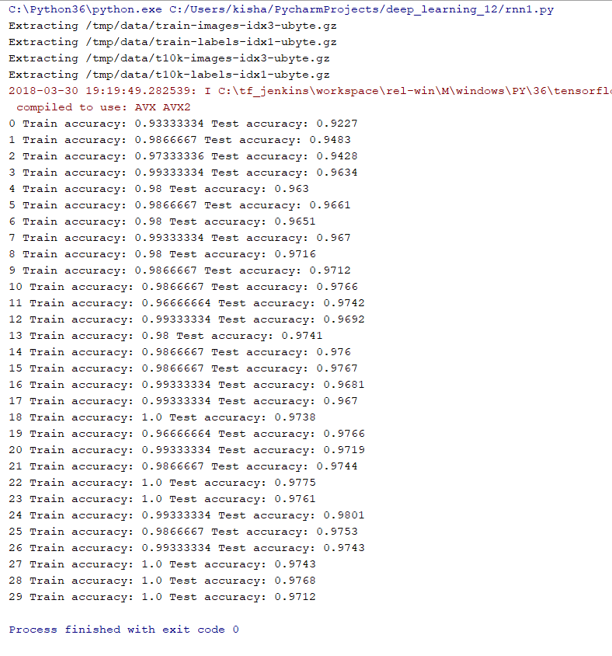

First while loop:

94->98->58->64->67->

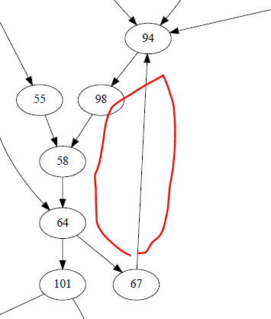

Second While Loop:

59->65->68->87->89->91->92->99->

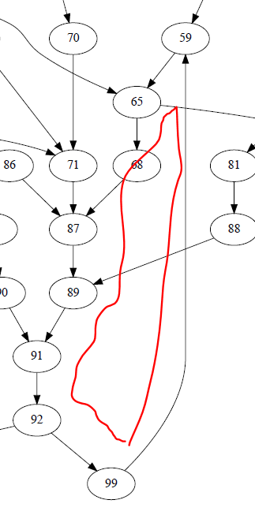

Third & Fourth While Loop:

61->62->63->66->95->96->97->

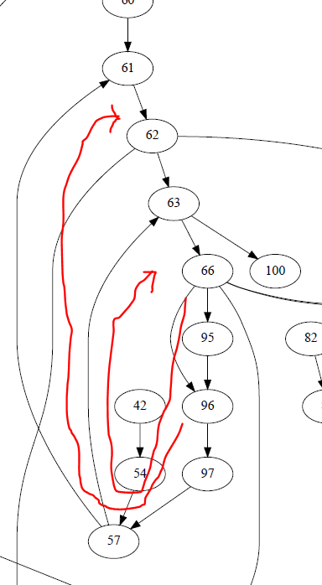

**Note: There are total of 4 loops.**