**Deep Learning Assignment – 13**

**Kishan Sarpangala**

**M04307966**

**Output Screenshots**:

1. Autoencoder1.py:

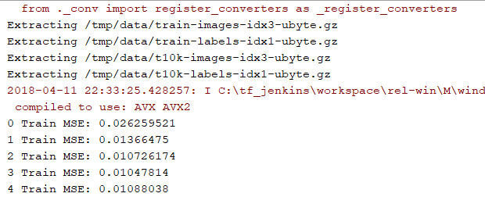

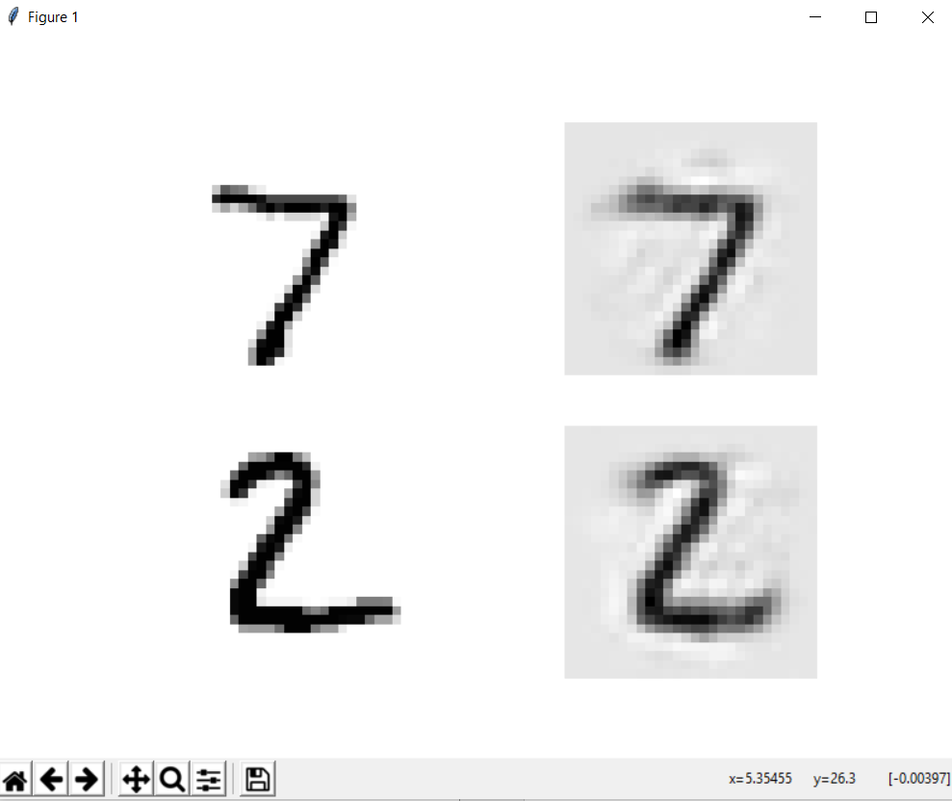

1. Autoencoder2.py:

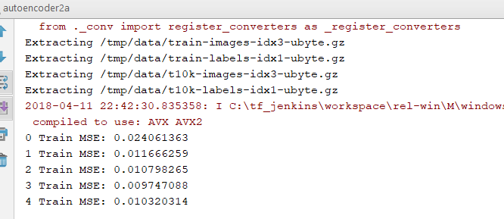

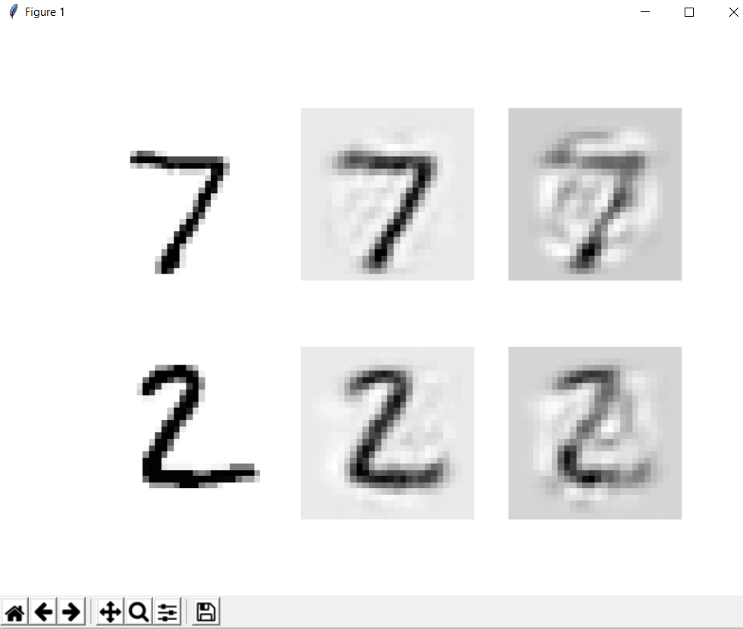

1. Autoencoder3.py:

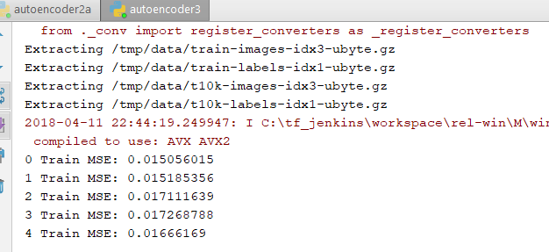

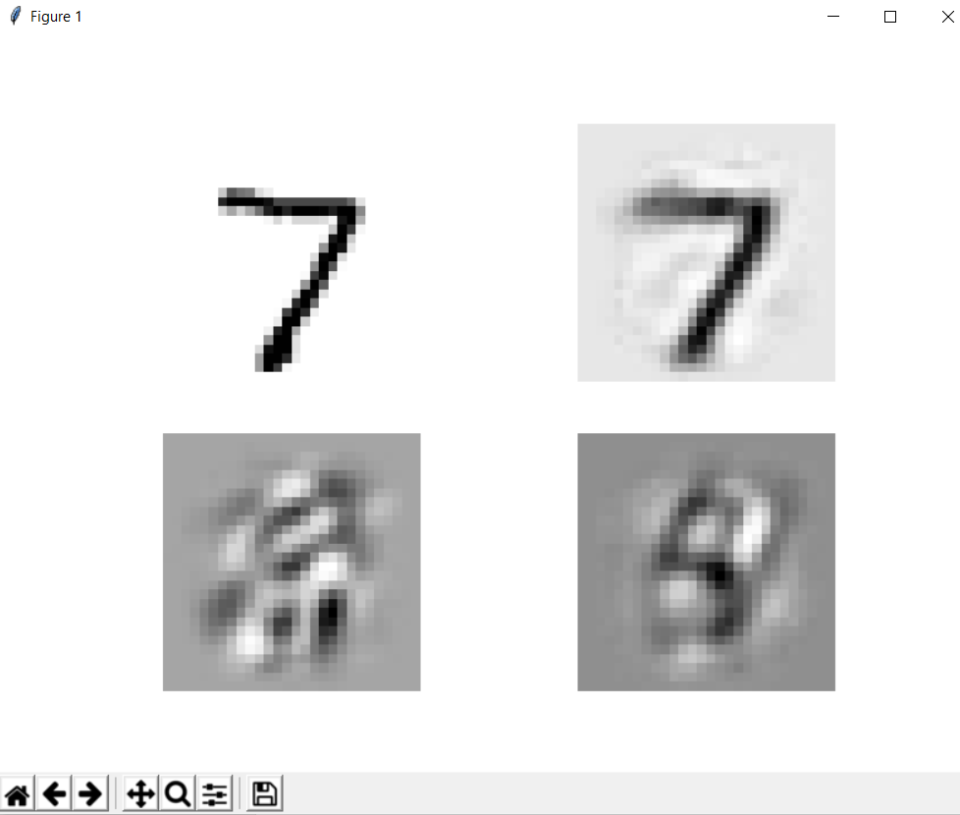

1. autoencoder4.py:

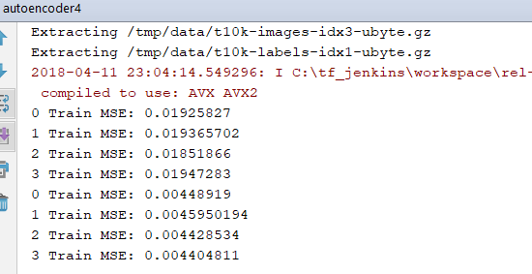

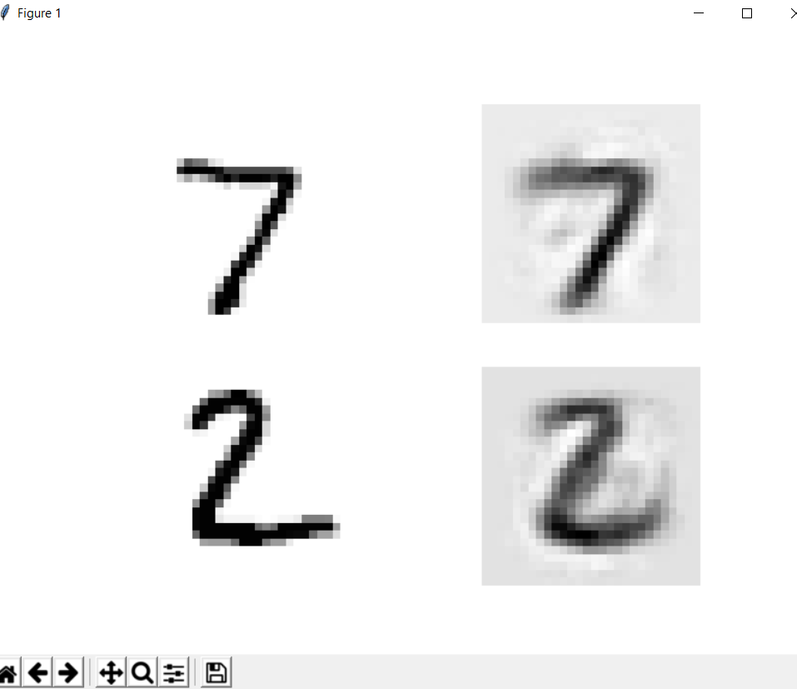

1. Autoencoder5.py:

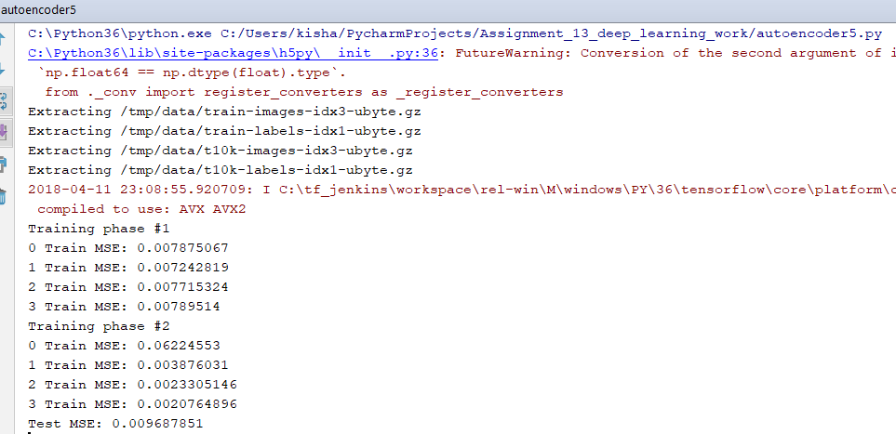

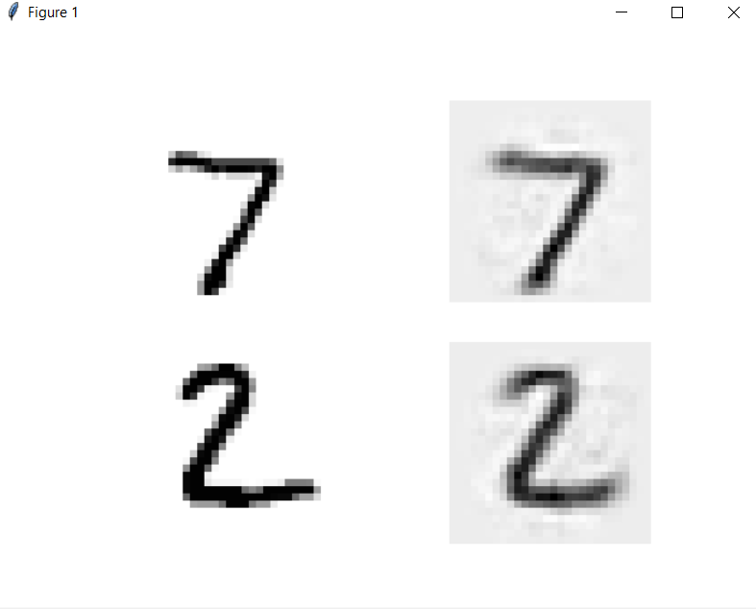

**Code for autoencoder4.py (to plot images)**

*# Training one autoencoder at a time by Geron  
# need visualization of reconstruction***import** tensorflow **as** tf  
**import** sys  
**import** numpy.random **as** rnd  
**from** functools **import** partial  
  
*#added by Kishan Sarpangala to plot images***import** matplotlib  
**import** matplotlib.pyplot **as** plt  
**from** tensorflow.examples.tutorials.mnist **import** input_data  
mnist = input_data.read_data_sets(**"/tmp/data/"**)  
  
  
**from** functools **import** partial  
  
  
**def** train_autoencoder(X_train, n_neurons, n_epochs, batch_size,  
 learning_rate = 0.01, l2_reg = 0.0005,  
 hidden_activation=tf.nn.elu,  
 output_activation=tf.nn.elu):  
 graph = tf.Graph()  
 **with** graph.as_default():  
 n_inputs = X_train.shape[1]  
  
 X = tf.placeholder(tf.float32, shape=[**None**, n_inputs])  
   
 my_dense_layer = partial(  
 tf.layers.dense,  
 kernel_initializer=tf.contrib.layers.variance_scaling_initializer(),  
 kernel_regularizer=tf.contrib.layers.l2_regularizer(l2_reg))  
  
 hidden = my_dense_layer(X, n_neurons, activation=hidden_activation, name=**"hidden"**)  
 outputs = my_dense_layer(hidden, n_inputs, activation=output_activation, name=**"outputs"**)  
  
 reconstruction_loss = tf.reduce_mean(tf.square(outputs - X))  
  
 reg_losses = tf.get_collection(tf.GraphKeys.REGULARIZATION_LOSSES)  
 loss = tf.add_n([reconstruction_loss] + reg_losses)  
  
 optimizer = tf.train.AdamOptimizer(learning_rate)  
 training_op = optimizer.minimize(loss)  
  
 init = tf.global_variables_initializer()  
  
 **with** tf.Session(graph=graph) **as** sess:  
 init.run()  
 **for** epoch **in** range(n_epochs):  
 n_batches = len(X_train) // batch_size  
 **for** iteration **in** range(n_batches):  
 print(**"\r{}%"**.format(100 * iteration // n_batches), end=**""**)  
 sys.stdout.flush()  
 indices = rnd.permutation(len(X_train))[:batch_size]  
 X_batch = X_train[indices]  
 sess.run(training_op, feed_dict={X: X_batch})  
 loss_train = reconstruction_loss.eval(feed_dict={X: X_batch})  
 print(**"\r{}"**.format(epoch), **"Train MSE:"**, loss_train)  
 params = dict([(var.name, var.eval()) **for** var **in** tf.get_collection(tf.GraphKeys.TRAINABLE_VARIABLES)])  
 hidden_val = hidden.eval(feed_dict={X: X_train})  
 **return** hidden_val, params[**"hidden/kernel:0"**], params[**"hidden/bias:0"**], params[**"outputs/kernel:0"**], params[**"outputs/bias:0"**]  
  
**from** tensorflow.examples.tutorials.mnist **import** input_data  
mnist = input_data.read_data_sets(**"/tmp/data/"**)  
  
hidden_output, W1, b1, W4, b4 = train_autoencoder(mnist.train.images, n_neurons=300, n_epochs=4, batch_size=150,  
 output_activation=**None**)  
_, W2, b2, W3, b3 = train_autoencoder(hidden_output, n_neurons=150, n_epochs=4, batch_size=150)  
  
tf.reset_default_graph()  
  
n_inputs = 28*28  
  
*#added by Kishan Sarpangala to plot images*X = tf.placeholder(tf.float32, shape=[**None**, n_inputs])  
hidden1 = tf.nn.elu(tf.matmul(X, W1) + b1)  
hidden2 = tf.nn.elu(tf.matmul(hidden1, W2) + b2)  
hidden3 = tf.nn.elu(tf.matmul(hidden2, W3) + b3)  
outputs = tf.matmul(hidden3, W4) + b4  
  
**def** plot_image(image, shape=[28, 28]):  
 plt.imshow(image.reshape(shape), cmap=**"Greys"**, interpolation=**"nearest"**)  
 plt.axis(**"off"**)  
  
**def** show_reconstructed_digits(X, outputs, model_path = **None**, n_test_digits = 2):  
 **with** tf.Session() **as** sess:  
 X_test = mnist.test.images[:n_test_digits]  
 outputs_val = outputs.eval(feed_dict={X: X_test})  
  
 fig = plt.figure(figsize=(8, 3 * n_test_digits))  
 **for** digit_index **in** range(n_test_digits):  
 plt.subplot(n_test_digits, 2, digit_index * 2 + 1)  
 plot_image(X_test[digit_index])  
 plt.subplot(n_test_digits, 2, digit_index * 2 + 2)  
 plot_image(outputs_val[digit_index])  
 plt.show()  
  
*#original code*show_reconstructed_digits(X, outputs)

**Code autoencoder5.py (to plot images)**

*# the single-graph approach from Geron  
# need visualization of results***import** tensorflow **as** tf  
*#Added (Kishan Sarpangala)***import** matplotlib  
**import** matplotlib.pyplot **as** plt  
  
n_inputs = 28 * 28  
n_hidden1 = 300  
n_hidden2 = 150 *# codings*n_hidden3 = n_hidden1  
n_outputs = n_inputs  
  
learning_rate = 0.01  
l2_reg = 0.0001  
  
activation = tf.nn.elu  
regularizer = tf.contrib.layers.l2_regularizer(l2_reg)  
initializer = tf.contrib.layers.variance_scaling_initializer()  
  
X = tf.placeholder(tf.float32, shape=[**None**, n_inputs])  
  
weights1_init = initializer([n_inputs, n_hidden1])  
weights2_init = initializer([n_hidden1, n_hidden2])  
weights3_init = initializer([n_hidden2, n_hidden3])  
weights4_init = initializer([n_hidden3, n_outputs])  
  
weights1 = tf.Variable(weights1_init, dtype=tf.float32, name=**"weights1"**)  
weights2 = tf.Variable(weights2_init, dtype=tf.float32, name=**"weights2"**)  
weights3 = tf.Variable(weights3_init, dtype=tf.float32, name=**"weights3"**)  
weights4 = tf.Variable(weights4_init, dtype=tf.float32, name=**"weights4"**)  
  
biases1 = tf.Variable(tf.zeros(n_hidden1), name=**"biases1"**)  
biases2 = tf.Variable(tf.zeros(n_hidden2), name=**"biases2"**)  
biases3 = tf.Variable(tf.zeros(n_hidden3), name=**"biases3"**)  
biases4 = tf.Variable(tf.zeros(n_outputs), name=**"biases4"**)  
  
hidden1 = activation(tf.matmul(X, weights1) + biases1)  
hidden2 = activation(tf.matmul(hidden1, weights2) + biases2)  
hidden3 = activation(tf.matmul(hidden2, weights3) + biases3)  
outputs = tf.matmul(hidden3, weights4) + biases4  
  
reconstruction_loss = tf.reduce_mean(tf.square(outputs - X))  
  
optimizer = tf.train.AdamOptimizer(learning_rate)  
  
**with** tf.name_scope(**"phase1"**):  
 phase1_outputs = tf.matmul(hidden1, weights4) + biases4 *# bypass hidden2 and hidden3* phase1_reconstruction_loss = tf.reduce_mean(tf.square(phase1_outputs - X))  
 phase1_reg_loss = regularizer(weights1) + regularizer(weights4)  
 phase1_loss = phase1_reconstruction_loss + phase1_reg_loss  
 phase1_training_op = optimizer.minimize(phase1_loss)  
  
**with** tf.name_scope(**"phase2"**):  
 phase2_reconstruction_loss = tf.reduce_mean(tf.square(hidden3 - hidden1))  
 phase2_reg_loss = regularizer(weights2) + regularizer(weights3)  
 phase2_loss = phase2_reconstruction_loss + phase2_reg_loss  
 train_vars = [weights2, biases2, weights3, biases3]  
 phase2_training_op = optimizer.minimize(phase2_loss, var_list=train_vars) *# freeze hidden1*init = tf.global_variables_initializer()  
saver = tf.train.Saver()  
  
training_ops = [phase1_training_op, phase2_training_op]  
reconstruction_losses = [phase1_reconstruction_loss, phase2_reconstruction_loss]  
n_epochs = [4, 4]  
batch_sizes = [150, 150]  
  
**from** tensorflow.examples.tutorials.mnist **import** input_data  
mnist = input_data.read_data_sets(**"/tmp/data/"**)  
  
**import** sys  
  
**with** tf.Session() **as** sess:  
 init.run()  
 **for** phase **in** range(2):  
 print(**"Training phase #{}"**.format(phase + 1))  
 **for** epoch **in** range(n_epochs[phase]):  
 n_batches = mnist.train.num_examples // batch_sizes[phase]  
 **for** iteration **in** range(n_batches):  
 print(**"\r{}%"**.format(100 * iteration // n_batches), end=**""**)  
 sys.stdout.flush()  
 X_batch, y_batch = mnist.train.next_batch(batch_sizes[phase])  
 sess.run(training_ops[phase], feed_dict={X: X_batch})  
 loss_train = reconstruction_losses[phase].eval(feed_dict={X: X_batch})  
 print(**"\r{}"**.format(epoch), **"Train MSE:"**, loss_train)  
 saver.save(sess, **"./my_model_one_at_a_time.ckpt"**)  
 loss_test = reconstruction_loss.eval(feed_dict={X: mnist.test.images})  
 print(**"Test MSE:"**, loss_test)  
  
*#Added by Kishan Sarpangala to plot images*n_test_digits = 2  
X_test = mnist.test.images[:n_test_digits]  
  
**with** tf.Session() **as** sess:  
 saver.restore(sess, **"./my_model_one_at_a_time.ckpt"**) *# not shown in the book* outputs_val = outputs.eval(feed_dict={X: X_test})  
  
**def** plot_image(image, shape=[28, 28]):  
 plt.imshow(image.reshape(shape), cmap=**"Greys"**, interpolation=**"nearest"**)  
 plt.axis(**"off"**)  
  
**for** digit_index **in** range(n_test_digits):  
 plt.subplot(n_test_digits, 2, digit_index * 2 + 1)  
 plot_image(X_test[digit_index])  
 plt.subplot(n_test_digits, 2, digit_index * 2 + 2)  
 plot_image(outputs_val[digit_index])  
plt.show()