**Kishan Sarpangala**

**Project 4**

**T-distributed stochastic neighbor embedding (t-SNE) algorithm**

T-SNE is a nonlinear embedding algorithm that is particularly adept at preserving points within clusters.

It reduces dimensionality while trying to keep similar instances close and dissimilar instances apart. It is mostly used for visualization, in particular to visualize clusters of instances in high-dimensional space Helps us to visualize the MNIST images in 2 dimensional. [1]

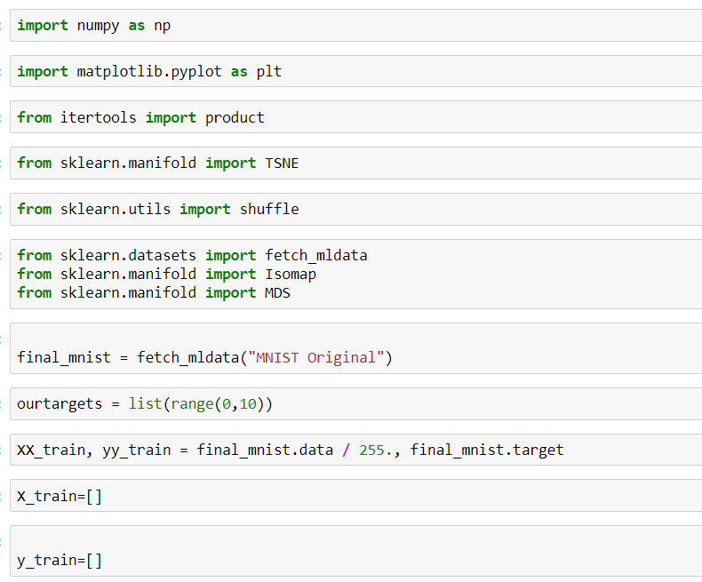

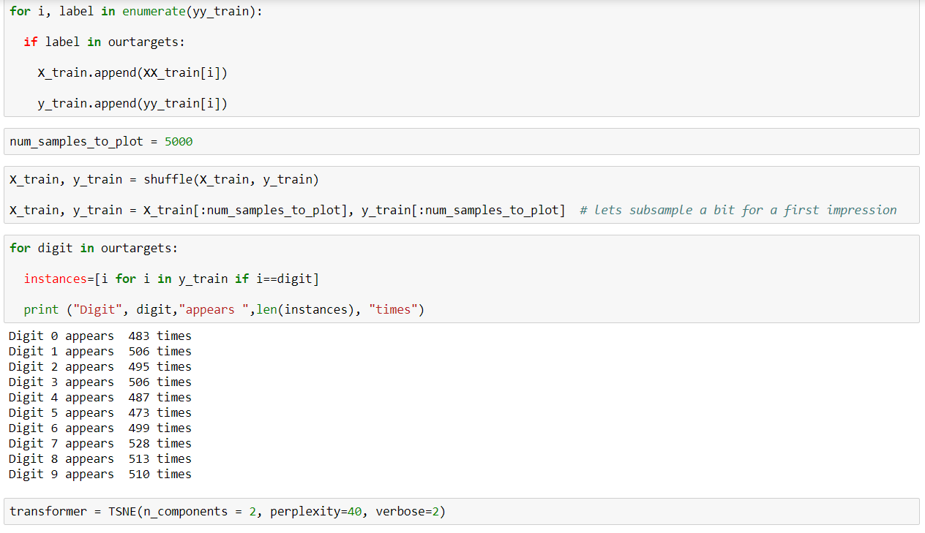

Look at the above image defined TSNE

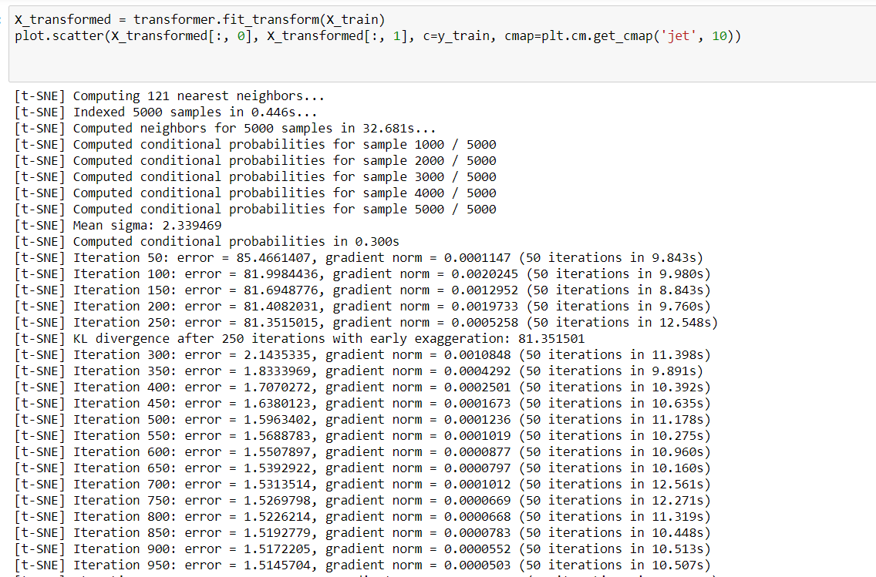

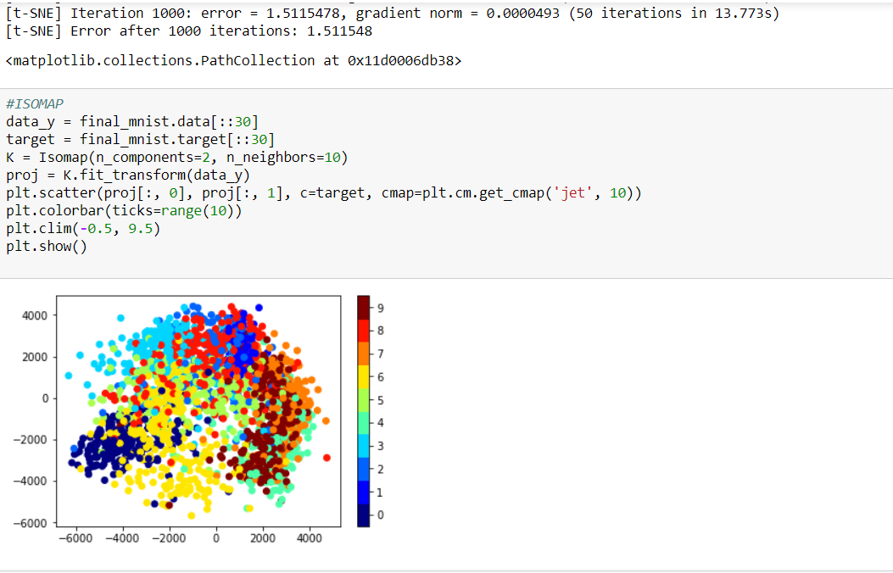

ISOMAP implemented above

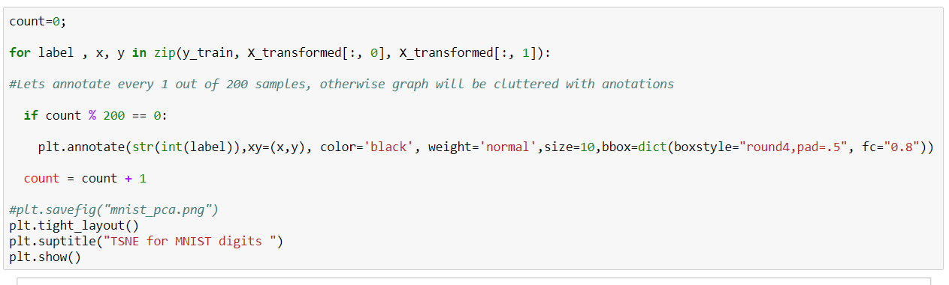

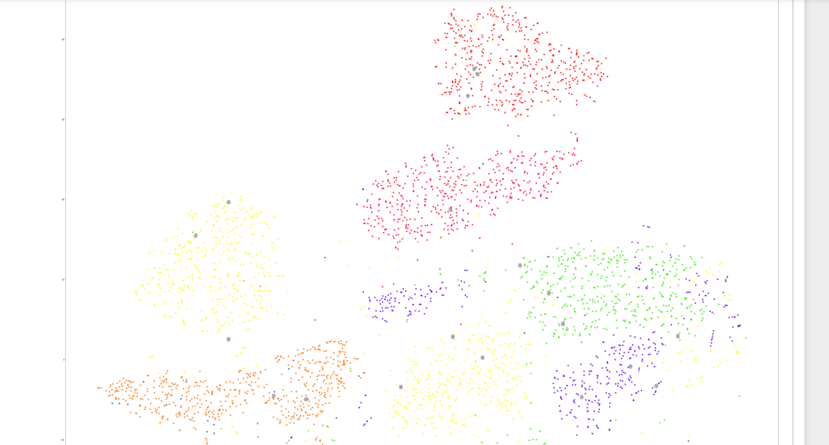

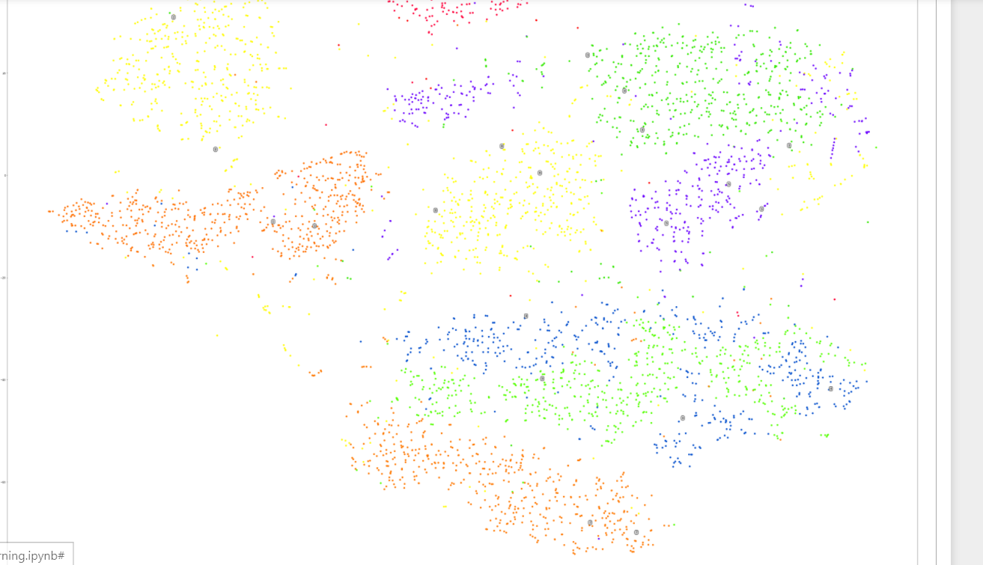

**Locally Linear Embedding (LLE)** is another, also equally powerful nonlinear dimensionality reduction (NLDR) technique.

It is a Manifold Learning technique that does not rely on projections like the previous algorithms. In a nutshell, LLE works by first measuring how each training instance linearly relates to its closest neighbors (c.n.), and then looking for a low-dimensional representation of the training set where these local relationships are best preserved (more details shortly). This makes it particularly good at unrolling twisted manifolds, especially when there is not too much noise. [2]

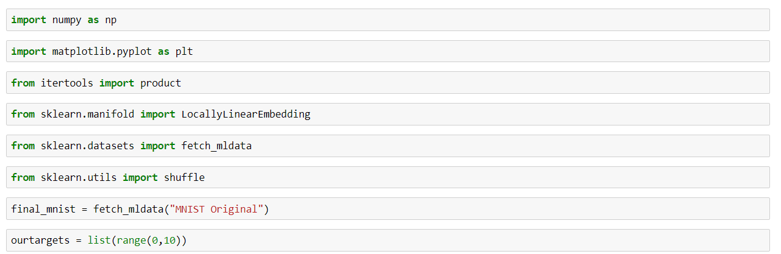

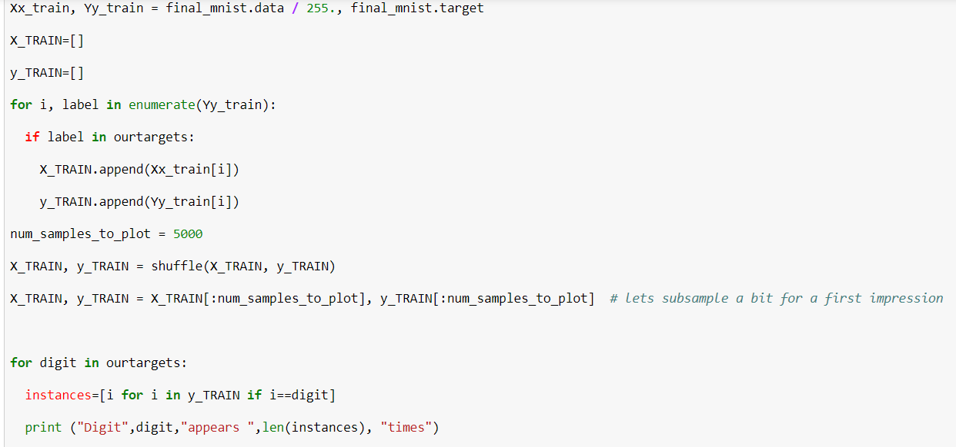

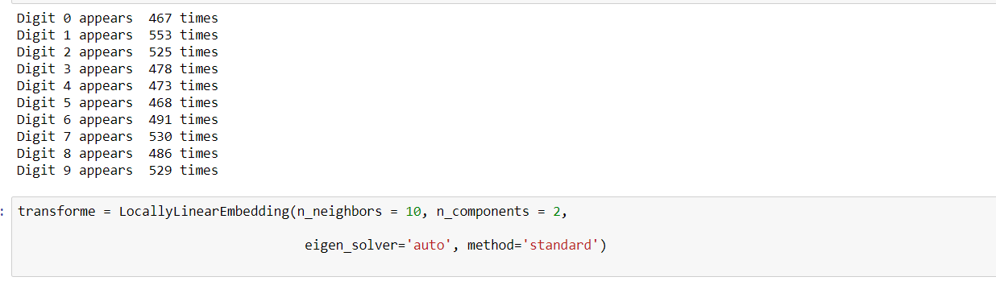

Look at the above image; defined LocallyLinerEmbedding

ISOMAP implemented below.

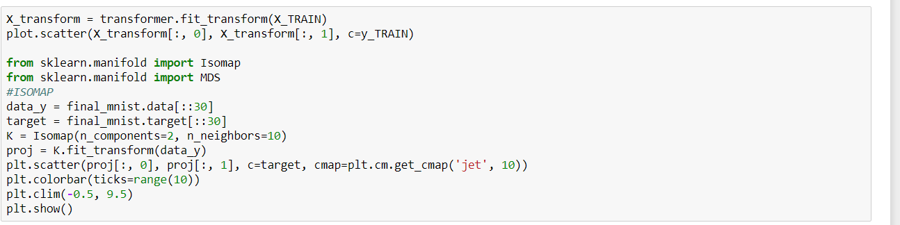

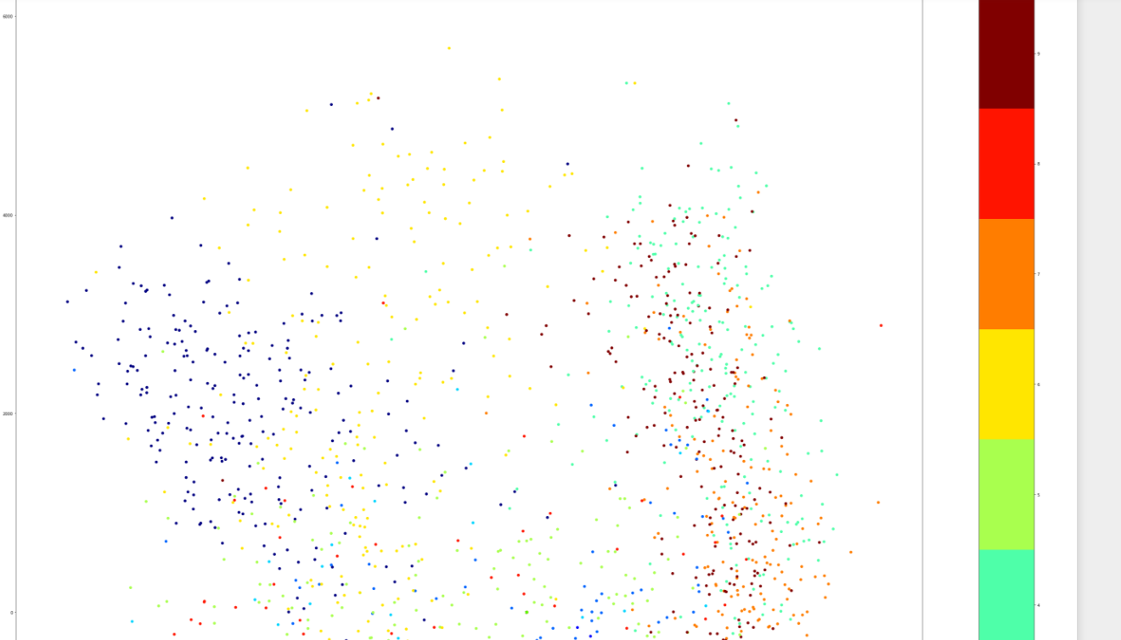

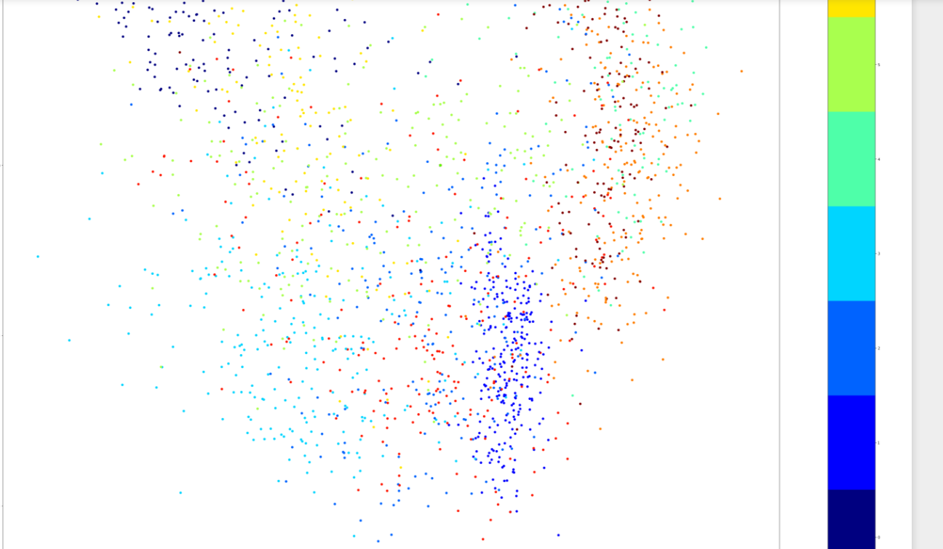

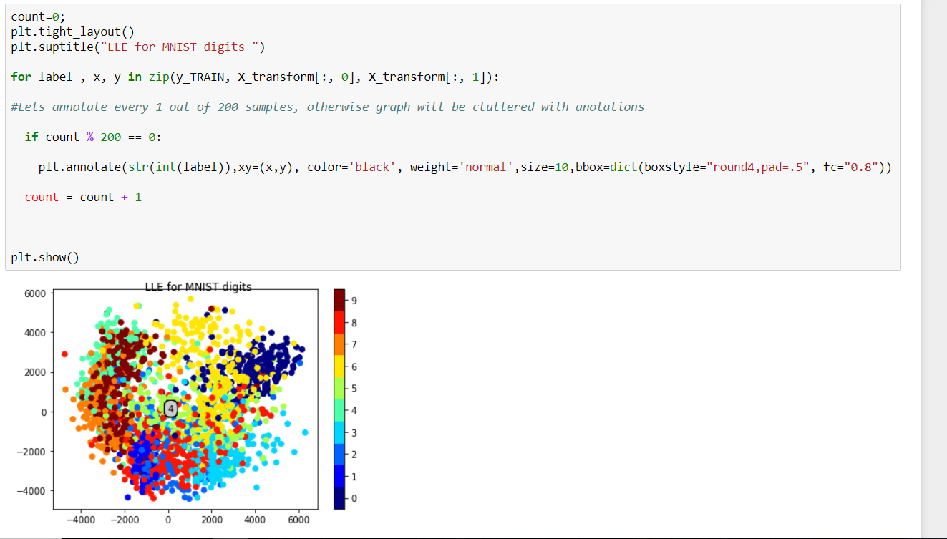

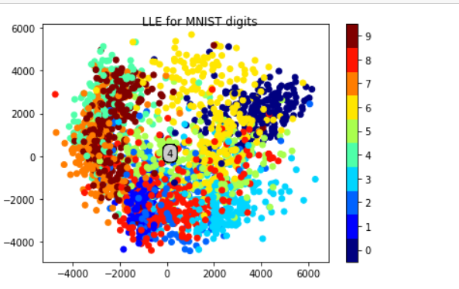

**MDS**

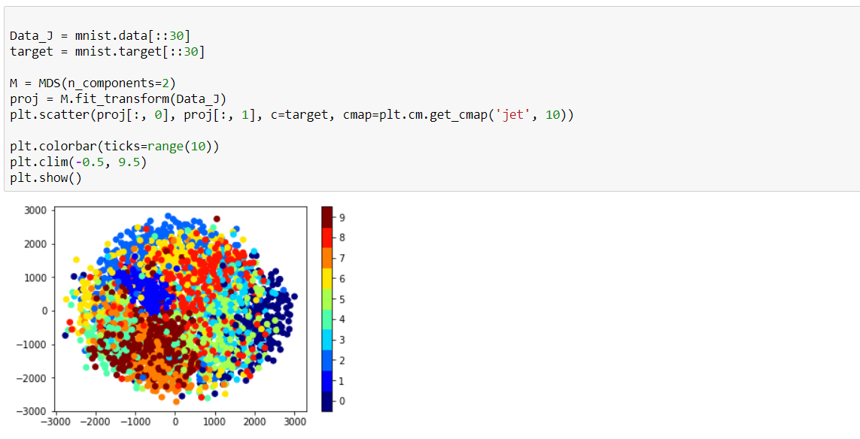

**What is Isomap and MDS ?**

**Isomap** is a [nonlinear dimensionality reduction](https://en.wikipedia.org/wiki/Nonlinear_dimensionality_reduction) method. It is one of several widely used low-dimensional embedding methods. Isomap is one representative of isometric mapping methods, and extends metric [**multidimensional scaling**](https://en.wikipedia.org/wiki/Multidimensional_scaling) **(MDS)** by incorporating the geodesic distances imposed by a weighted graph. [3]

Reference

[1] [2] [3] Wikipedia

<https://en.wikipedia.org/wiki/T-distributed_stochastic_neighbor_embedding>

<https://en.wikipedia.org/wiki/Nonlinear_dimensionality_reduction#Locally-linear_embedding>

<https://en.wikipedia.org/wiki/Isomap>

[4] Code : Jerone textbook