**CS 311 - Introduction to Software Engineering**

**Assignment 03: Due (Wednesday, Nov 28, 2018)**

**Software Systems Availability and Reliability (30 points)**

Consider a web application that provides online brokerage services. The application consists of 2 servers, one application server, and one database server. Suppose that historical data shows that the application server machine is rebooted every 20 days on average.

1. Assuming that the system administrator takes 10 min to reboot the machine, what is the application server availability? (15 points)

**Application Server Availability**

= (uptime) / (uptime + downtime)

= (20days) / (20days + 10mins)

= 28,800mins / 28,810mins

= 99.965%

1. Assuming also that the database server goes down for one minute every four hours, what is its availability? What is the availability of the whole site? (15 points)

**Database Server Availability**

= (uptime) / (uptime + downtime)

= (4hours) / (4hours + 1mins)

= 240mins / 241mins

= 99.585%

**Whole Site Availability**

= Product(individual server availabilities)  
= 99.965 * 99.585  
= 99.550%

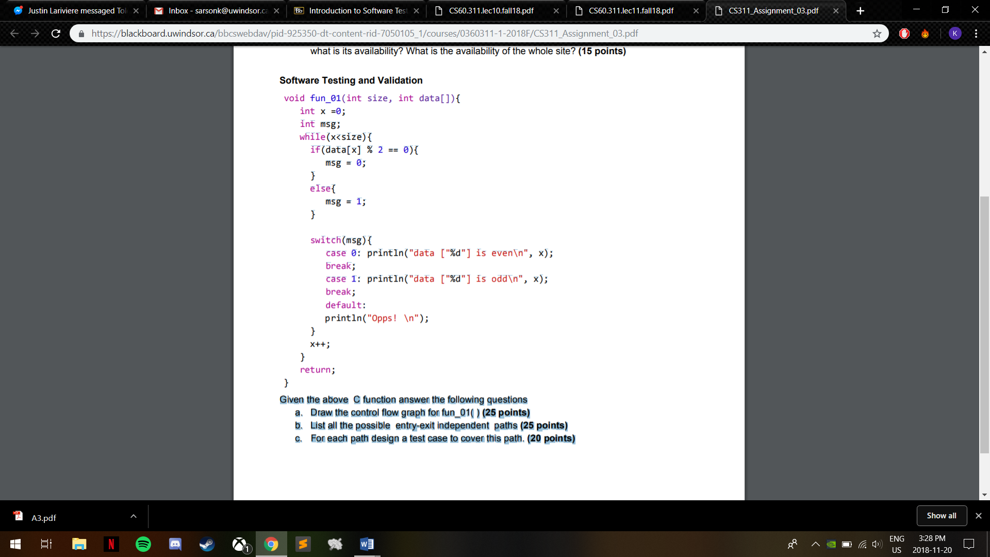**Software Testing and Validation Segments Paths**

**A**

**A**

**B**

**B**

**D**

**C**

**E**

**C**

**F**

**K**

**G**

**D**

**H**

**E**

**I**

**F**

**J**



**K**

**Given the above C function answer the following questions**

**I**

**H**

**G**

1. Draw the control flow graph for fun_01( ) (25 points)

**ABOVE**

1. List all the possible entry-exit independent paths (25 points)
2. ABK

**J**

1. A(BC**DFG**J)*BK
2. A(BC**EFG**J)*BK
3. A(BC**DFH**J)*BK
4. A(BC**EFH**J)*BK
5. A(BC**DFI**J)*BK
6. A(BC**EFI**J)*BK
7. For each path design a test case to cover this path. (20 points)

i. ABK - size=0, data[]={}

ii. A(BC**DFG**J)*BK - size=1, data[]={2}

iii. A(BC**EFG**J)*BK - UNREACHABLE PATH (**DFG** or **EFH** must be in the loop path to be valid)

iv. A(BC**DFH**J)*BK - UNREACHABLE PATH (**DFG** or **EFH** must be in the loop path to be valid)

v. A(BC**EFH**J)*BK - size=1, data[]={1}  
vi. A(BC**DFI**J)*BK - UNREACHABLE PATH (**DFG** or **EFH** must be in the loop path to be valid)

vii. A(BC**EFI**J)*BK - UNREACHABLE PATH (**DFG** or **EFH** must be in the loop path to be valid)