Creating and destroying ec2 instance using terraform:

1. Open the terraform yaml files.
2. Initiate the terraform using terraform init.
3. Plan the terraform using terraform plan.
4. Apply the terraform using terraform apply.
5. Ec2 instance is created.

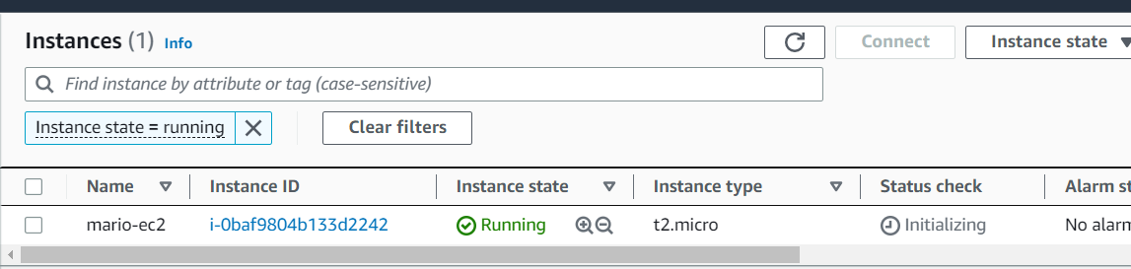

1. After the instance is created the instance need to be destroyed using terraform destroy.