* 1. If you want to share access to the Google Analytics report on the efficiency of Facebook campaigns with your advertising contractor, what will you need to set up?

 Property

 View

 Attribution

 Filter

* 1. Which of the following can you use to send data about transactions to Google Analytics? Select the correct options:

 Google Analytics API

 Measurement protocol

 Google Analytics JS library

 Measurement framework

* 1. In Google Analytics reports, you see all of your conversions are attributed to your payment processor as the referring site. What is most likely the reason? Select the correct options:

 Attribution tracking issue

 Payment processor issue

 Conversion tracking issue

* 1. Which of the in-market segments in the report shown below appear to be the least relevant to the website?

 Apparel & Accessories/Women's Apparel

 Employment

 Home & Garden/Home Furnishings

 Home & Garden/Home & Garden Services

* 1. How many users can have access to your Google Analytics property?

SELECT ONLY ONE

 25

 50

 100

 Unlimited

* 1. You are tracking "Add to carts" on your site as an event type of goal, and you want to see the total number of these actions from the previous week. SELECT ALL THAT APPLY How can you do this?

 Look at Events reports.

 Look at any report with the "Add to cart" goal chosen in the conversions section.

 Look at the Goal Flow report.

 Segment reports by "Add to cart" events.

* 1. You have an event-based goal in your GA that tracks leads from your site. Each lead brings, on average, a profit of $100. Which event component should you use to attach this amount to your goal?

 ENTER YOUR ANSWER HERE Your answer here

* 1. Once you turn on Enable Demographics and Interest reports in your Google Analytics, which additional dimensions will you see in your reports?

SELECT ALL THAT APPLY

 In-market segments

 Occupation

 Gender

 Affinity categories

 Interest group

 Age

* 1. In your Facebook Ads account, there are thousands of ads that lead traffic to your site. In the UTM tags of the ads, each campaign name is written using a variety of capitalizations and cases, such as "Our best offer," "our best offer," "OUR BEST OFFER."

How can you analyze these variations as one campaign in Google Analytics reports?

SELECT ONLY ONE

 Use segments.

 Use custom reports.

 Use lowercase in all UTM tags in the Facebook Ads cabinet.

 Use a custom view filter.

 You can't view these as one campaign in Google Analytics.

* 1. You want to see pageviews per user as a metric in your reports.

Which type of metric do you need to use in Google Analytics for that?

SELECT ONLY ONE

 Custom metric at the view level

 Calculated metric at the view level

 Custom metric at the property level

 Calculated metric at the property level

* 1. What data can only be added in the "option" field of an Enhanced Ecommerce hit?

SELECT ONLY ONE

 Payment method

 Affiliate code

 Coupon code

 Product view

* 1. You want to track how long your website's visitors spend watching the videos on it.

Which features can you use to track this with the most precision possible?

SELECT ALL THAT APPLY

 Time on page

 Custom metric

 Goal value

 Goal duration

* 1. Your developer has just implemented tracking for the "Add to cart" button click event.

SELECT ONLY ONE What would be the best report to use to ensure tracking works properly?

 Behavior - Site content - All pages

 Real-time Events

 Behavior - Events - Top events

 Behavior - Events - Pages

* 1. Which of the following criteria can you not use for Google Analytics segment creation?

SELECT ONLY ONE

 Sequences

 Dimensions

 Action Type

 Metrics

* 1. What does the Google Analytics Buy-to-Detail Rate metric measure?

SELECT ONLY ONE

 The average number of products sold per transaction.

 The total number of times a specified product was part of a transaction divided by overall transactions on the site.

 The number of times users viewed the product-detail page divided by unique purchases.

 The number of unique purchases divided by views of product pages.

* 1. Which Google Analytics metric is not affected by non-interaction events goals?

SELECT ONLY ONE

 Goal completion

 Conversion rate

 Goal value

 Bounce rate

* 1. The report below shows a comparison of different attribution models for your website.

True or false: You can stop buying referral links for the website without affecting conversions from other sources going forward.

SELECT ONLY ONE

 True

 False

* 1. The report below shows a comparison of different attribution models for your website.

SELECT ONLY ONE

True or false: You can stop buying referral links for the website without affecting conversions from other sources going forward.

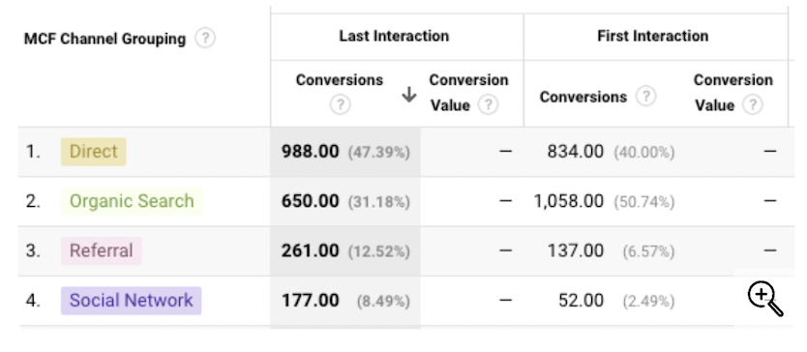

* 1. The screenshot below shows the Operating System report for an ecommerce site over a week.

Which secondary dimensions will help you better understand the difference in conversion rates between the different operating systems?

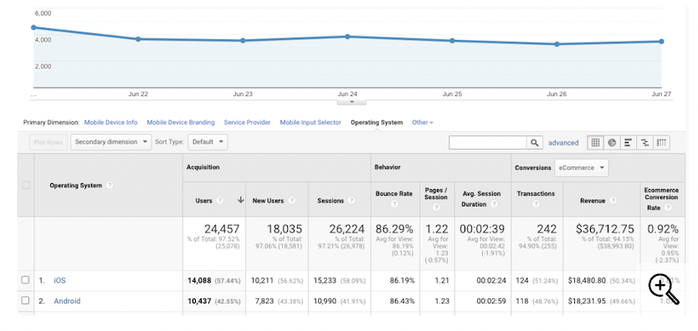

SELECT ALL THAT APPLY

 Gender

 Screen resolution

 Mobile device info

 Day of Week

* 1. True or false: A low conversion rate for Organic Search traffic in Google Analytics is a strong signal that you should stop search engine optimization activities.

SELECT ONLY ONE

 True

 False

* 1. Some of the users on your website are complaining about its speed.

Which dimensions in the Page Timings report can help you identify the reason for the problem?

SELECT ALL THAT APPLY

 Affinity category (reach)

 Operating System

 Browser

 Gender

* 1. You are a marketing analyst in an e-shop. You see that the sales decreased last week, which is unusual for this period, so you look for what on the website might be causing the decrease in sales. The only analytical tool your company uses is Google Analytics.

What Google Analytics data will you analyze to find the weak spot?

SELECT ONLY ONE

 Audience: demographics data and users' interests

 Shopping behavior: consumers' path on the website and inside the cart

 Behavior flow: actions from the landing pages through exit pages

 Acquisition: paid and owned channels' effectiveness

* 1. Making the report on your company website's organic traffic, you see that your e-shop has high traffic, high bounce rate, low average duration of a session, and low average number of pages per session.

What would you recommend checking and optimizing to improve this situation?

 Effectiveness of advertising

 Content of the website

 Content in social media

 Content of emails

 Structure of the cart

 Usability of the website

* 1. As your company's marketing analyst, you are asked to provide information on the age structure of your customers. Here is the data you see:
     + • 18-25 years old: 380 people
     + • 26-35 years old: 100 people
     + • 36-45 years old: 120 people
     + • 46-55 years old: 90 people
     + • 56+ years old: 10 people
     + • Unknown: 300 people

What is the age of your core audience?

 The core audience is under 25 years old.

 The core audience is 18-25 years old.

 The core audience is 18-35 years old.

 The core audience is 18-55 years old.

* 1. You are a member of the Digital Marketing team that works on search engine optimization (SEO) for your company's website. This is the first month your team has started promoting the website, so you want to be careful not to be blocked by search engine algorithms. At the same time, you want to get the best result possible. During the last 12 months, the SEO team added 5 backlinks per month.

How many backlinks should you plan to add in the first month?

SELECT ONLY ONE

 2 backlinks

 5 backlinks

 20 backlinks

 100 backlinks

* 1. As a member of the marketing department of a clothing e-shop with its own delivery service, you create a short questionnaire that will be sent automatically to all the buyers after their purchase. You are interested in evaluating both the product and the delivery service.

What is the best time to send the questionnaire to a buyer?

 3 days after the purchase

 3 days after the delivery

 10 days after the purchase

 10 days after the delivery

* 1. As a marketing analyst, you are asked to create research among your target audience by testing your company's newest cosmetics product. You have a limited budget, so you have to decide how to get the most accurate and detailed results with the least budget possible. You've determined that four different options will use the same budget.

Which of the four options will be the most effective for your research?

SELECT ONLY ONE

 Provide in-store samples to 20 people, then interview them after they try the product.

 Provide in-store samples to 50 people, then ask them to complete a printed questionnaire immediately after they try the product.

 Mail a product sample and a link to an online. questionnaire to 100 people, asking them to complete the questionnaire.

 Provide in-store samples to 10 people, interview them as they try the product, and give them 5 additional samples and questionnaires to share with friends.

* 1. The following chart shows the fluctuation in value of different currencies compared to the U.S. dollar.

Approximately how much was £1 (UK) worth in 2007?

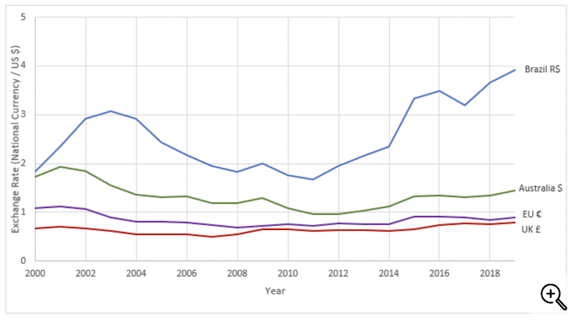

SELECT ONLY ONE

 US $0.5

 US $1

 US $2

 US $4

* 1. You are working on a marketing team, and you are tasked with producing some graphs to illustrate the results of a customer satisfaction survey. Which of the following datasets would be most suitable for displaying as a scatter chart?

SELECT ONLY ONE

 Customer satisfaction score by customer spend

 amount

 Customer satisfaction score by customer gender

 Customer satisfaction score by customer purchase category

 Customer satisfaction score by customer location

* 1. You are given the data below on carbon dioxide emissions associated with different forms of transport, so you can consider how transport type affects a company's environmental impact.

Which of the following statements are correct based on the information in the table?

SELECT ONLY ONE

 A taxi to the airport followed by an international flight will produce 453g CO2 in total.

 It is always preferable to travel by rail where possible because the CO2 emissions of 186g will be shared between hundreds of people.

 Traveling by sea is environmentally preferable to traveling by air in all scenarios.

 International flights have the lowest emissions per passenger per mile.

* 1. You are a member of the marketing department and responsible for data analysis. In your current project, you need to determine the share of users who have children.

Which method will you choose to collect this data?

SELECT ONLY ONE

 Experimental research

 Ouantitative analysis

 User experience analysis

 Oualitative research

* 1. As a member of the marketing department of a clothing e-shop with its own delivery service, you create a short questionnaire that will be sent automatically to all the buyers after their purchase. You are interested in evaluating both the product and the delivery service.

What is the best time to send the questionnaire to a buyer?

SELECT ONLY ONE

 3 days after the purchase

 3 days after the delivery

 10 days after the purchase

 10 days after the delivery

* 1. As a marketing analyst, you are planning your company's next marketing campaign. As part of this planning, you need to forecast the key performance indicators (KPIs). According to the company's strategy, you will increase traffic to the website by 50% and the conversion rate on the website by 20%.

What growth of the number of conversions will you show in the forecast?

SELECT ONLY ONE

 40%

 70%

 80%

 120%

* 1. As a member of the digital marketing team, you monitor your

company's social media performance on a weekly basis. Your

teammate asks you how interested the company account's followers

are in the content you post on one social network

What parameter should you look at to provide this

information?

SELECT ONLY ONE

 Paid reach

 Number of clicks on links

 Organic reach

 Number of comments

* 1. As a marketing analyst, you monitor the performance of your e-shop

company's website. To prepare a new weekly report, you look at the

scrolling heatmaps and see that the content block with goods on the

homepage has the level of 40%.

What does this parameter mean in this situation?

SELECT ONLY ONE

 40% of the homepage's visitors clicked on the block with goods

 40% of the homepage's visitors scrolled to the block with goods

 40% of the homepage's visitors read the block with goods.

 40% of the website's visitors saw the homepage

* 1. You are a member of the Digital Marketing team that works on

search engine optimization (SEO) for your company's website. This is

the first month your team has started promoting the website, so you

want to be careful not to be blocked by search engine algorithms. At

the same time, you want to get the best result possible. During the

last 12 months, the SEO team added 5 backlinks per month.

How many backlinks should you plan to add in the first month?

SELECT ONLY ONE

 2 backlinks

 5 backlinks

 20 backlinks

 100 backlinks

* 1. As an analyst in a retail company, you create a report on the

company's revenue for the board. The main question is if there were

any changes in its seasonality the previous year, or if the most

profitable months are still the same as they were during the last 10

years. You keep in mind that the prices changed every year, as well

as the inflation level and the exchange rate, and all these

parameters affected the total revenue.

How will you present the data to the board with just one slide

for the best understanding of revenue seasonality?

 Calculate separately the month-to-month growth between the previous years.

 Present the dynamics of the monthly indexes calculated for each ear separately.

 Show the share of each month in the total vearly revenue for each year separately

 Build a regression model based on the data you have including all the parameters.

* 1. As a member of the marketing team in a retail company, you create

weekly reports that include results of your digital marketing

activities, offline sales, and call center data. You receive data from

Google Analytics, Hotjar, and an accounting tool, as well as an Excel

file containing information on calls, which is updated weekly. You

want to automate the process of compiling the data and creating

your reports in the most efficient and cost-effective way. However,

due to your company's privacy policy, the Excel file can't be shared

with any external tool.

Which approach should you take?

SELECT ONLY ONE

 Create a macro in Excel that will download and collect all the data in .xls format and create graphs for the report.

 Set up a new tool that will collect all the data automatically and create a report based on this data.

 Upload files with the data every week to Google Data Studio and download dashboards for the report.

 Export the data from all the tools in .xls or .csv format and create a report based on this data.

* 1. As marketing analyst, you are asked to provide information on the

age structure of your customers. Here is the data you see:

• Under 18 vears old: 90 people

• 18-25 vears old: 150 people

• 26-35 years old: 200 people

• 36-45 vears old: 180 people

• 46-55 years old: 90 people

• 56+ years old: 10 people

• Unknown: 100 people

What is the age of your core audience?

SELECT ONLY ONE

 Everyone O+ years old

 18-45 years old

 18-55 years old

 26-35 years old

* 1. You are an analyst in an ecommerce company. To monitor sales, you

need to see the data on popular goods, site revenue, and e-shop

visitors, including their purchases and the average bill on a daily

basis. Since it takes too long to collect all the data manually, you

decide to use a tool for automation. You want to ensure the

automatic reports you generate have the most accurate data.

Which tool should you choose?

SELECT ONLY ONE

 Google Optimize

 BigQuery

 Google Tag Manager

 Google Data Studio

* 1. You are a member of the marketing team in a food manufacturing

holding company and are planning next year's marketing activities.

You need to choose the channels you will use to promote one of

your chocolate brands across the country within a high but limited

budget. The brand has low awareness, so the priority now is to show

the brand name and what the product looks like. The target

audience is wide, including all genders, starting from young students

up to middle-aged, family-oriented people.

What media would you consider for your marketing strategy?

SELECT ALL THAT APPLY

 Magazines

 Cable and local TV

 OOH (out-of-home)

 Digital: social media

 Digital: video platforms

 National radio

 Newspapers

 Digital: search engines

* 1. You are a marketing manager in a company that produces wine for

both business to business (B2B) and business to customer (B2C)

markets. You just analyzed the results of the research you've done

to learn more about your B2C customers' behavior. You learned that

a significant share of your clients drink your wine both in a

restaurant and at home after they buy it directly from your

company.

What conclusion should you draw?

SELECT ONLY ONE

 People learn about us in restaurants, so we should focus on B2B promotion to increase the number of restaurants we work with.

 People learn about us in restaurants, so we should increase B2B promotion in the restaurants we currently work with.

 People buy our wine both in restaurants and from us, so we should work on both B2B and B2C audiences simultaneouslv.

 People order our wine in restaurants after they try it at home, so we should focus on B2C promotion to increase this audience.

* 1. As an analyst in an e-shop, you provide insights to the marketing

team on how to improve the e-shop's performance. The company

uses SEO, search engine and social media advertising, and email

campaigns. Analyzing the previous month's data, you see that 70%

of purchases were made on weekends.

How would you recommend optimizing the promotion?

SELECT ONLY ONE

 Run advertising Saturday-Sunday only to save the budget and send emails on Saturday morning

 Run advertising Friday-Sunday only to save the budget and send emails on Friday morning.

 Increase daily budget on Saturday-Sunday, decrease it on other days, and send emails on Saturday morning

 Increase daily budget on Friday-Sunday, decrease it on other davs, and send emails on Friday morning

* 1. You are a member of the marketing team in a business to business

(B2B) service company. The head of marketing asks you to review

the marketing channels mix for the next year since the budget was

dramatically cut. The key marketing goals are awareness and sales.

Now, you are analyzing the effectiveness of each channel from the

previous year to choose which ones you must keep next year. The

data is in the table below.

Which channels will you add to the mix for the next year?

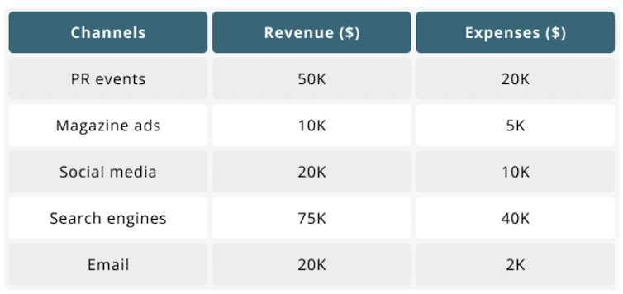

SELECT ONLY ONE

 PR events and search engines

 PR events and email

 Email and ads in magazines

 Email and social media

* 1. How would you find the mean of a set of numbers?

 Calculate the sum of the numbers and divide by the amount of numbers in the set.

 Find the number halfway between the smallest number and the largest number.

 Find the number that appears most frequently.

 Put all the numbers in ascending order and find the number in the middle

* 1. You are working as a marketing analyst for an ice cream company,

and you are presented with data from a survey on people's favorite

ice cream flavors. In the survey, people were asked to select their

favorite flavor from a list of 25 options, and over 800 people

responded. Your manager has asked you to produce a quick chart to

illustrate and compare the popularity of all the flavors.

Which type of chart would be best suited to the task?

 Scatter plot

 Line chart

 Pie chart

 Bar chart

* 1. You work for a furniture sales company that has stores across the

city. You are presented with the chart shown below comparing sales

in two different regions of the city.

Which of the following statements can be concluded from the

information in the chart?

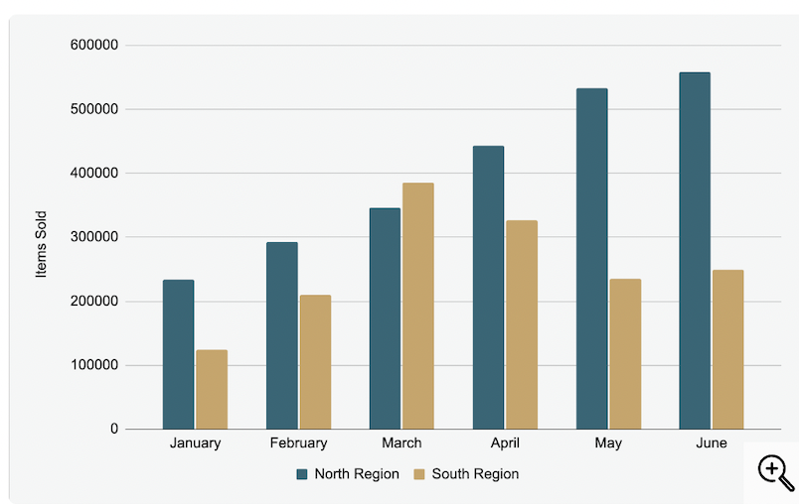

SELECT ALL THAT APPLY

 The average number of items sold per month is lower in the South region

 The North region makes a higher profit than the South region

 Sales generally decreased over the six months shown

 More items were sold in the North Region than the South Region during the six months shown.

 January was the month with the fewest sales

 More items will be sold in July than were sold in June

* 1. Which of the following data types would be suitable for storing the sale price of goods in a supermarket?

SELECT ONLY ONE

 string

 Integer

 Boolean

 Float

* 1. You are inputting customer data onto a database, but a customer did not want to provide their date of birth. How should you proceed?

SELECT ONLY ONE

 Input today's date.

 Enter a zero value

 Leave the input blank.

 Estimate their age and input an approximate date of birth.

* 1. You are designing an online survey for an international audience.

Which of the following formats would be suitable for the "Date

of Birth" question?

 Dropdown calendar for date selection

 --/--/--

 --/--/----

 mm/dd/yyyy

 Free text box

* 1. You are given the following results from a stock-checking exercise when you notice some errors in the data.

Which column is most likely to be the source of the errors?

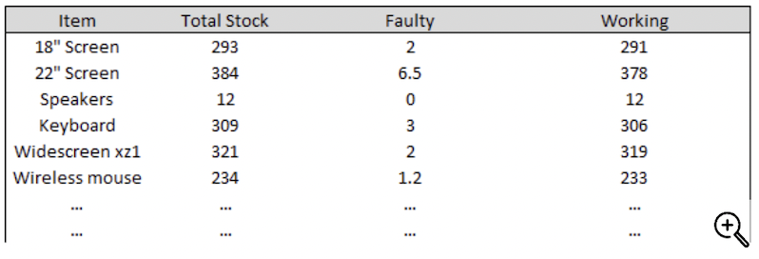

SELECT ONLY ONE

 Item

 Faulty

 Total Stock

 Working

* 1. You are checking a report produced by a colleague that contains the following extract: "Stock checks were performed across 203 stores. Inventorv accuracy ranged from 84% to 97.7% with 38 stores meeting the target." You notice that there is an inconsistency in the use of decimal places.

Which of the following would be a better way to present the data?

 Stock checks were performed across 203 stores. Inventory accuracy ranged from 84.0% to 97.3% with 38 stores meeting the target.

 Stock checks were performed across 203 stores Inventory accuracy ranged from 84% to 97% with 38 stores meeting the target.

 Stock checks were performed across 203.0 stores Inventory accuracy ranged from 84.0% to 97.7% with 38.0 stores meeting the target.

 Stock checks were performed across 203% stores Inventory accuracy ranged from 84% to 97.3% with 38% stores meeting the target.

* 1. You have calculated the total mileage traveled by a sales manager this year.

Which of the following would be acceptable ways to report this figure in a summary text?

 16km

 16.000 miles

 15.9k miles

 15.974 miles

 16k miles

 16.0 miles

* 1. You are presented with the following table of data, but the final column has not been labeled.

Which of the following is most likely to be a suitable label for the final column?

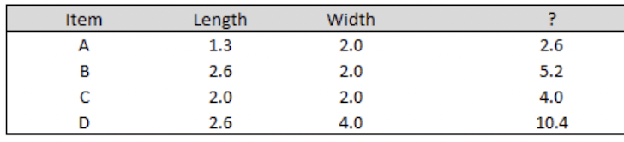

SELECT ONLY ONE

 Circumference

 Area

 Perimeter

 Volume

* 1. You are given the data below on carbon dioxide emissions

associated with different forms of transport, so you can consider

how transport type affects a company's environmental impact.

Which of the following statements are correct based on the

information in the table?

 A taxi to the airport followed by an international flight will produce 453g CO2 in total.

 It is always preferable to travel by rail where possible because the CO2 emissions of 186g will be shared between hundreds of people.

 Traveling by sea is environmentally preferable to traveling by air in all scenarios.

 International flights have the lowest emissions per passenger per mile

* 1. You are given the data below on carbon dioxide emissions

associated with different forms of transport, so you can consider

how transport type affects a company's environmental impact.

Which of the following statements are correct based on the

information in the table?

SELECT ONLY ONE

 A taxi to the airport followed by an international flight will produce 453g CO2 in total.

 It is always preferable to travel by rail where possible because the CO2 emissions of 186g will be shared

between hundreds of people.

 Traveling by sea is environmentally preferable to traveling by air in all scenarios

 International flights have the lowest emissions per passenger per mile

* 1. You are working on a marketing team, and you are tasked with

producing some graphs to illustrate the results of a customer

satisfaction survey.

Which of the following datasets would be most suitable for

displaying as a scatter chart?

 Customer satisfaction score by customer spend amount

 Customer satisfaction score by customer gender

 Customer satisfaction score by customer purchase category

 Customer satisfaction score by customer location

* 1. Which of the following would be suitable axes labels for a histogram?

 x-axis: date of birth

y-axis: average height

 x-axis: age category (18-25; 26-34; 35-44; 45-54: 55+)

y-axis: number of individuals

 ×-axis: age category (18-25; 26-34; 35-44; 45-54: 55+)

y-axis: average height

 x-axis: date of birth

y-axis: age category (18-25; 26-34; 35-44: 45-54: 55+)

_________________________________________________________________________

* 1. A car manufacturer sources various car components from its vendors. The car manufacturer sources some parts from multiple vendors. All parts are categorized into different categories based on their value. The company maintains this data in a database consisting of three tables: VENDORS, CATEGORIES, and PARTS. The structure of the tables and the sample data in them are shown below.

Note that the data provided are only sample data. Keep in mind that the full database has more rows of data in it, and your queries must return the correct results for all data.

You are required to carry out the following task:

Create a report that shows which vendor each part is sourced from and the category the part belongs to, as shown in the sample result below. Note that if a part is sourced from two different vendors, it appears twice on the list, once for each vendor.

