**Azure DevOps:**

<https://dev.azure.com/ksauravt/MLOps-WorkShop-1/_releaseProgress?_a=release-pipeline-progress&releaseId=24>

**Create Service Connection:**

**Added Group Variable:**

**CI Pipeline:**

**Release Pipeline:**

**Resource Group and Azure Machine Learning:**

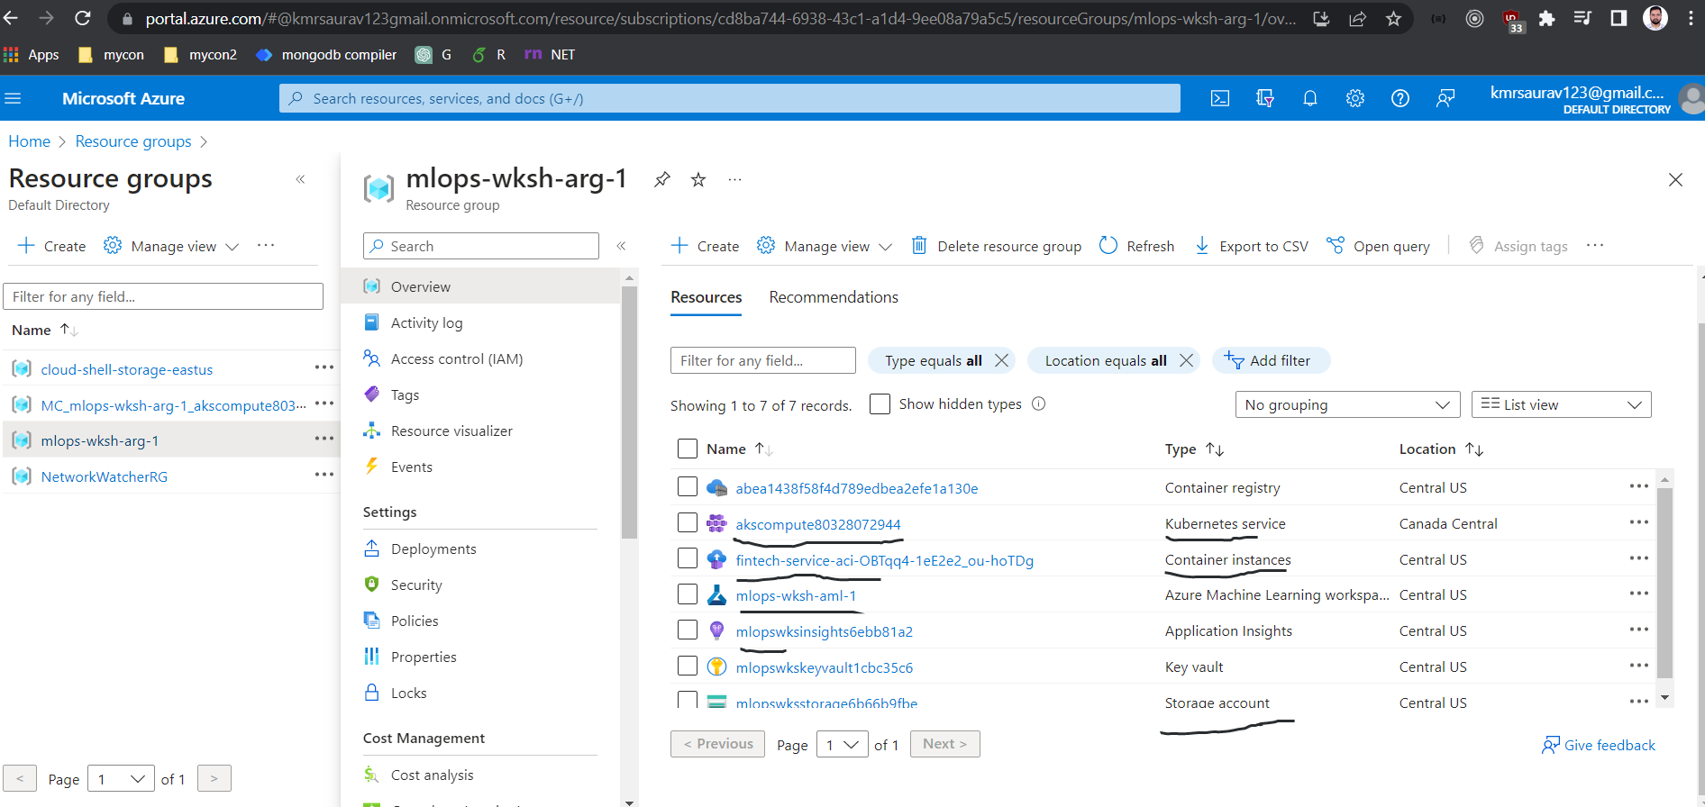

**DataSet:**

**Models:**

**Compute Cluster:**

**AKS Compute:**

**AKS inside resource group:**

**PODs:**

**Containers:**

**End Point Staging and Production:**

**Load balancer:**

**Network:**

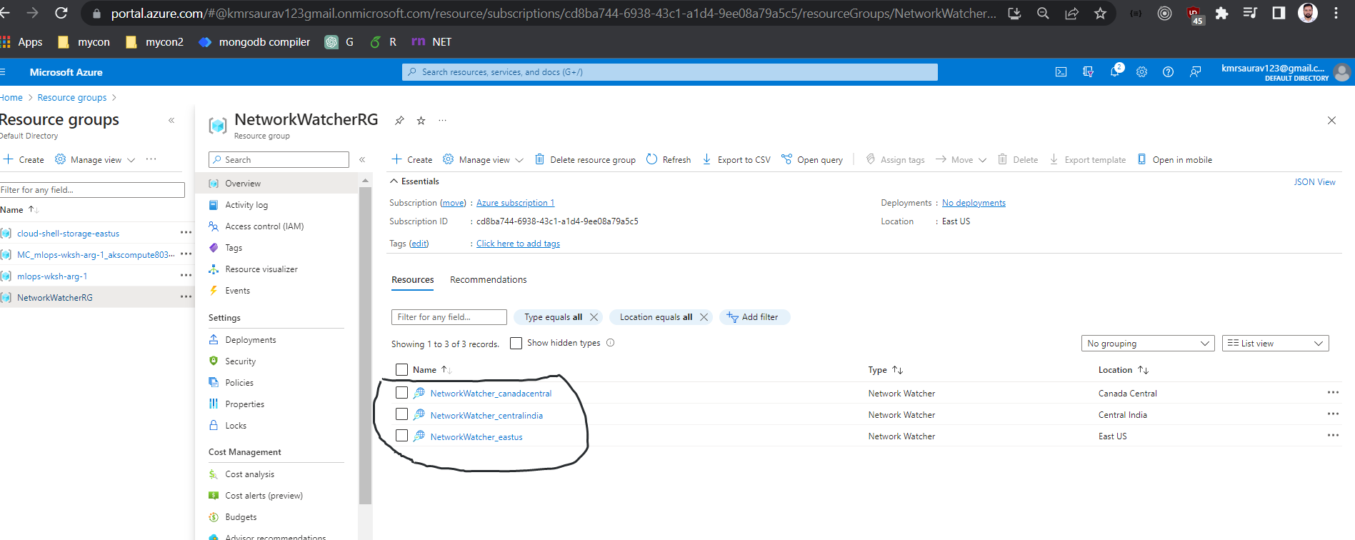

<http://20.151.197.20:80/api/v1/service/insurance-service-aks/score>

