**Q function for estimating error probability:** P(ÛML≠**u**) = Q(a/σ) = Q(||**uA – uB**||/2*sqrt(N0/2))

-Change out the ||**uA – uB**|| for dmin if there are more than two points, multiply Q function by (M-1)

# Amplitude modulation:

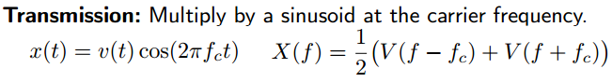

Processing received signal, we end up with v(t):

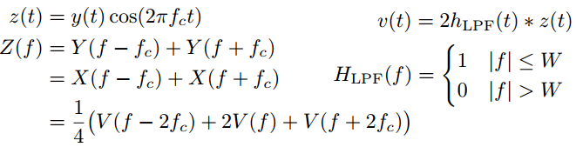

**Reflection off wall at distance d, velocity v to the right:**

**Reflecting wall, fixed Rx:**

To get from constructive interference: r2-r1=λ/4

**Discrete time:**

, only one tap if Td<1/w

Can be calculated if you have the longest and shortest paths, and divide by c (Td=(dmax-dmin)/c)

Coherence bandwidth: Wc=1/(2*Td), range of frequencies where the channel is relatively flat,

Frequency-selective if Wc<<W and flat fading if Wc>>W. (W should be given for the application)

Doppler spread and coherence time. The derivative of T is the same as the speed divided by c.

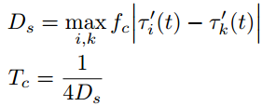Fast fading: TC<<delay requirement of application

Slow fading: TC>>delay requirement (what we want, channel stable)



**Decibels**: SNRDB=10log10(SNR) **Norm of a vector:**

**SNR:** avg signal power/avg noise power

**Deep fade event**: |h[0]|2=1/SNRL

Diversity: scheme has diversity has gain d if $\lim_{SNR→inf}{\frac{log⁡(P\left(\hat{x}≠x\right))}{\log{SNR}}=-d}$

For time diversity, this means that for a given L, none of the codewords share the same coordinate.

For antenna diversity, this means that the determinant criteria cannot be equal to 0 for any two points

**Exact error probability:**



**Estimated error probability:**



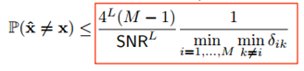

**Time diversity probability of error:**

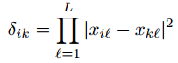

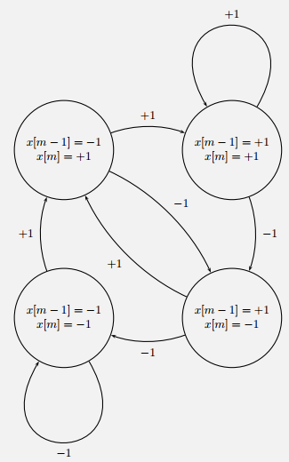**Antenna diversity probability of error:** 

**Rate:**

Time diversity: 1/L*log2M

Antenna diversity: 1/N * log2M

**Average power:**

Time diversity: Antenna diversity:

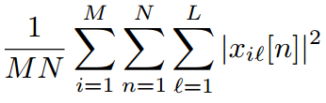 $1=\frac{1}{LM}\sum_{i=1}^{M}{{|\left|x_{i}\right||}^{2}}$

Cost function for Viterbi algorithm:

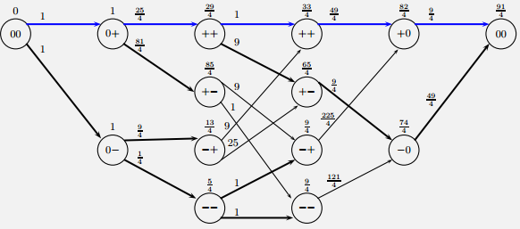Cm(S(m))= |y[m] – h1*x[m] - ... hL-1x[m-L-1]|2

