Kyle Savidge

Miniproject #2 – EC508

10/19/16

# Code for (a) & (b):

%initialize variables, loop over 10 SNR values

L = 3;

fail = zeros(11, L);

probErrSim = zeros(11, L);

probErrExact = zeros(11,L);

probErrEst = zeros(11,L);

for SNRdb_1 = 1:11

SNRdb = SNRdb_1 - 1;

SNR = 10.^(SNRdb/10);

%simulate 10000 trials of sending bit x and getting y at the Rx

for trial = 1:10000

h = 1/sqrt(2) * randn(L,1) + 1j/sqrt(2) * randn(L,1);

w = 1/sqrt(2) * randn(L,1) + 1j/sqrt(2) * randn(L,1);

x = sqrt(SNR)*((-1)^randi([0 1]));

y = h * x + w;

%ML detection, determines whether the projection of magnitude h * %value of y onto the real line is closer to x or the %complementary BPSK value of x

for l = 1:L

h_temp = h(1:l);

y_temp = y(1:l);

decider = real(((h_temp)'*y_temp)/norm(h_temp));

if (abs(decider - x) > abs(decider - (-1 * x)))

fail(SNRdb_1, l) = fail(SNRdb_1, l) + 1;

end

%calculate the error rate

probErrSim(SNRdb_1, l) = (fail(SNRdb_1,l)/trial);

end

end

%exact error probablity for each L

mu = sqrt(SNR/(1 + SNR));

for l_temp = 1:L

sum = 0; % reset the summation over l for each L

for l = 0:(l_temp - 1)

sum = sum + (((1 - mu)/2))^l_temp * nchoosek(l_temp - 1... + l, l) * ((1 + mu)/2)^l;

probErrExact(SNRdb_1,l_temp) = sum;

end

end

%estimated error probability for each L

for l = 1:L

probErrEst(SNRdb_1, l) = nchoosek(2*l - 1, l)*(1/((4 * SNR)^l));

end

end

SNRdb = transpose(0:10);

semilogy(SNRdb,probErrSim);

hold on

semilogy(SNRdb,probErrExact);

semilogy(SNRdb,probErrEst);

hold off

legend('Simulated Error, L = 1', 'Simulated Error, L = 2', 'Simulated Error, L = 3', ...

'Exact error, L =1', 'Exact error, L =2', 'Exact error, L =3', ...

'Estimated error, L=1', 'Estimated error, L=2', 'Estimated error, L=3');

xlabel('SNR in dB')

ylabel('Error percentage (log scale)')

# Plot from (a) & (b):

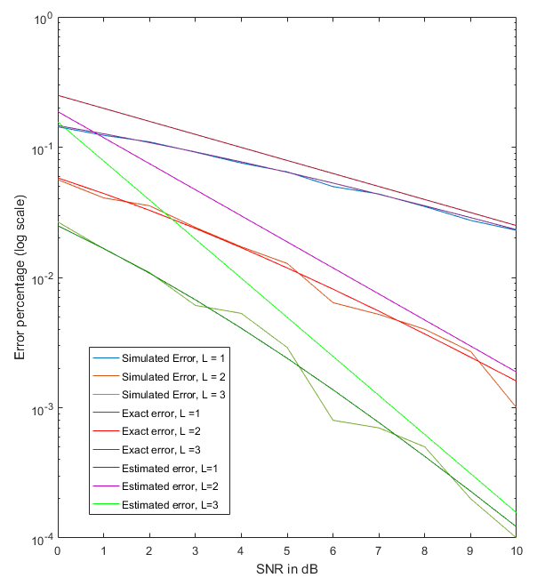

# Part (c):

%initialize variables, loop over 20 M_train values

L = 3;

M_train = 20;

M_c = 100;

w = zeros(M_train, L);

hhat_l = zeros(L);

fail = zeros(M_train, L);

probErrSim = zeros(M_train, L);

probErrExact = zeros(M_train,L);

SNRdb = 0;

SNR = 10.^(SNRdb/10);

for m_temp = 1:M_train

%simulate 1000 trials of sending bit x and getting y at the Rx

for trial = 1:10000

%generate h_l

h = 1/sqrt(2) * randn(L,1) + 1j/sqrt(2) * randn(L,1);

%generate M_train noise values

w = 1/sqrt(2) * randn(L,M_train) + 1j/sqrt(2) * randn(L,M_train);

%calculate h(hat)_l using MMSE

sum = 0;

for m = 1:m_temp

sum = sum + (sqrt(SNR)/(1 + M_train * sqrt(SNR))*(h * sqrt(SNR) + w(:,m)));

end

hhat_l = sum;

%send x over the channel during the remaining time on the coherence

%interval

x = sqrt(SNR)*((-1)^randi([0 1]));

w = 1/sqrt(2) * randn(L,1) + 1j/sqrt(2) * randn(L,1);

y = h * x + w;

%ML detection, determines whether the projection of magnitude h * value of y

%onto the real line is closer to x or the complementary BPSK value of x

for l = 1:L

h_temp = hhat_l(1:l);

y_temp = y(1:l);

decider = real(((h_temp')*y_temp)/norm(h_temp));

if (abs(decider - x) > abs(decider - (-1 * x)))

fail(m_temp, l) = fail(m_temp, l) + 1;

end

%calculate the error rate

probErrSim(m_temp, l) = (fail(m_temp,l)/trial);

end

end

%exact error probablity for each L

mu = sqrt(SNR/(1 + SNR));

for l_temp = 1:L

sum = 0; % reset the summation over l for each L

for l = 0:(l_temp - 1)

sum = sum + (((1 - mu)/2))^l_temp * nchoosek(l_temp - 1 + l, l) * ((1 + mu)/2)^l;

probErrExact(m_temp,l_temp) = sum;

end

end

end

x_axis = transpose(1:M_train);

semilogy(x_axis,probErrSim);

hold on

semilogy(x_axis,probErrExact);

hold off

legend('Simulated Error, L = 1', 'Simulated Error, L = 2', 'Simulated Error, L = 3', ...

'Exact error, L =1', 'Exact error, L =2', 'Exact error, L =3');

xlabel('M_train period length')

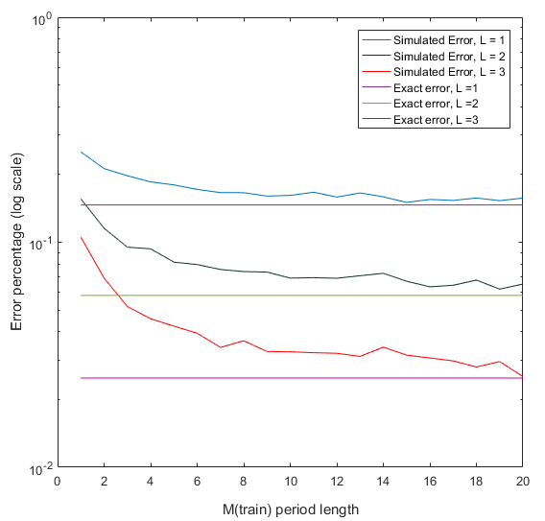ylabel('Error percentage (log scale)')

%initialize variables, loop over 10 SNR values

# Part (d):

L = 3;

M_train = 5;

M_c = 100;

w = zeros(M_train, L);

hhat_l = zeros(L);

fail = zeros(11, L);

probErrSim = zeros(11, L);

probErrExact = zeros(11,L);

probErrEst = zeros(11,L);

for SNRdb_1 = 1:11

SNRdb = SNRdb_1 - 1;

SNR = 10.^(SNRdb/10);

%simulate 1000 trials of sending bit x and getting y at the Rx

for trial = 1:5000

%generate h_l

h = 1/sqrt(2) * randn(L,1) + 1j/sqrt(2) * randn(L,1);

%generate M_train noise values

w = 1/sqrt(2) * randn(L,M_train) + 1j/sqrt(2) * randn(L,M_train);

%calculate h(hat)_l using MMSE

sum = 0;

for m = 1:M_train

sum = sum + (sqrt(SNR)/(1 + M_train * sqrt(SNR))*(h * sqrt(SNR) + w(:,m)));

end

hhat_l = sum;

%send x over the channel during the remaining time on the coherence

%interval

x = sqrt(SNR)*((-1)^randi([0 1]));

w = 1/sqrt(2) * randn(L,1) + 1j/sqrt(2) * randn(L,1);

y = h * x + w;

%ML detection, determines whether the projection of magnitude h(hat) * value of y

%onto the real line is closer to x or the complementary BPSK value of x

for l = 1:L

h_temp = hhat_l(1:l);

y_temp = y(1:l);

decider = real(((h_temp')*y_temp)/norm(h_temp));

if (abs(decider - x) > abs(decider - (-1 * x)))

fail(SNRdb_1, l) = fail(SNRdb_1, l) + 1;

end

%calculate the error rate

probErrSim(SNRdb_1, l) = (fail(SNRdb_1,l)/trial);

end

end

%exact error probablity for each L

mu = sqrt(SNR/(1 + SNR));

for l_temp = 1:L

sum = 0; % reset the summation over l for each L

for l = 0:(l_temp - 1)

sum = sum + (((1 - mu)/2))^l_temp * nchoosek(l_temp - 1 + l, l) * ((1 + mu)/2)^l;

probErrExact(SNRdb_1,l_temp) = sum;

end

end

end

SNRdb = transpose(0:10);

semilogy(SNRdb,probErrSim);

hold on

semilogy(SNRdb,probErrExact);

hold off

legend('Simulated Error, L = 1', 'Simulated Error, L = 2', 'Simulated Error, L = 3', ...

'Exact error, L =1', 'Exact error, L =2', 'Exact error, L =3');

xlabel('SNR in dB')

ylabel('Error percentage (log scale)')

