Financial Risk & Data Integrity Audit
Analyzing Loan Default Risk Using Machine Learning
Kevin Sayavong
Data Analytics Bootcamp — Capstone Project
Dataset: LendingClub Loan Data — Kaggle
Python | pandas | numpy | scipy | scikit-learn | matplotlib | seaborn

1. Introduction
Every lender faces the same problem: decide who gets a loan before knowing if they will pay it back. My background as a developer in the Master Data Management department at Northwestern Mutual is relevant here, bad data leads to bad risk decisions, and this project treats loan default prediction as both a data quality problem and a data science problem. The goal was to work through a real loan dataset, identify which factors actually predict default, and come away with findings a lender could act on.

2. The Data
The dataset is the LendingClub Loan Data (Imbalance Dataset) sourced from Kaggle (dataset link). It contains 9,578 real loan records covering borrower credit score, income, interest rate, loan purpose, and whether the loan was repaid. After cleaning, the dataset had 22 variables and zero missing values.

Attribute | Value
Total Records | 9,578 loans
Variables | 22 (after cleaning and feature engineering)
Missing Values | 0
Loans Repaid | 8,045 (84%)
Loans Defaulted | 1,533 (16%)

Cleaning & Feature Engineering
The raw data required five cleaning steps: stripping symbols from numeric fields, converting all financial columns from text to numbers, one-hot encoding the loan purpose column into 8 binary columns, standardizing rate columns to decimal format, and removing leftover artifact columns.
Two new columns were also built from existing data, marked with * since they were not in the original dataset:
- Monthly Income *: reverses the natural log stored in the dataset and divides by 12 to produce a readable monthly dollar figure.
- Installment as Percent of Income *: divides the loan payment by monthly income, mirroring the payment-to-income ratio used in mortgage underwriting. Statistical testing confirmed this variable is real but has a very small effect size, more exploration is needed before it drives any policy decision.

3. Methodology
Four key decisions were made before building the model:
- Class imbalance: With 84% repaid and 16% defaulted, a model on raw data would just predict "repaid" every time and look 84% accurate while catching zero defaults. The minority class was oversampled to balance the groups.
- Feature scaling: Income values in the tens of thousands would drown out smaller variables like a 0.12 interest rate without scaling. StandardScaler brought everything to the same scale.
- Train/test split: 80% training, 20% held back for testing. The model never sees test data during training, so the accuracy numbers are honest.
- Model choice: Logistic Regression was chosen for transparency, every coefficient directly shows how much a variable pushes the default probability up or down. That matters when decisions need to be explainable.

An independent samples t-test was run on three key variables to confirm whether differences between defaulted and repaid borrowers were real. Cohen's d was also calculated alongside each p-value, with nearly 10,000 records, even a tiny difference can look significant, so effect size matters.

Variable | p-value | Cohen's d | Takeaway
FICO Score | 4.23 x 10^-49 | 0.43 | Real gap, but heavy distribution overlap
Installment as % of Income * | 3.74 x 10^-13 | 0.19 | Significant but very small effect
Credit Inquiries (Last 6 Mo.) | 5.79 x 10^-49 | 0.36 | 4+ inquiries = 2x more likely to default

4. Findings
A Pearson correlation analysis across all 21 variables showed that Interest Rate had the strongest positive correlation with default (+0.16), followed by Credit Inquiries (+0.15). FICO Score and meeting credit policy had the strongest negative correlation. No single variable stood out on its own, default risk comes from multiple factors together, which is why a model is more useful than any one-rule approach.
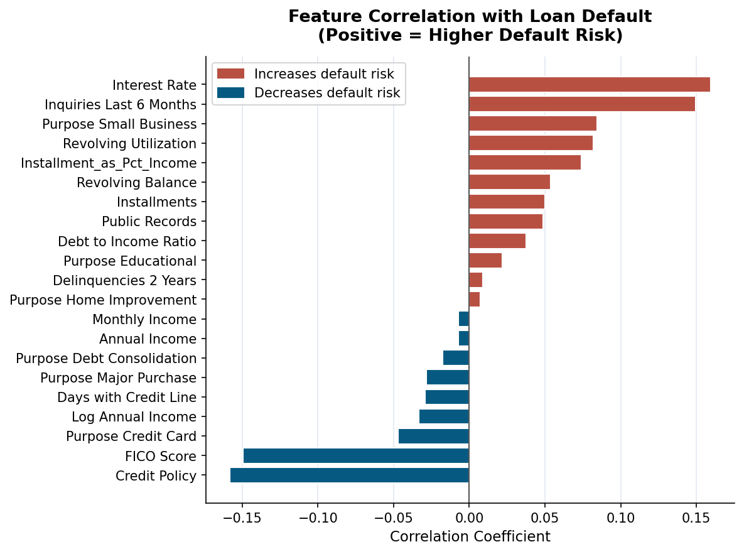
Figure 1: Pearson correlation of all features with the loan default target.
On FICO score: defaulted borrowers averaged 697.8 vs. 713.3 for repaid, a 15.5-point gap that is statistically real but small in practical terms (Cohen's d = 0.43). The distributions overlap too much for FICO to work as a standalone signal. Credit inquiries told a more useful story: at 4 or more inquiries in the last 6 months, defaulted borrowers were more than twice as likely to hit that threshold (23.2% vs. 10.9%), with the gap strengthening further at 5+ inquiries.
On loan purpose: small business loans defaulted at 27.8%, nearly double the 16% platform average. Educational loans were also elevated. Credit card and debt consolidation loans were at or below average. These categories carry different risk profiles and should not be priced the same way.
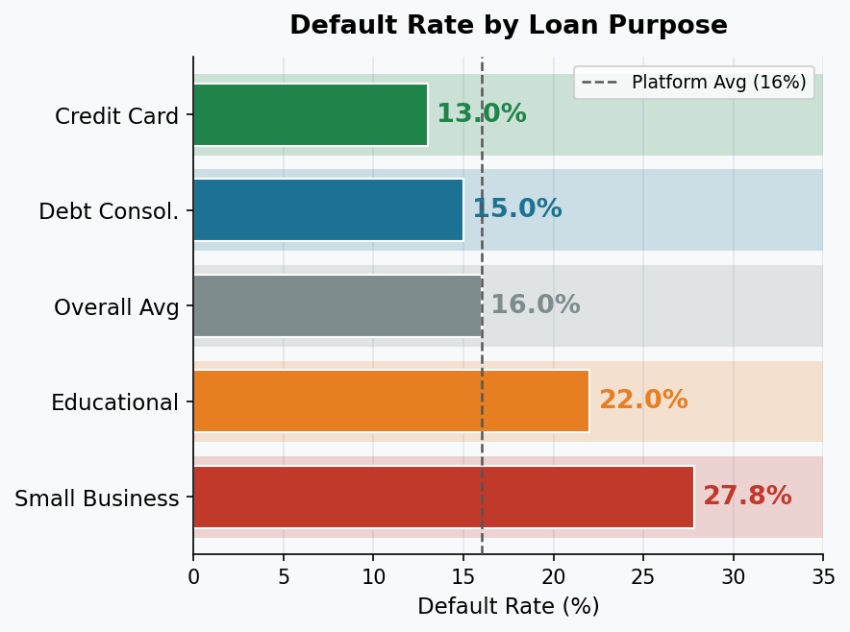
Figure 2: Default rate by loan purpose. Small business at nearly 2x the platform average.

5. Model Results
The Logistic Regression model produced 62% accuracy on the held-out test set, with 61% of actual defaults correctly identified and 64% precision. A finding of 62% is not a strong result. It is only 12 points above random guessing at 50%, and a model that always predicts "repaid" would score 84%. However, that same model would also catch zero defaults. My model needs more data to be deployment-ready: payment history, employment status, total savings, and bank account activity are all missing from this dataset and would meaningfully improve performance. What this version demonstrates is that the signals exist in the available data and can be extracted through a rigorous process.
One notable finding: correlation ranked Interest Rate as the top risk predictor, but the model (looking at all variables together) moved Credit Inquiries to the top. Log Annual Income also emerged as nearly as important as FICO Score inside the model, which the correlation analysis alone did not surface.
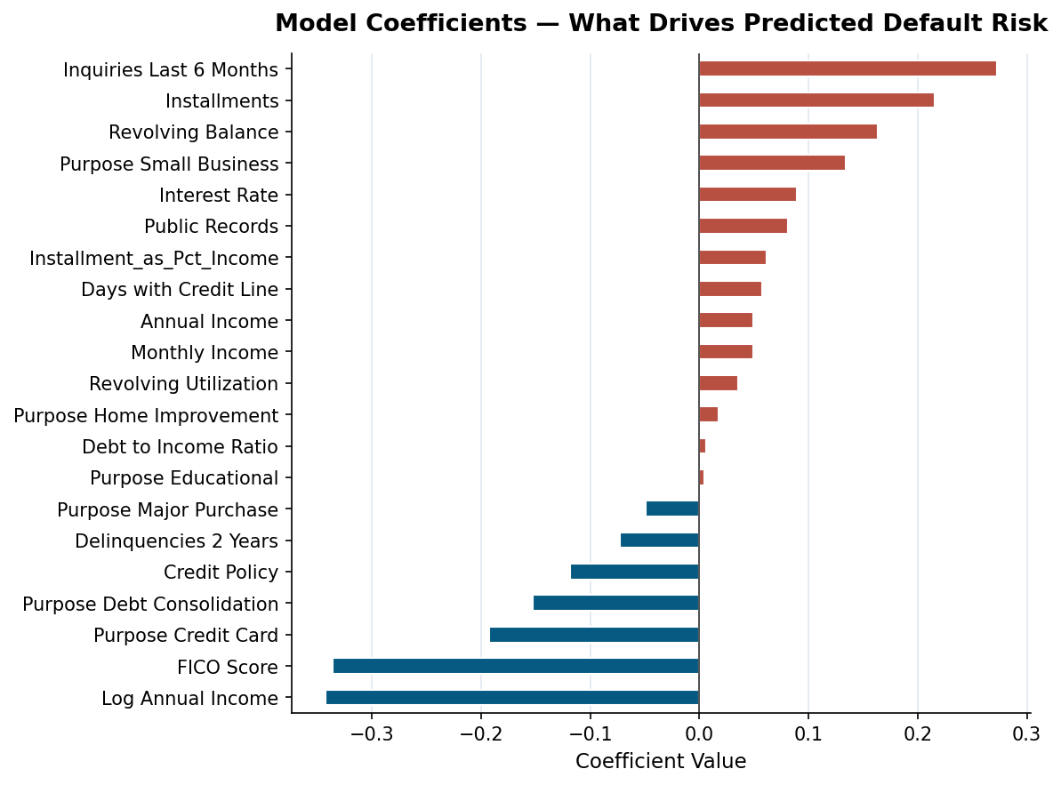
Figure 3: Logistic Regression coefficients. Red = increases default probability. Blue = decreases.

6. Recommendations
- Flag 4+ credit inquiries for manual underwriting review. Borrowers in this group are more than twice as likely to default. Not a reason for automatic denial, but a reason to look closer.
- Separate risk framework for small business loans. A 27.8% default rate cannot be priced identically to a 13% credit card loan. Higher FICO minimums or adjusted rates are worth exploring.
- Continue exploring payment burden metrics. Installment as Percent of Income showed a real but small effect. Debt-service-to-income ratio (DTI) is already standard in mortgage lending and could add more signal beyond FICO and interest rate alone.
- Expand the model with additional data. The debt-service-to-income ratio, or DTI, is already a standard metric in mortgage lending precisely because it captures payment burden in context of total income, and its inclusion in LendingClub's model would add a meaningful signal beyond what FICO and interest rate alone provide. On top of that, adding payment history, employment duration, total assets, and bank account data would all improve accuracy. The methodology is in place, better data is the next step.

7. Conclusion
This project applied the full analytics pipeline to a real financial risk problem: cleaning, feature engineering, statistical testing, correlation analysis, modeling, and recommendations. With every step documented and reproducible in the accompanying Jupyter notebook. Loan default is not random. Interest rate, FICO score, credit inquiry patterns, and loan purpose all carry real, measurable relationships with whether a borrower repays. With richer data and continued iteration, this methodology can meaningfully improve how lending decisions get made.

Submitted Artifacts:
- Comprehensive Analytics Report — Sayavong_Kevin_Capstone_Report_Final.docx (this document)
- Jupyter Notebook — Sayavong_Kevin_Capstone_Notebook.ipynb — all Python code, statistical tests, and chart generation
- Presentation Slide Deck — Sayavong_Kevin_Capstone_Presentation_Final.pptx (13 slides)
- Dataset — LendingClub Loan Data (Kaggle) | Cleaned file: loan_data_Python_Data3.csv

