Effect of increasing the non-diagonal elements on the error and residual

1. With increasing non-diagonal element till the value of the diagonal element, error reduces to zero. When non-diagonal element becomes greater than diagonal element, error becomes positive and starts rising with increasing rate.
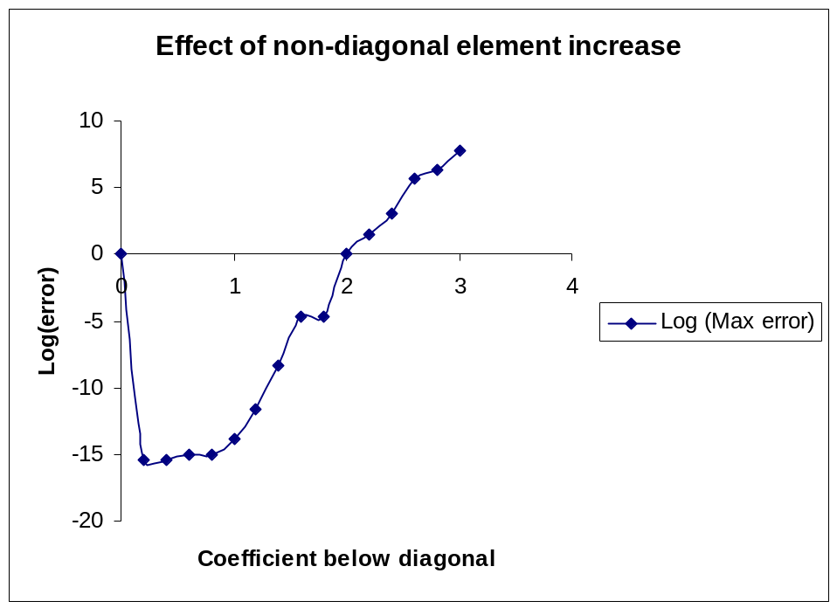
2. Increase in the maximum residual is plotted in the figure below. The residual starts increasing with increasing non-diagonal element gradually till it is less than diagonal element. After non-diagonal element becomes greater than diagonal element, at some point it rises suddenly to very value.
